A matched bridge’s admission threshold sets its bias: at the threshold used in practice the bridged contrast was biased by twice the true effect
A simulation study answering catalog problem DIS-21
Ahmad Sofi-Mahmudi
2026-09-23

Abstract
Background. A disconnected network can be bridged by matching arms of trials on either side on their reported covariate means and treating a close pair as if randomized. The analyst sets the maximum admissible distance. In the one published calibration, arms of the same trial differed by about a tenth of the threshold used (1). Catalog problem DIS-21 asks how the threshold relates to the bridge’s bias.
Methods. Two subnetworks of six trials each, with populations close or shifted across the gap; control arms matched at thresholds of 1 to 20 times the median distance between arms of one randomized trial; an index with all three covariates or without the most prognostic one; study-level baseline heterogeneity absent or present. 2000 replicates per cell.
Results. With populations shifted across the gap, the bridged contrast (truth ) was biased by -0.028 at the within-trial distance, where the network was connected in 8% of replicates, by -0.126 at three times it, and by -0.437 at ten times it, where it was always connected and its interval covered 0% of the time. An index that omitted the most prognostic covariate was biased by -0.254 even at the tightest threshold.
Conclusion. The threshold trades bias against whether the comparison exists, and neither the trade nor its terms are visible in a single analysis. A bridged estimate should be reported as a curve over the threshold in within-trial units, with the probability that the bridge exists at each point.

1. The problem
A matched bridge assumes that two arms from different trials, similar on reported covariates, differ only by their treatments. The residual difference in prognosis is the bridge’s bias, and it grows with the distance admitted. The threshold also decides which pairs exist, so tightening it to control bias can disconnect the network. The natural unit for the threshold is the distance between two arms of one randomized trial, which are exchangeable by design. A case study comparing this bridge with component network meta-analysis found they could disagree (2).

2. Design
Registered protocol: protocol.md. Six trials of A versus C and six of B versus D, 150 patients per arm. Trial populations have three covariate means from on one side of the gap and on the other, ; arm means add sampling error. Arm outcome means: study-level baseline , , plus , plus the treatment effect (A , B , C and D 0). Every C-D arm pair within the threshold enters as a pseudo-trial; all pairs, A-C trials and B-D trials are pooled by fixed effect, as in practice. The within-trial unit was 0.104 (all covariates).

3. Results
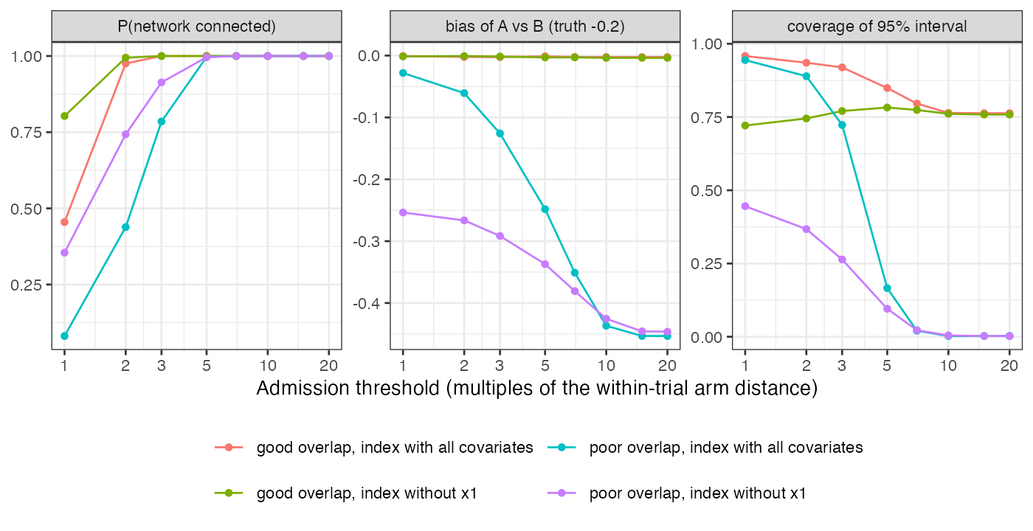
Figure 1: Probability the bridge exists, bias and coverage against the threshold, without study-level heterogeneity. Bias and coverage are conditional on the bridge existing.
Table 1: Threshold in multiples of the within-trial distance; no study-level heterogeneity; 2000 replicates, bias MCSE at most 0.010.
gap shift | index | threshold | connected | pairs | bias | coverage
0.0 | all covariates | 1 | 46% | 0.6 | -0.001 | 0.958
0.0 | all covariates | 3 | 100% | 11.4 | -0.002 | 0.919
0.0 | all covariates | 5 | 100% | 27.4 | -0.001 | 0.849
0.0 | all covariates | 10 | 100% | 36.0 | -0.002 | 0.764
0.5 | all covariates | 1 | 8% | 0.1 | -0.028 | 0.944
0.5 | all covariates | 3 | 78% | 2.7 | -0.126 | 0.723
0.5 | all covariates | 5 | 100% | 11.6 | -0.248 | 0.166
0.5 | all covariates | 10 | 100% | 34.6 | -0.437 | 0.003
0.0 | without x1 | 1 | 80% | 1.8 | -0.001 | 0.721
0.0 | without x1 | 3 | 100% | 12.7 | -0.002 | 0.770
0.0 | without x1 | 5 | 100% | 25.4 | -0.003 | 0.782
0.0 | without x1 | 10 | 100% | 35.7 | -0.004 | 0.761
0.5 | without x1 | 1 | 35% | 0.5 | -0.254 | 0.446
0.5 | without x1 | 3 | 91% | 4.5 | -0.292 | 0.264
0.5 | without x1 | 5 | 100% | 12.4 | -0.337 | 0.095
0.5 | without x1 | 10 | 100% | 32.3 | -0.425 | 0.004

The registered condition failed: in the poor-overlap cells the bias moved by 0.19 to 0.39 across the thresholds at which the bridge existed at least a fifth of the time (Figure 1, Table 1). The threshold near the one used in practice, about ten within-trial units here, admitted almost every pair and returned the bias of an unmatched comparison. Tight thresholds removed most of the bias only when the index contained the prognostic covariates, and then the bridge often did not exist.
Coverage failed even without bias. With populations close across the gap, the interval covered 96% at the tightest threshold and 76% at ten units, because pairs that reuse the same arms were pooled as independent. An index missing a prognostic covariate left each pair’s prognostic difference as unmodeled noise, and coverage was about three quarters at every threshold. Study-level baseline heterogeneity (SD 0.1) lowered coverage further at every threshold (to 80% at the tightest with good overlap), since no covariate distance can see it.

4. What this does not answer
Monte Carlo networks only, no deletions from real networks; one distance with two covariate sets and no alternative normalization; no component network meta-analysis bridge; admitted pairs pooled as independent, as in practice, rather than by a model for shared arms. Peer review has not been done.

References
1. Susanne Schmitz, others. The use of single armed observational data to closing the gap in otherwise disconnected evidence networks: A network meta-analysis in multiple myeloma. BMC Medical Research Methodology. 2018;18. doi:10.1186/s12874-018-0509-7
2. Gerta Rücker, Susanne Schmitz, Guido Schwarzer. Component network meta-analysis compared to a matching method in a disconnected network: A case study. Biometrical Journal. 2021;63. doi:10.1002/bimj.201900339

