A diagonal-weight influence ranked studies correctly only with two-arm studies and heterogeneity held fixed
A simulation study answering catalog problem CMP-24
Ahmad Sofi-Mahmudi
2026-09-23

Abstract
Background. cpaic’s edge_influence() reports each study’s contribution to a requested contrast from a hat matrix with diagonal inverse-variance weights and held fixed. The catalog (CMP-24) says this is exact for two-arm studies at fixed weights and approximate otherwise. The refuting sentence: the approximation preserves the ranking even where it misstates values.
Methods. Random connected four-treatment networks of 8 or 16 studies, all two-arm or with three-arm studies, true of 0, 0.1 or 0.3; 500 networks per cell. The diagonal influence was compared with leave-one-study-out refits of the correct model (within-study covariance, re-estimated by REML), scored by variance importance. Registered rule: not fit for ranking if in any cell the mean Spearman correlation is below 0.9 or the most important study is misidentified in more than 10% of networks.
Results. The diagonal influence equaled the correct hat row for two-arm networks (largest difference 8.2e-15) and ranked studies well there with fixed at 0 (Spearman 0.95 to 0.97, top study missed in 5% to 6%). With three-arm studies and fixed, Spearman stayed at 0.90 to 0.92 but the top study was missed in 28% to 46% of networks, almost always because a three-arm study was promoted. With re-estimated, the mean Spearman was 0.51 to 0.70 (two-arm networks 0.53 to 0.70) and the top study was missed in 20% to 59%. The registered verdict is not fit for ranking.
Conclusion. The refuting sentence fails. Both dropped terms change which study the diagnostic names as most influential; the heterogeneity term lowers the rank correlation more.

1. The problem
An influence diagnostic is read as an ordering: which study carries the contrast. cpaic’s calculation writes the contrast as over all pairwise rows, with , and sums over each study’s rows. Two terms are dropped. A multi-arm study’s pairwise rows are correlated and linearly dependent, so the diagonal weights count its information more than once. Removing a study changes and thereby every weight, which a fixed- hat matrix cannot see. The reference is the refitted influence, following the variance-based definition of study importance (1).

2. Design
Registered protocol: protocol.md. Treatments A to D with true effects against A; target D versus A. Each study compares a random pair, or with probability 0.3 a random triple (three-arm cells); arm sizes 50 to 300; random effects with correlation 0.5 within multi-arm studies. The diagonal influence is reimplemented from cpaic’s formula (commit cf27b1a) with from the correct model. Reference: leave-one-study-out refits of the correct model (basic contrasts, block within-study covariance, REML ; fixed at 0 in the cells), scored by variance importance and by absolute change in the estimate. The cells therefore isolate the multi-arm term; the cells add the re-estimation term. Networks in which removing one study disconnected a treatment other than A or D made the refit singular and were dropped: 120 of 6000, all in 8-study cells (2% to 6% per cell).

3. Results
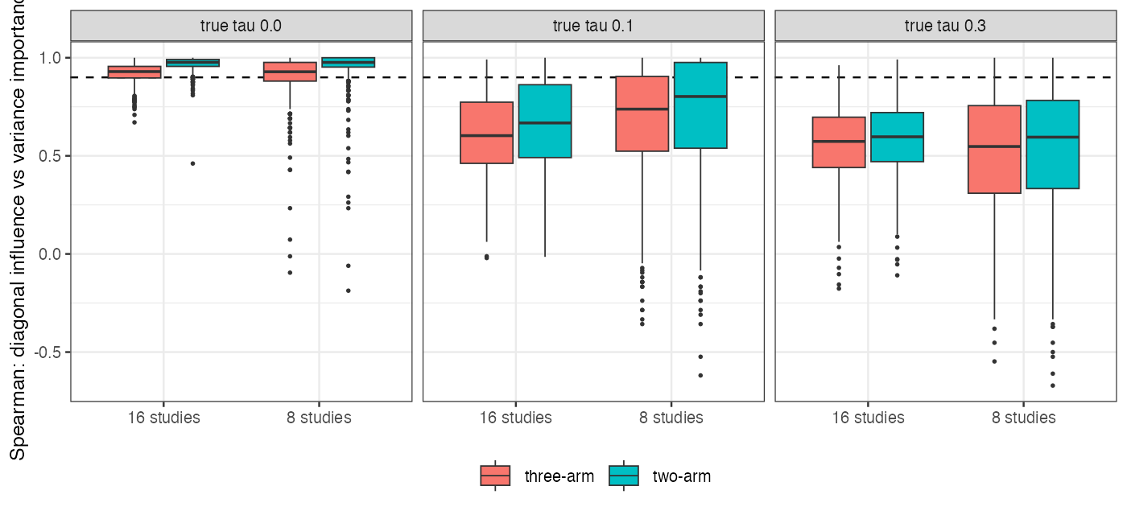
Figure 1: Per-network Spearman correlation between the diagonal influence and refitted variance importance; dashed line, the registered 0.9.
Table 1: Registered results. Spearman correlations are means over networks.
studies | design | true | networks | mean Spearman | share below 0.9 | top study missed | Spearman with estimate change
8 | two-arm | 0.0 | 480 | 0.95 | 0.10 | 0.05 | 0.58
8 | three-arm | 0.0 | 484 | 0.90 | 0.29 | 0.28 | 0.55
8 | two-arm | 0.1 | 471 | 0.70 | 0.61 | 0.20 | 0.59
8 | three-arm | 0.1 | 487 | 0.66 | 0.74 | 0.37 | 0.55
8 | two-arm | 0.3 | 468 | 0.53 | 0.89 | 0.34 | 0.55
8 | three-arm | 0.3 | 490 | 0.51 | 0.92 | 0.47 | 0.51
16 | two-arm | 0.0 | 500 | 0.97 | 0.05 | 0.06 | 0.57
16 | three-arm | 0.0 | 500 | 0.92 | 0.28 | 0.46 | 0.51
16 | two-arm | 0.1 | 500 | 0.66 | 0.78 | 0.25 | 0.54
16 | three-arm | 0.1 | 500 | 0.61 | 0.90 | 0.51 | 0.51
16 | two-arm | 0.3 | 500 | 0.58 | 0.98 | 0.37 | 0.54
16 | three-arm | 0.3 | 500 | 0.56 | 0.99 | 0.59 | 0.50

Exactness (P1). In every two-arm network the diagonal influence equaled the correct model’s hat row at the same to 8.2e-15.
Multi-arm term. With fixed at 0, three-arm networks kept a mean Spearman of 0.90 to 0.92, but the most important study was misidentified in 28% to 46% of networks (two-arm: 5% to 6%). A post hoc rerun of the first 150 networks of these cells (R/05-ties.R) showed the misses were not near-ties: the reference importance of the study the diagonal named was a median 15% to 21% below the reference maximum. When the two disagreed, the diagonal’s top study was three-arm in 98% to 100% of networks against 18% to 25% for the reference’s, while 30% to 32% of studies were three-arm. Summing absolute coefficients over three dependent rows promotes multi-arm studies, as the design predicted.
Heterogeneity term. With re-estimated, the mean Spearman was 0.51 to 0.70 and the top study was missed in 20% to 59%, including two-arm networks where the fixed- calculation is exact. Removing a study moves and so reweights all others; removing a study that raises can make the estimate more precise, which gives negative importance. In 8-study two-arm networks with , 259 of 365 studies with zero diagonal influence (their comparison did not reach D versus A) moved the estimate when removed, through alone.
Estimate change. Spearman with the absolute change in the estimate was 0.50 to 0.59 in every cell, including the exact case: the influence measures leverage, while the realized change also depends on the study’s residual.

4. What this does not answer
Standard network meta-analysis, not component networks with population adjustment; study-level, not edge-level, deletion; the formula was reimplemented rather than called, because the package’s working tree was changing during the study. No fixed- reference was computed, so in the cells the reference’s own sampling noise through is part of the disagreement, which is the dropped term by construction. Whether a block-weighted hat matrix, exact at fixed for multi-arm studies, restores the ranking in the cells was not tested. The tie analysis is post hoc. Dropped networks with singular refits are the ones containing a sole bridge to an off-target treatment. Peer review has not been done. Conflict of interest: cpaic is written by this catalog’s author.

References
1. Gerta Rücker, Adriani Nikolakopoulou, Theodoros Papakonstantinou, Georgia Salanti, Richard D. Riley, Guido Schwarzer. The statistical importance of a study for a network meta-analysis estimate. BMC Medical Research Methodology. 2020;20:190. doi:10.1186/s12874-020-01075-y

