TADA’s bootstrap undercovered under heavy censoring and poor overlap, and a censoring model fitted through administrative follow-up left part of the censoring bias in place
A simulation study answering catalog problem MIS-02
Ahmad Sofi-Mahmudi
2026-09-24

Abstract
Background. TADA (1) transports a survival effect to a population known only through published means by multiplying method-of-moments participation weights by inverse-probability-of-censoring weights, with a bootstrap for variance. Catalog problem MIS-02 asks how it behaves under heavy censoring, poor overlap and censoring-model misspecification; the refuting sentence says close to its published behavior.
Methods. A trial of A versus C (250 per arm) transported to a target shifted on one covariate (good or poor overlap); censoring depending on the same covariate so that the two weight sets are positively or negatively correlated, 25% or 60% censored before 24 months; estimand the target RMST difference to 24 months. Participation-weighted Kaplan-Meier, TADA with bootstrap SE, TADA with a fixed-weight sandwich, and TADA with a censoring model omitting the covariate; 10 cells, 500 replicates.
Results. In the registered primary cell (60% censored, poor overlap, positive correlation) TADA’s bootstrap SE ratio was 0.80 and coverage 0.886: the registered verdict is fails by variance. The product’s effective sample size was 25 against 112 for the participation weights alone, and TADA’s RMSE (3.25) exceeded that of the estimator with no censoring weights (2.23). After the run, the registered censoring model was found to be fitted through the administrative end of follow-up at 36 months, which attenuated its covariate coefficient; refitted on the 24-month horizon (post hoc), TADA’s bias in the positively correlated cells was 0.10 to 0.31 months (registered 0.23 to 0.43) and its bootstrap coverage in the primary cell 0.874.
Conclusion. The refuting sentence fails. Under heavy censoring with poor overlap the product of the two weight sets keeps too few effective patients for the bootstrap to calibrate, and TADA trades censoring bias for variance. Its censoring model has to be fitted on the analysis horizon.

1. The problem
With participation weights matching the target’s published moments and censoring survivor function , TADA’s RMST estimate in arm is normalized by the weights’ sum, where indicates that was observed. When large and large fall on the same patients the effective sample size of the product falls faster than either factor’s, and a bootstrap that re-estimates both weight sets inherits that instability.

2. Design
Registered protocol: protocol.md. , in the trial; target means for and 0.6 for . Weibull proportional hazards (shape 1.2, control median 18 months) with log hazard . Exponential censoring with hazard , , administrative end at 36 months. Censoring model: Cox on within arm (omitting for the misspecified arm); 100 bootstrap resamples re-estimating both weight sets. Controls: no censoring before the horizon (TADA equals the weighted Kaplan-Meier) and censoring independent of covariates.

3. Results
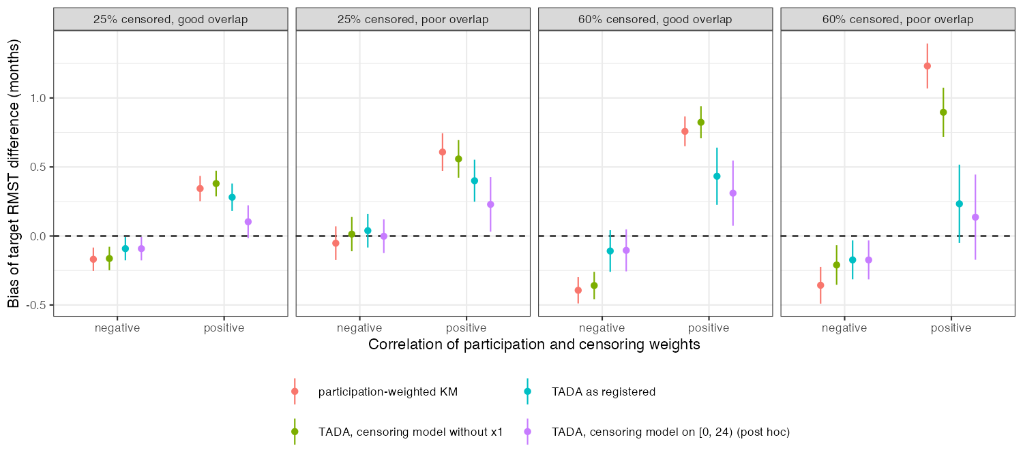
Figure 1: Bias of the target RMST difference by cell, with 95% Monte Carlo intervals. The post hoc arm refits the censoring model on the 24-month horizon.
Table 1: 500 replicates per cell; bias in months (truth 1.85 at good and 0.90 at poor overlap); TADA bias MCSE 0.04 to 0.16.
censored | overlap | weight correlation | product / participation ESS | weighted KM bias | TADA bias | TADA SE ratio (bootstrap) | coverage | TADA bias, horizon-fitted censoring model (post hoc)
25% | good | positive | 0.64 | 0.344 | 0.280 | 0.94 | 0.924 | 0.103
60% | good | positive | 0.15 | 0.758 | 0.433 | 0.81 | 0.888 | 0.310
25% | poor | positive | 0.69 | 0.608 | 0.400 | 0.95 | 0.910 | 0.229
60% | poor | positive | 0.22 | 1.232 | 0.233 | 0.80 | 0.886 | 0.136
25% | good | negative | 0.86 | -0.169 | -0.092 | 0.99 | 0.940 | -0.092
60% | good | negative | 0.32 | -0.394 | -0.109 | 0.86 | 0.942 | -0.104
25% | poor | negative | 0.99 | -0.052 | 0.038 | 0.97 | 0.922 | -0.002
60% | poor | negative | 0.80 | -0.357 | -0.173 | 0.93 | 0.918 | -0.174

Primary. At 60% censoring, poor overlap and positive correlation TADA with bootstrap SE had bias 0.233 (MCSE 0.145), SE ratio 0.80 and coverage 0.886 (MCSE 0.014): fails by variance. The bias is not resolved at 500 replicates, not shown to be zero. The fixed-weight sandwich did no worse there (SE ratio 0.80, coverage 0.892): re-estimating both weight sets in each resample bought nothing where it was needed. Part of the undercoverage is the participation weights’ alone: with no censoring before the horizon the bootstrap’s SE ratio was 0.92 and coverage 0.916 at poor overlap. With negatively correlated weights the sandwich’s SE ratio was 1.00 to 1.04 and the bootstrap’s 0.86 to 0.99.
Weight collapse. The product’s effective sample size relative to the participation weights’ was 0.15 to 0.22 at 60% censoring with positive correlation, 0.56 with covariate-independent censoring and 0.32 to 0.80 with negative correlation; the registered positive control (below 0.8 in the primary cell) was met. The correlation of the two weight sets among uncensored patients was only 0.18 to 0.35 in absolute value, so the collapse is driven as much by the censoring weights’ spread, which this design cannot vary separately.
Bias against variance. In the primary cell TADA removed most of the weighted Kaplan-Meier’s bias (0.233 against 1.232) and lost on RMSE (3.25 against 2.23); the censoring model without had RMSE 2.22.
Censoring model fitted through administrative follow-up (post hoc). The registered code fits the Cox censoring model to the whole follow-up, so the administrative end at 36 months enters as a covariate-free mass of censoring events; the partial likelihood of a risk set in which everyone fails pulls the coefficient toward zero. In a check with 20000 patients per arm the fitted coefficient was 0.88 against a true 1.2, and 1.23 when the censoring process was observed on only, which is all the weights use. Refitted that way with the registered seeds (R/05-corrected.R), TADA’s bias in the positively correlated cells was 0.10 to 0.31 months (registered 0.23 to 0.43), its empirical SD rose (primary cell 3.52 against 3.24), and in the primary cell its bootstrap SE ratio was 0.78 with coverage 0.874 (500 replicates). The correction does not change the registered verdict’s direction. Analysts who fit the censoring model to all follow-up will reproduce the registered behavior.
Controls. With no censoring before the horizon TADA equaled the weighted Kaplan-Meier exactly. With covariate-independent censoring the weighted Kaplan-Meier’s bias was -0.180 (MCSE 0.074), inside the registered 3 MCSE but at 2.4: a near miss. No replicate failed.

4. What this does not answer
RMST only, with complete-case IPCW rather than TADA’s time-varying weights in a Cox model; one covariate drives both weight sets, so correlation and spread are confounded; no stacked M-estimation variance; no censoring by unmeasured prognosis; target moments treated as exact. The horizon-fitted censoring model is a post hoc correction of a registered implementation error and is reported beside, not instead of, the registered result. Peer review has not been done.

References
1. Yichen Yan, Quang Vuong, Rebecca K. Metcalfe, Tianyu Guan, Haolun Shi, Jay J. H. Park. Target aggregate data adjustment method for transportability analysis utilizing summary-level data from the target population. Pharmaceutical Statistics. 2025;24(5):e70029. doi:10.1002/pst.70029

