Standardizing over an independence reconstruction of the target biased the marginal log odds ratio by up to 0.21; a correlation matrix removed the bias, and the error was linear in one covariance term
A simulation study answering catalog problem MOD-01
Ahmad Sofi-Mahmudi
2026-09-24

Abstract
Background. Standardizing an outcome model over the target population needs the target’s joint covariate law, and publications report marginal means and SDs. G-computation and multiple imputation marginalization are established (1); catalog problem MOD-01’s residual is the error left by reconstructing the joint law from marginals. The refuting sentence: the standardized contrast depends on the joint law only through quantities the marginals fix.
Methods. A logistic outcome model fitted correctly in an individual-data trial (500 patients) and standardized over the target; target covariates built from Gaussian, Clayton or Gumbel copulas with correlation 0, 0.3 or 0.6 and exact published marginals; 2 or 5 covariates, all-positive or alternating prognostic signs, linear or quadratic effect modification, log odds ratio or risk difference, good or poor overlap. G-computation over the true law, an independence reconstruction and a Gaussian copula with the correlation matrix borrowed from the trial; an interval over declared correlations; STC at target means as a reference. 224 cells, 476 replicates.
Results. In the registered primary cells (5 or 2 covariates, all-positive signs, quadratic modification, correlation 0.6) independence biased the target log odds ratio by 0.126 on average and 0.210 in the worst cell, against a material threshold of 0.05, with coverage 0.898; the borrowed correlation matrix was within 0.002 of the true law. The registered verdict: the reconstruction matters, and is fixable. The error was linear in the covariance term independence drops (R-squared 0.92 to 0.99 by block). Mixed prognostic signs reversed the error rather than cancelling it, so the registered falsifier fired. Copula family beyond the correlation matrix changed the estimate by at most 0.004.
Conclusion. The refuting sentence fails. Reporting the target’s correlation matrix would remove the residual this entry names; the copula family would not need reporting.

1. The problem
For the target marginal log odds ratio depends, to second order, on . Published marginals fix the diagonal of ; independence sets the rest to zero, so its error is proportional to , which an analyst can compute from the fitted and a declared correlation.

2. Design
Registration: the design and decision rule are DESIGN.md sections 4 to 8, and the rule is applied by R/07-decision.R. Both were committed on 2 August 2026 before the grid was launched. There is no separate protocol document, and DESIGN.md’s header still reads “not registered”; the replicate count (476, derived from the MCSE the two registered outcomes need) replaced the design’s 2000 in the same commit. Every cell publishes the same marginal means and SDs, so only the joint law behind them varies. Truth: the target marginal contrast over 50000 draws of the true law; each method standardizes over 80000 points of its law, with a delta-method variance. The reconstruction interval spans exchangeable correlations declared from to 0.7.

3. Results
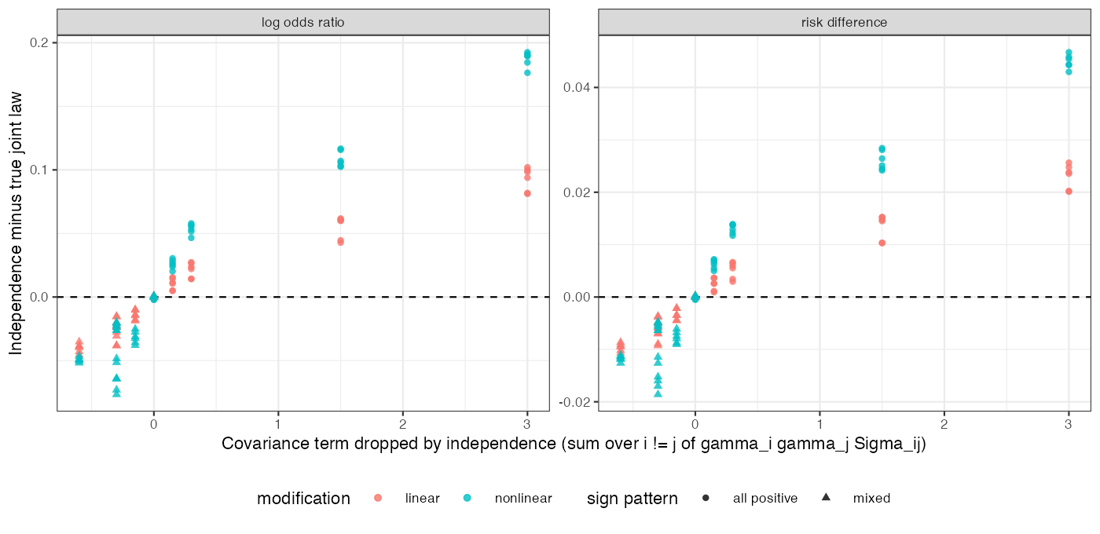
Figure 1: Independence minus true-law estimate by cell against the covariance term independence drops; mixed signs give negative terms.
Table 1: Registered primary cells (all-positive signs, quadratic modification, correlation 0.6), log odds ratio; 12 cells, 476 replicates each.
method | mean bias | worst-cell bias | coverage | interval width
G-computation, borrowed correlation | 0.004 | 0.016 | 0.944 | 0.689
G-computation, true joint law | 0.006 | 0.019 | 0.945 | 0.688
STC at target means (reference) | 0.029 | 0.148 | 0.940 | 1.115
interval over declared correlations | 0.068 | 0.113 | 0.971 | 1.011
G-computation, independence | 0.126 | 0.210 | 0.898 | 0.838

Primary. Independence was biased by more than the material 0.05 while the borrowed correlation was not: the registered “matters and is fixable” branch (Table 1). The interval over declared correlations covered at 0.971 with width 1.01 against 0.69 for the true law.
Mechanism. Across all 224 cells the independence error was linear in , with R-squared 0.92 to 0.99 in each scale, modification and dimension block (Figure 1). The slope differed by block (0.009 to 0.194), so no single constant converts the term into a bias; a bound using the fitted slopes contained the realized error in 335 of 448 cells, an in-sample check of its shape only.
Falsifier. The design predicted that mixed signs would cancel the covariance term and leave independence adequate. With two covariates and signs the term is not cancelled but reversed, and with five it shrinks from 3.0 to at correlation 0.6 without vanishing. Independence was biased by -0.056 (worst -0.077) under mixed signs with quadratic modification and -0.035 with linear: the registered falsifier fired. The mechanism held; the prediction drawn from it was wrong, because a sign pattern does not fix the term, the correlations do.
Scale. On the risk-difference scale the mean absolute error of independence was 0.011 against 0.044 on the log odds ratio, about a quarter, not zero: collapsibility fixes the relation between marginal and mean conditional effect, not that mean against the joint law.
Copula family. All families were matched on Pearson correlation. The borrowed-correlation estimate differed from the true-law estimate by -0.004 to 0.000 across families, modifications and scales: the family carried no dependence the correlation matrix missed, at these strengths.
Controls. With one covariate every reconstruction equaled the truth to 0.005 (tolerance 0.008); at correlation zero the independence and true-law estimates agreed to 0.004. Both exact controls passed.

4. What this does not answer
Reported marginals are exact; the outcome model is correct; covariates are continuous; the borrowed correlation is optimistic because the trial shares the target’s dependence. One sample size. A formatting error in R/07-decision.R (a missing argument to one sprintf call reporting the withdrawn control’s ratio) was fixed after the run; the rule was not changed. Peer review has not been done.

References
1. Antonio Remiro-Azócar, Anna Heath, Gianluca Baio. Parametric G-computation for compatible indirect treatment comparisons with limited individual patient data. Research Synthesis Methods. 2022;13(6):716–44. doi:10.1002/jrsm.1565

