Informative censoring does not cancel in an unanchored comparison, and adjusting one side can make it worse
A simulation study answering catalog problem OUT-07
Ahmad Sofi-Mahmudi
2026-09-23

Abstract
Background. When censoring depends on patients’ risk, Kaplan-Meier estimates in each trial are biased. It is often argued that the biases cancel in an indirect comparison. Catalog problem OUT-07 asks when they do.
Methods. A shared frailty drove both event and censoring hazards, with separate dependence in the source (none or moderate) and the comparator (none, moderate or strong), censoring of 20% or 50%, in unanchored and anchored comparisons: 24 scenarios, 1000 replicates each. Estimand: RMST difference at 24 months (0.62 months unanchored). Methods: Kaplan-Meier, inverse probability of censoring weighting on the source side with a baseline proxy of risk, and a one-sided comparator sensitivity analysis.
Results. Unanchored, with differing mechanisms the bias ranged from -2.33 to 1.42 months, and the sign of the comparison was wrong in up to 0.973 of analyses. Equal mechanisms nearly cancelled (-0.080 to -0.030). Anchored comparisons were protected in every scenario (-0.202 to 0.219), because both arms of each trial shared its mechanism. Source-side weighting reduced source bias only partly and, where the mechanisms were equal, broke the cancellation (bias -0.080 to -0.515 at 50% censoring). The comparator sensitivity parameter that reproduced the truth lay outside the conventional range 0.5 to 2 in up to 0.703 of analyses.
Conclusion. Cancellation needs equal mechanisms, which an external or single-arm comparator seldom has. Anchoring protects; adjusting the source alone does not, and a one-sided sensitivity analysis must allow larger departures than usual.

1. The problem
Each Kaplan-Meier RMST (1) carries a censoring bias ; an unanchored contrast carries and an anchored one the difference of within-trial differences, in which each trial’s shared mechanism largely cancels. Inverse probability of censoring weighting (2) needs the censoring predictors, which exist for the individual-data source and not for an aggregate comparator.

2. Design
Registered protocol: protocol.md; ADEMP structure (3). Frailty ; event hazard (, , per month); censoring hazard , set for the censoring prevalence by 24 months; administrative end at 36; 300 per arm. The source records . The sensitivity analysis gives censored comparator patients a remaining hazard of times the arm’s crude rate ( is independent censoring).

3. Results
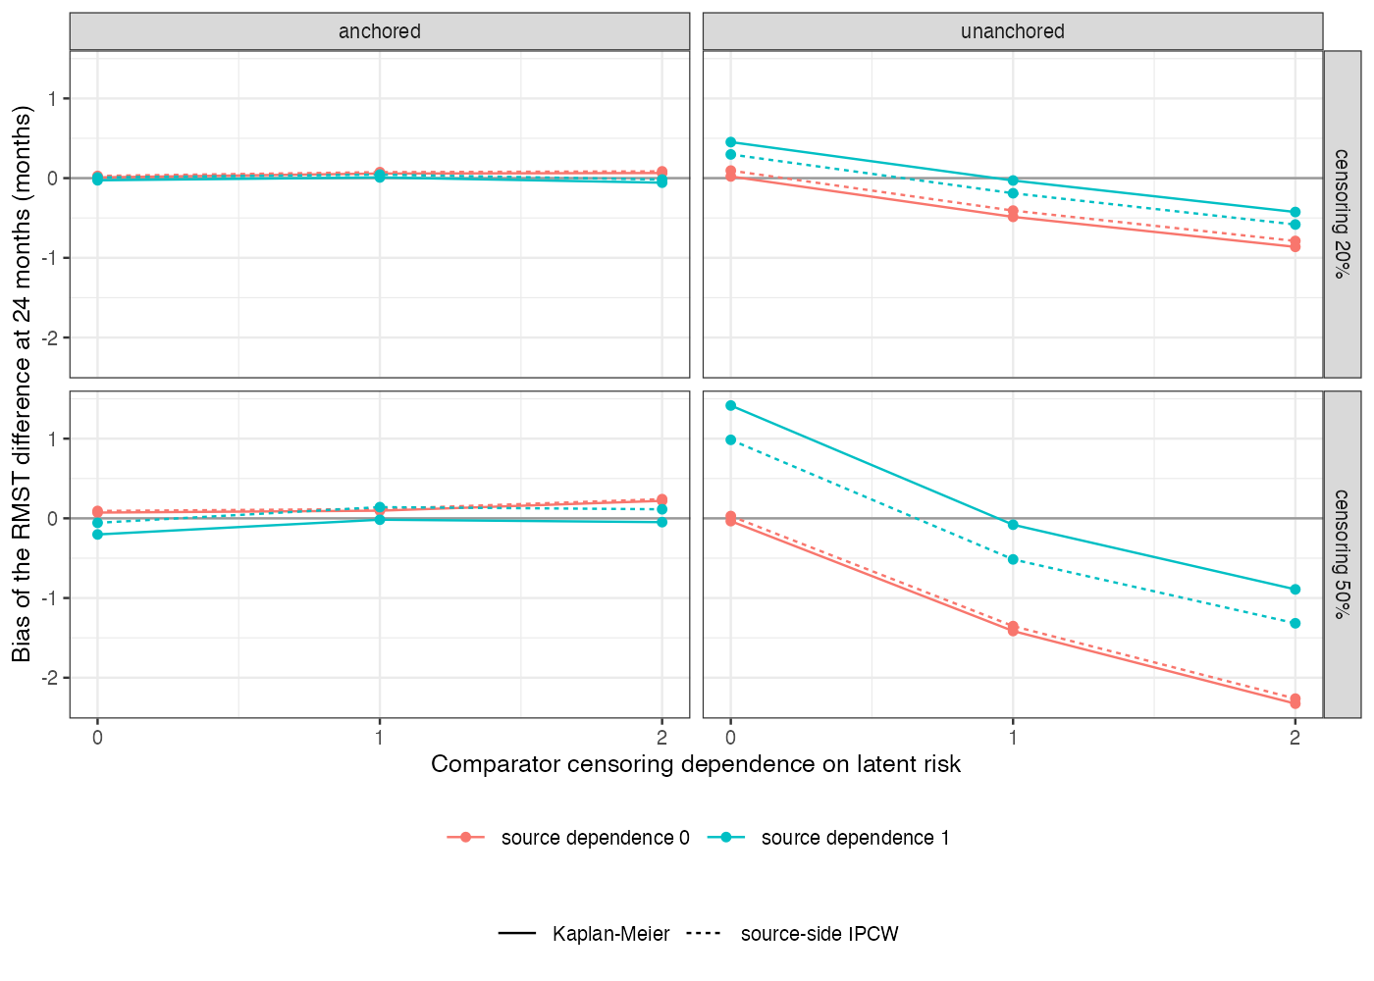
Figure 1: Bias of the RMST difference by comparator censoring dependence, for each level of source dependence.
Unanchored bias followed (Figure 1): positive when only the source censored its high-risk patients, negative when only the comparator did, and roughly twice as large at 50% censoring. With a true difference of 0.62 months, a comparator with strong dependence reversed the comparison in 0.973 of analyses at 50% censoring.
Weighting on a proxy correlated 0.7 with the latent risk removed about a third of the source bias. Applied only to the source, it turned a cancelled comparison into a biased one. In the sensitivity analysis the that reproduced the truth had a median of 2.43 with strong comparator dependence, so a range capped at 2 would often not reach it.

4. What this does not answer
No covariate shift between trials, so the population-adjustment layer is absent; time-constant censoring hazards; one sensitivity parameterization; a single baseline proxy stands in for the source’s time-varying censoring predictors. Peer review has not been done.

References
1. Patrick Royston, Mahesh K. B. Parmar. Restricted mean survival time: An alternative to the hazard ratio for the design and analysis of randomized trials with a time-to-event outcome. BMC Medical Research Methodology. 2013;13:152. doi:10.1186/1471-2288-13-152
2. James M. Robins, Dianne M. Finkelstein. Correcting for noncompliance and dependent censoring in an AIDS clinical trial with inverse probability of censoring weighted (IPCW) log-rank tests. Biometrics. 2000;56(3):779–88. doi:10.1111/j.0006-341X.2000.00779.x
3. Tim P. Morris, Ian R. White, Michael J. Crowther. Using simulation studies to evaluate statistical methods. Statistics in Medicine. 2019;38(11):2074–102. doi:10.1002/sim.8086

