An encoding that reconstructs 91% of the covariates’ variance dropped the effect modifier entirely
A simulation study answering catalog problem ADJ-17
Ahmad Sofi-Mahmudi
2026-09-23

Abstract
Background. Learned covariate representations are proposed for harmonizing populations before an indirect comparison. An encoding trained to reconstruct the covariates keeps the directions of largest variance. Catalog problem ADJ-17 asks whether a reconstruction check can certify that the encoding kept what transport needs.
Methods. Twenty covariates with five high-variance and fifteen low-variance directions; the treatment effect modified along one direction; outcome-regression transport (STC) on 2, 5 or 10 principal components, on all covariates, or on a declared modifier score; targets shifted 0.5 or 1 SD along the modifier; 1000 replicates per cell.
Results. With the modifier on a low-variance direction, five components reconstructed 91% of the covariate variance and the transported effect was biased by -0.199 (coverage 0.488) at a 0.5 SD shift and -0.396 at 1 SD: the whole modification was lost. Ten components (95% reconstructed) still lost most of it. The full covariate set and a declared modifier score were unbiased with nominal coverage in every cell.
Conclusion. Reconstruction quality does not certify transport. An encoding must be checked for preserving the treatment-by-covariate interaction, and a declared mapping that names the modifier is the baseline it has to beat.

1. The problem
Transport needs the conditional treatment effect to be expressible in the variables the adjustment uses (1). A reconstruction objective ranks directions by covariate variance, which is unrelated to whether a direction modifies the treatment effect. A modifier on a low-variance direction is exactly what such an encoding drops first, while its reconstruction error stays small.

2. Design
Registered protocol: protocol.md. in 20 dimensions, with five eigenvalues of 3 and fifteen of 0.1 under a fixed rotation. , the standardized score along one eigenvector (the first, high variance, or the twelfth, low variance), 300 per arm. Target shifted along that eigenvector by 0.5 or 1 SD and along an unrelated high-variance direction by 0.5 SD. Estimand shift. Each method is linear STC with treatment interactions, standardized at the target means.

3. Results
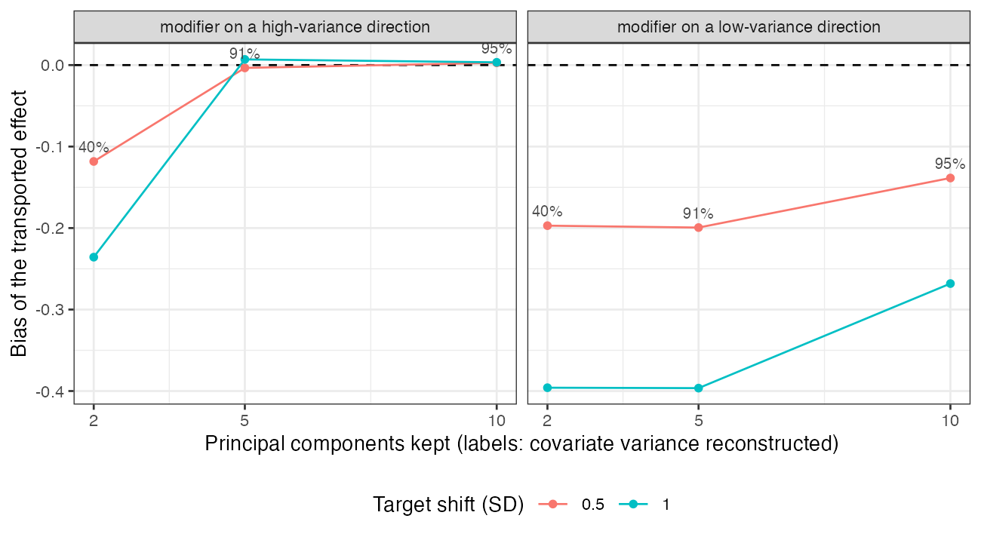
Figure 1: Bias of STC on principal components by number kept. Labels: covariate variance reconstructed.
Table 1: 1000 replicates per cell; bias MCSE at most 0.013.
modifier direction | components | shift | principal components: bias (coverage) | all covariates | declared score
high | 2 | 0.5 | -0.118 (0.718) | -0.000 (0.953) | -0.002 (0.947)
low | 2 | 0.5 | -0.197 (0.462) | -0.001 (0.951) | 0.000 (0.946)
high | 5 | 0.5 | -0.003 (0.931) | -0.002 (0.937) | -0.005 (0.937)
low | 5 | 0.5 | -0.199 (0.488) | 0.004 (0.947) | 0.001 (0.954)
high | 10 | 0.5 | 0.003 (0.945) | 0.004 (0.950) | 0.005 (0.953)
low | 10 | 0.5 | -0.139 (0.706) | -0.007 (0.945) | -0.007 (0.950)
high | 2 | 1.0 | -0.236 (0.419) | 0.001 (0.945) | 0.002 (0.948)
low | 2 | 1.0 | -0.396 (0.018) | -0.002 (0.948) | -0.001 (0.952)
high | 5 | 1.0 | 0.007 (0.955) | 0.008 (0.954) | 0.008 (0.961)
low | 5 | 1.0 | -0.396 (0.017) | 0.002 (0.954) | 0.002 (0.958)
high | 10 | 1.0 | 0.003 (0.956) | 0.003 (0.965) | 0.004 (0.957)
low | 10 | 1.0 | -0.268 (0.336) | -0.002 (0.954) | -0.002 (0.950)

The registered primary was confirmed (Figure 1, Table 1). A low-variance modifier was lost by every encoding that stopped short of its direction, however much variance the encoding reconstructed: at five components the bias equaled the whole modification ( shift). A high-variance modifier was kept once the encoding spanned the high-variance subspace (five components); with two components it was partly lost even though it lay on a leading direction, because the five high-variance directions had equal variance and the leading two components were an arbitrary rotation within them. The encoding’s reconstruction error gave no signal in either case.

4. What this does not answer
Principal components as the only encoder; no treatment-effect-preserving objective, nonlinear encoder, nonlinear heterogeneity or measurement shift between populations; continuous outcome and linear STC. Peer review has not been done.

References
1. James E. Signorovitch, Eric Q. Wu, Andrew P. Yu, Charles M. Gerrits, Evan Kantor, Yanjun Bao, Shiraz R. Gupta, Parvez M. Mulani. Comparative effectiveness without head-to-head trials: A method for matching-adjusted indirect comparisons applied to psoriasis treatment with adalimumab or etanercept. PharmacoEconomics. 2010;28(10):935–45. doi:10.2165/11538370-000000000-00000

