A transported control-arm check carries no information about the anchored contrast
A simulation study answering catalog problem IDN-10
Ahmad Sofi-Mahmudi
2026-09-23

Abstract
Background. When an anchored population-adjusted comparison shares a control arm, the control-arm outcome transported from the individual-data trial can be compared with the one the target trial observed. Agreement is read as support for the analysis. Catalog problem IDN-10 asks what the check’s operating characteristics are.
Methods. Anchored MAIC with a binary outcome. Between the two trial populations we shifted, independently, an unmeasured prognostic covariate and an unmeasured modifier of the individual-data treatment’s effect, over 18 scenarios with 1000 replicates each, and recorded the check’s -statistic and the anchored contrast’s error.
Results. A shift in raised the check’s alarm rate to 0.478 while the contrast stayed essentially unbiased (-0.028); a shift in biased the contrast by 0.297 on the log odds ratio scale and cut coverage to 0.778 while the alarm rate stayed at 0.044. Pooled over all replicates, separated biased from unbiased analyses with an AUROC of 0.502, and at every threshold its detection rate equaled its false-alarm rate.
Conclusion. The check tests prognostic transport; the anchored contrast depends on effect-modification transport. In an anchored comparison it is a test of the wrong assumption and should not be reported as support for the relative effect.

1. The problem
The control arm transports when the prognostic structure does; the relative effect transports when the effect-modification structure does. In an anchored comparison a purely prognostic imbalance cancels between arms, so the relative effect is protected from exactly the failure the check detects, and unprotected from the one it cannot see: a modifier of the treatment effect that does not move control-arm outcomes. The check has been used in hidden-truth benchmarks of external controls (1); its operating characteristics as a screen for relative-effect bias had not been measured.

2. Design
Registered protocol: protocol.md. Individual data on A versus C (300 per arm) in the source; arm counts on B versus C in the target (200 or 500 per arm). Binary outcome with , A’s effect , B’s . MAIC balances the measured (target mean 0.5); and are unmeasured, with target means . Estimand: the anchored B-versus-A marginal log odds ratio in the target. The check is .

3. Results
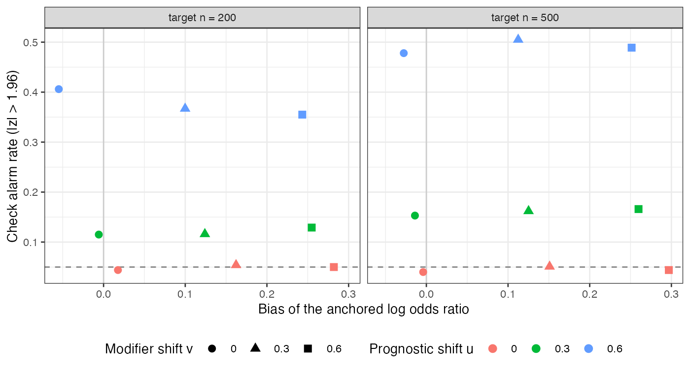
Figure 1: Each scenario’s check alarm rate against its contrast bias. The dashed line is the nominal 5% rate.
Alarm rate moved with and bias moved with (Figure 1). The design’s four cases held in every scenario:
 | control arm transports | contrast unbiased | alarm rate, target 500 per arm
no shift | yes | yes | 0.040
prognostic shift only | no | yes | 0.478
modifier shift only | yes | no | 0.044
both | no | no | 0.489
Across thresholds on the check flagged unbiased and biased analyses at the same rate: 0.206 against 0.207 at 1.96, 0.524 against 0.530 at 1. The AUROC of 0.502 is chance. A prognostic shift slightly reduced the contrast bias when combined with a modifier shift (for example 0.282 to 0.243 at 200 per arm), through the non-collapsibility of the odds ratio, but did not change the conclusion.

4. What this does not answer
Binary outcome only; the survival-curve and RMST versions are not run. In an unanchored comparison the relative effect does depend on prognostic transport, and there the check targets a relevant assumption; that case, and offsetting prognostic mechanisms, are not simulated. Outcome-definition and follow-up differences, which also move control arms, are absent. Peer review has not been done.

References
1. Ashwini Gupta, others. Quantitative bias analysis for single-arm trials with external control arms. JAMA Network Open. 2025. doi:10.1001/jamanetworkopen.2025.2152

