Prior-to-posterior contraction and effective likelihood rank measure information, not bias
An exploratory computation answering catalog problem CMP-14
Ahmad Sofi-Mahmudi
2026-09-22

Abstract
Background. In component network meta-regression, an interaction informed only by aggregate data can be held to a finite credible interval by its prior alone. Catalog problem CMP-14 asks for two default summaries to expose this: prior-to-posterior contraction per interaction and an effective likelihood rank. We asked what those summaries would tell an analyst about whether the reported interval covers.
Methods. An exact computation on a four-component network with known truth. The first arm (E1) uses an identity link with known residual variance, so every posterior is closed form: 504 scenarios crossing the information state of the target interaction (own trial, additivity, ecological route, absent), between-study covariate spread, network size, prior scale on the interactions, between-within discordance and additivity violation. The second arm (E2) uses a logit link and asymptotic information over 72 scenarios, adding a curvature state identified only by differing covariate variances. Coverage of the nominal 95% interval for the target interaction was classed as failing (below 0.90), nominal (within 0.01 of 0.95) or neither.
Results. No threshold on contraction, on either effective-rank reading, or on the estimability screen separates failing from nominal scenarios on either arm: every statistic takes at least one value that both classes share. The reason is structural. On the identity link the posterior covariance does not involve the outcomes, so within one design and prior the summaries are exactly constant while coverage ranges over 0.956. Decomposed by cause, 109 E1 failures come from a prior of SD 0.1 pulling a true interaction of 0.4 toward zero, and 142 from a biased route, meaning discordance on the ecological route or synergy on the additivity route. Contraction flags 58.7% of the first kind; no summary flags any of the second. On the logit arm the summaries separate much better on average (Youden 0.805 for contraction) because 34 of its 41 failures sit at the tight prior, but the overlap persists.
Conclusion. The summaries CMP-14 asks for answer the question they were designed for, whether the prior dominates a coordinate, and partially catch the failures a dominant prior causes. They are blind by construction to the failure an aggregate route adds, which is that the route is not randomized and can identify the wrong quantity with plenty of information. A clean contraction is evidence that the likelihood spoke, not that it told the truth. Every result here is exploratory: E1 ran before the protocol existed and E2’s rules were rebuilt after its output had been read.

1. The problem
Multilevel network meta-regression (1) and its component extensions estimate how covariates modify treatment effects by combining individual participant data (IPD), where the modification is identified within trials, with aggregate data, where it can only be identified through differences between studies. A proper prior yields a proper posterior, so an interaction the likelihood barely touches still gets a finite credible interval (2). Existing mitigations are visual or require a deliberate refit: prior and posterior overlays, prior sensitivity refits, power scaling (3). CMP-14 asks for two default numerical summaries so that an analyst who does not ask still sees a warning:
- contraction, the marginal posterior standard deviation of the interaction over its marginal prior standard deviation, where values near 1 mean the data did not move the prior; and
- effective likelihood rank, the number of directions in which the likelihood outweighs the prior, reported for the whole model and per parameter.
Both are functions of Fisher information and the prior. That observation is the whole study: a summary built from information can tell an analyst how much the likelihood said, and cannot tell them whether what it said was right.

2. Design
The protocol (protocol.md) went through thirteen rounds of adversarial critique and records its own standing first: nothing here is confirmatory. E1 was computed before the protocol existed; E2’s separation rules were rebuilt after its output was read. CHANGES.md lists every design choice changed after a number was seen. The decomposition in Section 3.3 was added for this manuscript, after the decision file, and is labeled post hoc.

2.1 The model
Four binary components. A treatment is an indicator vector with additive main effect and additive modification of a scalar covariate . On E1,

with the residual variance known, so the posterior covariance is in the scale of the prior precision and depends on the covariate design but not on the outcomes. E2 uses the same linear predictor on the logit scale, with the likelihood integrated over a normal within-study covariate law by 64-point Gauss-Hermite quadrature. Every true interaction is 0.4, every main effect , the prognostic slope 0.3. Component 3 is the target; components 1, 2 and 4 always have their own IPD trials.

2.2 Information states for the target interaction
state | route to the target interaction | randomized
own IPD | its own IPD trial | yes
additivity | only inside a combination arm, under additivity | yes
ecological | aggregate studies, between-study contrast in covariate means | no
curvature (E2 only) | two aggregate studies with equal means and different SDs | no
absent | nothing | not applicable
Every state has the same twelve arms and the same per-arm information weight, so states differ in route and not in size.

2.3 Departures
Two departures make a route identify the wrong quantity without changing how much information it carries. Discordance adds or to the target interaction in the aggregate rows, so the between-study association differs from the within-study one. Synergy adds to the covariate slope of the combination arm, violating additivity. The fitted model has one interaction per component and is otherwise correctly specified.

2.4 Grid
E1 crosses state, between-study covariate spread (0.3 to 3), total network size (1000, 3000, 10000), prior SD on the interactions (0.1, 0.5, 1, 2.5), discordance (ecological only) and synergy (additivity only): 504 scenarios. E2 is a reduced factorial of 72 scenarios on the logit link at prior SDs 0.1 and 1. Coverage on E1 is exact for a design realized at its quadrature nodes; on E2 it is the asymptotic normal approximation.

2.5 Diagnostics and rules
rule | alarms when | threshold
contraction | posterior SD / prior SD 0.50 | conventional
target ratio | likelihood precision / prior precision on the target 1 | conventional
effective rank | count of eigendirections with likelihood outweighing prior parameter count | structural
rank screen | target coordinate not identified by the likelihood | structural
A post hoc candidate, the share of the target’s likelihood precision surviving deletion of the between-study source, is reported in the protocol and is not part of any claim here.

3. Results

3.1 Classes
Table 1: Scenarios by coverage class.
arm | failing | nominal | neither | total
E1, exact | 251 | 169 | 84 | 504
E2, logit | 41 | 12 | 19 | 72

3.2 No threshold separates the classes
For each statistic we asked whether the range of values taken by failing scenarios overlaps the range taken by nominal ones. One shared value is enough to show that no threshold can separate them, whatever mixture of scenarios a practitioner faces. All four registered statistics overlap on both arms (Table 2). The rank screen’s overlap is half structural: a non-identified coordinate has coverage exactly 0 or 1 on both arms and so is never nominal, but 233 of E1’s 251 failures are identified, so the screen misses most failures.
Table 2: E1: the most reassuring value among failing scenarios against the least reassuring value among nominal ones. Where the first is more reassuring than the second, the ranges overlap.
statistic | reassuring when | most reassuring failure | least reassuring nominal | overlaps
contraction | low | 7.444e-03 | 0.634 | yes
target_ratio | high | 1.804e+04 | 1.444 | yes
eff_rank | high | 1.400e+01 | 12.000 | yes
rank_screen | high | 1.000e+00 | 1.000 | yes

3.3 Why: the summaries are functions of the design
Within one information state, spread, network size and prior, E1’s contraction, target ratio and effective rank are exactly constant across the discordance and synergy levels (largest range 0.0000), while coverage ranges over 0.956. That is the algebra of the known-variance Gaussian model: the posterior covariance does not involve , so a departure that shifts the mean the route identifies moves the posterior mean and nothing the summaries read.
The failures therefore split by cause, and the split is by design factor rather than by any outcome (Table 3, post hoc).
Table 3: Post hoc. Share of E1’s failing scenarios each rule flags, by cause of failure, and its false-alarm rate among nominal scenarios. Tight prior: prior SD 0.1. Biased route: prior SD 0.5 or wider with discordance or synergy.
rule | tight prior | biased route | false alarm
contraction | 58.7% | 0.0% | 3.6%
target_ratio | 41.3% | 0.0% | 0.0%
eff_rank | 56.0% | 0.0% | 0.6%
rank_screen | 16.5% | 0.0% | 0.0%

Of the 142 failures from a biased route (88 ecological, 54 additivity), no rule flags any. Of the 109 failures from the tight prior, contraction flags 58.7%, which is the failure the summary was built for (Figure 1). The ecological route can deliver an interval that is well informed, far from its prior, and wrong: at discordance 0.4, ecological scenarios with a wide prior reach coverage as low as 2.0e-57.
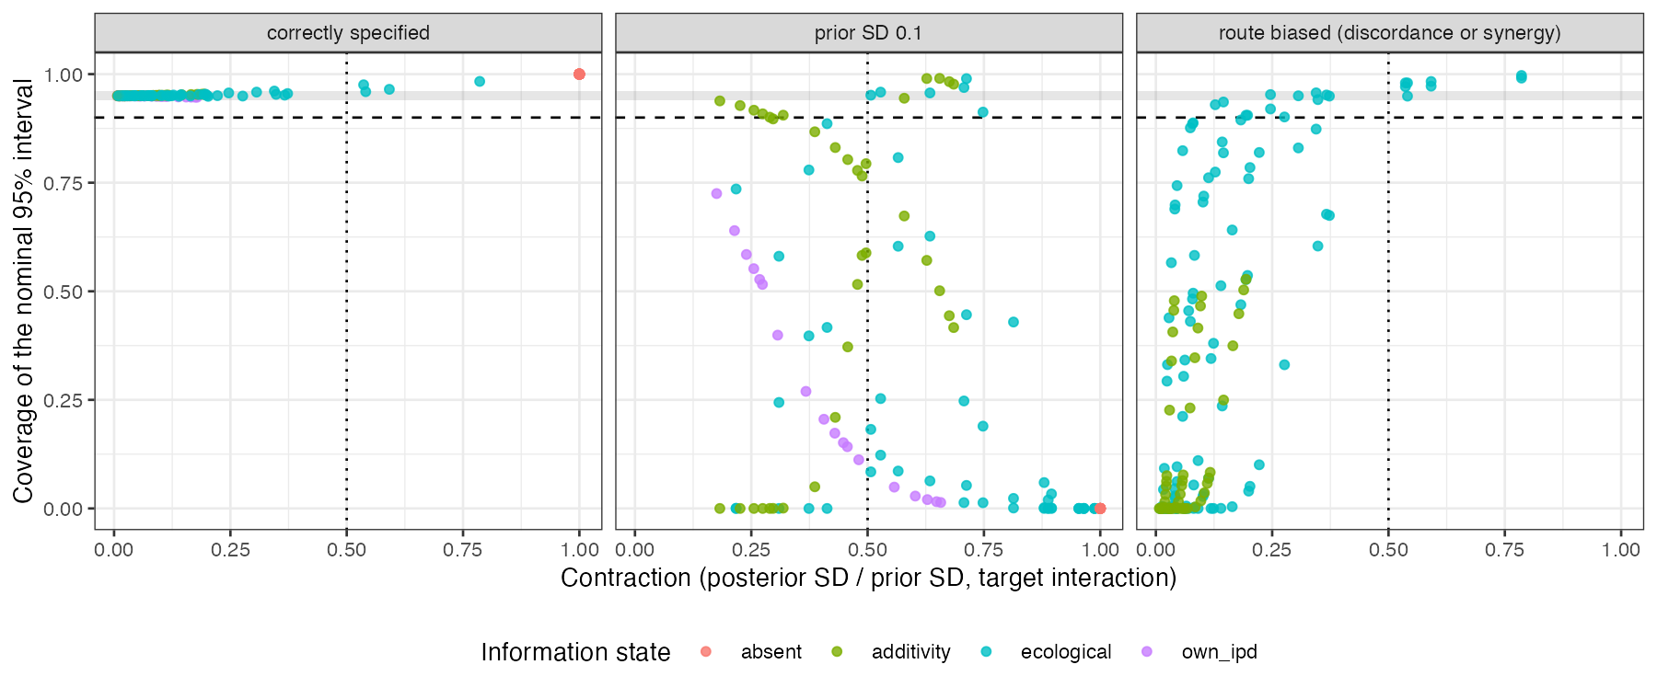
Figure 1: E1: contraction against coverage, by cause of failure. The shaded band is nominal coverage, the dashed line the failure threshold, the dotted line the contraction alarm.

3.4 Matched information, different coverage
Pairing each additivity scenario with ecological scenarios sharing its spread, size and prior, the pairs whose contraction differs by less than 0.02 (54 of 216) differ in coverage by up to 0.951. Two evidence structures an analyst would read as equally well identified differ by almost the whole unit interval in whether the interval covers. On E2 the only close pair has no discordance, so the comparison is not available there.

3.5 The logit arm
On E2 the registered rules look far better on average: Youden 0.805 for contraction and 0.829 for effective rank, against 0.220 and 0.237 on E1. The improvement is a property of the grid: 34 of E2’s 41 failures sit at prior SD 0.1, the cause the summaries catch, and E2 has only 12 nominal scenarios, so its zero false-alarm rates are weakly determined. On the curved link the summaries do move a little with the departures, because Fisher information depends on the parameter, but the overlap of Section 3.2 persists on E2 for every statistic.

3.6 The sign of the contraction and coverage relation
Across E1’s 144 confounded ecological scenarios the rank correlation between contraction and coverage is 0.3295: contraction becomes more reassuring as coverage gets worse, because a larger between-study spread sharpens the route without reducing the bias it carries, so the interval narrows around the wrong value. On E2’s eight confounded scenarios the correlation is -0.5952. A correlation over eight deterministic points describes those points and settles nothing.

4. What this means for CMP-14
The entry is right that nothing in the default output tells an analyst the prior did the work, and the two summaries it asks for would say so where it is true. They should be reported. But they should be reported as what they are, statements about information, and the entry’s framing, that a proper interval is not evidence that the likelihood contributed, has a second half it does not state: a contracted interval is not evidence that the likelihood was right. An aggregate route to an interaction is non-randomized, and its failure mode is confounding, which is invisible to any summary built from Fisher information and the prior. The check that addresses that failure is not a contraction number but a statement of which route identifies each interaction and whether that route is randomized, which estimable_effects_at() in the unreleased cpaic partly provides, together with a within-between separation of the kind our CMP-13 study evaluated.

5. What this does not answer
- Nothing is confirmatory. E1 ran before the protocol; E2’s rules were rebuilt after its output was read; the cause decomposition was added for this manuscript.
- Exact, not sampled. E1 is exact for a design realized at its quadrature nodes and E2 is asymptotic; neither is an average over realized designs, and no posterior was sampled, so sampler failure is outside the study.
- The invariance is specific to known-variance Gaussian models. On E2 the summaries move slightly with the departures. With an estimated residual variance or a random-effects model they would move more, and whether that movement is ever large enough to warn is untested.
- One target component, one covariate, one network geometry, a normal within-study covariate law on the logit arm, and departures that act on the mean only.
- Peer review of this manuscript has not been done, though the protocol went through thirteen rounds of critique.

Reproducing this study
Rscript R/03-run-e1.R && Rscript R/04-analyze.R
Rscript R/07-run-e2.R
Rscript R/05-export.R && Rscript R/11-decision.R
Rscript R/12-decompose.R && Rscript R/13-figures.R

References
1. David M. Phillippo, Sofia Dias, A. E. Ades, Mark Belger, Alan Brnabic, Alexander Schacht, Daniel Saure, Zbigniew Kadziola, Nicky J. Welton. Multilevel network meta-regression for population-adjusted treatment comparisons. Journal of the Royal Statistical Society Series A. 2020;183(3):1189–210. doi:10.1111/rssa.12579
2. Andrew Gelman, Daniel Simpson, Michael Betancourt. The prior can often only be understood in the context of the likelihood. Entropy. 2017;19(10):555. doi:10.3390/e19100555
3. Noa Kallioinen, Topi Paananen, Paul-Christian Bürkner, Aki Vehtari. Detecting and diagnosing prior and likelihood sensitivity with power-scaling [Internet]. 2024. Available from: https://arxiv.org/abs/2107.14054

