Sharing one heterogeneity parameter across a bridged network cost little; the interval method mattered more
A simulation study answering catalog problem CMP-16
Ahmad Sofi-Mahmudi
2026-09-23

Abstract
Background. A bridged network contrast pools two subnetworks, and a single between-study SD lends one subnetwork’s heterogeneity to the other. Catalog problem CMP-16 asks whether that breaks the bridged contrast’s interval and whether a stratified does better at realistic study counts.
Methods. A bridged contrast formed as the sum of two subnetworks’ pooled effects; heterogeneity ratio 1, 2 or 5 in the bridging or the other subnetwork; 3, 6 or 12 studies each; shared, stratified and shrunk REML heterogeneity with Wald intervals, and Hartung-Knapp intervals; 2000 replicates per cell.
Results. With the non-bridging subnetwork five times as heterogeneous, the shared model’s Wald interval covered 0.906, 0.911 and 0.932 at 3, 6 and 12 studies per subnetwork, against 0.917, 0.927 and 0.943 for the stratified model: at most 0.016 apart. Every Wald interval undercovered at few studies, and Hartung-Knapp intervals covered 0.974 to 0.997 at three studies, at 1.5 times the width.
Conclusion. For a contrast that sums both subnetworks, a shared overstates one part’s variance and understates the other’s, and the errors largely offset. The undercoverage comes from ignoring uncertainty in , not from sharing it.

1. The problem
A shared inflates the homogeneous subnetwork’s variance and deflates the heterogeneous one’s. For a contrast that uses only one subnetwork this misstates its interval directly; for a bridged contrast that sums both, the two errors enter with opposite signs. Stratifying fixes the structure but estimates two poorly determined variances instead of one.

2. Design
Registered protocol: protocol.md. studies of component A against its backbone (effect ) and of B against A (0.1); the target is their sum. Within-study SE uniform on 0.1 to 0.25; between-study SDs 0.05 in one subnetwork and in the other. Shared, stratified and shrunk (weight toward the shared value) REML heterogeneity; Wald intervals, and Hartung-Knapp intervals (1) for shared and stratified.

3. Results
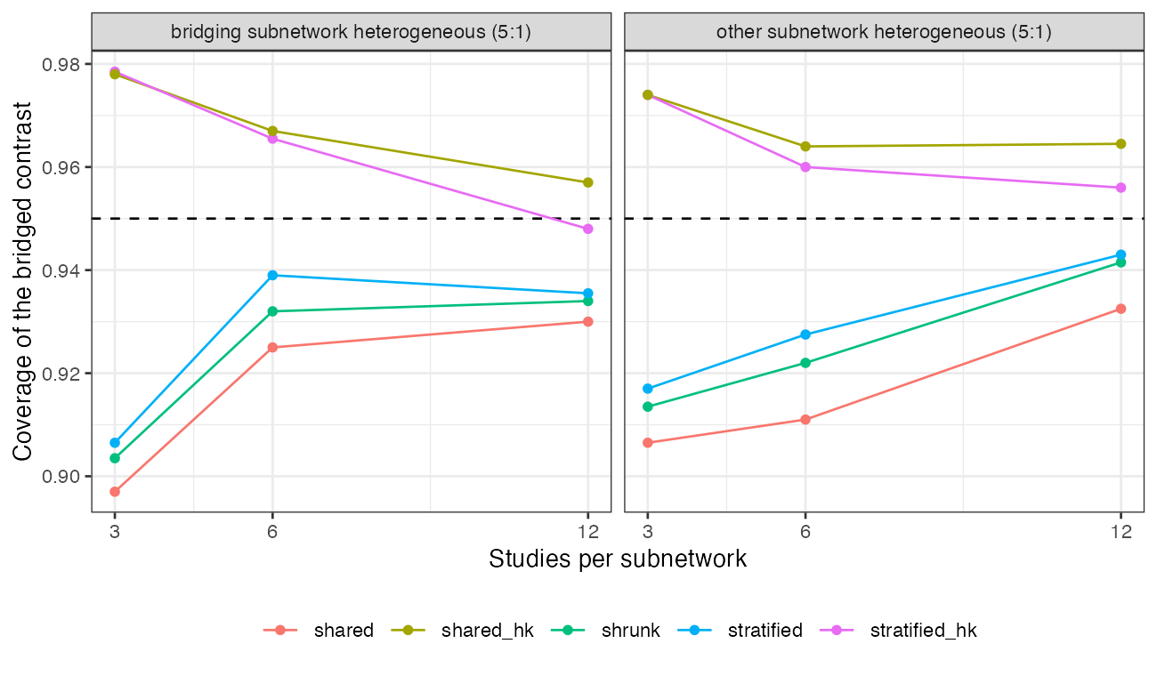
Figure 1: Coverage of the bridged contrast at a 5:1 heterogeneity ratio.
Table 1: Coverage of 95% intervals, 2000 replicates per cell (MCSE at most 0.007).
ratio | heterogeneous | studies each | shared | stratified | shrunk | shared, Hartung-Knapp | stratified, Hartung-Knapp
1 | bridging | 3 | 0.955 | 0.960 | 0.958 | 0.997 | 0.997
2 | bridging | 3 | 0.944 | 0.951 | 0.948 | 0.991 | 0.992
5 | bridging | 3 | 0.897 | 0.906 | 0.903 | 0.978 | 0.979
2 | other | 3 | 0.941 | 0.957 | 0.948 | 0.997 | 0.997
5 | other | 3 | 0.906 | 0.917 | 0.913 | 0.974 | 0.974
1 | bridging | 6 | 0.951 | 0.957 | 0.957 | 0.979 | 0.978
2 | bridging | 6 | 0.943 | 0.950 | 0.947 | 0.976 | 0.973
5 | bridging | 6 | 0.925 | 0.939 | 0.932 | 0.967 | 0.966
2 | other | 6 | 0.950 | 0.961 | 0.958 | 0.978 | 0.977
5 | other | 6 | 0.911 | 0.927 | 0.922 | 0.964 | 0.960
1 | bridging | 12 | 0.954 | 0.955 | 0.955 | 0.968 | 0.968
2 | bridging | 12 | 0.950 | 0.951 | 0.952 | 0.968 | 0.967
5 | bridging | 12 | 0.930 | 0.935 | 0.934 | 0.957 | 0.948
2 | other | 12 | 0.942 | 0.945 | 0.947 | 0.961 | 0.961
5 | other | 12 | 0.932 | 0.943 | 0.942 | 0.965 | 0.956

The registered rule returned mixed: in the registered cells (non-bridging subnetwork heterogeneous) the shared model never covered below 0.90, and the shrunk model was not nominal where the shared one fell short (Table 1); the lowest shared coverage, 0.897, was with the bridging subnetwork heterogeneous. Across the grid the three structures differed by at most 0.016 in coverage and a few percent in width (Figure 1). The gap to nominal was driven by the heterogeneity ratio and the study count, not by the structure: at a 5:1 ratio and three studies per subnetwork every Wald interval covered 0.90 to 0.92, rising to 0.93 to 0.94 at twelve. The shared estimate of sat between the two true values, as it must, and the bridged contrast’s variance, which sums both subnetworks, was close to right on average.

4. What this does not answer
The bridged contrast here sums both subnetworks; a contrast drawing on one subnetwork only would carry the shared ’s error without the offset. Frequentist REML without priors; no residual-variance arm, IPD studies or sparse network. Peer review has not been done.

References
1. Joachim Hartung, Guido Knapp. On tests of the overall treatment effect in meta-analysis with normally distributed responses. Statistics in Medicine. 2001;20(12):1771–82. doi:10.1002/sim.791

