Change scores and endpoints do not diverge under population adjustment
A simulation study answering catalog problem OUT-06
Ahmad Sofi-Mahmudi
2026-09-22

Abstract
Background. Catalog problem OUT-06 proposes that when baseline severity modifies the treatment effect, change-score and endpoint analyses imply different effect-modification structures and diverge after population adjustment, in proportion to the product of the baseline-by-treatment interaction and the baseline shift between populations.
Methods. Because baseline is measured before treatment, the target contrasts of follow-up and of change are the same quantity under any adjustment. We tested the implication in 24 scenarios (anchored and unanchored comparisons, baseline shift 0 to 1 SD, interaction 0 or 0.3, baseline-to-follow-up correlation 0.4 or 0.8), 1000 replicates each, for naive comparison, MAIC matching the baseline mean, and G-computation, each in both representations.
Results. For MAIC and G-computation the mean endpoint-minus-change difference never exceeded 0.0068 and was within 3 Monte Carlo SE of zero in every scenario; in unanchored comparisons the two representations were identical to 4e-13 in every replicate. The only divergence was in naive unanchored comparisons, where the difference was 1.0013 (SE 0.0018) times the shift and 0.0069 (SE 0.0066) times the interaction-by-shift product.
Conclusion. The proposed product structure does not exist. Change and endpoint analyses diverge only when baseline is left unadjusted across populations, and then by the baseline shift alone, independent of effect modification. Where baseline is adjusted for, the choice of representation affects precision and not the target estimate.

1. The problem
Combining trials that report change from baseline with trials that report follow-up values is generally valid in conventional meta-analysis (1), because the change contrast equals the follow-up contrast minus the baseline contrast and randomization makes the latter zero in expectation. OUT-06 asks whether population adjustment breaks this: DESIGN.md argued that with baseline as an effect modifier the two representations “agree at the source and diverge at the target”.
They cannot diverge at the level of the estimand. Baseline is pre-treatment, so and, for any target law ,

Estimators can still differ. A linear model for with as a covariate has the same treatment and treatment-by- coefficients as the model for ; only the coefficient shifts by one. MAIC that matches the baseline mean makes the weighted baseline equal the target’s exactly. Without adjustment for baseline, an unanchored comparison of follow-up is biased by and of change by , for baseline slope , interaction and shift : they differ by whatever is. In an anchored comparison each trial’s randomization removes the baseline contrast in expectation.

2. Design
Registered protocol: protocol.md. Individual-data trial A versus C with ; aggregate trial B versus C with reporting arm means of , and . , , , , 300 per arm. Factors: anchored or unanchored; ; ; . Estimand . Methods: naive, MAIC on the baseline mean, and G-computation with a linear model in , each in both representations. 1000 replicates per scenario.

3. Results
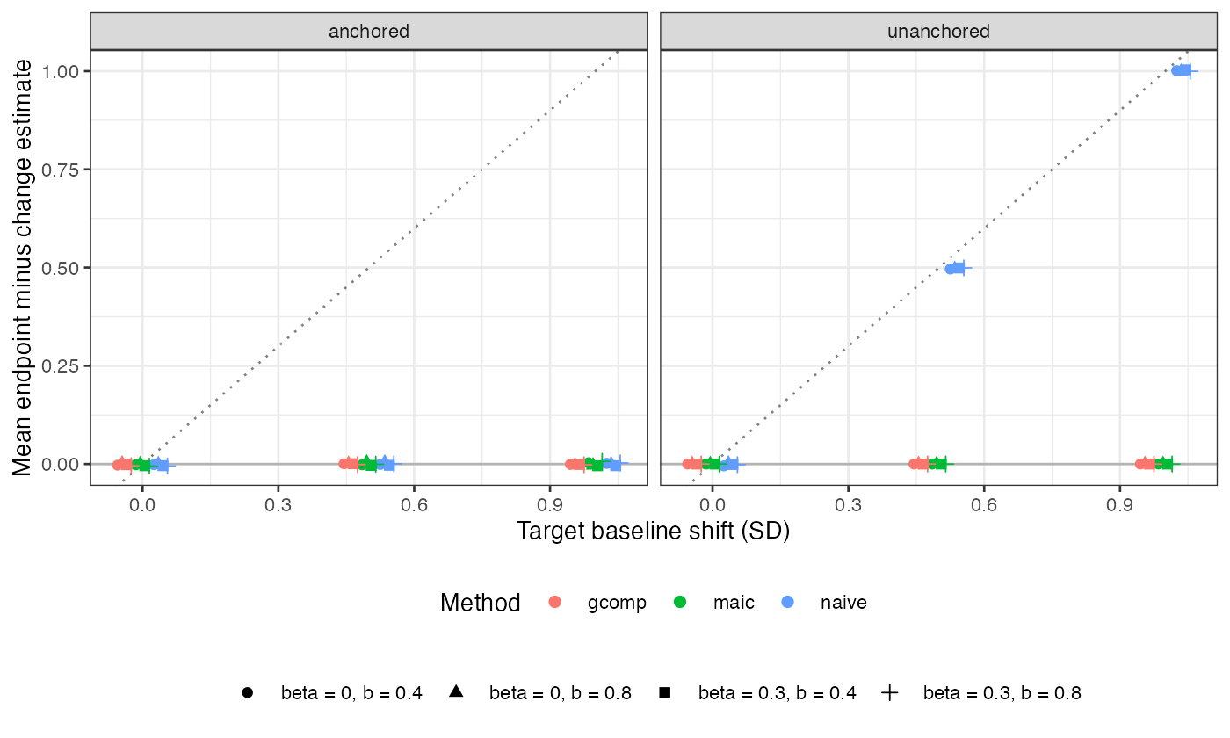
Figure 1: Mean difference between the endpoint and change estimates. The dotted line has slope 1.
Adjusted estimators did not diverge (Figure 1). The anchored MAIC and G-computation differences are the aggregate trial’s chance baseline imbalance, mean zero; in unanchored comparisons the individual-data side is algebraically identical and the difference is at machine precision. Naive anchored comparisons also agree in expectation (largest mean difference 0.0050) though both are biased when , because neither adjusts for the modifier.
Table 1: Bias (Monte Carlo SE) at shift 1, b = 0.4.
design | beta | naive_end | naive_chg | maic_end | maic_chg | gcomp_end | gcomp_chg
anchored | 0.0 | 0.0032 (0.0036) | 0.0013 (0.0040) | 0.0003 (0.0050) | -0.0029 (0.0059) | -0.0015 (0.0043) | -0.0008 (0.0044)
unanchored | 0.0 | 0.4042 (0.0026) | -0.5973 (0.0028) | 0.0063 (0.0032) | 0.0063 (0.0032) | 0.0052 (0.0029) | 0.0052 (0.0029)
anchored | 0.3 | 0.2951 (0.0038) | 0.2993 (0.0038) | -0.0018 (0.0057) | 0.0026 (0.0055) | -0.0015 (0.0042) | -0.0006 (0.0042)
unanchored | 0.3 | 0.6991 (0.0028) | -0.3041 (0.0027) | -0.0032 (0.0033) | -0.0032 (0.0033) | -0.0019 (0.0030) | -0.0019 (0.0030)

In naive unanchored comparisons the endpoint and change estimates are biased in opposite directions when (Table 1), matching and . Both registered controls passed: every method was unbiased at , and the naive unanchored biases matched their predictions at .

4. What this does not answer
A continuous outcome with a linear conditional mean. Under a nonlinear link (for example a log-transformed outcome analyzed on the original scale) the equivalence of coefficients fails, although the estimand identity does not. Responder probabilities defined by a threshold on change and on follow-up are different estimands by definition and are not compared. The joint repeated-measures model is represented only by G-computation with baseline as a covariate. Peer review has not been done.

References
1. Bruno R. da Costa, Eveline Nüesch, Anne W. S. Rutjes, Bradley C. Johnston, Stephan Reichenbach, Sven Trelle, Gordon H. Guyatt, Peter Jüni. Combining follow-up and change data is valid in meta-analyses of continuous outcomes: A meta-epidemiological study. Journal of Clinical Epidemiology. 2013;66(8):847–55. doi:10.1016/j.jclinepi.2013.03.009

