When two sponsors’ MAICs disagree: how often, why, and which common target resolves it
A simulation study answering catalog problem EST-06
Ahmad Sofi-Mahmudi
2026-09-23

Abstract
Background. Two sponsors analyzing the same two trials, each holding its own individual data and weighting it to the other trial’s population, can reach opposite conclusions while each analysis is internally coherent (1). Catalog problem EST-06 asks how often, under what configurations, and whether the disagreement is a target-population difference or sampling error and differing adjustment sets.
Methods. Two trials (A versus C in population , B versus C in ) with linear modification of B’s effect by one covariate. The sponsors’ targets, and , have opposite signs exactly when the zero-effect point of the modifier lies between the two populations. We placed that point between, at, or outside the populations and crossed separation, modification strength, trial sizes and adjustment sets over 108 scenarios, 1000 replicates each; we also scored transport of both trials to a declared population and the average of the two analyses.
Results. Placing the zero-effect point between the populations rather than outside raised the probability that the sponsors’ estimates had opposite signs by more than 0.20 in 11 of 18 common-set configurations (median 0.314). In the plausible range (separation up to 1 SD, modification up to 0.4) reversals occurred in 0.229 to 0.556 of analyses. The two sponsors’ estimates were correlated (0.143 to 0.994), and a normal approximation ignoring that correlation misstated the reversal probability by up to 0.436. When one sponsor omitted the modifier its bias was 0.101 to 0.907. Transport of both trials to a declared population and the simple average of the two analyses had essentially the same error (median RMSE 0.231 and 0.239).
Conclusion. Disagreement between sponsors is mostly a real difference in target populations, and it is frequent at ordinary separations. Under linear modification the average of the two analyses is not arbitrary: it estimates the effect in the population with the midpoint covariate mean, as accurately as transporting both trials there.

1. The problem
With , the zero-effect point is , and the sponsors’ targets differ in sign exactly when lies between the populations’ means. Sampling error can reverse estimates anywhere, and a sponsor that leaves the modifier out of its weights estimates neither target. The simulation separates these.

2. Design
Registered protocol: protocol.md. Two covariates (prognostic coefficients 0.5), and with means sep/2; continuous outcome, residual SD 1. Factors: separation 0.5, 1 or 1.5 SD; ; at sep (between), at ’s mean, or at sep/2 + 0.5 (outside); 200 per arm in both trials or 300 and 100; common adjustment sets, or sponsor B adjusting for only. Estimands in closed form; has covariate means 0.

3. Results
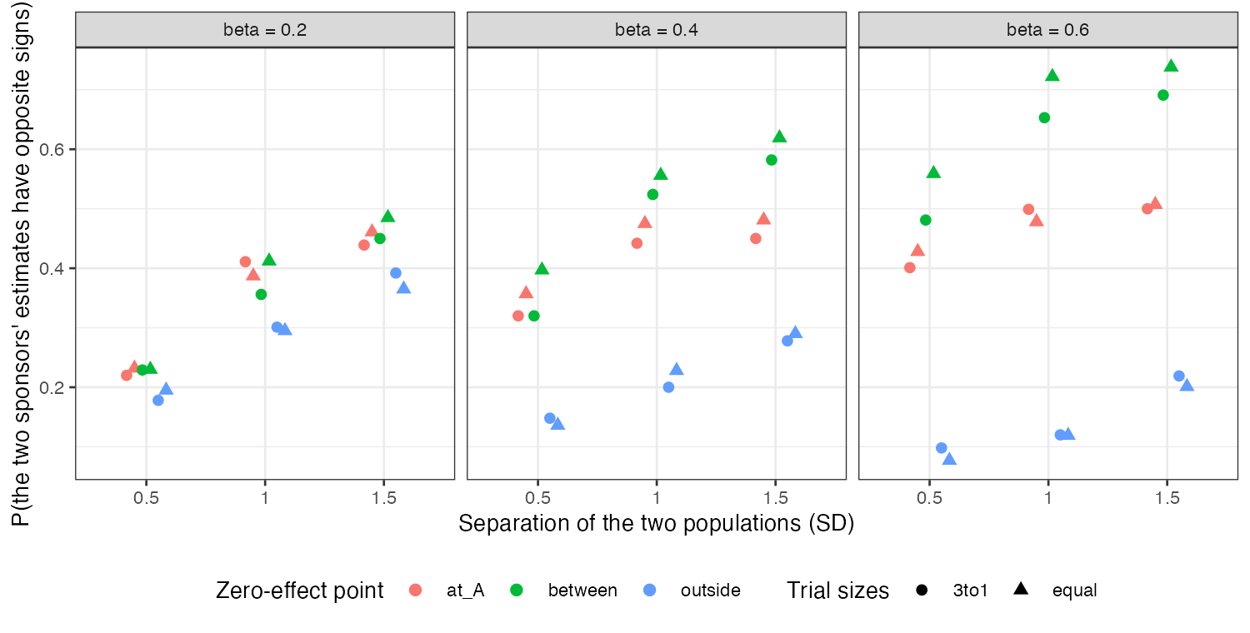
Figure 1: Probability that the two sponsors’ estimates have opposite signs, common adjustment sets.
Reversal probability tracked the position of the zero-effect point far more than any other factor (Figure 1). With the point outside the populations, reversals came from sampling error alone and fell as separation and modification grew; with it between, they rose toward the true reversal. A bivariate normal with the estimates’ correlation predicted the simulated reversal probability within 0.036. The correlation arises because both sponsors use both trials’ data, one as individual records and one as its published contrast.
Omitting the modifier made sponsor B’s estimate a mixture of the two targets, biased by up to 0.907 against its own. Both remedies were unbiased for (largest bias 0.027). The average of the two analyses needs no individual data from both sponsors, but it equals the midpoint population’s effect only because modification is linear here.

4. What this does not answer
Linear modification and a continuous outcome; under nonlinear modification or a non-collapsible scale the average is not the midpoint effect. The arbitrated indirect comparison and measurement differences between trials were not run; overlap was set by separation rather than varied separately. Peer review has not been done.

References
1. Ziren Jiang, others. A critical assessment of matching-adjusted indirect comparisons in relation to target populations. Research Synthesis Methods. 2025;16:569–74. doi:10.1017/rsm.2025.10

