Effective sample size counted in events: right direction, no gain over ESS times the event rate
A simulation study answering catalog problem OUT-02
Ahmad Sofi-Mahmudi
2026-09-23

Abstract
Background. With rare binary outcomes, the information in a MAIC estimate is carried by events, which Kish’s ESS does not count. Catalog problem OUT-02 proposed an event-based effective sample size (EESS) and argued it would reveal weights that concentrate away from the patients who have events.
Methods. is the reciprocal of the sandwich variance of a weighted log odds for small risks, and its ratio to is . We compared EESS, ESS times the event rate and ESS as predictors of interval failure in 108 scenarios (event risk 0.005 to 0.1, target shift that concentrates weights on high-risk, low-risk or no particular patients, 300 or 1000 per arm, null or nonzero effect), 1000 replicates each.
Results. The direction held in every scenario, reversed from the design’s statement: EESS was below ESS times the event rate when weights concentrated on high-risk patients (ratio 0.473 to 0.794) and above it when they concentrated on low-risk patients (1.281 to 2.401). As predictors of failure (no estimate or non-coverage), EESS and ESS times the event rate were equivalent (AUROC 0.839 and 0.858) and ESS alone was poor (0.662). Among analyses that produced an estimate, non-coverage was 0.057 and no diagnostic predicted it (AUROC 0.535 to 0.589).
Conclusion. Counting events matters: ESS alone misreads rare-event information. Counting them by EESS rather than ESS times the event rate adds nothing a planner or reader can use, because EESS is what the sandwich variance already reports.

1. The problem
For a weighted proportion, when risks are small, so EESS is the effective number of events. Against the weights-only reading, , which falls below 1 when weights and risk covary positively. DESIGN.md stated the opposite direction. Its refuting sentence was that ESS and event risk together are sufficient.

2. Design
Registered protocol: protocol.md. Source trial A versus C with three normal covariates, only prognostic (log odds 1 per SD). MAIC to a target shifted by in upward (weights on high-risk patients), downward, or in the non-prognostic . Target control-arm risk 0.005, 0.02 or 0.10; ; 300 or 1000 per arm; conditional log odds ratio 0 or . Estimand: target marginal log odds ratio by quadrature. Weighted log odds ratio with a sandwich variance; no estimate when an arm has no events. Diagnostics combined over arms as .

3. Results
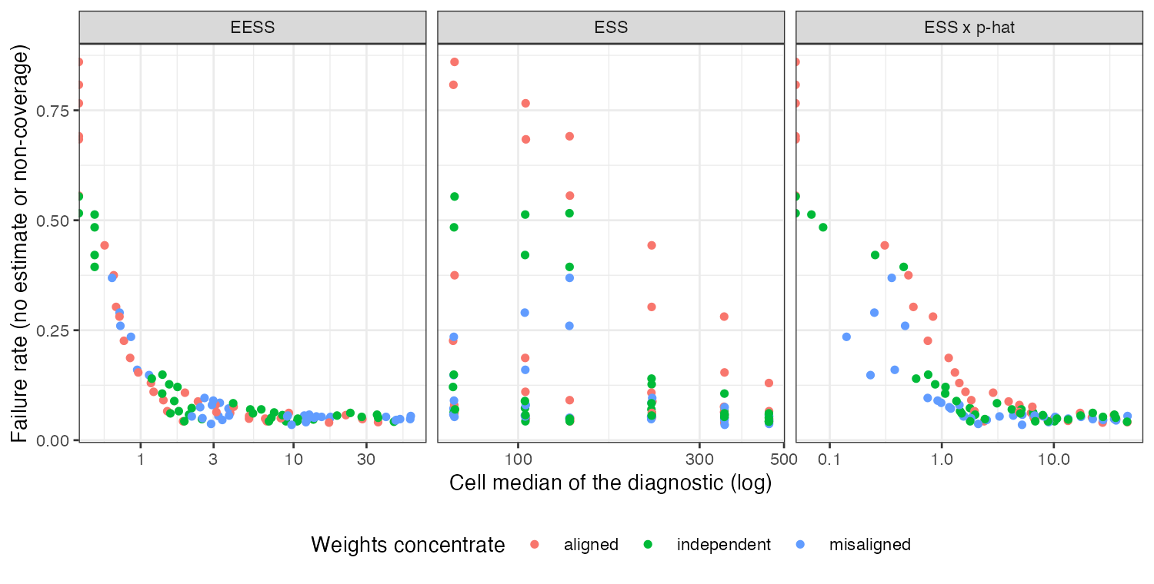
Figure 1: Cell failure rate against each diagnostic’s cell median.
Failure was dominated by analyses with no events in an arm, up to 0.858 of replicates at the lowest risk and smaller size, and both event-based diagnostics track it closely (Figure 1); ESS does not, because it is the same whatever the risk. The registered rule, which required EESS to beat ESS times the event rate by at least 0.05, reads refuted: the difference was -0.018 (bootstrap SE 0.001). Coverage among estimated analyses was 0.874 to 1.000.
The exploratory restriction to analyses with an estimate (R/05-exploratory.R, written after the registered analysis) shows why neither diagnostic predicts non-coverage: EESS is the reciprocal of the variance the interval already uses.

4. What this does not answer
One prognostic covariate and MAIC on means; the Firth, penalized, Bayesian and fail-closed estimators in DESIGN.md were not run, so what happens to a zero-event analysis under those methods is not measured. Unanchored comparisons and separation in multivariable outcome models are outside the design. Peer review has not been done.

References

