Which covariates a transported contrast depends on changes with the scale, but not in a nested way
A numerical study answering catalog problem COV-02
Ahmad Sofi-Mahmudi
2026-09-23

Abstract
Background. Effect modification is scale-specific, and on non-collapsible scales purely prognostic covariates change marginal contrasts. Catalog problem COV-02 asks how the set of covariates a transported contrast depends on differs between the scales a decision might use.
Methods. Population-level calculation with a logistic outcome model: zero, one or three conditional modifiers, two or six prognostic non-modifiers, two prognostic strengths and two imbalances between source and target (24 scenarios). For each covariate we computed how much leaving it unbalanced changed the target contrast on the risk difference, log risk ratio, marginal log odds ratio and conditional log odds ratio scales, and counted it in the scale’s set if the change exceeded 5% of the contrast.
Results. The conditional log odds ratio set never contained a prognostic non-modifier; some marginal scale’s set did in 13 of 24 scenarios. The sets differed between the risk difference, marginal and conditional odds ratio scales in 10 of 24, below the registered threshold of half, so the refuting sentence holds as registered. DESIGN.md’s prediction that the marginal odds ratio set contains the risk-difference set failed in 5 scenarios, because with a logistic model every prognostic variable modifies the risk difference. The median relative change from leaving one prognostic variable unbalanced was 0.045 on the risk difference, 0.035 on the log risk ratio and 0.016 on the marginal log odds ratio scale: the risk difference, not the odds ratio, was the most sensitive.
Conclusion. The covariates a transport must balance depend on the decision scale, and prognostic variables can matter on every marginal scale, the risk difference included. The dependence is a matter of degree around any threshold, not a nested rule; declare the scale and balance prognostic variables that are imbalanced.

1. The problem
With a logistic model the conditional risk difference is , which depends on even when . DESIGN.md said that on the risk-difference scale only conditional modifiers matter; that holds for a linear-risk model, not a logistic one. On the marginal odds ratio scale prognostic variables enter through non-collapsibility (1). Only the conditional log odds ratio depends on modifiers alone.

2. Design
Registered protocol: protocol.md. ; source , target . Balancing a covariate’s mean moves it to its target law (independent normals); an unbalanced covariate stays at its source law. Contrasts from common random draws.

3. Results
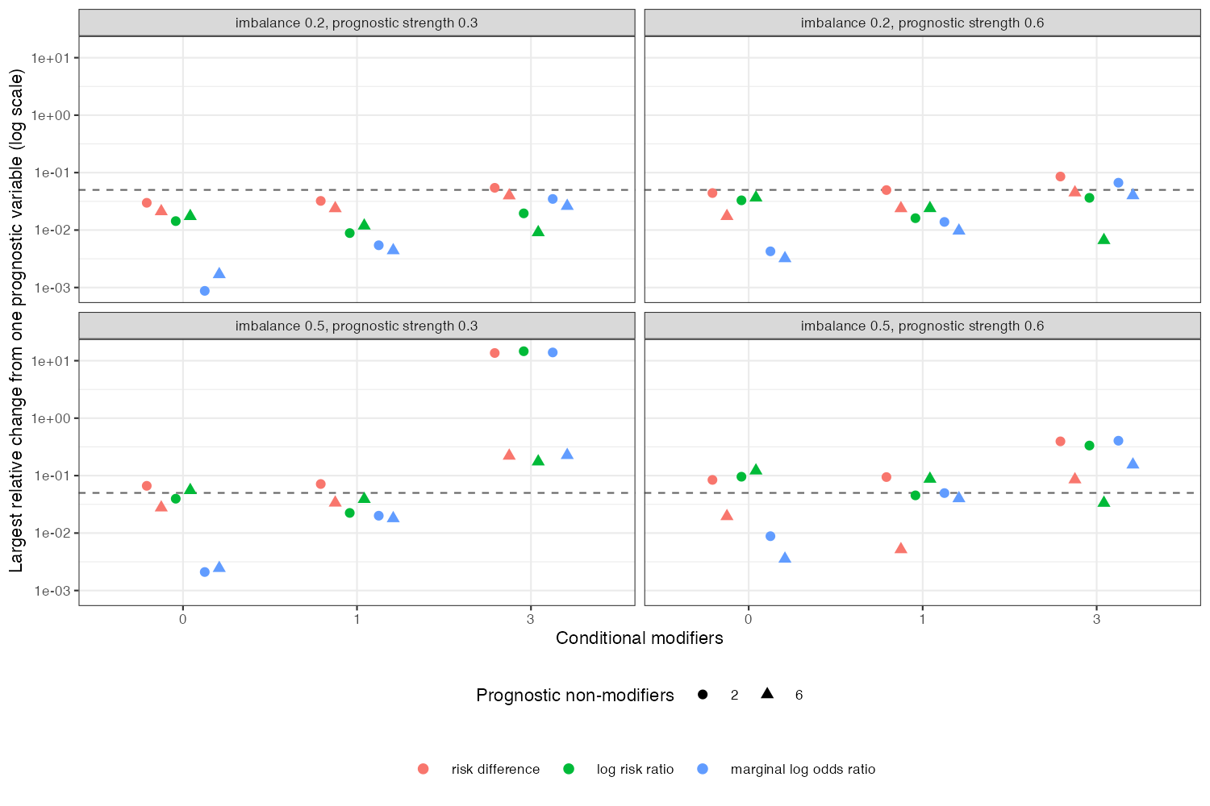
Figure 1: Largest relative change in the target contrast from leaving one prognostic non-modifier unbalanced, by marginal scale (the conditional log odds ratio is unaffected). Log scale; the dashed line is the 5% threshold defining set membership.
The relative changes (Figure 1) rose with imbalance and prognostic strength on every marginal scale and were zero on the conditional one. Which marginal scale was most sensitive depended on the scenario: with many prognostic variables the log risk ratio crossed the threshold where the risk difference and odds ratio did not, and with few the risk difference crossed first. Because the changes sit close to any fixed threshold, set membership flipped with small changes in the scenario, which is why a nested rule does not describe it. Where the target contrast itself was near zero (3 scenarios with three modifiers and larger imbalance, contrast -0.001 or closer to zero on the odds ratio scale) relative changes were very large and set membership says little; absolute changes are the better guide there.

4. What this does not answer
No time-to-event scale; no sampling, so how well the sets can be estimated (COV-01) and the cost of balancing more covariates are not studied; independent normal covariates. Peer review has not been done.

References
1. Rhian Daniel, Jingjing Zhang, Daniel Farewell. Making apples from oranges: Comparing noncollapsible effect estimators and their standard errors after adjustment for different covariate sets. Biometrical Journal. 2021;63(3):528–57. doi:10.1002/bimj.201900297

