When the trials that share individual data are selected on their own effect modification
A simulation study answering catalog problem CMP-22
Ahmad Sofi-Mahmudi
2026-09-23

Abstract
Background. Individual participant data carry the within-trial evidence on effect modification, and which trials supply them is not random. Catalog problem CMP-22 asks what selection on data availability does and whether a leave-IPD-out diagnostic reveals it.
Methods. Twelve trials with trial-specific treatment-by-covariate interactions. Individual data were available for a quarter, half or three quarters of trials, selected on an observed trial variable, on each trial’s latent interaction, or both (18 scenarios, 1000 replicates each). Interaction and target effect were estimated from the IPD trials’ within-trial interactions alone, or combined with the across-trial association in all trials.
Results. Selection on the observed trial variable left the within-trial estimate unbiased (-0.003 to 0.003). Selection on the latent interaction biased it by up to 0.142 (true interaction 0.3), most when few trials supplied data, and coverage fell to 0.589. Combining with aggregate trials halved the bias (at most 0.065). Leave-IPD-out influence did not respond: at half the trials supplying data it correlated -0.85 with the bias across selection strengths.
Conclusion. Availability that depends on a trial’s own effect modification biases the evidence that population adjustment relies on, and influence diagnostics cannot see it; only a stated selection model can address it. Report which trials were missing and use aggregate evidence alongside.

1. The problem
Combined IPD and aggregate meta-analysis (1) separates a within-trial interaction, identified by the IPD trials, from an across-trial association. If trials with stronger modification are more likely to share data, the within-trial evidence is a selected sample. Selection on observed trial variables can be modeled; selection on the latent interaction cannot be estimated from the network, because the trials that would reveal it are the ones without data.

2. Design
Registered protocol: protocol.md; ADEMP structure (2). Trials of 200 per arm, covariate means uniform on ; , , . IPD available with probability with an observed trial variable correlated with the covariate mean. Within-trial interactions pooled by DerSimonian-Laird; the combined estimator averages that with the across-trial slope by inverse variance. Influence: the largest change in the combined target estimate when one IPD trial is treated as aggregate.

3. Results
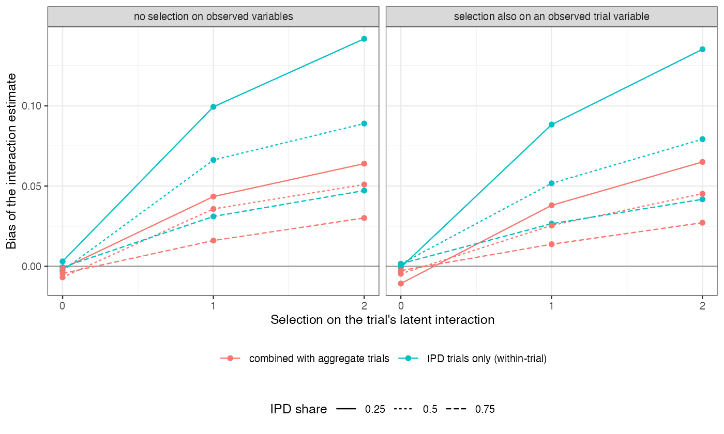
Figure 1: Bias of the interaction estimate by strength of selection on the latent interaction, for each IPD share.
The bias grew with selection strength and fell as more trials supplied data, since the selected set then approaches the whole (Figure 1). The across-trial slope is not selected, so combining diluted the bias in proportion to its weight. The influence diagnostic changed with the IPD share, because each trial matters less when more supply data, but not with selection.

4. What this does not answer
Pairwise meta-analysis with a continuous outcome rather than component ML-NMR; no selection-model sensitivity analysis; one network size. Peer review has not been done.

References
1. Richard D. Riley, Paul C. Lambert, Jan A. Staessen, Jiguang Wang, Francois Gueyffier, Lutgarde Thijs, Florent Boutitie. Meta-analysis of continuous outcomes combining individual patient data and aggregate data. Statistics in Medicine. 2008;27(11):1870–93. doi:10.1002/sim.3165
2. Tim P. Morris, Ian R. White, Michael J. Crowther. Using simulation studies to evaluate statistical methods. Statistics in Medicine. 2019;38(11):2074–102. doi:10.1002/sim.8086

