Treating an estimated risk score as data costs little in risk-modeling meta-regression, most at the tails
A simulation study answering catalog problem MOD-18
Ahmad Sofi-Mahmudi
2026-09-23

Abstract
Background. Risk-modeling approaches fit a prognostic score in one cohort and use it as a regressor for treatment-effect heterogeneity in trials, treating the score as observed. Catalog problem MOD-18 asks whether the plug-in interval is too narrow, especially at the tails of risk where recommendations are made.
Methods. Logistic prognostic score from a cohort of 300, 1000 or 5000 patients with eight covariates, used in a pooled six-trial logistic regression of outcome on score, treatment and their interaction, with or without trial calibration drift (6 scenarios, 500 replicates each). Plug-in intervals for the treatment effect at the 10th, 50th and 90th risk percentiles were compared with intervals adding bootstrap variance from refitting the score.
Results. Propagating the score’s uncertainty widened intervals by 0.001 to 0.024 (proportion) with cohorts of 1000 or more and by 0.011 to 0.073 with 300. The widening was larger at the tails than at the median (1.065 to 1.073 against 1.011 to 1.012 for the ratio with 300). Plug-in coverage was 0.924 to 0.970; the registered rule required 0.93 everywhere and was missed in one scenario with the 300-patient cohort.
Conclusion. With a prognostic cohort of about a thousand patients or more, the plug-in interval is adequate here; with smaller cohorts, propagate the score’s uncertainty, which matters most at the risk percentiles where decisions are made.

1. The problem
In risk-modeling heterogeneity analysis (1) the score is estimated, and a model using it as a regressor omits from every coefficient multiplying it. The omitted term is largest where the score is least precise, at extreme covariate values.
Uniform shrinkage of the score’s slopes is a linear rescaling that the trial intercepts and the treatment-by-score interaction absorb, so effects at score percentiles do not depend on it; DESIGN.md’s claim that shrinkage compounds the problem does not apply to that form of shrinkage.

2. Design
Registered protocol: protocol.md; ADEMP structure (2). Eight covariates, true risk logit with ; six trials of 400 per arm with calibration shifts ; treatment effect on the log odds scale. Estimand: the effect at the 10th, 50th and 90th percentiles of true risk; estimate at the same percentiles of the fitted score. Twenty bootstrap refits of the score per replicate.

3. Results
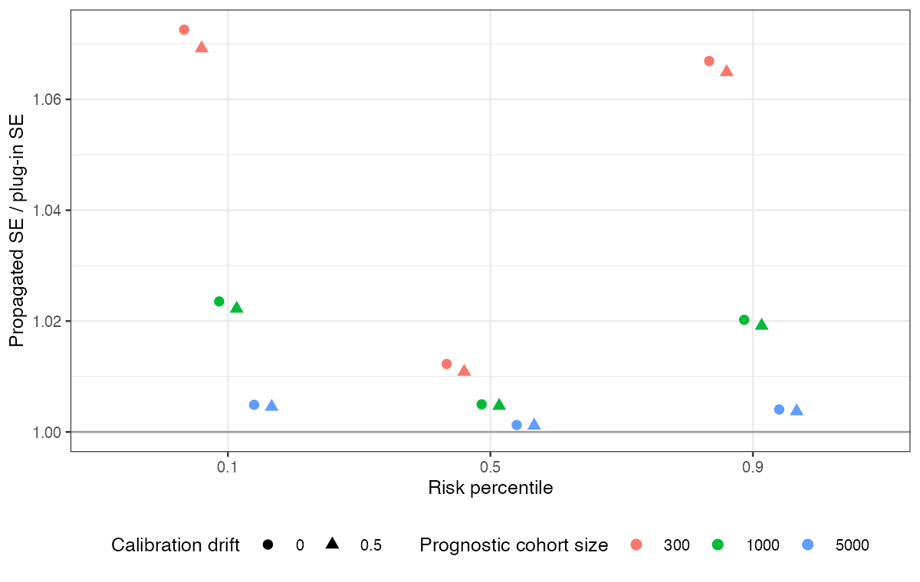
Figure 1: Ratio of the propagated to the plug-in SE by risk percentile, cohort size and calibration drift.
The widening shrank with cohort size and was concentrated at the tails (Figure 1). The score’s estimation error was small relative to the trials’ sampling error even with 300 cohort patients, because six trials of 800 patients determine the interaction more loosely than 300 patients determine eight score coefficients. Calibration drift was absorbed by the trial intercepts.

4. What this does not answer
A pairwise six-trial analysis rather than a network; frequentist fits with a bootstrap rather than a joint Bayesian or cut model; a well-specified score. Peer review has not been done.

References
1. David M. Kent, Jessica K. Paulus, David van Klaveren, others. The predictive approaches to treatment effect heterogeneity (PATH) statement. Annals of Internal Medicine. 2020;172(1):35–45. doi:10.7326/M18-3667
2. Tim P. Morris, Ian R. White, Michael J. Crowther. Using simulation studies to evaluate statistical methods. Statistics in Medicine. 2019;38(11):2074–102. doi:10.1002/sim.8086

