Effective sample size tracks the error an analysis got by chance better than the error it got from adjusting on the wrong covariates
The routine population-adjustment diagnostic panel scored as a classifier of realized error, answering catalog problem DIA-03
Ahmad Sofi-Mahmudi
2026-07-27

Abstract
Population-adjusted indirect comparisons are conventionally reported with a panel of numbers beside them: the effective sample size after weighting, the same figure as a percentage, the largest individual weight, standardized differences before and after adjustment. These conventions come from the NICE DSU guidance on population adjustment (1) and, for the overlap statistics, from the transportability literature (2,3). A simulation reported at ISPOR Europe 2024 found bias in unanchored MAIC once absolute effective sample size fell below roughly 30 to 35 (4), and that region is now widely quoted informally as a cutoff. We have not surveyed how appraisal committees actually use these numbers, and this paper makes no claim about that. What a structured audit of an open-problem catalog did establish is that no published work scores any of them as a classifier of realized error, with discrimination and calibration, against a known truth.
We do that. The design has a continuous outcome and an identity link, chosen because on that scale the realized error of a linear estimator splits exactly into three pieces: chance covariate imbalance between the source arms, transport error, and outcome noise. The primary reference is the error in the transported source effect rather than in the anchored contrast, which is the version most favorable to the diagnostics; the anchored contrast is reported throughout. Two of the three pieces are functions of covariates, treatment assignment and weights, and the panel is built from those same ingredients; the third, transport error, is what covariate adjustment exists to remove. Scoring each diagnostic against each piece separately is the instrument of the study. The design has 128 cells crossing an omitted effect modifier, a cross-moment modifier that no baseline table could ever reveal, overlap, source size, how correlated the omitted modifier is with the adjustment set, and a target dispersion ratio that destroys effective sample size while adding no bias wherever the modifier structure is correctly specified. 4,000 replicates per cell, four estimators.
The prespecified verdict is that no evaluated fixed cutoff met the registered operating requirements, sensitivity 0.80 at specificity 0.50 in every misspecification stratum. Effective sample size below 35 reaches sensitivity 0.309 at specificity 0.926 where an effect modifier is omitted and the omission is diagnosable in principle. The panel is not uninformative; what it is informative about is the wrong thing. Effective sample size separates the two components that are functions of covariates, assignment and weights at 0.847 and 0.813, and the transport component, which is what adjustment exists to remove, at 0.653.
Three of the panel’s members are one statistic written three ways, because exactly (5) and area under the ROC curve is invariant to monotone transformation; a fourth, the post-weighting balance on the matched moments, is zero at the solution of the calibration equations and among converged analyses cannot discriminate anything. Where the bias is an omitted modifier the target reports, checking balance on the covariate that was measured and not matched reaches 0.946 against the transport component; where the bias sits in a cross-moment no baseline table reports, nothing computable and no oracle we could construct exceeds 0.648. Two of four registered mechanism claims failed, including one of our own proposals, and both failures are reported as failures.

1. What the audit left open
The catalog entry DIA-03 originally said that whether population-adjustment diagnostics predict error “has never been quantified”. Two independent auditors judged that too strong, and they were right. An ISPOR Europe 2024 simulation reported bias in unanchored MAIC once absolute effective sample size fell below roughly 30 to 35 (4), and Remiro-Azócar, Heath and Baio tied small effective sample size to underestimation of variability by the robust sandwich variance estimator (6). What survived the audit is narrower:
Neither treats a diagnostic as a classifier with discrimination and calibration against known truth.
One auditor added the objection that turns this from a complaint into a research question. Computing a diagnostic from the fitted data does not logically prevent it from predicting error. Sensitivity, specificity and calibration are defined only relative to a specified distribution of analyses and a prespecified threshold for material error; they are not intrinsic properties of a statistic. That is why the field has no numbers: nobody has written the distribution down. This study writes one down in advance, and reports everything twice, once under it and once with all cells weighted equally.
It also reports the primary results within strata of misspecification rather than over a mixture of them, which removes the dependence on our chosen misspecification frequencies though not on the rest of the design, as Section 6 sets out. That change came from an adversarial critique of this design, before the run.

2. What a covariate diagnostic could possibly know
Write the source trial’s outcome as with , and let the estimand be the transported effect in the target superpopulation, . The identity link does not make the heterogeneous conditional effect equal to the marginal one; what it buys is the absence of non-collapsibility, so the marginal effect is exactly the average of the conditional effects over the target covariate distribution.
MAIC, STC and the unadjusted comparison are all linear in the outcome vector for a fixed design: each is for some linear functional . For MAIC, ; for STC, with . Applying the same to each piece of gives an identity, not an approximation:

Only the middle term is what adjustment exists to remove. The first is chance covariate imbalance between the source arms, which randomization makes mean-zero but not zero in any one trial. The third is sampling error in the outcomes. The identity holds per replicate; we verified it numerically to before the run.
An earlier version of this manuscript claimed that the middle term is the only one knowable from covariates. All three reviewers of the first round said that is wrong, and it is. The correction matters enough to state precisely, because it changes what the headline number means.
The arm-imbalance term uses no outcome at all. applies the estimator’s linear functional to the prognostic index, which is a function of the realized covariates, the treatment assignment and the weights. It is therefore diagnosable in principle from exactly the information the panel has. It is now scored like the other two.
The noise term’s variance is a known function of the weights. For MAIC,

with arm-specific effective sample sizes. So a statistic built from the weights is not merely correlated with the noise channel, it is the natural sufficient summary of it. This is not quite the identity it looks like for the reported number: submissions report the pooled effective sample size, and is about half the correct value in a representative cell of this design, correlating with the exact noise standard deviation at on the log scale rather than at . But it is close enough that a high area under the ROC curve against the noise channel should be read as a check on the arithmetic and not as an empirical discovery.
What survives, and it is the point of the paper. Two of the three components are functions of covariates, treatment assignment and weights alone; the panel is built out of those same ingredients, and it tracks both of them well. The third, transport error, is the one covariate adjustment exists to remove, and it is the one the panel tracks poorly. That comparison is not arithmetic: nothing forces a weight-dispersion statistic to be uninformative about the gap between a weighted source and a target, and where the modifier structure is correctly specified it is in fact highly informative. What it cannot see is the part of the modifier structure the weights never touched.

3. Two facts that algebra settles before any data exist
The panel is smaller than it appears.
Effective sample size, effective sample size as a percentage, and the coefficient of variation of the weights are one statistic. With the mean weight and the population variance of the weights,

Area under the ROC curve depends on the score only through its ranks, so a strictly monotone transformation cannot change it. Within a fixed source size the three therefore have identical discrimination as a matter of arithmetic. Across sizes they differ, because varies. A submission that reports all three is reporting one number three times and calling it triangulation.
The post-weighting standardized difference on the matched moments is zero. The MAIC calibration equations are ; the balance statistic is that expression divided by a standard deviation. It is set to zero by the thing being reported as evidence that it worked. In this run it never exceeded 1.4e-14.
Both are checked in the results rather than assumed, because the check is a test of the implementation.

4. Design
The full protocol was registered before the run and follows ADEMP (7). What matters for reading the results:
Four estimators. MAIC calibrating the target’s means and standard deviations of the adjustment set; MAIC calibrating means only; STC with a heteroskedasticity-consistent variance (8); and no adjustment at all. All adjust for the same three covariates, so when a modifier is omitted they are misspecified in the same way. MAIC’s variance is the M-estimation sandwich over the stacked calibration and arm-mean equations (9).
Three bias channels, differing in whether anything could see them. An omitted effect modifier , which the source data can estimate an interaction for and a baseline table may report a mean for, so it is diagnosable in principle. A cross-moment term in with source and target correlations of 0.30 and 0.70, which no marginal balance statistic can see and which no baseline table reports. And extrapolation, which moves effective sample size and bias together and is what gives effective sample size its only real chance.
The factor that makes the study falsifiable. The target’s covariate standard deviations are either equal to the source’s or 25% larger. Matching second moments to a more dispersed target destroys effective sample size while adding no bias in the well-specified stratum, because the modifier is linear in the adjustment set and its mean is matched either way. Without it, every low-effective-sample-size cell would also be a poor-overlap cell, and a variance statistic would look like a bias statistic because the design never separated the two.
The reference, and what is scored. Material error means : the error in the transported versus effect, not in the anchored versus contrast. That is deliberate, because the anchored contrast additionally carries the target trial’s own sampling error, which no source-side diagnostic has any information about, and including it would depress every discrimination measure by a common amount. It gives the panel the most favorable version of the question. Two reviewers pointed out that calling the design anchored while scoring only the transported component is not licensed, and they are right; the anchored contrast is now reported alongside throughout, and the conclusions are the same.
0.20 is a fifth of the residual standard deviation. It is not a fifth of the marginal outcome standard deviation, which also contains the prognostic index and runs from 1.37 to 1.66 across the design; an earlier version of this manuscript said outcome standard deviation and was corrected in review. Results at 0.10 and 0.30 are reported. No diagnostic enters the definition of the reference.
Scale. 128 cells, 4,000 replicates each, four estimators. MAIC found a solution on 99.3% of replicates; the rest are reported per cell rather than dropped silently.

5. Results

5.1 The panel at the thresholds in use
Table 1: Sensitivity and specificity for material error, within each misspecification stratum, cells weighted equally inside a stratum. Monte Carlo standard errors in brackets.
diagnostic (sensitivity / specificity) | well.specified | omitted.modifier | cross.moment | both
ESS | 0.326 / 0.923 | 0.309 / 0.926 | 0.265 / 0.918 | 0.251 / 0.915
ESS % | 0.742 / 0.623 | 0.735 / 0.654 | 0.649 / 0.607 | 0.642 / 0.633
largest weight | 0.350 / 0.919 | 0.332 / 0.920 | 0.285 / 0.913 | 0.269 / 0.909
balance, matched moments | 0.000 / 1.000 | 0.000 / 1.000 | 0.000 / 1.000 | 0.000 / 1.000
imbalance before weighting | 0.822 / 0.408 | 0.823 / 0.431 | 0.767 / 0.403 | 0.771 / 0.440
Mahalanobis distance | 0.656 / 0.692 | 0.652 / 0.721 | 0.570 / 0.683 | 0.564 / 0.707
balance, unmatched covariate | 0.559 / 0.610 | 0.571 / 0.639 | 0.520 / 0.608 | 0.543 / 0.681
estimated bias (proposed) | 0.099 / 0.962 | 0.393 / 0.807 | 0.091 / 0.957 | 0.358 / 0.827

The prespecified bar was sensitivity at least 0.80 with specificity at least 0.50 in every stratum, lower Monte Carlo limits above both. No rule met it.
In the omitted-modifier stratum, which is where a diagnostic has both something to find and the information with which to find it, the published cutoff reaches sensitivity 0.309 (0.001) at specificity 0.926. Two members of the panel reach high sensitivity by firing on nearly everything: the pre-weighting imbalance rule fires on 70.6% of analyses in that stratum and the unmatched-balance rule on 47.4%. A rule that warns about almost every analysis is not a classifier, and its specificity says so: 0.431 and 0.639.
Replicates on which MAIC had no solution: 3,747. Those replicates are excluded from every operating point above, because an analysis that does not exist has no realized error to classify. Bracketing the primary rule’s sensitivity by counting every one of them as a caught failure, then as a missed one, gives 0.285 and 0.273. The bracket is over the whole design with cells weighted equally, not within the omitted-modifier stratum, and it moves the figure by less than a percentage point either way because MAIC found a solution on 99.3% of replicates.

5.2 The statistics carry information the thresholds do not use
Table 2: Discrimination under the declared deployment distribution. The last two columns are the point of the study: which component of the realized error does each statistic actually track?
 | diagnostic | AUROC | AUPRC | vs outcome noise | vs transport error
ess | ESS | 0.731 (0.001) | 0.707 | 0.847 | 0.653
ess_pct | ESS % | 0.723 (0.001) | 0.698 | 0.813 | 0.667
cv_w | CV(w) | 0.723 (0.001) | 0.698 | 0.813 | 0.667
max_w | largest weight | 0.741 (0.001) | 0.716 | 0.833 | 0.660
smd_matched | balance, matched moments | 0.550 (0.001) | 0.509 | 0.571 | 0.538
smd_pre | imbalance before weighting | 0.683 (0.001) | 0.671 | 0.799 | 0.655
maha | Mahalanobis distance | 0.682 (0.001) | 0.669 | 0.796 | 0.656
smd_unmatched | balance, unmatched covariate | 0.606 (0.001) | 0.592 | 0.663 | 0.665
bias_hat | estimated bias (proposed) | 0.604 (0.001) | 0.591 | 0.643 | 0.684
orc_cross | oracle: cross-moment | 0.581 (0.001) | 0.551 | 0.505 | 0.809

Table 3: All three components of the realized error, the other two material thresholds, equal cell weights, and the anchored contrast. The first column is new since round one of review: the arm-imbalance component uses no outcome and is therefore diagnosable in principle from exactly the information the panel has.
 | diagnostic | vs arm imbalance | vs transport | vs noise | equal weights | material 0.10 | material 0.30 | anchored
ess | ESS | 0.813 | 0.653 | 0.847 | 0.721 | 0.683 | 0.779 | 0.699
ess_pct | ESS % | 0.807 | 0.667 | 0.813 | 0.717 | 0.675 | 0.770 | 0.692
cv_w | CV(w) | 0.807 | 0.667 | 0.813 | 0.717 | 0.675 | 0.770 | 0.692
max_w | largest weight | 0.837 | 0.660 | 0.833 | 0.729 | 0.690 | 0.791 | 0.708
smd_matched | balance, matched moments | 0.583 | 0.538 | 0.571 | 0.557 | 0.537 | 0.564 | 0.544
smd_pre | imbalance before weighting | 0.739 | 0.655 | 0.799 | 0.690 | 0.641 | 0.728 | 0.658
maha | Mahalanobis distance | 0.737 | 0.656 | 0.796 | 0.690 | 0.640 | 0.726 | 0.657
smd_unmatched | balance, unmatched covariate | 0.615 | 0.665 | 0.663 | 0.623 | 0.583 | 0.629 | 0.590
bias_hat | estimated bias (proposed) | 0.603 | 0.684 | 0.643 | 0.619 | 0.582 | 0.625 | 0.588
orc_cross | oracle: cross-moment | 0.502 | 0.809 | 0.505 | 0.586 | 0.577 | 0.576 | 0.566

Discrimination is not zero. Nothing here is uninformative in the sense of being independent of error. The pattern across components is the answer to what the panel is measuring. Effective sample size reaches 0.847 against the noise channel and 0.813 against the arm-imbalance channel, which are the two components that are functions of covariates, assignment and weights; against the transport component, which is what adjustment exists to remove, it reaches 0.653. The first of those numbers is close to arithmetic for the reason given in Section 2. The second is not, and the third is not.
That comparison is at the level of one analysis, and it has to be, because that is the level at which a diagnostic is read. A reviewer objected in round two that the transport term of a single replicate is the realized effect-modifier component and contains finite-sample composition and allocation variation, so a low area under the curve against it does not by itself establish anything about systematic bias. The objection is correct and the analysis it asks for is Section 5.3, where the answer is different and the difference matters.
The conclusion does not depend on the material threshold: at 0.10 and 0.30 the ordering is unchanged, and it survives the switch from the declared mixture to equal cell weights and the switch from the transported component to the anchored contrast a submission reports.
The oracle row separates two different failures. The cross-moment oracle uses the target’s true , which no baseline table reports, and reaches 0.809 against transport error while everything computable sits near 0.667. Where the oracle wins, the information is missing rather than the statistic being the wrong function of it.
One row needs a warning label. The balance statistic on the matched moments shows AUROC 0.550, which is not 0.5 and might be read as weak signal. It is not. That statistic never exceeded 1.4e-14 anywhere in the run: what is being ranked is floating-point residual from the calibration solver, and the residual is larger in cells where the equations were harder to solve, which are also harder cells. The apparent discrimination is discrimination of arithmetic difficulty.
That claim has a boundary a reviewer was right to insist on, and it is narrower than it first appears. Post-weighting balance on the matched moments is zero conditional on accepting a solution to the calibration equations, and this analysis conditions on exactly that. Its real operational job is to reveal that the balancing algorithm failed or nearly failed, and by scoring only accepted fits we removed the cases where it can do that job. So the finding is: among analyses that converged, the matched-moment balance statistic is redundant by construction and reporting it as evidence the adjustment worked is reporting that the solver terminated. Whether it is useful as a convergence check is a different question and this design cannot answer it. MAIC found no solution on 0.7% of replicates, 3,747 in total, and those are reported as an operational outcome rather than folded into the classifier analysis.

5.3 Systematic bias, with the cell as the unit
Round two of review asked for the analysis this section contains, and it changes what can be claimed. The systematic part of the transport error is a property of a design cell, not of a replicate, so it is estimated as the Monte Carlo mean of the transport term within a cell and the diagnostics are scored with the cell as the unit.
Table 4: Discrimination against SYSTEMATIC transport bias above 0.20, with the design cell as the unit rather than the replicate. Added in round two of review.
 | diagnostic | AUROC vs systematic bias | Spearman with |bias|
ess | ESS | 0.808 | 0.469
ess_pct | ESS % | 0.818 | 0.495
cv_w | CV(w) | 0.818 | 0.495
max_w | largest weight | 0.813 | 0.479
smd_matched | balance, matched moments | 0.708 | 0.337
smd_pre | imbalance before weighting | 0.813 | 0.492
maha | Mahalanobis distance | 0.808 | 0.476
smd_unmatched | balance, unmatched covariate | 0.821 | 0.508
bias_hat | estimated bias (proposed) | 0.829 | 0.545
orc_cross | oracle: cross-moment | 0.845 | 0.764
lambda_norm | tilt norm | 0.783 | 0.451

42 of the 128 cells carry a systematic transport bias above 0.20. Against that target, effective sample size reaches 0.808 and everything else in the panel lands between 0.708 and 0.845. Two readings of that are available and only one of them survives inspection.
The reading that does not survive is that the panel does after all detect systematic bias. The statistic that is identically zero reaches 0.708 on this analysis. Nothing in a statistic that never departs from can be detecting bias; what is happening is that 128 cells is a small sample in which almost everything, including the bias, moves along the overlap axis, so a cell-level ranking cannot separate the diagnostics from each other or from noise. This analysis has very little resolving power and we report it with that stated rather than omitted.
What survives is the practical form of the question. An analyst holds one analysis, not a cell, and asks whether this one is materially wrong. At that level the panel ranks the two components an analysis got by chance far above the one it got from adjusting on the wrong covariates, and no threshold on it separates a small sound analysis from a large biased one. The title of this paper is a claim about that level and not about the cell level, and the earlier version of it, which asserted a variance-versus-bias dichotomy outright, went further than these results support and has been withdrawn.

5.4 The panel is smaller than it looks
Table 5: The algebraic identities, checked. Within a fixed source size the three weight-dispersion statistics have the same AUROC to machine precision, and the matched-moment balance statistic is zero.
source per arm | ESS | ESS % | CV(w) | max matched imbalance
150 | 0.706 | 0.706 | 0.706 | 1.3e-14
400 | 0.740 | 0.740 | 0.740 | 1.4e-14

5.5 Calibration
A diagnostic is calibrated if a mapping from it to a risk of material error, fitted once and locked, tells the truth on analyses it has not seen (10). The mapping is a logistic regression of the material-error indicator on one transformed diagnostic, minus the natural logarithm where a low value is the warning and the statistic itself otherwise, with a single linear term and no splines.
The first version of this analysis trained on odd-numbered cells and tested on even ones. A reviewer warned that such a split can separate levels of a design factor depending on how cells are enumerated, and in this design it did so perfectly: cells are enumerated with the target dispersion ratio varying fastest, so every odd cell had ratio 1.00 and every even cell 1.25. That analysis measured transport across one factor and reported it as transport in general. It is replaced by leave-one-factor-level-out: fourteen folds, each holding out every cell at one level of one factor, balanced across everything else by construction.
Table 6: Calibration of a locked logistic mapping from each diagnostic to the risk of material error. Perfect calibration is intercept 0 and slope 1.
 | diagnostic | intercept | slope | error, median fold | error, worst fold | error, same cells
ess | ESS | -0.257 | 1.179 | 0.076 | 0.197 | 0.066
ess_pct | ESS % | -0.269 | 1.195 | 0.095 | 0.200 | 0.069
max_w | largest weight | -0.350 | 1.381 | 0.117 | 0.201 | 0.091
smd_pre | imbalance before weighting | -0.317 | 1.227 | 0.098 | 0.235 | 0.075
maha | Mahalanobis distance | -0.315 | 1.192 | 0.096 | 0.235 | 0.075
smd_unmatched | balance, unmatched covariate | -0.331 | 0.877 | 0.163 | 0.362 | 0.101
bias_hat | estimated bias (proposed) | -0.430 | 1.151 | 0.165 | 0.280 | 0.086

Table 7: Which held-out factor level breaks each mapping. For every weight-dispersion statistic it is the cross-moment channel: a risk mapping learned where that bias is present does not transport to where it is absent, or the reverse.
diagnostic | held-out factor | level | calibration error
ESS | joint | 0 | 0.197
ESS % | joint | 0 | 0.200
largest weight | joint | 0 | 0.201
imbalance before weighting | sd_target | 1 | 0.235
Mahalanobis distance | sd_target | 1 | 0.235
balance, unmatched covariate | rho4 | 0 | 0.362
estimated bias (proposed) | overlap | 0 | 0.280
oracle: cross-moment | overlap | 0 | 0.299

Across a median fold the weight-dispersion statistics calibrate tolerably: effective sample size has intercept -0.257, slope 1.179 and an integrated calibration error of 0.076. The worst fold is what matters for an analyst, who does not know which setting they are in, and there the error is 0.197: a mapping from effective sample size to risk, learned elsewhere, is off by about twenty points of absolute risk in the setting it transports worst to.
That worst setting is the same for every weight-dispersion statistic in the panel, and it is the cross-moment channel. A mapping fitted where a bias no baseline table can reveal is operating, applied where it is not, or the reverse, gets the risk badly wrong.
One caution on reading that, raised in round two and accepted. A one-term logistic mapping can fail either because the diagnostic does not transport or because a single linear term in the transformed statistic is the wrong functional form in the held-out setting, and this analysis cannot separate those. We did not fit richer forms. What can be said without choosing between them is the operational fact: a mapping of this shape, fitted on other settings, is off by about twenty points of absolute risk in the setting it transports worst to, and an analyst using it would not know which setting they were in.
This is the substantive version of the transportability question, and it is the analysis the registered mechanism claim should have used; the registered version compared predictive values across cells, which move with prevalence and case mix even when a rule’s operating characteristics are stable, and a reviewer was right that it is not a test of transportability at all.

5.6 Is acting on the warning better than not acting?
Net benefit relative to flagging nothing, over a range of threshold probabilities at which an analyst would act (11). A rule earns its place only above both flagging nothing and flagging everything.
Table 8: Net benefit relative to flagging nothing, under the deployment weights.
action threshold | flag nothing | flag everything | ESS < 35 | ESS < 50% | imbalance > 0.25 | Mahalanobis > 1 | estimated bias > 0.10
0.1 | 0 | 0.421 | 0.086 | 0.281 | 0.341 | 0.242 | 0.066
0.2 | 0 | 0.348 | 0.083 | 0.259 | 0.297 | 0.224 | 0.061
0.3 | 0 | 0.255 | 0.080 | 0.231 | 0.241 | 0.202 | 0.056
0.4 | 0 | 0.131 | 0.075 | 0.194 | 0.167 | 0.172 | 0.049
0.5 | 0 | -0.043 | 0.069 | 0.142 | 0.063 | 0.130 | 0.039

Every rule in the panel is beaten by flagging everything at action thresholds up to 0.300. An analyst who would act on a 10.0% chance of material error does better scrutinizing every population adjustment than reading any of these numbers. From an action threshold of 0.400 upwards, meaning an analyst who intervenes only when material error is at least that likely, three distinct statistics beat both alternatives: relative effective sample size, pre-weighting imbalance and Mahalanobis distance. The coefficient of variation of the weights appears as a fourth entry in Table 8 and is not a fourth statistic; it is relative effective sample size under another name, for the reason given in Section 3. The absolute effective-sample-size cutoff that gets quoted is not among them at any threshold examined.
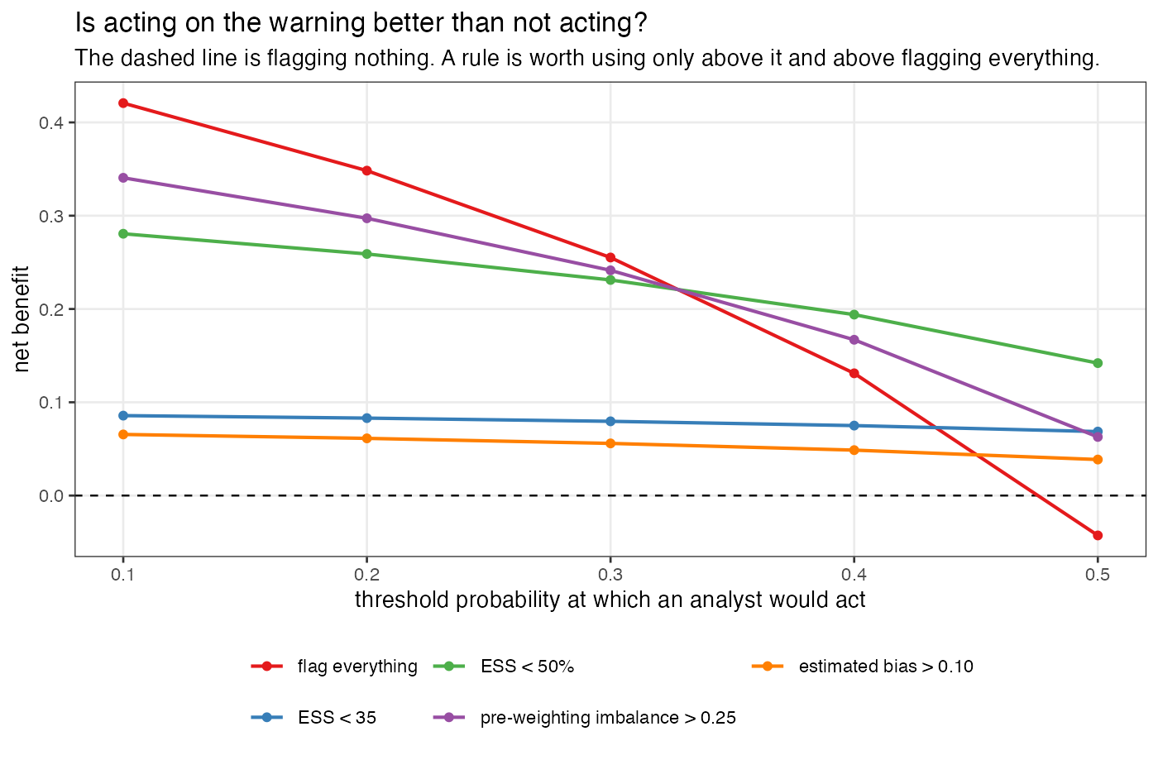

5.7 The four prespecified mechanism claims
Table 9: The four claims registered before the run, and whether the run supports them.
claim | holds | evidence
It is a variance statistic, not a bias statistic | yes | Effective sample size discriminates outcome noise at AUROC 0.847 and transport error at 0.653, a gap of 0.194 against a prespecified 0.10.
The threshold is not transportable | no | Across the 24 cells the rule flags on most replicates, the material-error rate runs from 0.751 to 0.902, a span of 0.150 against a prespecified 0.30. Across the 88 cells it is silent on, the rate runs from 0.045 to 0.835.
The panel is one statistic | yes | Within a fixed source size the three agree to 0.0e+00 in AUROC, and the matched-moment balance statistic never exceeds 1.4e-14.
A better statistic is available from the same information | no | In the diagnosable stratum, against the transport component, the proposal reaches 0.937 and the best routinely reported diagnostic 0.851, a gain of 0.086 against a prespecified 0.10.

Two of the four hold and two do not, and the two that do not are reported as they were registered rather than adjusted until they did. The two gaps that carry the surviving claims, 0.194 and 0.086, are reported as point estimates against a registered threshold and not as tested differences: the bootstrap used for the areas under the curve is cell-stratified and unpaired, so it does not give a Monte Carlo interval for a difference between two diagnostics on the same replicates. A reviewer asked for paired intervals and this is the reason they are absent.
The threshold-transportability claim failed as written. We registered a span of at least 0.30 in the material-error rate across the cells the rule flags. The observed span is 0.150, and the reason is visible in Figure 1: the flagged cells are all in the low-effective-sample-size region where almost everything is wrong, so there is little room for a spread. Across the 88 cells the rule is silent on, the material-error rate runs from 0.045 to 0.835.
A first draft called that second number a stronger version of the registered claim. It is not, and a reviewer was right to object. Both spans are variation in predictive value across cells, and predictive value moves with prevalence and case mix even when sensitivity and specificity are stable, so neither is a test of whether a threshold transports. They are descriptions of what an analyst faces: the same silence covers a 4.5% and an 83.5% chance of material error depending on which cell you are in. The claim registered as a test of transportability failed, and the proper evidence on transportability is the calibration of a locked risk model in held-out cells, which is Section 5.5.
The proposal missed its bar too. Registered at a gain of at least 0.10 in area under the ROC curve against the transport component in the diagnosable stratum; observed 0.937 against 0.851, a gain of 0.086. It is a real improvement and it is not the one we said would count.
Those two numbers are computed over a different set from Table 10 and two reviewers were right that presenting them side by side without saying so reads as an inconsistency, and that the comparator was never named. It is named now. The registered claim compares our statistic against effective sample size as a percentage, over the diagnosable set, which is every cell with the cross-moment channel off and therefore spans two of the four strata, under the declared deployment weights. On that set the comparator reaches 0.851, its alias the coefficient of variation of the weights reaches the same by Section 3, and the next routinely reported member is pre-weighting imbalance at 0.847. Table 10 is per stratum, under equal cell weights, and includes our proposals as well as the panel. Both are correct for what they are; neither is the other.
Read together they correct something we said in the round-one response. Over the diagnosable set our converted statistic reaches 0.937 and the plain unmatched-balance check 0.890, so the conversion does help there. Inside the omitted-modifier stratum alone the order reverses: the plain check reaches 0.946 against 0.938. The two sets differ by whether the well-specified cells are included, and that is the whole explanation. Where the unmatched covariate is a modifier in every cell, imbalance in it and bias from it are the same thing and converting one to the other adds estimation noise for nothing. Where the analyst does not know whether it is a modifier, which is the real situation, the conversion is what keeps the statistic quiet on covariates that are imbalanced and harmless.
So the honest summary of our own contribution is narrower than the registered claim and wider than the retraction we offered in round one: check balance on everything you measured, and weight it by an interaction you can estimate if you do not already know which of those covariates matter.
Table 10: Discrimination against the transport component within each stratum, cells weighted equally. This table does NOT contain the two numbers behind mechanism claim 4, which are computed over the diagnosable set under deployment weights and are given in the text; a reviewer caught an earlier caption claiming otherwise.
diagnostic | well specified | omitted modifier | cross-moment | both
ESS | 0.946 | 0.837 | 0.637 | 0.658
ESS % | 0.925 | 0.862 | 0.642 | 0.679
largest weight | 0.940 | 0.841 | 0.643 | 0.664
imbalance before weighting | 0.897 | 0.859 | 0.617 | 0.681
Mahalanobis distance | 0.894 | 0.859 | 0.618 | 0.683
balance, unmatched covariate | 0.737 | 0.946 | 0.573 | 0.755
estimated bias (proposed) | 0.725 | 0.938 | 0.566 | 0.746
oracle: cross-moment | 0.500 | 0.500 | 0.648 | 0.626

Two things in that table matter more than the registered claim. Where the omitted modifier is the only bias channel, checking balance on the covariate you did not match reaches 0.946 and converting it into effect units reaches 0.938, against 0.862 for effective sample size. The plain balance check is as good as our conversion here, because with a single unmatched covariate the estimated interaction adds noise without adding information; with several unmatched covariates of differing importance the conversion should separate them and this design cannot show that. The practical advice that survives is the plain one: check balance on everything you measured, not only on what you matched.
Where the bias sits in a cross-moment, everything collapses to 0.566 to 0.637, including the oracle. No baseline table reports a correlation, so nothing computable and nothing we could construct sees it.
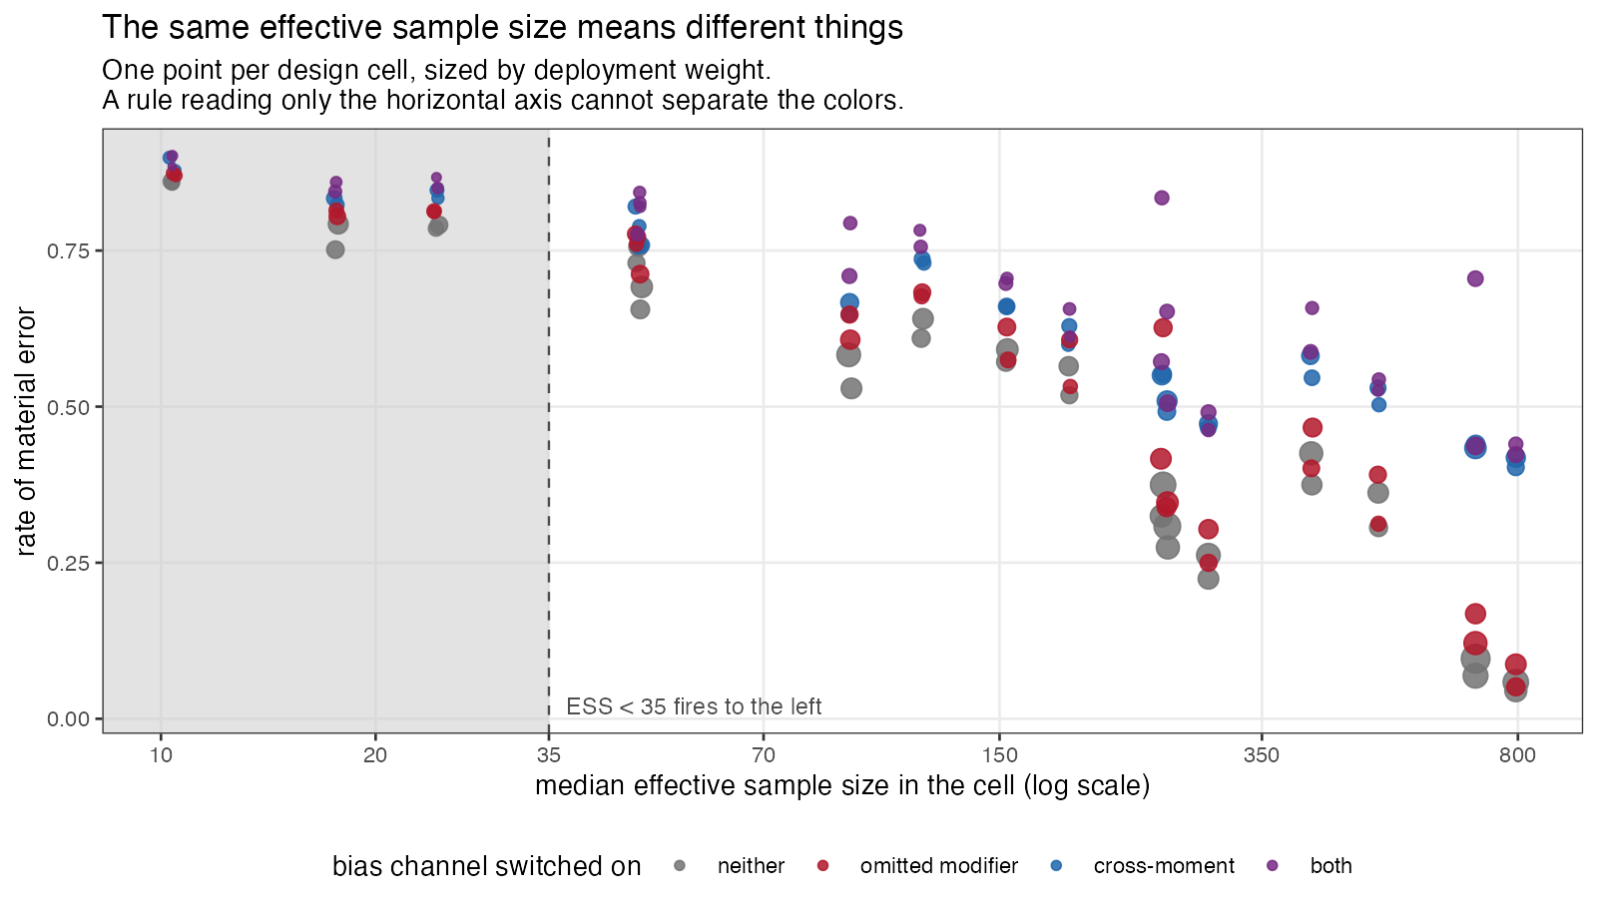
Figure 1
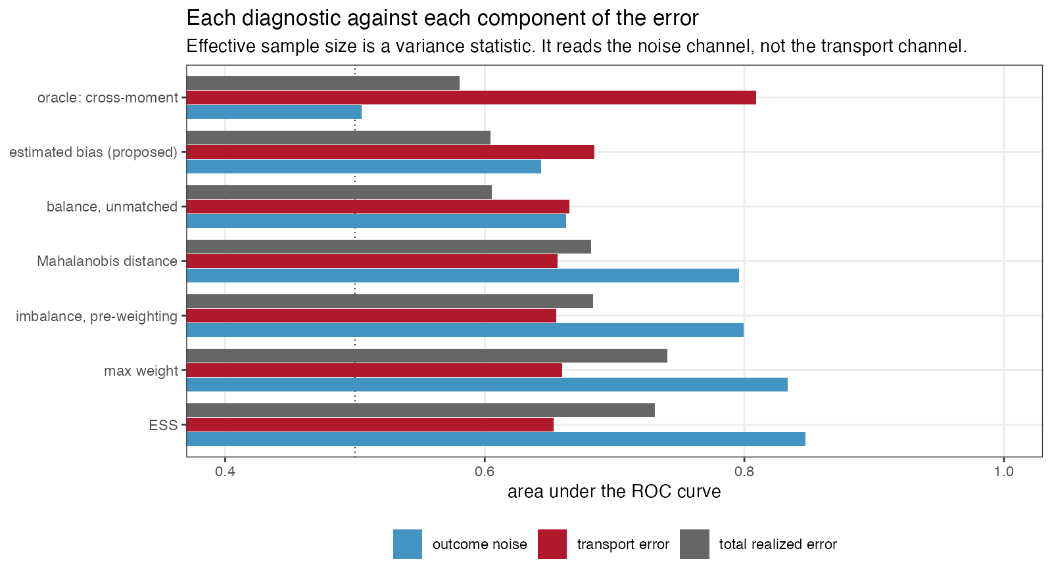

5.8 The other estimators
Table 11: The same replicates seen by the other three estimators. Median effective sample size is over the whole design.
method | diagnostic | AUROC | vs transport | material error | median ESS | coverage
MAIC, means only | ESS | 0.704 | 0.599 | 0.433 | 261.783 | 0.730
MAIC, means only | imbalance before weighting | 0.685 | 0.607 | 0.433 | 261.783 | 0.730
MAIC, means only | Mahalanobis distance | 0.683 | 0.608 | 0.433 | 261.783 | 0.730
MAIC, means only | balance, unmatched covariate | 0.602 | 0.624 | 0.433 | 261.783 | 0.730
MAIC, means only | estimated bias (proposed) | 0.602 | 0.641 | 0.433 | 261.783 | 0.730
STC | imbalance before weighting | 0.656 | 0.635 | 0.340 | 550.000 | 0.533
STC | Mahalanobis distance | 0.655 | 0.636 | 0.340 | 550.000 | 0.533
STC | balance, unmatched covariate | 0.606 | 0.619 | 0.340 | 550.000 | 0.533
STC | estimated bias (proposed) | 0.611 | 0.628 | 0.340 | 550.000 | 0.533
no adjustment | imbalance before weighting | 0.804 | 0.891 | 0.596 | 550.000 | 0.357
no adjustment | Mahalanobis distance | 0.804 | 0.891 | 0.596 | 550.000 | 0.357
no adjustment | balance, unmatched covariate | 0.802 | 0.892 | 0.596 | 550.000 | 0.357
no adjustment | estimated bias (proposed) | 0.798 | 0.873 | 0.596 | 550.000 | 0.357

Table 12: Coverage of the nominal 95% interval, over the whole design. Added after round one of review, which noted that the primary estimator’s coverage was missing.
 | method | transported effect | anchored contrast | fitted
maic | MAIC, means and SDs | 0.748 | 0.774 | 0.993
maic_mean | MAIC, means only | 0.730 | 0.773 | 1.000
stc | STC | 0.533 | 0.609 | 1.000
unadj | no adjustment | 0.357 | 0.428 | 1.000

No estimator here covers at nominal. MAIC reaches 0.748 on the transported effect over a design that contains a great deal of deliberate misspecification, and the sandwich contributes its own shortfall at small effective sample size, which is the failure Remiro-Azócar and colleagues documented for the variance estimator used in their study (6). That is context for the diagnostic results rather than a finding about the estimators: an interval that misses is one of the things a diagnostic might be asked to predict, and Table 2 reports discrimination against non-coverage as well.
The unadjusted comparison is the control that explains the rest of the paper. Its pre-weighting imbalance statistic predicts its own transport error at AUROC 0.891, against 0.655 for the same statistic applied to MAIC. The statistic is not weak. It is an excellent measure of the gap between the two populations, and the gap between the two populations is exactly the error of an estimator that does nothing about it. Once weighting has closed those gaps, the statistic is measuring something that has been removed, and what remains is the part of the modifier structure the weights never touched. The diagnostic is informative about the problem and uninformative about the solution.
Means-only MAIC is worth a line for the same reason. It carries a median effective sample size of 261.783 against 170.748 for the version that also matches standard deviations, and a lower material-error rate, 0.433 against 0.479. Calibrating second moments that the modifier structure does not use costs effective sample size and buys nothing here. A reader should not generalize that: with a modifier that is nonlinear in the covariates, those moments would matter.

6. What this answers, and what it does not
DIA-03. The entry asked for the routine panel to be scored as a classifier of realized error with discrimination and calibration against a known truth, under a specified scenario distribution and a prespecified material-error threshold. That is done, for the MAIC weighting panel and the overlap statistics it shares with STC. The second half of the entry, the mismatch between the hierarchical level at which cross-validation is reported and the level at which the prediction is made, is untouched: no PSIS-LOO is computed at any level here, and grouped study-level leave-one-out is no more implemented in this study than it is in the packages. That half remains open.
DIA-06. Answered in part, and the part is small. Four estimators from two families see the same replicates, so their failure modes can be compared on identical data; but ML-NMR, NMI, doubly robust estimators and flexible learners are absent, and the entry names five families. A design critique made this point before the run and it is accepted rather than argued with.
What the mechanism deliberately makes true. Randomization holds. The prognostic and modifier functions are shared across trials, so conditional constancy holds. Covariates are normal. The link is the identity. Target moments are exact, because study 1 of this program already measured what their sampling error costs and carrying it here would add a noise channel no source-side diagnostic can observe. Every estimator adjusts for the same covariates.
Therefore the study says nothing about non-collapsible effect measures, time-to-event outcomes, skewed or discrete covariates, unanchored comparisons, target-moment sampling error, or the diagnostics specific to Bayesian population adjustment. A binary or survival outcome would add a component of error that is a collapsibility artifact rather than an adjustment failure, and the exact decomposition in Section 2 would not be available; that is the price paid for the instrument, and it is the largest limitation here.
The deployment weights are a judgment, not a measurement. Nothing in this program estimated how often an effect modifier is omitted in practice. That is why the primary results are within strata and why every mixture-level figure is reported under two weightings. Reporting within strata removes the dependence on the misspecification frequencies only. The design points themselves, the overlap levels, the sample sizes, the dispersion ratio, the magnitude of the modifier coefficients, and equal weighting of cells inside a stratum are all still ours, and every operating characteristic in this paper is a property of that distribution rather than an intrinsic property of a diagnostic. An earlier draft said the stratum reporting removed the dependence “entirely”; it does not.
Extensions this study does not attempt, each named because a reviewer asked for it. Heteroskedastic outcome errors, which would loosen the tie between weight dispersion and the noise channel. Multiple omitted modifiers, or one entering nonlinearly, which is where converting imbalance into effect units should beat a plain balance check and where this design cannot show it. Target moments carrying their own sampling error, measured separately in study 1 of this program. Cross-fitting the interaction that the proposed diagnostic uses, which would remove the in-sample optimism we have instead disclosed. And a design in which the target mean is displaced by different amounts in different covariates: here the displacement is common, which is why the maximum standardized difference and the Mahalanobis distance agree to three decimals throughout and cannot be told apart.
The transport component is not pure bias. It is the realized effect-modifier component of one replicate, containing finite-sample source composition and allocation variation as well as systematic transport bias. Scoring against it answers “can the panel see the part of this analysis’s error that came from the covariate structure”, which is the question here, and not “can the panel see the expected bias of this cell”, which would need a per-cell Monte Carlo expectation and is a different analysis.
The proposal is ours, and it is not compared on an equal footing. uses the source outcomes, through a treatment-by-covariate interaction estimated in the same sample whose error is being diagnosed, while every routine diagnostic in the panel is an outcome-free function of covariates and weights. It is therefore an outcome-model-assisted diagnostic and should be read as one; a reviewer was right that comparing it with the panel without saying so overstates it. Estimating the interaction in-sample also invites optimism that cross-fitting would remove and that we did not do. It missed its registered bar, the plain balance check on unmatched covariates does about as well in this design, and the practical recommendation that survives is the plain one.
The verdict is about cutoffs, not about the statistics. “The panel does not classify realized error at the thresholds in use” is a registered label, and what it means precisely is that no evaluated fixed cutoff met a sensitivity and specificity pair chosen in advance. Those requirements were not derived from an elicited loss function. The statistics do carry information, effective sample size calibrates tolerably out of cell, and a reader who wants a different operating point can take one off the ROC curves. What the decision-curve analysis adds is that at the action thresholds a cautious analyst would use, none of the available operating points beats scrutinizing everything.

7. Peer review
This manuscript was reviewed by three independent reviewers over two rounds. The reports, the authors’ responses and the editorial decision are published in full and unedited alongside it.

8. Reproducibility
All code is in the study directory. R/00-config.R holds the design, the thresholds and the decision rule; R/01-dgm.R the mechanism; R/02-estimators.R the four estimators and the exact error decomposition; R/03-diagnostics.R the panel; R/04-run.R the run; R/05-analyze.R the analysis; R/06-figures.R the figures. Replicates are seeded from one master seed through independent L’Ecuyer-CMRG streams, so a replicate draws the same data whatever the core count. results/provenance.md records the R version and package versions that produced these numbers. Raw replicate output is regenerable from the seed and is not tracked; the tracked artifacts are the summary tables, the figures and the rendered manuscript.

References
1. David M. Phillippo, A. E. Ades, Sofia Dias, Stephen Palmer, Keith R. Abrams, Nicky J. Welton. Methods for population-adjusted indirect comparisons in health technology appraisal. Medical Decision Making. 2018;38(2):200–11. doi:10.1177/0272989X17725740
2. Elizabeth A. Stuart, Stephen R. Cole, Catherine P. Bradshaw, Philip J. Leaf. The use of propensity scores to assess the generalizability of results from randomized trials. Journal of the Royal Statistical Society Series A. 2011;174(2):369–86. doi:10.1111/j.1467-985X.2010.00673.x
3. Elizabeth Tipton. How generalizable is your experiment? An index for comparing experimental samples and populations. Journal of Educational and Behavioral Statistics. 2014;39(6):478–501. doi:10.3102/1076998614558486
4. MSR65 can low effective sample size in matching-adjusted indirect comparisons (MAICs) lead to bias? Findings from a simulation study [Internet]. ISPOR Europe 2024, abstract published in Value in Health; 2024. Available from: https://www.valueinhealthjournal.com/article/S1098-3015(24)05162-3/fulltext
5. Leslie Kish. Survey sampling. New York: Wiley; 1965.
6. Antonio Remiro-Azócar, Anna Heath, Gianluca Baio. Methods for population adjustment with limited access to individual patient data: A review and simulation study. Research Synthesis Methods. 2021;12(6):750–75. doi:10.1002/jrsm.1511
7. Tim P. Morris, Ian R. White, Michael J. Crowther. Using simulation studies to evaluate statistical methods. Statistics in Medicine. 2019;38(11):2074–102. doi:10.1002/sim.8086
8. James G. MacKinnon, Halbert White. Some heteroskedasticity-consistent covariance matrix estimators with improved finite sample properties. Journal of Econometrics. 1985;29(3):305–25. doi:10.1016/0304-4076(85)90158-7
9. Leonard A. Stefanski, Dennis D. Boos. The calculus of m-estimation. The American Statistician. 2002;56(1):29–38. doi:10.1198/000313002753631330
10. Peter C. Austin, Ewout W. Steyerberg. The integrated calibration index (ICI) and related metrics for quantifying the calibration of logistic regression models. Statistics in Medicine. 2019;38(21):4051–65. doi:10.1002/sim.8281
11. Andrew J. Vickers, Elena B. Elkin. Decision curve analysis: A novel method for evaluating prediction models. Medical Decision Making. 2006;26(6):565–74. doi:10.1177/0272989X06295361

