Node splitting reads a population difference as inconsistency unless the split is adjusted
A simulation study answering catalog problem HET-04
Ahmad Sofi-Mahmudi
2026-09-23

Abstract
Background. Node splitting compares direct and indirect evidence for a contrast. If the studies supplying the two paths differ in an effect modifier, the difference arrives as inconsistency. Catalog problem HET-04 asks how often the unadjusted split flags a population difference or misses a real conflict that the difference cancels.
Methods. Triangle networks with two or four studies per comparison, a covariate gap of 0, 0.5 or 1 SD between the direct and indirect study sets, modification 0, 0.2 or 0.4 and true loop inconsistency of −0.2, 0 or 0.2: 54 scenarios, 2000 replicates each. Unadjusted node split against a meta-regression-adjusted split with a loop-specific inconsistency term.
Results. With no true inconsistency the unadjusted split flagged 0.141 to 0.982 of analyses where populations differed, and the adjusted split 0.041 to 0.058. Where the gap cancelled a real inconsistency the unadjusted split flagged 0.058 to 0.105, its null rate, and the adjusted split up to 0.254. Adjustment cost precision: its SE for the inconsistency rose from 0.099 to 0.302 as the gap grew, because the inconsistency and the interaction are separated only by the covariate spread within each study set.
Conclusion. An unadjusted node split tests a composite of inconsistency and population mismatch. Adjust the split for the modifiers whose distribution differs between the paths; its power then falls with the gap, which should be reported.

1. The problem
Under linear modification the node-split statistic (1) is . With it is the population mismatch; with a real conflict disappears. An adjusted split estimates the interaction from the study-level covariates and the inconsistency beyond it.

2. Design
Registered protocol: protocol.md; ADEMP structure (2). Study estimates with SE 0.1; AB and AC studies with covariate means , BC studies . C’s effect against A is modified by with consistent interactions; BC studies carry . Both splits at .

3. Results
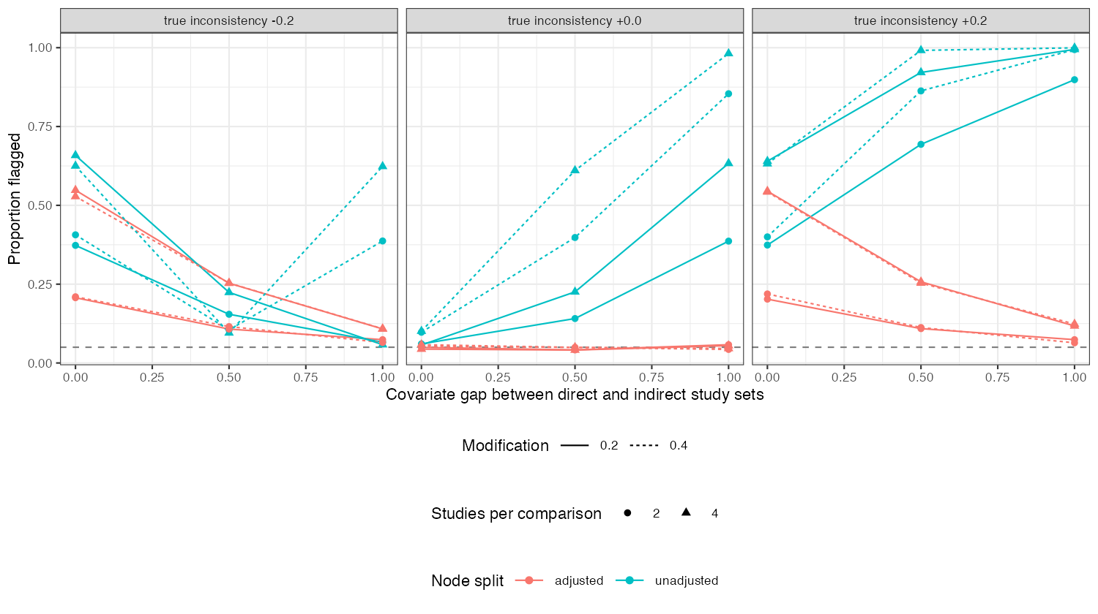
Figure 1: Proportion flagged by the unadjusted and adjusted node splits by covariate gap, for each true inconsistency.
The unadjusted flag rate followed (Figure 1): it rose with the gap when inconsistency was absent or had the same sign, and fell to the null rate when they cancelled. It was above nominal even with no gap (0.101), because study-level covariate variation under modification adds between-study heterogeneity that a fixed-effect split ignores. The adjusted split held nominal size throughout, and its power against an inconsistency of 0.2 fell from 0.542 with no gap to 0.123 with a gap of 1.

4. What this does not answer
Continuous study estimates, so the marginal and conditional inconsistency factors coincide and marginalization to a named target was not needed; one loop; no Bayesian node split. Peer review has not been done.

References
1. Sofia Dias, Nicky J. Welton, Deborah M. Caldwell, A. E. Ades. Checking consistency in mixed treatment comparison meta-analysis. Statistics in Medicine. 2010;29(7-8):932–44. doi:10.1002/sim.3767
2. Tim P. Morris, Ian R. White, Michael J. Crowther. Using simulation studies to evaluate statistical methods. Statistics in Medicine. 2019;38(11):2074–102. doi:10.1002/sim.8086

