A hazard-ratio bias does not translate into a fixed RMST bias
A numerical study answering catalog problem QBA-24
Ahmad Sofi-Mahmudi
2026-09-23

Abstract
Background. Bias analyses for population-adjusted survival comparisons are usually stated on the hazard-ratio scale, while decisions use restricted mean survival time (RMST). Catalog problem QBA-24 asks whether a hazard-scale bias can be reinterpreted as a proportional RMST bias.
Methods. Population-level calculation: four baseline hazard shapes (constant, increasing, decreasing, bathtub), each at 80%, 50% or 20% survival by 24 months, multiplied by bias hazard ratios of 1.1 to 2. The change in RMST at 24 months was compared across shapes and with the first-order (proportional) prediction.
Results. At the same survival by 24 months and the same bias, RMST changed by up to 1.44 times as much for one baseline shape as another (decreasing against increasing hazard). The proportional prediction understated the change by about 26% at 80% survival and a bias hazard ratio of 2, and was off by -1% to +8% at 20% survival, where RMST saturates.
Conclusion. The RMST consequence of a hazard-scale bias depends on the baseline hazard’s shape and the event level, so a hazard-ratio sensitivity analysis cannot be read on the RMST scale without the baseline curve. State the bias on the decision scale, or translate it with the target’s baseline survival.

1. The problem
With , RMST over (1) changes by . Its first-order slope in is , which weights the cumulative hazard by survival and so depends on when events occur. Beyond first order the change is convex in when events are few and saturates when most patients have an event within the window.

2. Design
Registered protocol: protocol.md. Cumulative hazards with , and for the bathtub shape, set for the survival level. Integrals by adaptive quadrature.

3. Results
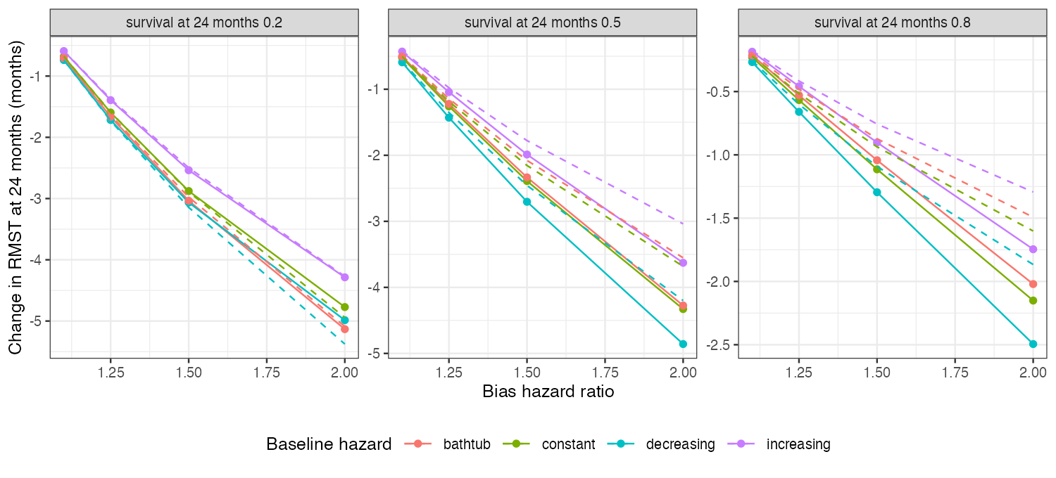
Figure 1: Change in RMST at 24 months against the bias hazard ratio, by baseline hazard shape and survival level. Dashed lines are the proportional (first-order) predictions.
A decreasing hazard concentrates events early, where each extra unit of hazard removes more remaining time, so the same bias moved RMST most; an increasing hazard moved it least (Figure 1). The spread across shapes was largest when events were fewest. The direction of the proportional prediction’s error depended on the event level: convexity dominated with few events and saturation with many, so no single correction factor applies.

4. What this does not answer
Only the translation from a hazard-scale bias to RMST. The unanchored comparison with an unmeasured confounder, pseudo-IPD and curve-based estimation, reconstruction error and tipping sets were not run. Peer review has not been done.

References
1. Patrick Royston, Mahesh K. B. Parmar. Restricted mean survival time: An alternative to the hazard ratio for the design and analysis of randomized trials with a time-to-event outcome. BMC Medical Research Methodology. 2013;13:152. doi:10.1186/1471-2288-13-152

