An MNAR shift moved an anchored transported contrast in a direction that differed from dataset to dataset, but the tipping set was almost always one interval
A simulation study answering catalog problem CMP-21
Ahmad Sofi-Mahmudi
2026-09-23

Abstract
Background. A missing-not-at-random (MNAR) shift in imputed effect-modifier values enters a transported comparison through each trial’s fitted interaction, through the covariate law used for integration, and through differences in missingness that an anchor would otherwise cancel. Catalog problem CMP-21 asks whether these routes can offset and whether the tipping point of a sensitivity analysis is then still a single value.
Methods. Two individual-data trials anchored through a common control, the modifier missing not at random in 30% of patients in one and 30% or 10% in the other, imputation plus a sensitivity shift from to , and outcome-regression transport to a target; 500 replicates per cell with common random draws across the shift.
Results. The tipping set (shifts that reverse the estimate’s sign) was a single interval in 96% or more of replicates; the registered rate of non-single sets was 0.030 to 0.044, under the 5% threshold. The routes did offset on average: the mean slope of the estimate against the shift was -0.004 to 0.030. But in single datasets the slope’s SD was 0.103 to 0.144 and its sign was positive in 48% to 62% of them, so the direction in which an MNAR departure moves the contrast was not predictable from the design. The decision reversed somewhere in the range in 29% to 30% of replicates.
Conclusion. A single tipping point was adequate here, but a sensitivity analysis must explore both directions of the shift: the anchor cancels the routes only on average.

1. The problem
In an anchored comparison both trials’ estimates move with a common MNAR shift, and the contrast differences the movements away if they are equal. They are equal only in expectation, and only if missingness is the same in both trials. The integration law, when built from the completed data, adds a third route. If the routes offset, the contrast can be flat or non-monotone in the shift, and a single tipping point can understate the region of concern.

2. Design
Registered protocol: protocol.md; ADEMP (1). Trials of A versus C and B versus C, 300 per arm, , . is missing with probability . Imputation by normal regression of on outcome, arm and their product in complete cases, plus the shift ; one imputation, common random draws across in steps of 0.1. Each trial is standardized by G-computation to a target with or from the completed data. Estimand: marginal log odds ratio B versus A (truth -0.165).

3. Results
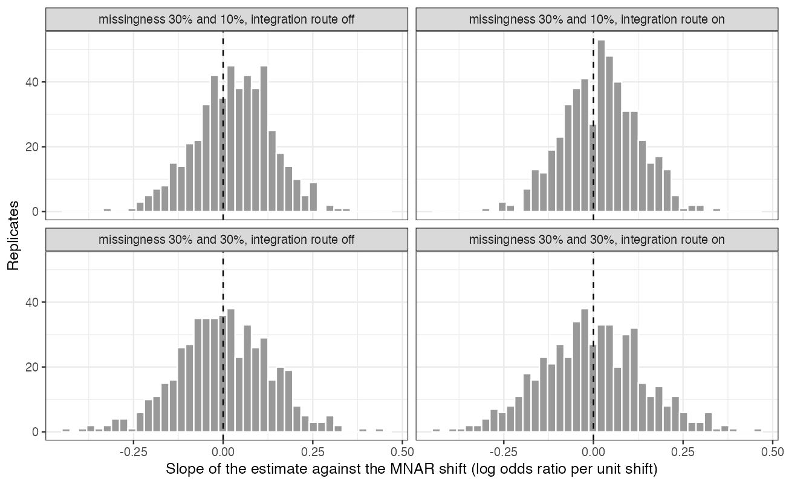
Figure 1: Per-replicate slope of the transported contrast against the MNAR shift.
Table 1: 500 replicates per cell.
missingness trial 2 | integration route | tipping set not one interval | decision reverses somewhere | mean slope | slope positive | curve moves under 0.05 | bias at
30% | off | 0.044 | 0.288 | -0.000 | 50% | 0.034 | -0.011
10% | off | 0.036 | 0.292 | 0.030 | 62% | 0.064 | -0.030
30% | on | 0.042 | 0.300 | -0.004 | 48% | 0.034 | -0.022
10% | on | 0.030 | 0.286 | 0.020 | 59% | 0.032 | -0.027

The registered primary did not confirm non-unique tipping sets: at most 4% of replicates had more than one reversal interval (Table 1). Because a curve flat to within 0.05 occurred in up to 6% of replicates with differing missingness, the registered branch is cancellation without non-unique tipping sets. The more useful result is Figure 1: the per-replicate slope was centered near zero and spread widely in both directions, with differing missingness shifting its center only slightly. The registered non-monotonicity count (any sign change in successive differences) exceeded 75% in every cell, but it counts sub-0.01 wiggles from refitting and is not interpretable as substantive non-monotonicity.

4. What this does not answer
Two anchored individual-data trials rather than a disconnected component network; one imputation per shift; a congenial imputation model; one MNAR mechanism; the tipping set defined by the point estimate’s sign, not by an interval. Peer review has not been done.

References
1. Tim P. Morris, Ian R. White, Michael J. Crowther. Using simulation studies to evaluate statistical methods. Statistics in Medicine. 2019;38(11):2074–102. doi:10.1002/sim.8086

