Splitting a multi-arm trial’s adjusted contrasts is conservative for one contrast and anticonservative for another
A simulation study answering catalog problem CMP-12
Ahmad Sofi-Mahmudi
2026-09-23

Abstract
Background. When a three-arm trial’s contrasts are population-adjusted, they share an arm and a weight vector, so their estimates are correlated. Catalog problem CMP-12 asks what is lost when they are treated as independent, as splitting the trial into pairwise comparisons does, and its design predicted that the error could have either sign depending on how the arms’ effect modification aligns.
Methods. A three-arm individual-data trial (A, B, C) weighted by MAIC to a target, with two aggregate trials (A versus C, B versus C) in the target. Thirty scenarios crossed effect-modification strength, its alignment across arms, target shift and the shared arm’s size, 1000 replicates each. The pair was given zero covariance (split), a joint sandwich with fixed weights, or a stacked sandwich over weights and arm means; networks were fitted by generalized least squares; dropping the trial was the fourth option.
Results. Ignoring the covariance made the trial’s own interval conservative in every scenario (coverage 0.957 to 1.000) and the network interval anticonservative (coverage below nominal beyond Monte Carlo error in 15 of 30 scenarios, against 0 for the stacked sandwich). The shared-weighting part of the covariance took both signs, -22% to 15% of the total, but never changed which way a contrast erred. Dropping the trial widened the network interval by 29% to 91%.
Conclusion. The sign of the error from ignoring within-trial covariance is set by the contrast, not by effect-modification alignment: a difference of the two contrasts gains, a network contrast that borrows through them loses. A joint sandwich is enough; dropping the trial is unbiased but costs precision a decision would notice.

1. The problem
For a trial with arms A, B, C adjusted with one weight vector, has a shared-arm term, , and a term from estimating the shared weights. For the within-trial , the variance is , so a positive covariance set to zero overstates it. In a network, the same pair is combined with other evidence by generalized least squares; treating the pair as independent counts arm A twice and gives the trial too much weight, which understates the variance of contrasts that borrow through it. DESIGN.md predicted instead that the error’s sign depends on the alignment of the arms’ effect modification, through the weighting term.

2. Design
Registered protocol: protocol.md. Source , 200 per arm in B and C and in A; with and ; MAIC with one weight vector to . Aggregate A-versus-C and B-versus-C trials of 200 per arm run in the target. Factors: for B and C; alignment ; ; . Truths in closed form. The Monte Carlo covariance of the trial’s pair is the reference for each method’s estimated covariance.

3. Results
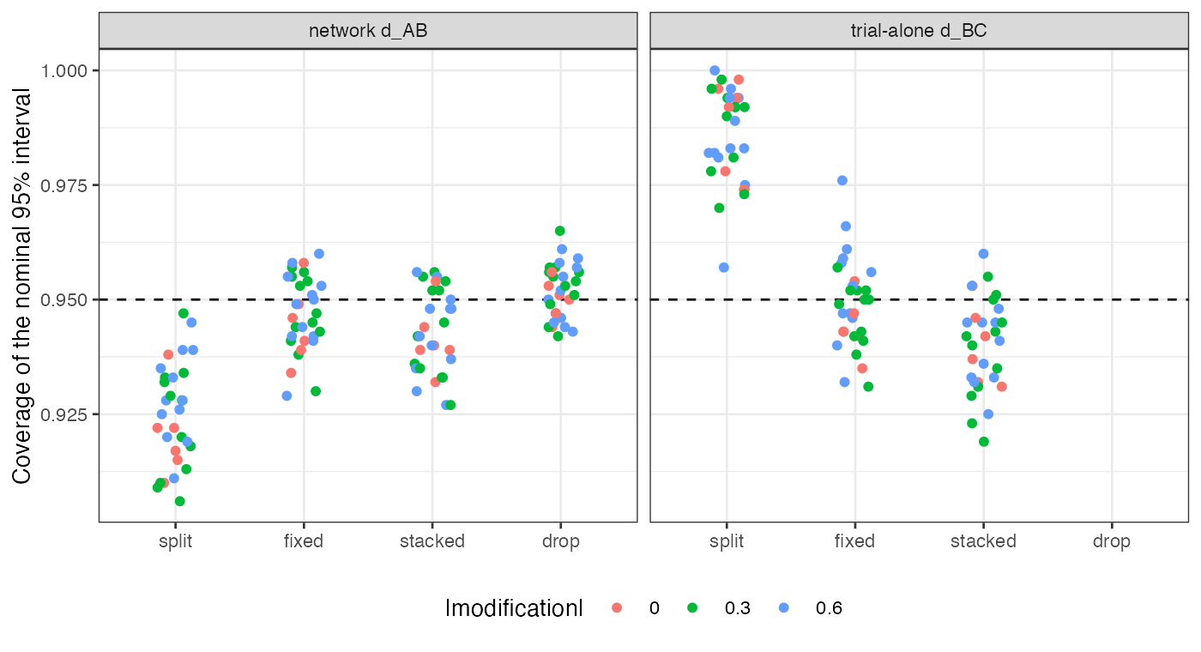
Figure 1: Coverage by method for the network A-versus-B contrast and the trial-alone B-versus-C contrast, one point per scenario.
The within-trial difference. With the covariance set to zero, the trial’s interval covered in 0.957 to 1.000, above nominal beyond three Monte Carlo standard errors in 29 of 30 scenarios and below it in none (Figure 1). The registered sign test, which required overcoverage in some scenarios and undercoverage in others, therefore withdraws DESIGN.md’s prediction.
The network contrast. In the network, is estimated from the trial’s pair and from the aggregate trials together. Splitting lowered its coverage by 0.004 to 0.037 relative to the stacked sandwich, taking it below nominal beyond Monte Carlo error in 15 scenarios.
The weighting term. Stacked minus fixed-weight covariance was -22% to 15% of the Monte Carlo covariance, positive in some scenarios and negative in others, as DESIGN.md said. It was dominated by the shared-arm term, so it never reversed a contrast’s direction of error. Both joint sandwiches recovered 0.762 to 1.153 (stacked) of the Monte Carlo covariance, and the stacked trial-alone intervals undercovered slightly (0.919 to 0.960), the usual small-sample shortfall of a sandwich with estimated weights.
Dropping the trial was unbiased and widened the network interval by 29% to 91% (median 53%), beyond the registered 10% materiality in every scenario.

4. What this does not answer
Continuous outcome and linear modification; one three-arm trial and a fixed two-trial aggregate network; no four-arm trials, no one-stage ML-NMR comparator and no bootstrap, whose whole-trial resampling the stacked sandwich approximates. The target moments are treated as fixed. Peer review has not been done.

References

