Reconstructing a target covariate from a median: when the mean is enough and when it is not
A simulation study answering catalog problem COV-12
Ahmad Sofi-Mahmudi
2026-09-23

Abstract
Background. Integration-based population adjustment needs the target’s whole covariate marginal, and publications often report a skewed covariate as a median with interquartile range or range. Catalog problem COV-12 asks whether the error this puts into the transported contrast is controlled by the error in the reconstructed mean, which is what median-to-mean estimators minimize.
Methods. A known conditional model was integrated over reconstructed target marginals so that reconstruction was the only error. Seventy-two scenarios crossed the link (identity, logit), skewness (none, moderate, strong), the reported summary (median with IQR or with range), target size (50, 200, 1000) and effect modification, 1000 replicates each. Reconstructions: a normal law with Wan et al.’s mean and SD (1), and a shifted lognormal matched to the reported quantiles.
Results. Under the identity link, contrast error equaled the modification coefficient times the mean error exactly (slope 1.000, 1.000). Under the logit link it did not ( 0.597). With strong skew and a reported range, the normal reconstruction biased the contrast by 1.145 (identity) and 0.426 (logit) at 200 patients, and the bias grew with sample size because the range does. The quantile-matched lognormal kept every bias within 0.092.
Conclusion. The mean is the right target for a collapsible, linear adjustment and the wrong one for a curved link, where the variance and shape of the reconstruction also reach the estimate. For a skewed covariate reported with a range, a normal reconstruction is badly wrong; a reconstruction that respects the asymmetry of the reported quantiles is not.

1. The problem
For a reconstructed marginal , the contrast error is . With an identity link and linear , it is : only the mean matters. With a logit link the marginal contrast integrates a nonlinear function, so the reconstruction’s variance and higher moments enter. Reporting a median with a range is itself a signal of skew, which is where a normal reconstruction’s shape is wrong.

2. Design
Registered protocol: protocol.md. The target covariate is lognormal with log-SD 0, 0.5 or 1, rescaled to mean 1 and SD 1. Conditional A-versus-C effect with prognostic slope 0.8, on the identity or logit scale (logit baseline ), , held known. Truth integrates over 2000 quantiles of the true law. A third arm integrates over the target’s own sample, the floor for any reconstruction; the registered regression uses errors net of that floor. After registration, the regressor was corrected to measure mean error against the sample mean; two completed cells were discarded unread (see protocol.md).

3. Results
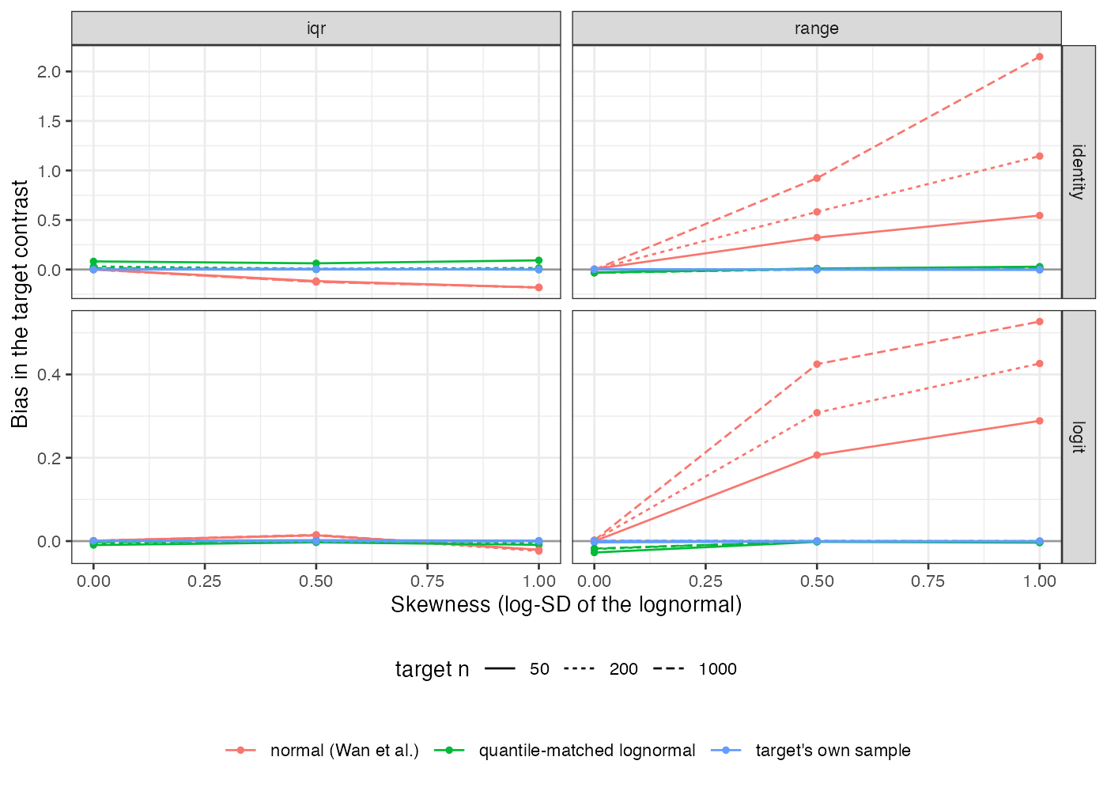
Figure 1: Bias in the target contrast by skewness, reported summary and link (\beta = 0.8).
The registered test separates the two links: the refuting sentence holds under the identity link and fails under the logit link. Under the identity link the normal reconstruction’s bias is entirely its biased mean, which reaches -0.123 with moderate skew and an IQR and 2.150 with strong skew, a range and 1000 patients (Figure 1). Under the logit link the contrast is less sensitive to the mean but carries errors the mean does not explain. The lognormal reconstruction’s bias stayed within 0.092 in every scenario. It is not free without skew: sampling asymmetry in the reported quantiles triggers it, and its bias there reached 0.082 against 0.005 for the normal reconstruction.

4. What this does not answer
One covariate with a known conditional model; in practice the outcome model is also estimated and a multivariate marginal needs a dependence structure (CMP-15). The lognormal matcher suits right skew; other shapes, bounded scales and bimodality are not tested. ML-NMR integration is represented by direct integration over the reconstructed law. Peer review has not been done.

References
1. Xiang Wan, Wenqian Wang, Jiming Liu, Tiejun Tong. Estimating the sample mean and standard deviation from the sample size, median, range and/or interquartile range. BMC Medical Research Methodology. 2014;14:135. doi:10.1186/1471-2288-14-135

