An infeasible MAIC is signaled by its own balance table, not by its effective sample size
A simulation study answering catalog problem OVL-02
Ahmad Sofi-Mahmudi
2026-09-23

Abstract
Background. Method-of-moments MAIC has a solution only if the target mean lies in the convex hull of the source covariates (1). Without one, the optimizer returns weights that satisfy nothing. Catalog problem OVL-02 asks whether this is signaled, and whether a low effective sample size is the signal.
Methods. Binary-outcome MAIC with 3 or 8 covariates, the target shifted so that 0% to 90% of source samples were infeasible by linear program, with and without effect modification; 24 scenarios, 1000 replicates each. Detectors: Kish ESS, maximum weight, the residual imbalance of the returned weights, and the optimizer’s convergence code.
Results. The residual imbalance separated infeasible from feasible calibrations almost perfectly (AUROC 1.000; above in 0.999 of infeasible and 0.001 of feasible analyses). The optimizer reported convergence on 17% of infeasible problems. ESS ranked analyses well (AUROC 0.996) but the conventional reading, ESS below 10% of , flagged every infeasible analysis and 73% of feasible ones near the hull boundary. Near the boundary feasible analyses were themselves unreliable, with coverage 0.617 to 0.853.
Conclusion. Infeasibility is decidable and already visible: the balance of the returned weights on the matched moments is zero at any solution and bounded away from zero without one. Balance tables should be computed from the returned weights, not assumed; a threshold on ESS cannot tell “impossible” from “hard”.

1. The problem
MAIC minimizes . If lies outside the convex hull of the , there is a direction in which every term decreases, the objective has no minimizer, and a quasi-Newton routine drifts until a tolerance stops it. The returned weights then put almost all mass on the few rows nearest the target and match nothing. Our DIA-03 study found post-weighting balance on matched moments identically zero; that holds only when a solution exists. The catalog’s refuting sentence is that infeasibility is rare and yields an ESS low enough that existing conventions catch it.

2. Design
Registered protocol: protocol.md. Source trial of 400 with independent normal covariates; target mean at distance along the equal-weight direction, with set by probe to give 10%, 30%, 50%, 70% and 90% infeasibility (results/shifts.csv), plus a feasible-with-margin shift of 1.5. Binary outcome with prognostic coefficient 0.4 per covariate and modification 0 or 0.5 on . Feasibility by linear program (Rglpk).

3. Results
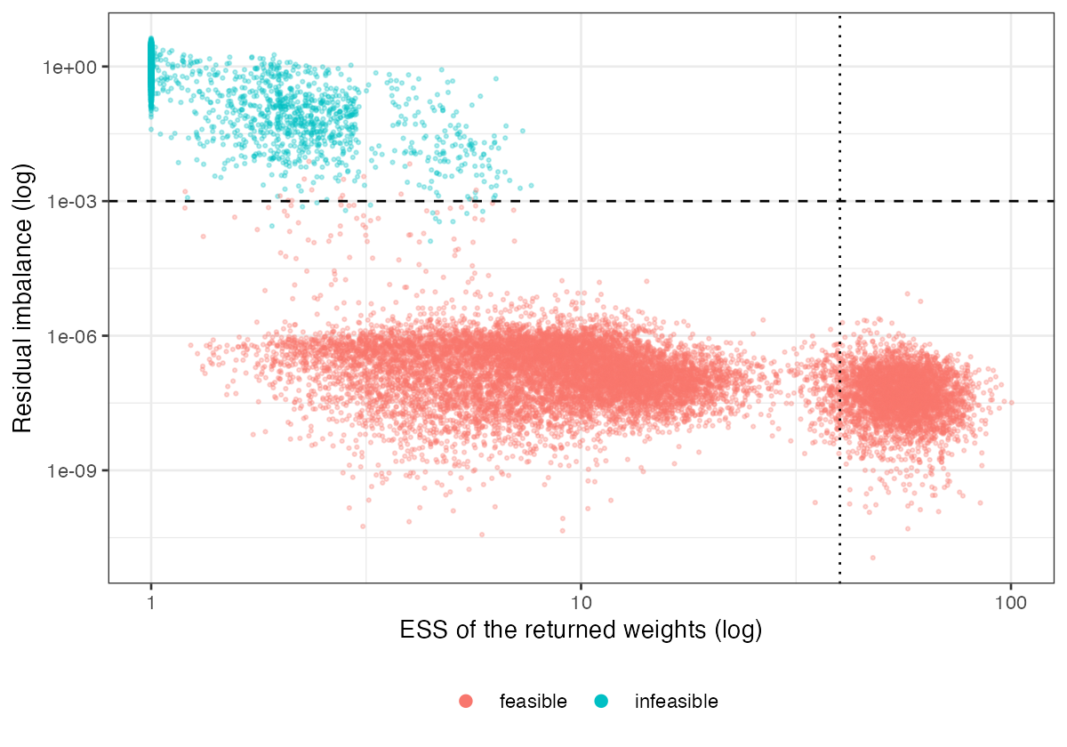
Figure 1: Each replicate’s ESS against its residual imbalance. The dashed line is the 0.001 residual threshold; the dotted line is ESS at 10% of n.
The two detectors carry different information (Figure 1). Residual imbalance is effectively binary: at most about for feasible analyses and at least for infeasible ones. ESS is continuous and small on both sides of the boundary: median ESS was 3.037 to 14.279 for feasible and about 1 for infeasible analyses. Silent failure depended on dimension: the optimizer reported convergence on 0% to 8% of infeasible problems in three dimensions and 22% to 34% in eight. Infeasible analyses produced no usable estimate or an absurd one; feasible analyses close to the boundary undercovered badly, so passing the feasibility check is necessary, not sufficient.

4. What this does not answer
Feasibility of the mean constraint only; a feasible calibration can still correspond to a target joint law with no support in the source, which published marginals cannot reveal. Normal covariates, MAIC on means, one sample size. The computability taxonomy of the proposed diagnostics in DESIGN.md is analytic and was not simulated. Peer review has not been done.

References
1. Ekkehard Glimm, Lillian Yau. Geometric approaches to assessing the numerical feasibility for conducting matching-adjusted indirect comparisons. Pharmaceutical Statistics. 2022. doi:10.1002/pst.2210

