Planning a MAIC from the estimator’s influence function, not from n or Kish ESS
A simulation study answering catalog problem OVL-06
Ahmad Sofi-Mahmudi
2026-09-23

Abstract
Background. A MAIC’s precision depends on overlap, the balancing constraints, the outcome and the allocation, not on nominal sample size alone. Catalog problem OVL-06 asks whether a precision calculation made before any data exist can predict what the analysis will achieve.
Methods. For each of 72 scenarios (total size 150 to 1000, target shift, 2 or 5 covariates, 1:1 or 2:1 allocation, event prevalence 0.1 or 0.3) we computed three planned standard errors from the posited source and target laws: nominal ; replaced by each arm’s Kish ESS; and the estimator’s influence-function variance, evaluated on a large draw from the posited laws. Each was compared with the standard deviation MAIC achieved over 1000 replicates.
Results. The influence-function plan was within 10% of the achieved SD in 85% of scenarios (median ratio 0.963), Kish ESS in 58% (median 0.912), nominal in 21% (median 0.797). The Kish plan understated the achieved SD in 99% of scenarios. Every miss of the influence-function plan was at 150 patients with 10% prevalence, where the asymptotic variance does not yet hold.
Conclusion. Planning in Kish ESS is optimistic, not pessimistic, and misses by more than 10% in four scenarios of ten. The estimator’s own influence function, which a planner can evaluate at posited distributions, predicts achieved precision within 10% except where events are too few for any asymptotic calculation.

1. The problem
Kish’s ESS is a functional of the weights alone; it ignores allocation, outcome variance and the estimation of the weights, and it is recorded as likely an underestimate of the true effective sample size (1). The variance of a weighted estimator is for its influence function , which carries all of those things, and it can be computed from posited source and target laws before any data exist. The catalog’s refuting sentence is that nominal with a crude overlap adjustment predicts achieved precision well enough for planning.

2. Design
Registered protocol: protocol.md. Individual-data trial A versus C with independent normal covariates; binary outcome ; MAIC on means to a target at Mahalanobis distance . Estimand: the SD of the MAIC estimate of the marginal log odds ratio, achieved over 1000 replicates. Plans: nominal, ; Kish, the same with multiplied by the arm’s population ESS fraction; influence function, the stacked sandwich over weights and arm risks evaluated on 100,000 draws from the posited laws.

3. Results
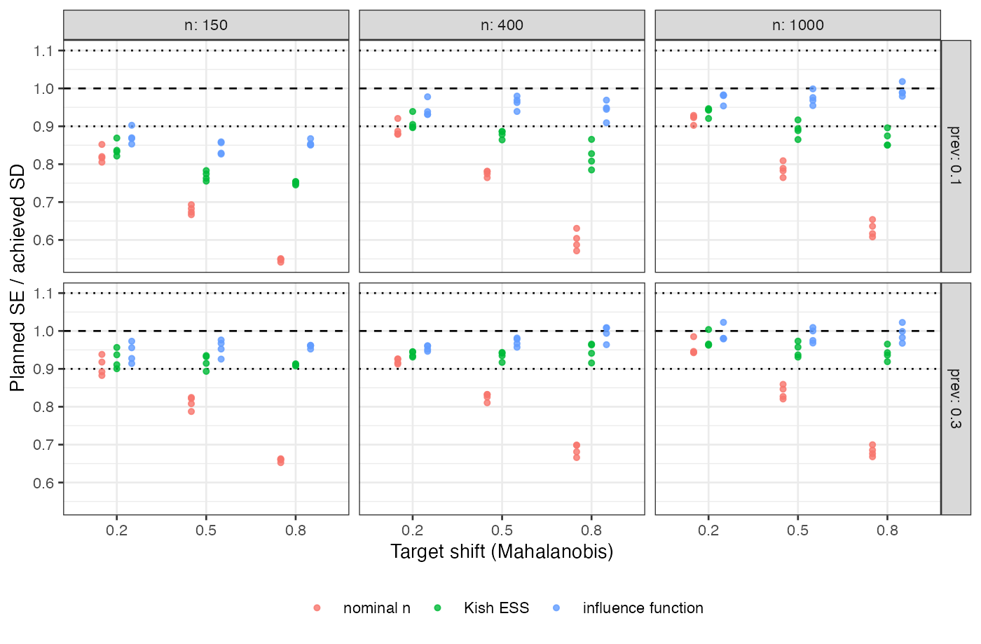
Figure 1: Planned SE over achieved SD for each plan, by target shift, total size and prevalence. Dotted lines mark 10%.
plan | within 10% | median ratio | range
nominal | 21% | 0.797 | 0.541 to 0.985
Kish ESS | 58% | 0.912 | 0.745 to 1.004
influence function | 85% | 0.963 | 0.827 to 1.023
Both simpler plans are optimistic, increasingly so with the shift (Figure 1): Kish ESS corrects nominal for weight concentration but not for how the weights interact with the outcome and the allocation. The influence-function plan’s 11 misses were all at 150 patients and 10% prevalence, about eight events per arm, and its median ratio rose from 0.908 at 150 patients to 0.981 at 1000.

4. What this does not answer
The planner is assumed to know the source and target laws; misspecifying them is a separate error not studied. Binary outcome and anchored-side precision only: the unanchored bias floor, which no sample size removes, and survival outcomes, where the unit is weighted risk-set information, are not run. MAIC on means only. Peer review has not been done.

References
1. David M. Phillippo, A. E. Ades, Sofia Dias, Stephen Palmer, Keith R. Abrams, Nicky J. Welton. Methods for population-adjusted indirect comparisons in health technology appraisal. Medical Decision Making. 2018;38(2):200–11. doi:10.1177/0272989X17725740

