Stacking the weighting step into the MAIC sandwich makes intervals narrower, not better
A simulation study answering catalog problem SFW-10
Ahmad Sofi-Mahmudi
2026-09-23

Abstract
Background. MAIC weights are estimated, and a variance that treats them as fixed omits a term. Catalog problem SFW-10 asks whether stacking the weight and outcome estimating equations improves on the fixed-weight sandwich and on the ESS-based conventional variance that Chandler and Proskorovsky found accurate (1), and what a trimmed analysis estimates.
Methods. Binary-outcome MAIC with three covariates, 90 scenarios crossing target shift, event risk, effect modification, its alignment with the prognostic direction and weight trimming, 1000 replicates each. Four variance estimators: fixed-weight sandwich, ESS-based, stacked sandwich, stacked with an correction. Trimmed analyses were scored against the declared target and against the population the capped weights induce.
Results. Stacking lowered the standard error relative to the fixed-weight sandwich in all 30 untrimmed scenarios (ratio 0.887 to 0.993), so the weighting term had one sign here, not the two DESIGN.md expected. Because intervals already undercovered at poor overlap, stacking made coverage worse: 0.844 to 0.953 against 0.893 to 0.960 for the fixed-weight sandwich and 0.885 to 0.980 for the ESS-based variance. Coverage within 0.93 to 0.97 held in 24, 18 and 17 of 30 scenarios respectively. Trimming moved the estimand by up to 0.192 on the log odds ratio scale.
Conclusion. The stacked sandwich is the asymptotically correct variance, and at the effective sample sizes where MAIC variance matters it is the most anticonservative of the four. The fixed-weight sandwich or the ESS-based variance, as current guidance recommends, is the better default. A trimmed analysis should report the population its weights induce.

1. The problem
MAIC solves with and then computes weighted arm risks. Stacking both sets of estimating equations gives , whose outcome block carries a term through that the fixed-weight sandwich drops. For calibration-type weights, estimating the weights projects out outcome variation explained by the balancing covariates, which lowers the variance. Trimming caps the weights, breaks the calibration, and so changes the population the analysis describes.

2. Design
Registered protocol: protocol.md. Individual-data trial A versus C, 200 per arm, three independent normal covariates; ; MAIC on means to . Factors: , , with of either sign, trimming none or capped at the 99th or 95th weight percentile. Truths by Monte Carlo over 400,000 draws with population-level weights.

3. Results
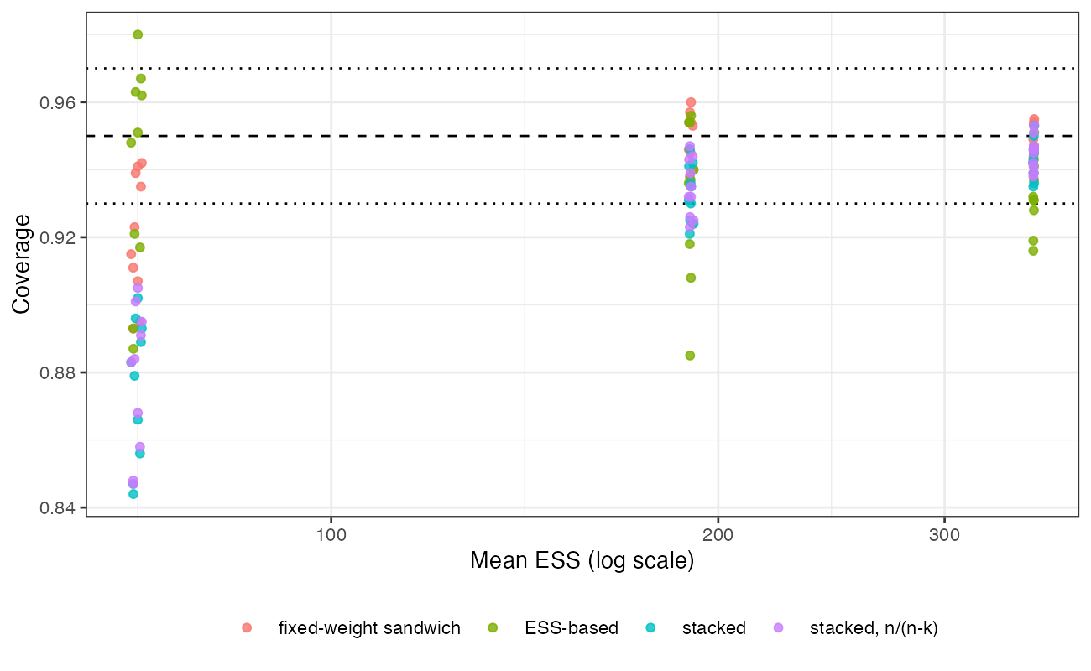
Figure 1: Coverage of each variance estimator against the mean ESS of the scenario, untrimmed analyses. Dotted lines mark 0.93 and 0.97.
All four estimators lose coverage as ESS falls (Figure 1). The stacked sandwich falls fastest because it is the smallest; the correction, with parameters and 400 patients, is too small to matter. The registered comparison of the ESS-based and stacked variances reads “holds” (in band in 18 against 17 scenarios): stacking adds nothing an analyst can use. The ESS-based variance overcovered at good overlap (up to 0.980), the fixed-weight sandwich was closest to nominal overall.
In trimmed analyses the declared and induced truths differed by up to 0.192, most at the 95th-percentile cap, and the estimate was closer to the induced truth in 72% of trimmed scenarios: trimming changes what is estimated, not only how precisely.

4. What this does not answer
No bootstrap arm and no small-sample correction beyond ; one sample size, so the point at which stacking’s asymptotic advantage appears is not located. Binary outcome, three covariates, MAIC on means. The induced population is computed from population-level weights and a population cap. Peer review has not been done.

References
1. Conor Chandler, Irina Proskorovsky. Uncertain about uncertainty in matching-adjusted indirect comparisons? A simulation study to compare methods for variance estimation. Research Synthesis Methods. 2024;15(6):1094–110. doi:10.1002/jrsm.1759

