A bootstrap that drops failed resamples reassures most where the weighting is least reliable
A simulation study answering catalog problem QBA-23
Ahmad Sofi-Mahmudi
2026-09-23

Abstract
Background. Sensitivity analyses for MAIC often bootstrap over a grid of assumptions, and resamples whose weights cannot be computed are dropped. Catalog problem QBA-23 asks whether that conditioning matters.
Methods. MAIC of 100 or 300 patients with one covariate, sweeping the assumed target mean from 1 to 2.5 SD above the source’s (2 scenarios, 500 replicates, 200 bootstrap resamples each). Percentile intervals from the successful resamples were scored against the analysis’s own estimand.
Results. Where fewer than 10% of resamples failed, coverage was 0.874 to 0.934. Where more failed, it was 0.288 to 0.645 among analyses whose original fit succeeded, and 0.136 to 0.560 counting failed original fits as giving no interval. Resample failure reached 0.670 and effective sample size fell to 2.6.
Conclusion. Failed resamples are the ones lacking the few patients who make the weights possible, so the survivors are a selected sample and their interval is falsely narrow. Report the failure share at each grid point as a result; where it is material, the interval should not be presented.

1. The problem
MAIC (1) to a target mean is feasible only if the mean lies inside the sample’s range, and near its edge the weights rest on a handful of patients. A bootstrap (2) resample that omits them cannot reach the target and fails; the resamples that succeed are those that include them, so their spread understates the estimate’s.

2. Design
Registered protocol: protocol.md; ADEMP structure (3). , ; the estimand at assumed target mean is . Weights by log-sum-exp minimization, failed when outside the sample range or when balance was not reached to . A first solver overflowed at the edge of its search interval and was replaced before the probes.

3. Results
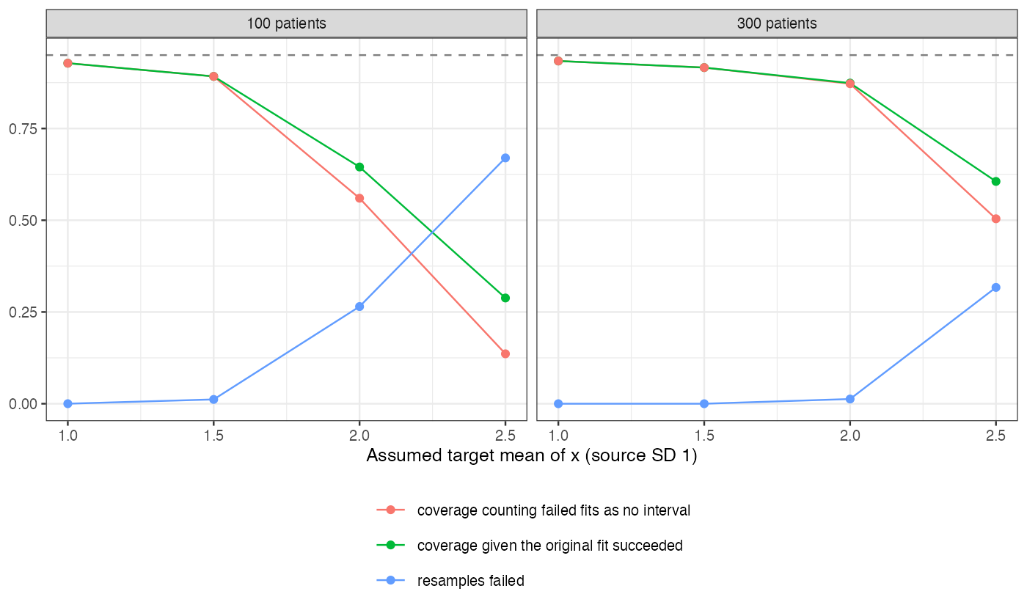
Figure 1: Share of failed bootstrap resamples and interval coverage along the assumed target mean.
Failure and undercoverage rose together (Figure 1). Even where every resample succeeded, the percentile interval undercovered somewhat, since effective sample size was already small; beyond the point where failures began, coverage collapsed. A larger sample moved the collapse further out but did not remove it.

4. What this does not answer
One covariate and a continuous outcome; the cost side of nested resampling (warm starts, surrogates) and identified-set outputs were not studied. Peer review has not been done.

References
1. James E. Signorovitch, Eric Q. Wu, Andrew P. Yu, Charles M. Gerrits, Evan Kantor, Yanjun Bao, Shiraz R. Gupta, Parvez M. Mulani. Comparative effectiveness without head-to-head trials: A method for matching-adjusted indirect comparisons applied to psoriasis treatment with adalimumab or etanercept. PharmacoEconomics. 2010;28(10):935–45. doi:10.2165/11538370-000000000-00000
2. Bradley Efron, Robert J. Tibshirani. An introduction to the bootstrap. New York: Chapman; Hall; 1993. doi:10.1007/978-1-4899-4541-9
3. Tim P. Morris, Ian R. White, Michael J. Crowther. Using simulation studies to evaluate statistical methods. Statistics in Medicine. 2019;38(11):2074–102. doi:10.1002/sim.8086

