Shared and class-specific heterogeneity cannot be told apart below about 40 studies per class
A simulation study answering catalog problem HET-03
Ahmad Sofi-Mahmudi
2026-09-23

Abstract
Background. Network analyses usually assume one between-study variance for all treatment classes. Separate variances are available, but whether the data can choose between the structures at realistic network sizes has not been measured. Catalog problem HET-03 asks at what number of studies per class they become distinguishable.
Methods. Two classes of 2 to 40 studies each, with a between-study variance ratio of 1, 2 or 5; shared and separate REML fits compared by AIC, BIC and a likelihood-ratio test; 2000 replicates per cell.
Results. With a fivefold variance ratio, AIC chose separate variances in 18% of networks with five studies per class, 40% with twelve and 79% with forty. Balanced accuracy (choosing correctly under both truths) reached 0.8 only at 40 studies per class, and only for AIC; BIC and the likelihood-ratio test did not reach it within 40. With a twofold ratio no criterion detected the difference in more than 27% of networks.
Conclusion. At the network sizes population-adjusted analyses use, the heterogeneity structure cannot be chosen from the data. The shared default is untested rather than supported, and structure should be set by prior evidence and reported as an assumption.

1. The problem
The likelihood information about a class-specific between-study variance grows with that class’s study count, and with few studies a separate variance is only nominally identified. Empirical priors for heterogeneity exist (1), but whether the variance structure itself can be selected from data has not been established for network sizes typical of population-adjusted analyses.

2. Design
Registered protocol: protocol.md. Two classes of studies; study estimates with within-study SE uniform on 0.1 to 0.25 and between-study SDs 0.1 and . REML fits with one or two variances; selection by AIC, BIC (with residual degrees of freedom) and a 5% likelihood-ratio test against .

3. Results
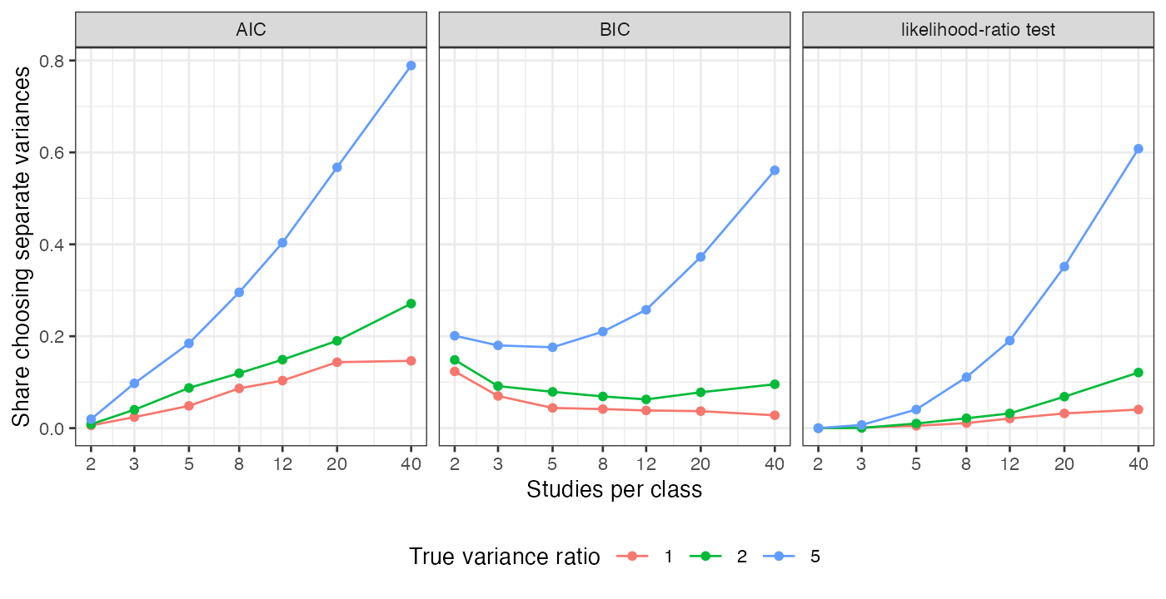
Figure 1: Share of networks choosing separate variances.
Table 1: 2000 replicates per cell.
studies per class | AIC: separate chosen, ratio 5 | ratio 2 | ratio 1 (false positive) | balanced accuracy AIC | BIC | LRT
2 | 0.019 | 0.009 | 0.006 | 0.507 | 0.539 | 0.500
3 | 0.098 | 0.040 | 0.024 | 0.537 | 0.555 | 0.503
5 | 0.184 | 0.087 | 0.049 | 0.568 | 0.566 | 0.518
8 | 0.295 | 0.119 | 0.086 | 0.605 | 0.584 | 0.550
12 | 0.404 | 0.149 | 0.103 | 0.650 | 0.610 | 0.585
20 | 0.568 | 0.190 | 0.143 | 0.712 | 0.668 | 0.660
40 | 0.789 | 0.271 | 0.146 | 0.821 | 0.766 | 0.784

The registered deliverable is a threshold of 40 studies per class for AIC and none within 40 for the other criteria (Table 1, Figure 1). Below twelve studies per class every criterion chose the shared structure in most networks even when the variances differed fivefold, so a converged separate-variance fit in a small network says little about the data. BIC with very few studies chose separate variances more often under the null than AIC, because its penalty per parameter, , is below 2 when .

4. What this does not answer
Two classes, contrast-level data and frequentist criteria; no Bayesian model comparison, informative priors, ML-NMR fit or class-specific treatment SD. Peer review has not been done.

References
1. Rebecca M. Turner, Jonathan Davey, Mike J. Clarke, Simon G. Thompson, Julian P. T. Higgins. Predicting the extent of heterogeneity in meta-analysis, using empirical data from the Cochrane database of systematic reviews. International Journal of Epidemiology. 2012;41(3):818–27. doi:10.1093/ije/dys041

