What conditioning on sampled target moments costs a population-adjusted indirect comparison
A simulation study answering catalog problems MIS-03 and EST-07
Ahmad Sofi-Mahmudi
2026-07-27

1. The problem
A population-adjusted indirect comparison estimates the relative effect of two treatments that have never been compared in one trial. Individual patient data are available for a source trial comparing with a common comparator ; for the target trial comparing with , only a publication is available. Matching-adjusted indirect comparison (1) reweights the source participants so their covariate distribution matches the target’s, transports the versus effect into the target population, and subtracts the target trial’s own versus effect (2).
Everything hangs on a small table. The target publication reports, per covariate, a mean and a standard deviation, alongside the sample size. Those numbers are the matching targets, and every standard estimator treats them as exact.
They are not exact. They are sample moments computed from participants and they carry sampling error of order . A reported confidence interval that conditions on them omits that variability whenever the intended estimand refers to a target superpopulation rather than to the particular people who happened to enroll.
The catalog entry MIS-03 states the position precisely. The weight-estimation half of the uncertainty problem is settled: sandwich, effective-sample-size-rescaled and bootstrap variance estimators exist, are implemented, and were benchmarked across 108 scenarios by (3). The published-moment half is untouched, because a baseline table arrives without the covariance among its own entries, so there is nothing to resample. MIS-03 asks for one number: how much coverage does conditioning on those moments cost, at realistic aggregate-data sample sizes. This study supplies it.
Two results in the transportability literature already propagate target-summary uncertainty for entropy-balancing estimators (4,5). Neither has been carried into indirect-comparison practice or software. This study is not a new derivation; it is a measurement of what the omission costs, and a test of what a publication would have to report for the correction to be usable.

2. The estimating system and what it omits
The source trial contributes participants with covariates , treatment indicator and outcome . Write ; matching on is matching on the reported means and standard deviations, because a mean and a standard deviation together determine the first and second raw moments. Let

be the six moments implied by the target publication. Matching-adjusted indirect comparison solves, over the source participants,

which is the method-of-moments weighting of (1) and the dual of entropy balancing (6). Stacking Equation 1 with the two weighted arm-mean equations gives an M-estimator (7) in with per-participant score

The transported effect is and the anchored estimate is , with the target trial’s own unadjusted arm-mean difference. With the empirical Jacobian of the mean score, and , the usual sandwich is

Equation 2 conditions on . To see what that costs, differentiate the estimating system with respect to the reported moments. Since and the arm-mean equations do not involve , the implicit function theorem gives

is the sensitivity of the transported effect to the published table. It is zero exactly when no covariate in modifies the treatment effect, which is why the study’s negative control is a scenario with no effect modification.
Two things follow, and the second is the one the field has missed. First, if were an independent estimate the interval would simply be too narrow, by where in the target. Second, and in the ordinary case, and come from the same people. Writing for the influence function of the target arm-mean difference, the correct unconditional variance uses the joint covariance of with gradient :

The cross term is negative when the target treatment’s effect is modified by the same covariates as the source treatment’s. Conditioning on therefore does not simply understate the variance. It omits a positive term and a negative term whose balance depends on a quantity that appears nowhere in a publication.

3. Methods
The full protocol was registered before the run and is reproduced at studies/MIS-03-target-moment-uncertainty/protocol.md. Reporting follows ADEMP (8).

3.1 Data-generating mechanism
Covariates are trivariate normal with unit variances and equicorrelation, centered at in the source with correlation and at in the target with correlation . Outcomes are continuous: in the source and in the target, with , a common prognostic function containing linear and quadratic terms, and

The target trial’s participants are generated and then discarded. The estimator receives , three means, three standard deviations, and with its standard error.
Two features of this design are worth stating because earlier drafts lacked them and would have produced a different answer.
Effect-modification strength is calibrated, not fixed. The scale is set per scenario so the treatment effect has a prespecified standard deviation across individuals in the target population. Because the quadratic coefficients of are half the linear ones, shifting the covariate means multiplies the effective linear coefficient by : one fixed coefficient vector gives an effect modifier of standard deviation 0.477 at and 0.745 at . Varying overlap with fixed coefficients would vary effect-modification strength at the same time and confound the two factors.
The alignment varies continuously. At only the source treatment is effect-modified and the omitted term is a pure positive variance, so the interval must be too narrow. At both are modified identically, the omitted covariance is negative, and the interval is too wide. Using only those endpoints fixes the sign of the result by construction; is included so the cancellation is located rather than assumed.

3.2 Factors
Factor | Levels
Source size | 500, 2000
Target size | 200, 500, 2000
Overlap | 0, 0.4, 0.8
Effect modification | 0, 0.45, 0.90
Alignment | 0, 0.5, 1
Target correlation | 0.30, 0.60
Fully factorial except that is collapsed where there is no effect modification: 252 scenarios, 5000 replicates each, 1,260,000 in total.
is a factor because the omitted term is against a retained term of order , so what governs whether the omission matters is the ratio of source to target information rather than alone. A pilot holding found the omission was 1% to 7% of total variance and would have supported concluding that nothing was wrong; at the same quantity reached 23%.

3.3 Estimand
The target-superpopulation marginal versus mean difference,

exact in closed form, verified against a -draw evaluation in every cell to within . The superpopulation qualifier is essential: conditioning on the reported moments is correct when the estimand is defined by those moments or when they are exact administrative counts. The problem exists only for a superpopulation estimand.

3.4 Methods compared
All four share the same point estimate, so the comparison isolates the interval.
Method | Interval variance | What the target must publish
Status quo |  | , means, SDs, effect and its SE
Normal reconstruction |  | the same, plus a borrowed correlation matrix
Reported moment covariance |  | additionally the covariance of
Full joint score | Equation 4 | additionally its covariance with the outcome influence function
is reconstructed from the reported means and standard deviations and a borrowed correlation under a multivariate normal model, using , and . This is the only one an analyst can compute today. The other two are enhanced-reporting benchmarks: they receive covariance matrices computed inside the simulation and never microdata, and their purpose is to price the reporting addition each would require.

3.5 Performance measures
Primary: coverage of the nominal 95% interval for , as the signed error in percentage points. Secondary: paired coverage differences, bias, empirical and model standard errors, relative error in model standard error, bias-eliminated coverage, interval width, effective sample size, and convergence. Every measure carries a Monte Carlo standard error; at nominal coverage that error is 0.31 points, so a two-point coverage error is more than six Monte Carlo standard errors from nominal.

4. Results
Convergence was at least 99.96% in every one of the 252 scenarios. The point estimate is not at fault anywhere: the largest absolute bias was 0.052 empirical standard errors, and coverage and bias-eliminated coverage never differed by more than 0.24 percentage points. Everything below is a property of the interval.

4.1 The registered gates fire, and why
The protocol declares the run uninformative if the full-joint-score reference or any negative control leaves 0.93 to 0.97. Read across the whole grid, that condition is met and the registered conclusion is uninformative.
The reason is a second failure, and it is worth reporting on its own account. At the effective sample size falls to a median of about 148 of 500 and the Wald sandwich undercovers for every method, including scenarios with no effect modification at all (Figure 1). Where the reported moments carry no information about the transported effect, is zero in expectation, and all four intervals must coincide. They do coincide, and at poor overlap they are all wrong together, by up to seven percentage points. That is a finite-sample failure of the sandwich under extreme weighting, consistent with (3) finding conventional estimators anticonservative under poor and moderate overlap, and it is not about target moments.
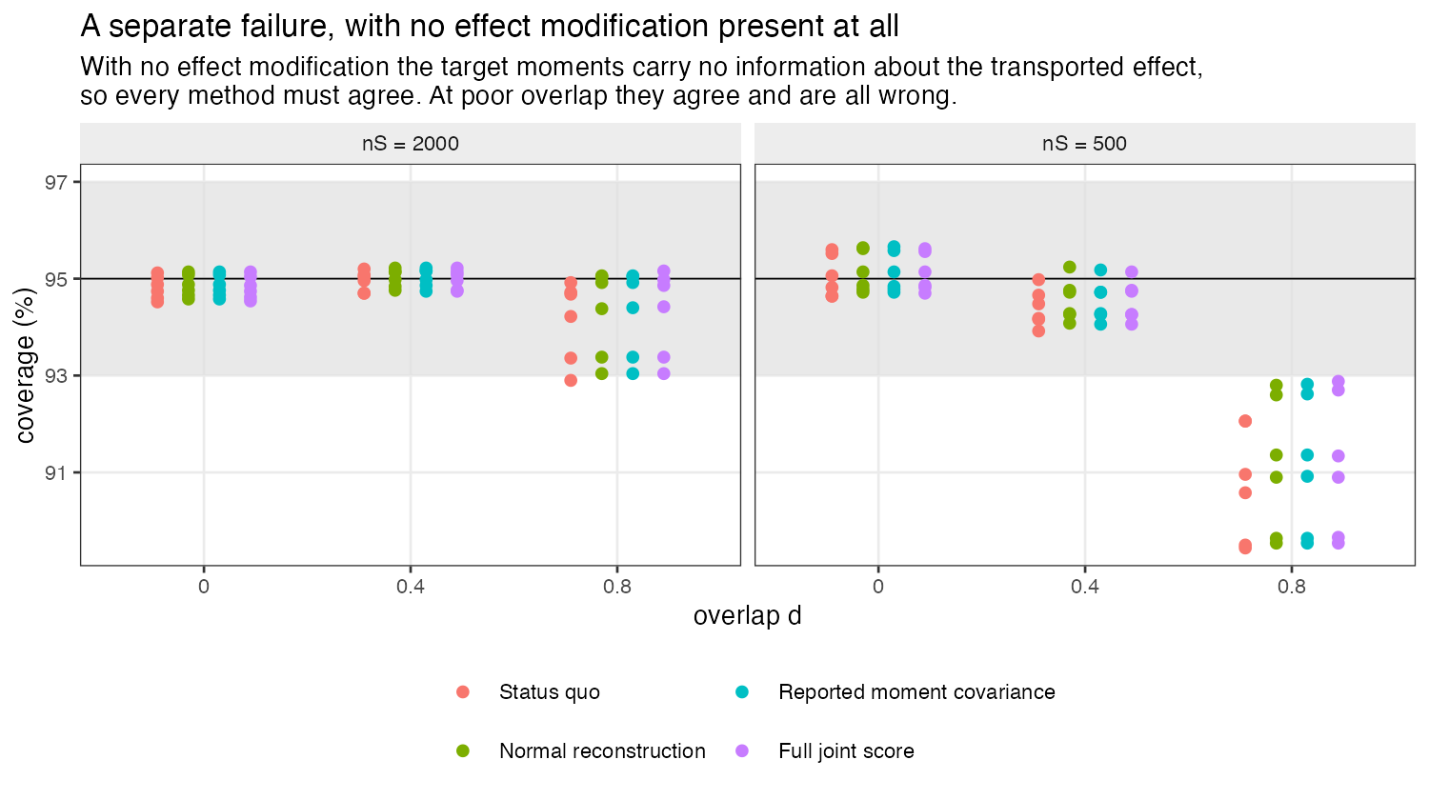
Figure 1: With no effect modification the target moments carry no information about the transported effect, so all four methods must agree. They do, and at poor overlap they are all wrong together.
Applying the same prespecified criterion per scenario rather than across the grid leaves 196 of 252 scenarios in which the reference and its matched negative control are both valid. This is recorded as a dated amendment in the protocol; it restricts the analysis set on a criterion that was itself prespecified and changes no threshold, factor or measure. Everything that follows is confined to those scenarios.

4.2 The omission is real, bounded, and of variable sign
Across usable scenarios with effect modification present, conditioning on the reported moments omits between -9.5% and 14.9% of the variance. The sign is governed almost entirely by (Figure 2):
Table 1: Variance omitted by the status quo, by the alignment between the two trials’ effect modification. Positive means the reported interval is too narrow.
Alignment | Minimum | Median | Maximum
0.0 | 0.9 | 4.1 | 14.9
0.5 | -0.0 | 0.7 | 2.5
1.0 | -9.5 | -2.3 | 0.0

At , where only the source treatment’s effect is modified, the reported interval is always too narrow. At , where both treatments are modified identically, it is mostly too wide. The cancellation sits near .
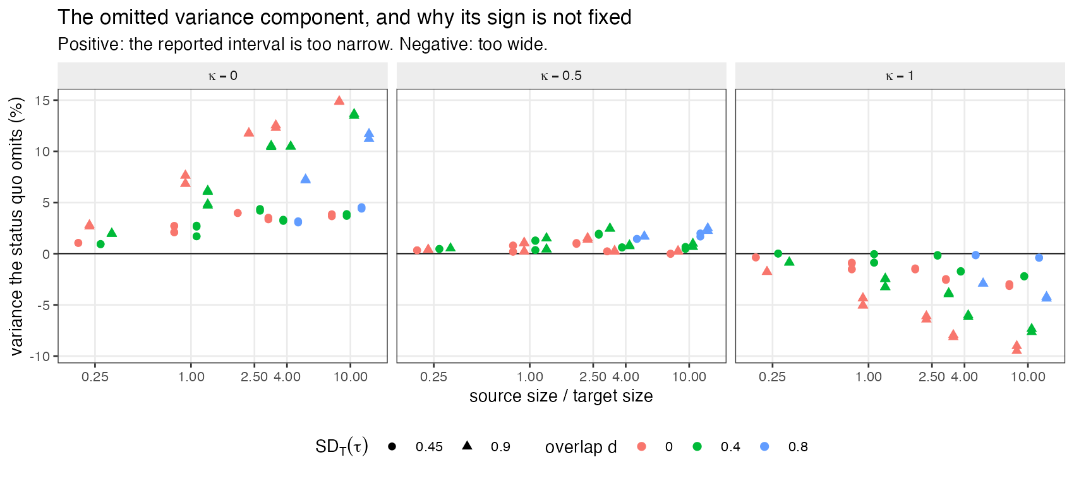
Figure 2: The omitted variance component. Its magnitude grows with the ratio of source to target information; its sign is set by an alignment that no publication reports.
Magnitude tracks the ratio of source to target information, as Equation 3 predicts: the omitted term scales as while the retained term scales as , so a large source trial matched to a small target publication is the worst case, not a small target trial as such.

4.3 What it costs in coverage
Table 2: Coverage of nominal 95% intervals across usable scenarios with effect modification present. Only the status quo leaves the band, and it leaves it in both directions.
Method | Minimum | Median | Maximum | Outside 93 to 97%
Status quo | 92.1% | 94.5% | 96.2% | 8 of 167
Normal reconstruction | 93.2% | 95.1% | 97.0% | 0 of 167
Reported moment covariance | 93.2% | 95.1% | 97.0% | 0 of 167
Full joint score | 93.2% | 94.7% | 95.8% | 0 of 167

The status-quo interval covers between 92.1% and 96.2%, leaving the 93% to 97% band in 8 of 167 scenarios. All three corrections stay inside it in every scenario (Figure 3, Figure 4).
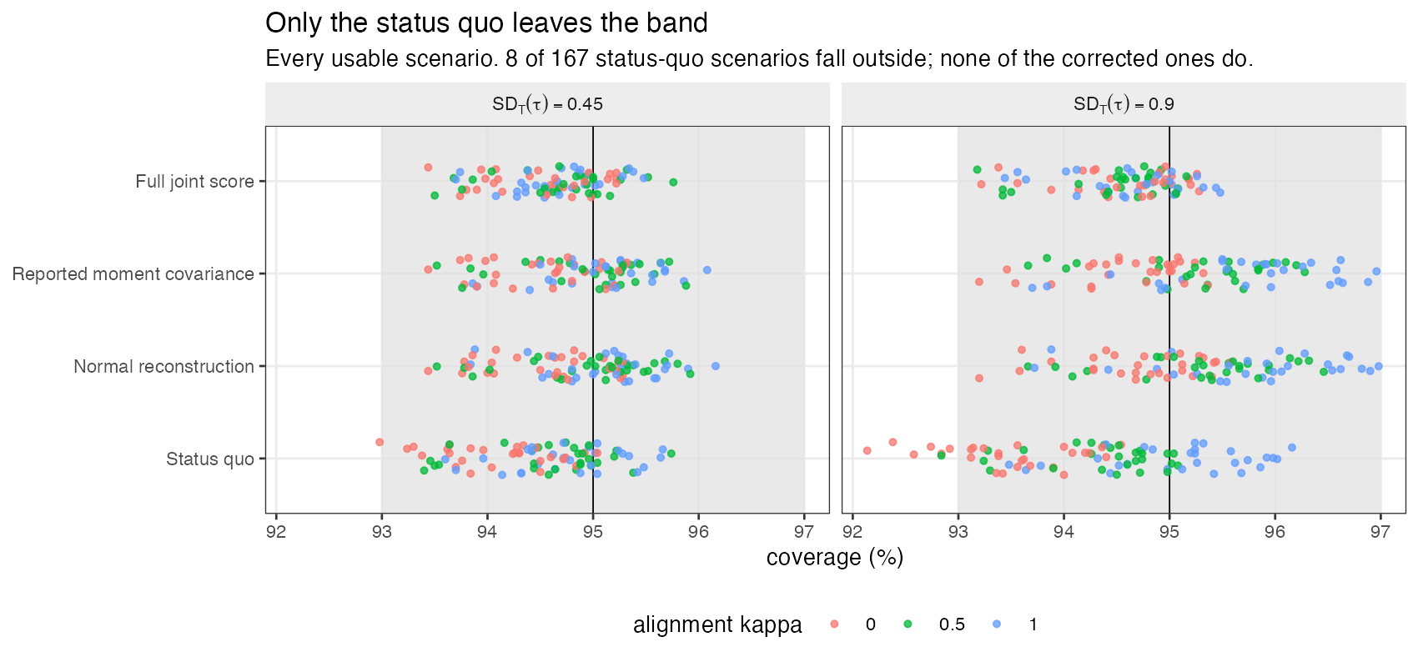
Figure 3: Only the status quo leaves the band.
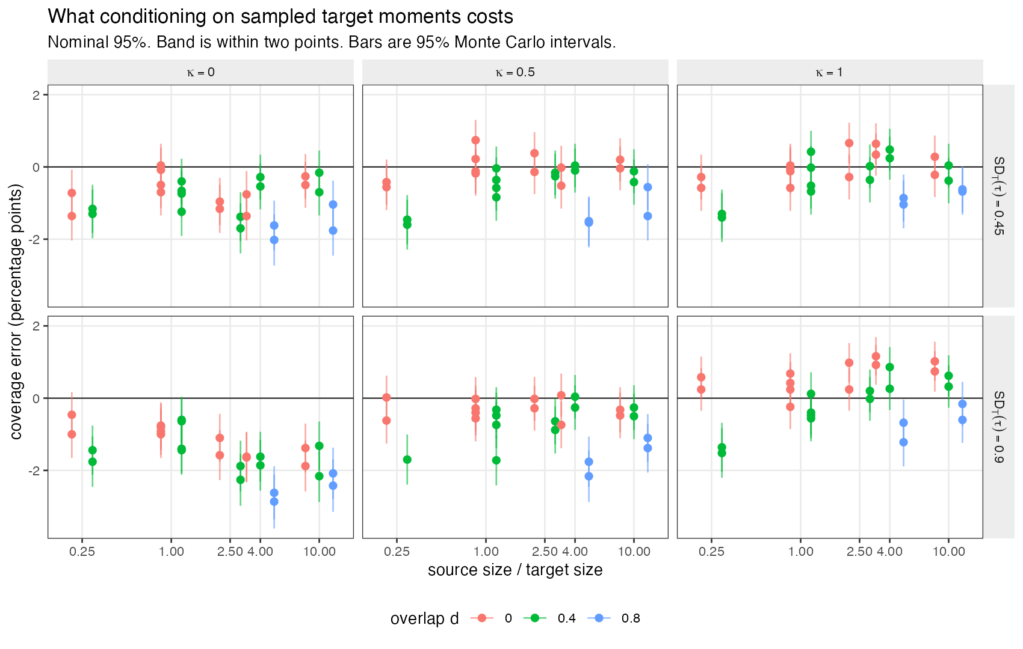
Figure 4: Status-quo coverage error against the ratio of source to target information, by alignment and effect-modification strength.
The prespecified categories resolve to material at ordinary effect-modification strength, but that category is triggered by a single marginal scenario and should not be leaned on. The robust reading is the one in Table 2 and Table 1: the cost is bounded by roughly three percentage points of coverage in either direction, is largest when effect modification is strong and unshared and the source trial is large relative to the target publication, and is negligible when the two trials’ effects are modified alike.

4.4 What a publication would have to report
The normal reconstruction needs nothing beyond what is already published plus a correlation matrix borrowed from the source. It restored coverage in every usable scenario, at a median interval-width cost of 2.24% and a maximum of 8.70%. Giving it the target’s true moment covariance instead of a reconstruction changed coverage by a median of 0.02 percentage points (Figure 5). Getting the borrowed correlation wrong, at against a source value of , did not break it.
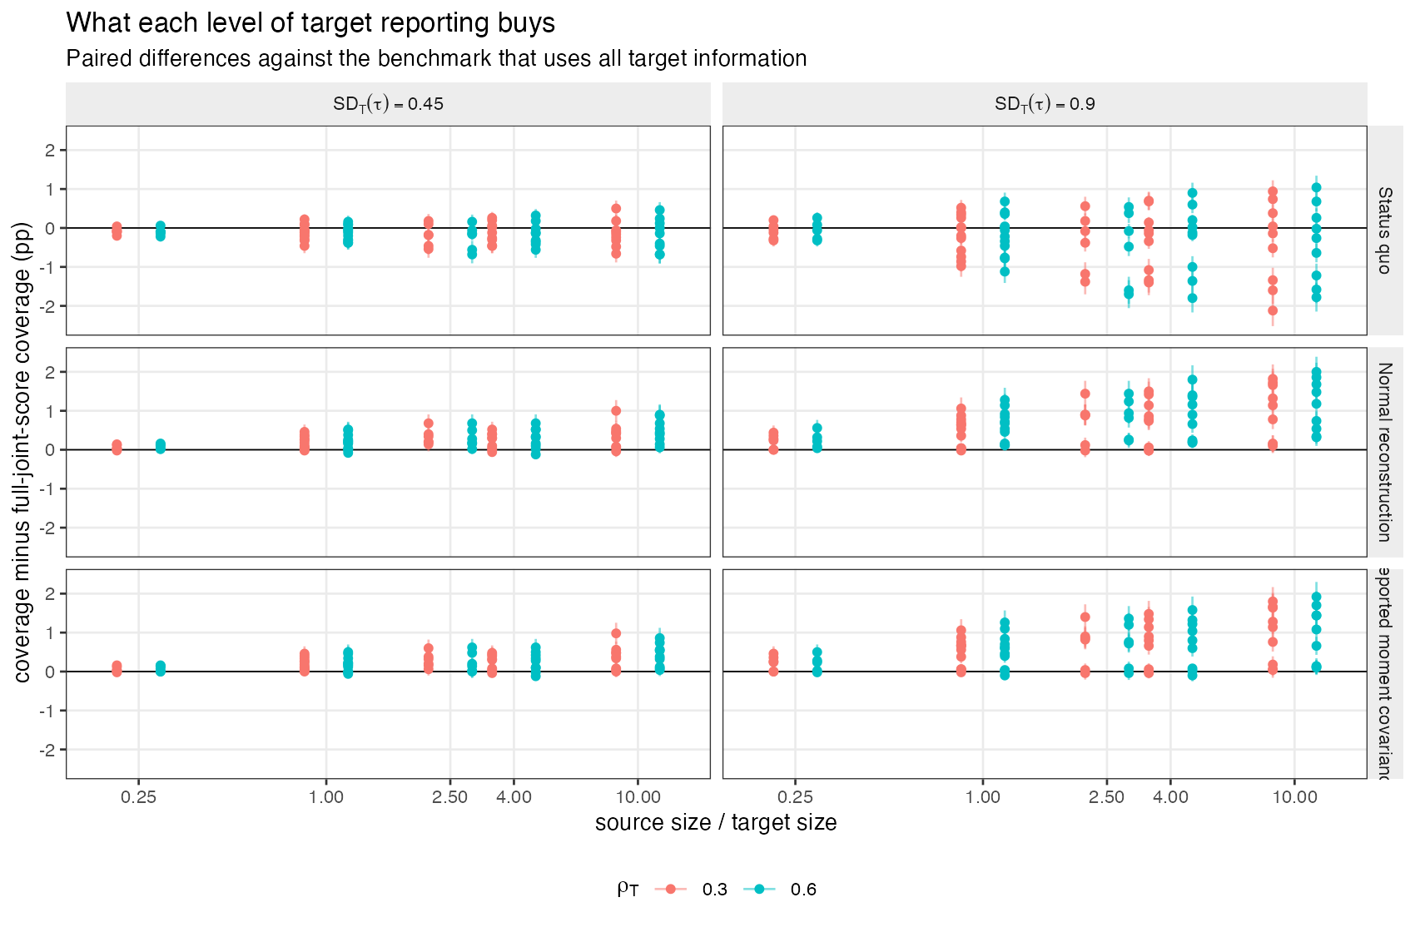
Figure 5: What each level of target reporting buys, as paired differences against the benchmark using all target information.
This is the practically useful finding. The deployable correction is as good as the one requiring enhanced reporting, so the case for asking journals to publish moment covariance matrices is weak. The case for analysts computing Equation 3 and adding is strong: it costs about 2% of interval width and removes a coverage error of up to three points whose sign they cannot otherwise determine.

5. What this answers, and what it does not
Answers. MIS-03 asked how much coverage is lost by conditioning on target moments at realistic aggregate-data sample sizes. In anchored matching-adjusted indirect comparison on a continuous outcome, where the sandwich is otherwise valid: between about three points lost and one point gained, with the sign determined by the alignment between the two trials’ effect modification. The problem is real and is worth correcting, and the correction is available now.
Does not answer. The study covers one estimator, one outcome type and one information structure.
Covariates are multivariate normal, which is also the assumption under which the deployable correction is derived, so its performance here is measured under conditions favorable to it. Skewed, bounded and categorical covariates are untested.
The outcome is continuous and the effect additive, so marginal and conditional effects coincide. Nothing here transfers directly to binary or time-to-event outcomes, where matching-adjusted indirect comparison is most often used and where noncollapsibility adds a term this design cannot see.
Effect modification lies exactly in the span of the six matched moments, so there is no unmeasured effect modifier and no extrapolation. This is a variance result under otherwise correct identification, not a statement about bias.
The target moments and the target treatment effect come from the same randomized trial. That is the common case and the one with the largest cross-covariance, but summaries drawn from a separate sample, or a covariate-adjusted published effect with a different influence function, would behave differently.
Simulated treatment comparison, multilevel network meta-regression, multilevel unanchored meta-regression and network meta-interpolation have different sensitivities and are not covered. The direction of the argument in Section 2 applies to all of them; the magnitudes here do not.
Accordingly this study answers MIS-03 in part and answers one named component of EST-07, namely sampling error in reported moments. EST-07’s remaining components, model uncertainty in reconstructed correlations, ambiguity in inclusion criteria and secular drift, are not sampling error and are untouched.
A finding nobody asked for. The poor-overlap sandwich failure in Section 4.1 is larger than the effect this study was built to measure. It is consistent with (3) and it deserves its own study.

6. Reproducibility
R: R version 4.6.0 (2026-04-24) Platform: aarch64-apple-darwin23 Running under: macOS Tahoe 26.5

6.1 Packages
package | version
base | 4.6.0
stats | 4.6.0
future | 1.70.0
furrr | 0.4.0

6.2 Run
- study: MIS-03 / EST-07 target-moment uncertainty
- scenarios: 252
- replicates_per_scenario: 5000
- total_replicates: 1260000
- master_seed: 20260727
Replicate seeds derive from one master seed through L’Ecuyer-CMRG streams, so a run gives identical results on any number of cores and an interrupted run resumes rather than restarting. Code, protocol and results are at https://github.com/choxos/ITC-open-problems/tree/main/studies/MIS-03-target-moment-uncertainty.
Rscript R/03-run.R # 252 scenarios, resumable
Rscript R/04-analyze.R # summary.csv, paired.csv, decision.md
Rscript R/05-figures.R

References
1. James E. Signorovitch, Eric Q. Wu, Andrew P. Yu, Charles M. Gerrits, Evan Kantor, Yanjun Bao, Shiraz R. Gupta, Parvez M. Mulani. Comparative effectiveness without head-to-head trials: A method for matching-adjusted indirect comparisons applied to psoriasis treatment with adalimumab or etanercept. PharmacoEconomics. 2010;28(10):935–45. doi:10.2165/11538370-000000000-00000
2. David M. Phillippo, A. E. Ades, Sofia Dias, Stephen Palmer, Keith R. Abrams, Nicky J. Welton. Methods for population-adjusted indirect comparisons in health technology appraisal. Medical Decision Making. 2018;38(2):200–11. doi:10.1177/0272989X17725740
3. Conor Chandler, Irina Proskorovsky. Uncertain about uncertainty in matching-adjusted indirect comparisons? A simulation study to compare methods for variance estimation. Research Synthesis Methods. 2024;15(6):1094–110. doi:10.1002/jrsm.1759
4. Ying Sheng, Yifei Sun, Chiung-Yu Huang. Transportable inference using target population summary statistics under covariate shift [Internet]. 2026. Available from: https://arxiv.org/abs/2603.02474
5. Yi Chen, Xinyuan Chen, Menggang Yu. Confidence interval construction for causally generalized estimates with target sample summary information. Statistics in Medicine. 2026;45(1-2):e70358. doi:10.1002/sim.70358
6. Jens Hainmueller. Entropy balancing for causal effects: A multivariate reweighting method to produce balanced samples in observational studies. Political Analysis. 2012;20(1):25–46. doi:10.1093/pan/mpr025
7. Leonard A. Stefanski, Dennis D. Boos. The calculus of m-estimation. The American Statistician. 2002;56(1):29–38. doi:10.1198/000313002753631330
8. Tim P. Morris, Ian R. White, Michael J. Crowther. Using simulation studies to evaluate statistical methods. Statistics in Medicine. 2019;38(11):2074–102. doi:10.1002/sim.8086

