Arm-separate matching cancels the aggregate trial’s chance imbalance; pooled matching carries it
A simulation study answering catalog problem MOD-16
Ahmad Sofi-Mahmudi
2026-09-23

Abstract
Background. An anchored MAIC can weight the individual-data trial with one weight function (pooled) or weight each arm to the corresponding aggregate arm (arm-separate) (1). Catalog problem MOD-16’s design predicted that arm-separate matching is biased by the product of an unmatched covariate’s prognostic strength and the aggregate trial’s arm imbalance.
Methods. Continuous outcome, one matched covariate reported by arm and one unreported prognostic covariate , 96 scenarios crossing an imposed aggregate-arm imbalance in (0 to 0.2 SD, or chance), ’s prognostic strength, the - correlation in each trial, and shared effect modification; 1000 replicates each. Unadjusted, pooled, arm-separate and two-stage (2) MAIC.
Results. Conditional on an imbalance , pooled matching was biased by (slope of simulated on predicted bias 1.004) and arm-separate matching by (slope 0.958). With the - correlation shared between trials, arm-separate bias was within Monte Carlo error of zero in all 16 scenarios with an unmatched prognostic covariate. Arm-separate matching had smaller bias than pooled in every scenario with an imposed imbalance, and under chance imbalance its RMSE was 10% to 27% lower.
Conclusion. The design’s product claim is wrong. Arm-separate matching reproduces the aggregate trial’s chance imbalance inside the individual-data contrast, so it cancels in the anchored difference; it is biased only when an unmatched prognostic covariate relates to the matched one differently in the two trials. Pooled matching preserves the individual trial’s randomization but leaves the aggregate trial’s imbalance in the answer.

1. The problem
Write the outcome as . The aggregate B-versus-C estimate contains the trial’s chance imbalance, , with . Pooled matching weights both individual-data arms to the pooled aggregate mean, which removes nothing of this, so the anchored contrast is biased by . Arm-separate matching weights arm A to the B-arm mean and arm C to the C-arm mean, which builds the same imbalance into the individual-data contrast, , and it cancels except for . DESIGN.md’s product of and omits the correlation mismatch the bias needs.

2. Design
Registered protocol: protocol.md. Individual-data trial A versus C and aggregate trial B versus C, 300 per arm; bivariate normal with correlation in the source and in the target (means 0.5); the aggregate B arm’s mean set to exactly, with drawn given . , , , shared by A and B, or chance. Estimand: . Sandwich variances with weights fixed.

3. Results
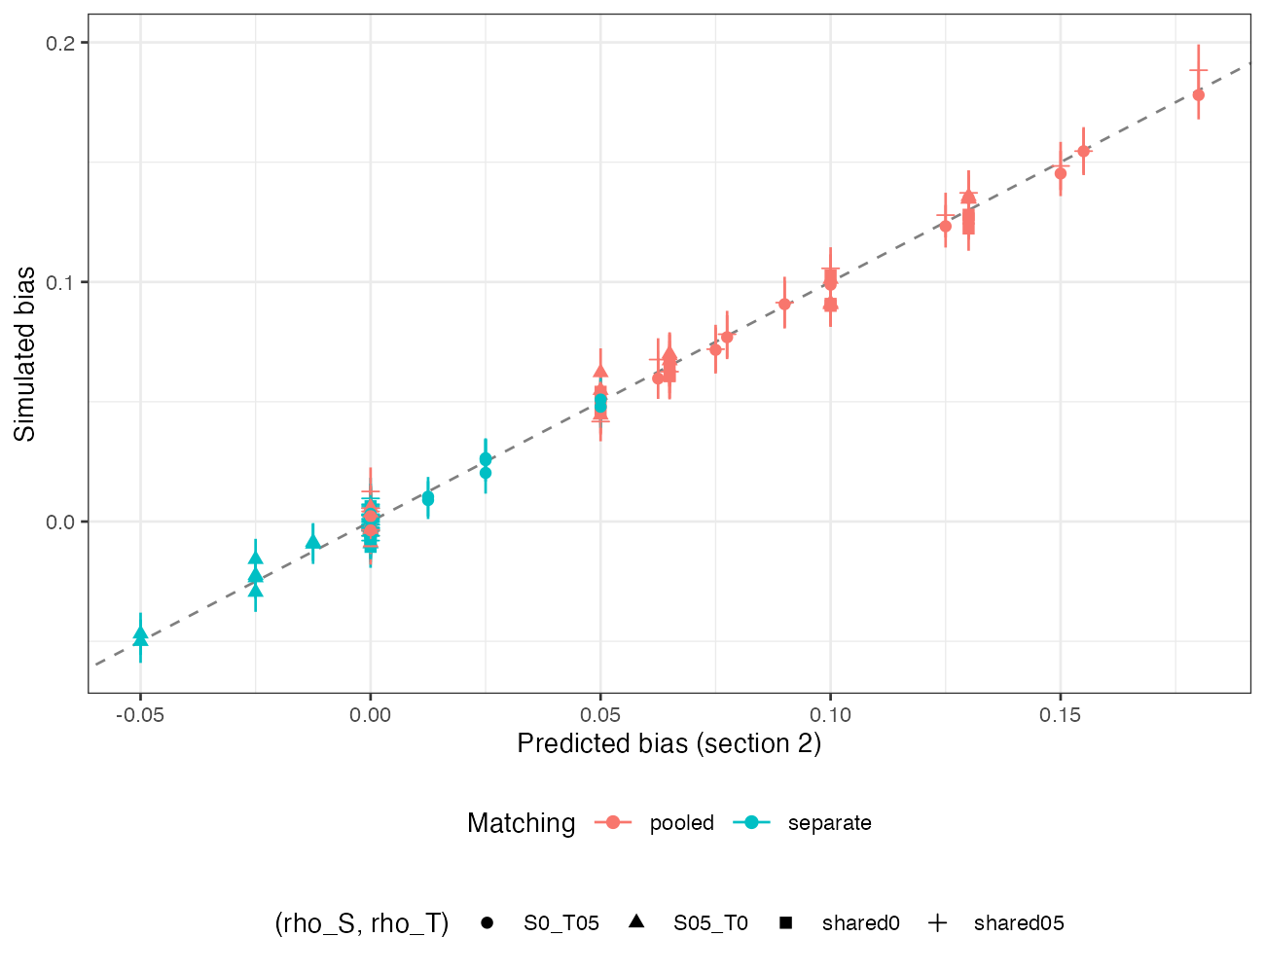
Figure 1: Simulated against predicted bias for pooled and arm-separate matching, imposed-imbalance scenarios.
Both formulas held (Figure 1). At , and , pooled bias was 0.128 to 0.188 and arm-separate bias -0.050 to 0.051, the extremes being the two mismatched-correlation structures. Two-stage MAIC behaved like pooled matching: it corrects the individual trial’s chance imbalance, not the aggregate trial’s.
Under chance imbalance every method except the unadjusted one was unbiased, and the difference was precision: arm-separate RMSE over pooled 0.728 to 0.904. Its sandwich interval overcovered (0.965 to 0.991) because it adds the two trials’ variances while their imbalances are positively correlated. The design’s candidate diagnostic, the weighted difference in between individual-data arms, estimates and cannot see ; its correlation with arm-separate bias was -0.414, with the sign set by which trial has the stronger correlation.

4. What this does not answer
Continuous outcome and linear model; one matched and one unmatched covariate; shared effect modification. On a non-collapsible scale arm-separate matching compares arms in different populations and its estimand needs separate treatment. The arm-separate interval’s conservatism is not repaired here. Peer review has not been done.

References
1. Helmut Petto, Zbigniew Kadziola, Alan Brnabic, Daniel Saure, Mark Belger. Alternative weighting approaches for anchored matching-adjusted indirect comparisons via a common comparator. Value in Health. 2019;22(1):85–91. doi:10.1016/j.jval.2018.06.018
2. Antonio Remiro-Azócar. Two-stage matching-adjusted indirect comparison. BMC Medical Research Methodology. 2022;22:217. doi:10.1186/s12874-022-01692-9

