Which evidence drives a network contrast changes across the plausible range of heterogeneity
A simulation study answering catalog problem DEC-17
Ahmad Sofi-Mahmudi
2026-09-23

Abstract
Background. Contribution tables attribute a network meta-analysis contrast to its studies and comparisons (1) and feed certainty assessments. They are computed at the point estimate of the between-study SD . Catalog problem DEC-17 asks whether they are stable across its plausible range.
Methods. Three-treatment star and loop networks of 4, 8 or 16 two-arm studies, with equal or 5:1 within-study variances and true of 0, 0.1 or 0.25; absolute hat-matrix contribution shares for the indirect-or-mixed contrast, evaluated across the REML profile interval for ; 1000 networks per cell.
Results. In the loop network with four studies and unequal within-study variances, the leading contributing comparison changed across the interval in 38% to 42% of networks, and some study’s share moved by 0.152 to 0.159 on average. With equal within-study variances shares did not move at all. The REML estimate of was zero in 30% to 67% of four-study networks and the interval’s upper end reached the grid’s cap in up to 62%.
Conclusion. A contribution table is conditional on one value of . With few studies of unequal precision it should be reported across the plausible range of , or stated as conditional on the point estimate.

1. The problem
Contribution shares are functions of the weights . As grows the weights flatten, so precise studies lose share and imprecise ones gain, and the leading study or comparison can change. With few studies is poorly determined, so the share reported at is one point in a wide range. With equal within-study variances the weights are proportional at every and shares cannot move.

2. Design
Registered protocol: protocol.md. Treatments A, B, C; two-arm studies of AB and AC (star) or AB, AC and BC (loop), allocated in turn; within-study variances 0.04, or 0.02 to 0.10 assigned at random; target contrast C versus B. by REML on a grid over with its 95% profile-likelihood interval. A study’s share is its absolute entry in the target row of the hat matrix over their sum; a comparison’s share sums its studies’. In the star network the target needs both comparisons with coefficient one, so comparison-level shares are exactly 50% at every and only study-level shares are informative (the comparison-level entries for the star in results/decision.md are ties broken by rounding and are not results).

3. Results
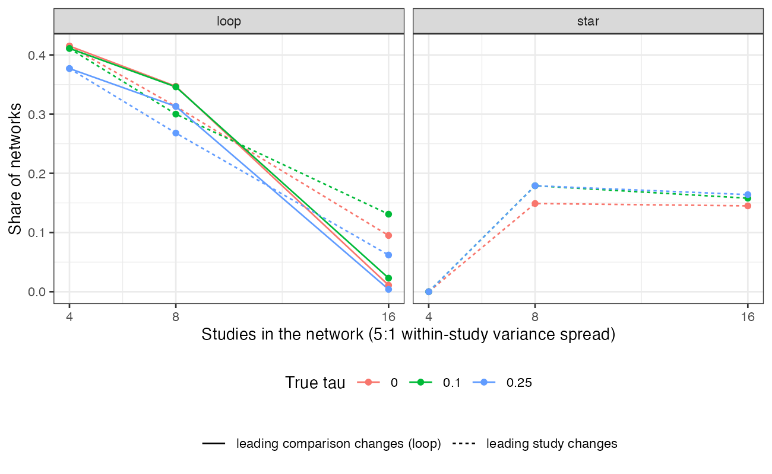
Figure 1: Share of networks whose leading contributor changes across the \tau interval, 5:1 within-study variance spread.
Table 1: 5:1 within-study variance spread; with equal variances no share moved in any cell. 1000 networks per cell.
network | studies | true | leading comparison changes | leading study changes | mean largest share movement | leading study at differs from true
star | 4 | 0.00 | tie | 0% | 0.125 | 0% | 65%
loop | 4 | 0.00 | 42% | 42% | 0.159 | 6% | 67%
star | 8 | 0.00 | tie | 15% | 0.095 | 2% | 62%
loop | 8 | 0.00 | 35% | 31% | 0.104 | 7% | 61%
star | 16 | 0.00 | tie | 14% | 0.050 | 2% | 58%
loop | 16 | 0.00 | 1% | 10% | 0.058 | 3% | 56%
star | 4 | 0.10 | tie | 0% | 0.126 | 0% | 57%
loop | 4 | 0.10 | 41% | 41% | 0.157 | 11% | 55%
star | 8 | 0.10 | tie | 18% | 0.096 | 5% | 48%
loop | 8 | 0.10 | 35% | 30% | 0.103 | 10% | 50%
star | 16 | 0.10 | tie | 16% | 0.054 | 4% | 36%
loop | 16 | 0.10 | 2% | 13% | 0.061 | 5% | 35%
star | 4 | 0.25 | tie | 0% | 0.122 | 0% | 37%
loop | 4 | 0.25 | 38% | 38% | 0.152 | 15% | 36%
star | 8 | 0.25 | tie | 18% | 0.093 | 8% | 19%
loop | 8 | 0.25 | 31% | 27% | 0.101 | 10% | 17%
star | 16 | 0.25 | tie | 16% | 0.048 | 4% | 4%
loop | 16 | 0.25 | 0% | 6% | 0.055 | 1% | 5%

The registered primary was confirmed (Figure 1, Table 1). Instability was greatest where is least determined and precision most unequal: four- and eight-study loop networks. With sixteen studies the interval for narrowed and the leading comparison was stable in almost every network, but the leading study still changed in 6% to 13% of them. Taking shares at rather than at the true changed individual shares by only 0.01 to 0.05 on average; the problem is not that is badly biased but that the data cannot distinguish values of that attribute the contrast differently.

4. What this does not answer
One contribution measure (absolute hat-matrix row), not the shortest-path or random-walk flow decompositions; three treatments, two-arm studies; frequentist only, so no posterior distribution of contributions, information-matrix interval or bootstrap. Peer review has not been done.

References
1. Theodoros Papakonstantinou, Adriani Nikolakopoulou, Gerta Rücker, Anna Chaimani, Guido Schwarzer, Matthias Egger, Georgia Salanti. Estimating the contribution of studies in network meta-analysis: Paths, flows and streams. F1000Research. 2018;7:610.

