A treatment hierarchy belongs to a population, and a changed hierarchy does not prove it
A simulation study answering catalog problem EST-12
Ahmad Sofi-Mahmudi
2026-09-23

Abstract
Background. Treatment hierarchies (SUCRA, P-scores) are reported without naming the population they refer to, although every contrast they combine can depend on the population. Catalog problem EST-12 asks whether ranks move more across plausible target populations than through sampling variability.
Methods. Star networks of five treatments against a common comparator, two or five trials per comparison, with treatment-specific linear effect modification of three strengths and two effect spacings; fixed-effect meta-regression and P-scores at three target covariate means (24 scenarios, 1000 replicates each). Rank movement per treatment was compared across targets within an analysis and across independent replicates at one target.
Results. Where the true ranking changed across targets, the estimated hierarchy moved 1.56 to 2.38 places per treatment across targets against 0.11 to 1.39 across replicates. Where the true ranking did not change, the estimated hierarchy still moved 0.23 to 2.07 places across targets, because evaluating a meta-regression away from the center of the data amplifies the uncertainty in its slopes. The best treatment was misidentified at an outer target in up to 0.697 of analyses.
Conclusion. A hierarchy should name its target population: effect modification of plausible size moves ranks more than sampling does. But a hierarchy that changes between targets is not by itself evidence of population dependence; report target-specific hierarchies with their uncertainty.

1. The problem
Under linear modification treatment ’s effect at target covariate mean is , and two treatments swap ranks between targets exactly when the targets lie on opposite sides of their zero-difference point. Ranking metrics such as the P-score (1) combine every pairwise contrast, so they inherit each one’s population dependence.

2. Design
Registered protocol: protocol.md; ADEMP structure (2). Trials of treatment against A with covariate means uniform on and estimates , SE 0.1; , ; , spread 0, 0.2 or 0.4. Targets at , 0 and , . Movement: mean absolute rank change per treatment between the outer targets, and between two replicates at the middle target.

3. Results
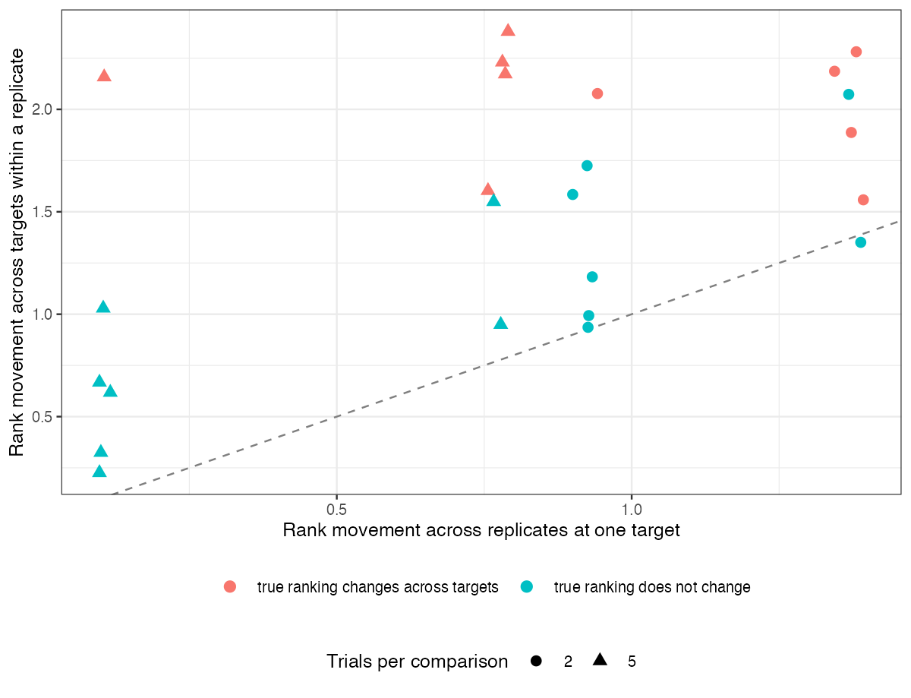
Figure 1: Rank movement across targets against movement across replicates. Points above the dashed line move more across targets than across replicates.
Every scenario with a true rank change lay above the line (Figure 1), so the refuting sentence fails. Scenarios without a true change lay above it too when effects were well separated relative to their sampling error: the replicate-to-replicate movement at the center was small, while the outer targets depended on slope estimates from few trials. The two kinds of movement are therefore separable only with the uncertainty of each target-specific hierarchy, not from the point hierarchies.

4. What this does not answer
Study-level meta-regression rather than ML-NMR on individual data; P-scores only; one covariate and fixed-effect models. Peer review has not been done.

References
1. Gerta Rücker, Guido Schwarzer. Ranking treatments in frequentist network meta-analysis works without resampling methods. BMC Medical Research Methodology. 2015;15:58. doi:10.1186/s12874-015-0060-8
2. Tim P. Morris, Ian R. White, Michael J. Crowther. Using simulation studies to evaluate statistical methods. Statistics in Medicine. 2019;38(11):2074–102. doi:10.1002/sim.8086

