Transporting competing-risks outcomes: the hazard ratio travels, the cumulative incidence does not
A simulation study answering catalog problem DIA-09 (competing-risks family)
Ahmad Sofi-Mahmudi
2026-09-23

Abstract
Background. Population adjustment reweights or models covariates, and results for hazard ratios are assumed to carry over to other outcome types. For competing risks the quantity a decision model uses, the cumulative incidence, also depends on the competing cause’s hazard in the target. Catalog problem DIA-09 asks whether outcome families beyond the hazard ratio behave differently; this study runs the competing-risks family.
Methods. Transport from a trial of A versus C (300 per arm) to a target whose competing hazard was 0.5, 1, 2 or 4 times the source’s beyond what a measured covariate explains, with and without effect modification, at two overlap levels: 16 scenarios, 1000 replicates each. MAIC, cause-specific STC, and STC with the competing hazard recalibrated to the target’s reported proportion of control patients with a competing event.
Results. The cause-1 log hazard ratio was unbiased in every scenario (largest bias 0.013). A’s cumulative incidence at two years, from MAIC or STC, was biased by 0.132 to 0.201 with coverage at most 0.030 when the target’s competing hazard was four times the source’s (true incidence 0.164 to 0.249), and by -0.063 to -0.042 when it was half. The A-minus-C difference was affected less (at most 0.049). Recalibration removed the bias (at most 0.004) but its intervals for the absolute incidence covered 0.851 to 0.943 because they ignore the uncertainty in the reported proportion. The registered rule, bias beyond 0.05 in every scenario with a differing competing hazard, was met in 20 of 24 method-scenarios; the four exceptions were at half the competing hazard.
Conclusion. Covariate adjustment transports cause-specific hazards, not cumulative incidences. When a decision model uses absolute event probabilities, the target’s competing risk must be supplied from target data.

1. The problem
With cause-specific hazards and , the cumulative incidence of cause 1 is with depending on both hazards (1). MAIC (2) or a cause-specific outcome model can transport correctly and still compute the incidence with the source’s . If the target’s competing risk differs for reasons the measured covariates do not capture (age, comorbidity, background mortality in another country), the absolute incidence is wrong while every hazard ratio is right.

2. Design
Registered protocol: protocol.md; ADEMP structure (3). Source , target , . Exponential hazards , , and with in the source and in the target. Administrative censoring at 3 years; horizon 2 years. The target reports covariate means and SDs and the proportion of its 300 control patients with a competing event by 2 years. MAIC uses weighted proportions (no censoring before the horizon); STC fits exponential cause-specific models and integrates over the target; recalibration shifts the competing-cause intercept to reproduce the reported proportion.

3. Results
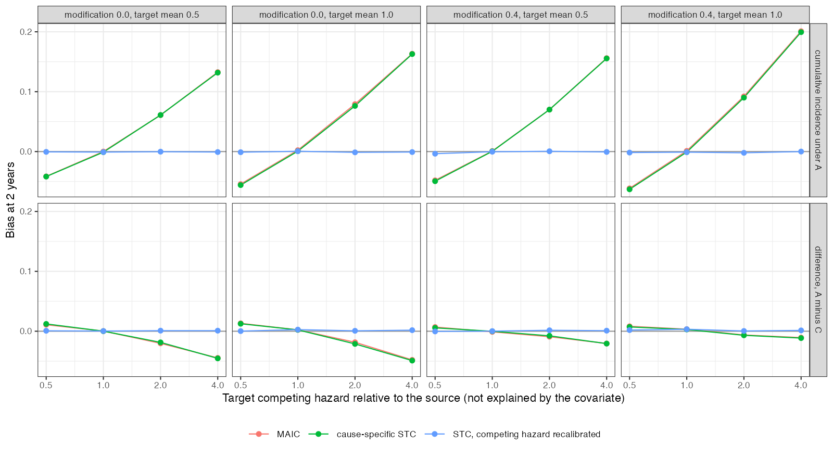
Figure 1: Bias at 2 years of A’s cumulative incidence and of the A-minus-C difference against the target’s relative competing hazard.
The bias of the absolute incidence grew with the competing-hazard ratio and had the sign the mechanism predicts (Figure 1): a higher competing hazard in the target removes patients before they can have the event, so source-based estimates were too high. The difference between arms moved in the same direction but by less, because the competing hazard scales both arms’ incidence.
The recalibrated analysis was unbiased for both quantities. Its intervals for the difference held nominal coverage (0.943 to 0.972); for the absolute incidence they did not, and adding the sampling variance of the reported proportion would be needed.

4. What this does not answer
Only the competing-risks family was run; cure fractions, recurrent events, ordinal outcomes and joint net-benefit outcomes, which DESIGN.md lists, were not. OUT-11 covers non-proportional survival. Exponential hazards and one covariate; no ML-NMR. Peer review has not been done.

References
1. Hein Putter, Marta Fiocco, Ronald B. Geskus. Tutorial in biostatistics: Competing risks and multi-state models. Statistics in Medicine. 2007;26(11):2389–430. doi:10.1002/sim.2712
2. James E. Signorovitch, Eric Q. Wu, Andrew P. Yu, Charles M. Gerrits, Evan Kantor, Yanjun Bao, Shiraz R. Gupta, Parvez M. Mulani. Comparative effectiveness without head-to-head trials: A method for matching-adjusted indirect comparisons applied to psoriasis treatment with adalimumab or etanercept. PharmacoEconomics. 2010;28(10):935–45. doi:10.2165/11538370-000000000-00000
3. Tim P. Morris, Ian R. White, Michael J. Crowther. Using simulation studies to evaluate statistical methods. Statistics in Medicine. 2019;38(11):2074–102. doi:10.1002/sim.8086

