A baseline-risk bridge carries design nuisance across a disconnected network as if it were prognosis
A simulation study answering catalog problem DIS-03
Ahmad Sofi-Mahmudi
2026-09-23

Abstract
Background. Disconnected networks are sometimes linked by assuming that study baseline risks are exchangeable across subnetworks. Catalog problem DIS-03 asks whether design differences between subnetworks, such as endpoint definitions, pass into the cross-gap contrast and whether design covariates can separate them from prognosis.
Methods. Two subnetworks of 5 or 10 trials; study baselines with prognostic variation, possible prognostic drift between subnetworks (0 or 0.2 on the log odds scale) and a design nuisance of 0, 0.2 or 0.5 attached to a binary design covariate that either coincided with the subnetwork or was used by a quarter of the other subnetwork’s trials: 24 scenarios, 2000 replicates each. Exchangeable bridge with and without adjustment for the design covariate.
Results. When the design covariate coincided with the subnetwork, adjustment was impossible and the bridge carried the nuisance one for one (bias 0.207 and 0.500 for nuisance 0.2 and 0.5; coverage 0.084). With a quarter of trials crossing over, adjustment removed the nuisance (bias -0.000) but not prognostic drift, which stayed at 0.204.
Conclusion. A baseline bridge transports whatever makes the subnetworks’ baselines differ. Design covariates separate nuisance from prognosis only if they vary within subnetworks; prognostic differences between subnetworks remain unidentified. Report how much of each cross-gap contrast the bridge supplies and treat it as an assumption, not an estimate.

1. The problem
Study baselines are : prognosis , which the bridge is meant to carry, plus design nuisance from endpoint definition, follow-up or ascertainment. The likelihood sees only , and the contrast that would separate from spans the gap. A design covariate identifies only where it varies within a subnetwork.

2. Design
Registered protocol: protocol.md; ADEMP structure (1). Subnetwork 1: A versus B; subnetwork 2: C versus D. Arm-level log odds with arm-level SE 0.15; . The exchangeable bridge estimates as the difference in mean control-arm log odds between subnetworks; the adjusted bridge regresses control-arm log odds on subnetwork and the design covariate.

3. Results
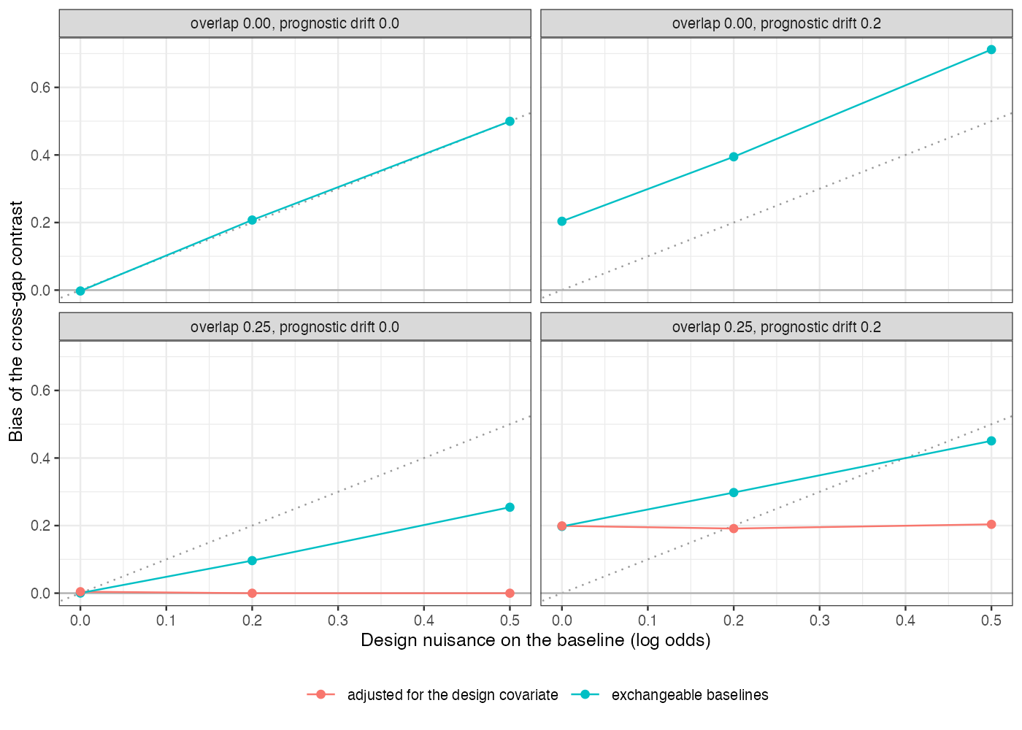
Figure 1: Bias of the cross-gap contrast by design nuisance, with and without adjustment, ten trials per subnetwork. The dotted line is bias equal to the nuisance.
Without crossover the unadjusted bias lay on the identity line (Figure 1), plus any prognostic drift. With crossover the unadjusted bias was diluted but not removed, and adjustment removed exactly the part attributable to the design covariate. Prognostic drift is by definition a baseline difference with no design signature, so no covariate in the network could remove it.

4. What this does not answer
Study-level summaries on the log odds scale rather than an arm-based Bayesian model; no commensurate prior; one design covariate. Peer review has not been done.

References
1. Tim P. Morris, Ian R. White, Michael J. Crowther. Using simulation studies to evaluate statistical methods. Statistics in Medicine. 2019;38(11):2074–102. doi:10.1002/sim.8086

