A negative-control outcome calibrates transport bias only when it shares the primary outcome’s bias exactly
A simulation study answering catalog problem IDN-09
Ahmad Sofi-Mahmudi
2026-09-23

Abstract
Background. Negative-control outcomes detect and calibrate confounding within one data source. Catalog problem IDN-09 asks whether they transfer to transport bias in indirect comparisons, where the bias comes from population differences between studies.
Methods. Unanchored MAIC with an unmeasured covariate shifted by 0.5 SD between populations or not; a negative-control outcome with no treatment effect whose dependence on was none, half, equal to or twice the primary outcome’s; and either modifying A’s effect or not: 16 scenarios, 2000 replicates each. A control test and a calibrated contrast (primary minus control) were compared with naive MAIC.
Results. The control test held its size without a shift (0.039 to 0.056) and flagged the shift in 0.043 to 0.834 of analyses depending on the control’s dependence on . Calibration removed the bias only when the control’s dependence equaled the primary’s and did not modify the effect (bias 0.001 against 0.229 naive). With modification it left 0.170; with a control twice as dependent it overcorrected to -0.183, and with modification it happened to cancel (-0.003).
Conclusion. For transport a negative control must share the primary outcome’s bias exactly, including any modification of the treatment effect, which an outcome with no treatment effect cannot do. Use a control signal to detect population differences, not to correct for them.

1. The problem
A negative control (1) shares the confounding pathway of the primary outcome within one population. Across studies the bias is a transport gap: an unmeasured covariate distributed differently between populations. It biases an unanchored MAIC (2) through its prognostic effect on the outcome and through any modification of the treatment effect. A control outcome with no treatment effect can share only the first, and only if its prognostic dependence matches.

2. Design
Registered protocol: protocol.md; ADEMP structure (3). Individual data on 500 patients of A; the target publishes B’s (500) proportions for the primary outcome and the control and the mean of a measured covariate. : , with B’s effect and A’s effect ; : . MAIC balances . The calibrated contrast subtracts the control contrast and adds its variance.

3. Results
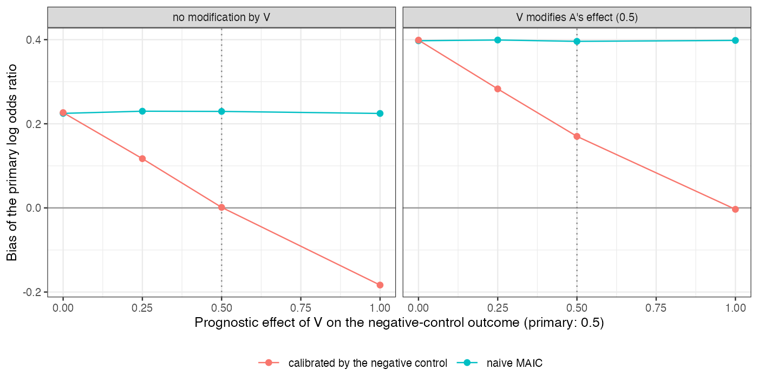
Figure 1: Bias of the naive and calibrated contrasts with a population shift, by the control’s dependence on the unmeasured covariate. The dotted line marks a control matching the primary.
Calibration moved the estimate by the control’s bias whatever the primary’s was (Figure 1). The naive bias came from two sources, prognosis and modification; the control could carry only the first, in proportion to its own dependence on . The control test’s power rose with that dependence, so the controls that are easiest to detect with are the ones most likely to overcorrect.

4. What this does not answer
One control outcome rather than a bank with empirical calibration; unanchored comparisons only; how often suitable control outcomes are reported in appraisal submissions was not surveyed. Peer review has not been done.

References
1. Marc Lipsitch, Eric Tchetgen Tchetgen, Ted Cohen. Negative controls: A tool for detecting confounding and bias in observational studies. Epidemiology. 2010;21(3):383–8. doi:10.1097/EDE.0b013e3181d61eeb
2. James E. Signorovitch, Eric Q. Wu, Andrew P. Yu, Charles M. Gerrits, Evan Kantor, Yanjun Bao, Shiraz R. Gupta, Parvez M. Mulani. Comparative effectiveness without head-to-head trials: A method for matching-adjusted indirect comparisons applied to psoriasis treatment with adalimumab or etanercept. PharmacoEconomics. 2010;28(10):935–45. doi:10.2165/11538370-000000000-00000
3. Tim P. Morris, Ian R. White, Michael J. Crowther. Using simulation studies to evaluate statistical methods. Statistics in Medicine. 2019;38(11):2074–102. doi:10.1002/sim.8086

