A proportional-odds violation biases an expected-utility difference in both directions, depending on where the utility increments sit
A simulation study answering catalog problem OUT-10
Ahmad Sofi-Mahmudi
2026-09-23

Abstract
Background. Target-standardized category probabilities from a proportional-odds model feed decision models with category utilities. Catalog problem OUT-10 asks whether a proportional-odds violation reaches the decision only through the utility increment at the violated cut-point, and whether relaxing the assumption changes the standardized decision quantity.
Methods. A trial with a four-category outcome and a treatment effect that was proportional, concentrated at the bottom cut-point, or concentrated at the top; utilities with their increments at the bottom or top; proportional-odds regression and separate cut-point logistic regressions, each standardized over a shifted target; 400 replicates per cell.
Results. Under a violation the proportional-odds estimate of the expected-utility difference was biased whichever end carried the utility increments: by -0.025 and -0.047 when the increments sat at the violated cut-point, and by 0.026 and 0.024 when they sat at the other end, with coverage 0.67 to 0.85. The separate cut-point models were unbiased with coverage 0.93 to 0.98 in every cell.
Conclusion. The single proportional-odds coefficient is a compromise that understates the effect at the violated cut-point and overstates it at the others, so the decision is biased whichever way the utilities fall. A proportional-odds check must be read against the utilities, and the relaxed model costs little.

1. The problem
The expected-utility difference is . A proportional-odds fit (1) replaces the cut-point-specific treatment effects by one least-false value. The catalog’s design predicted that the error reaches the decision in proportion to the utility increment at the violated cut-point. That requires the other cut-points’ errors to be small; the least-false averaging makes them not small but opposite in sign.

2. Design
Registered protocol: protocol.md. , , , or ; 300 per arm; target ; utilities or ; G-computation standardization with 60-resample bootstrap SEs.

3. Results
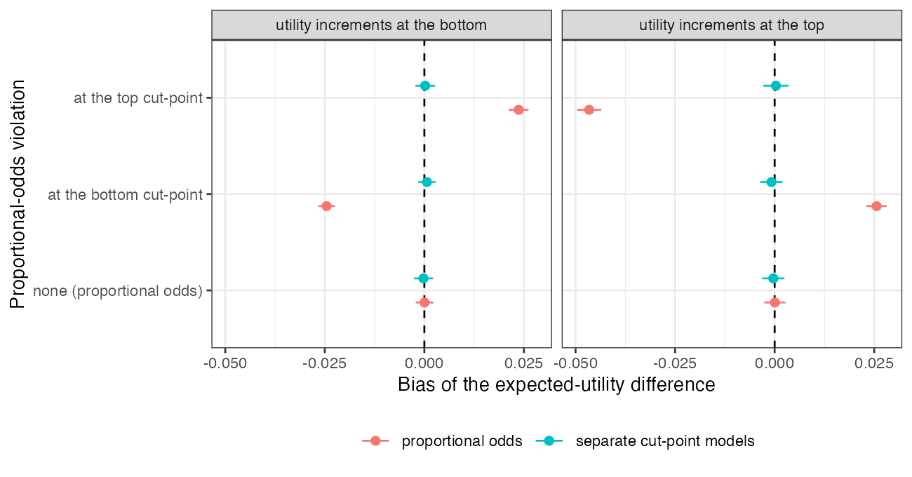
Figure 1: Bias of the expected-utility difference.
Table 1: 400 replicates per cell; bias MCSE at most 0.002.
violation | utility increments | truth | proportional odds: bias (coverage) | separate models: bias (coverage)
po | bottom | 0.078 | 0.000 (0.965) | -0.000 (0.955)
po | top | 0.095 | 0.000 (0.968) | -0.000 (0.978)
bottom | bottom | 0.093 | -0.025 (0.810) | 0.001 (0.950)
bottom | top | 0.061 | 0.026 (0.850) | -0.001 (0.953)
top | top | 0.171 | -0.047 (0.672) | 0.000 (0.930)
top | bottom | 0.080 | 0.024 (0.828) | 0.000 (0.940)

The registered primary was not confirmed (Table 1, Figure 1): the bias with the utility increments at the opposite end was about as large as with them at the violated cut-point, and of opposite sign, instead of being small. The one exception in magnitude was the top violation, where the aligned bias was about twice the misaligned one. Under proportional odds both models were unbiased and nominal.

4. What this does not answer
One individual-data trial rather than an ML-NMR network; separate logistic regressions as the relaxed model (no partial proportional odds or monotonicity constraint); fixed utilities; no dichotomized-publication arm. Peer review has not been done.

References
1. Peter McCullagh. Regression models for ordinal data. Journal of the Royal Statistical Society Series B. 1980;42(2):109–42. doi:10.1111/j.2517-6161.1980.tb01109.x

