Anchored MAIC on the odds ratio scale must balance the spread of prognosis, not only effect modifiers
A simulation study answering catalog problem COV-03
Ahmad Sofi-Mahmudi
2026-09-23

Abstract
Background. Guidance for anchored population adjustment says only effect modifiers need balancing, because purely prognostic covariates cancel in the relative effect. On the log odds ratio scale that is false: the marginal odds ratio depends on the spread of prognosis in the population (Remiro-Azócar 2024, doi:10.1002/sim.10111). Catalog problem COV-03 asks whether this matters in practice.
Methods. Anchored and unanchored binary-outcome comparisons, 500 per arm, three purely prognostic covariates. We varied the variance of the prognostic index in the target, its ratio between source and target, the target mean shift and effect modification: 108 scenarios, 1000 replicates each. MAIC on means, MAIC on means and variances, MAIC on means and the variance of an estimated prognostic index, and G-computation.
Results. In the 12 primary anchored scenarios without effect modification, MAIC on means was biased by 0.049 to 0.108 on the log odds ratio scale, beyond 0.05 in 9; balancing variances cut it to 0.022 or less in 11 scenarios (0.079 in the one with an effective sample size of 44). The unadjusted bias matched the exact population bias (slope 0.981). The price was effective sample size: when the source’s prognostic spread was half the target’s, balancing variances left 44 to 284 of 1000 and raised RMSE above that of MAIC on means. G-computation was unbiased (at most 0.010) with the lowest RMSE in every primary scenario.
Conclusion. On a non-collapsible scale an anchored comparison must account for differences in the spread of prognosis between trials. G-computation does so without losing precision; with MAIC, balancing variances helps when the source’s prognostic spread exceeds the target’s and costs more than it gains when it is smaller.

1. The problem
With prognostic index and no effect modification, the marginal log odds ratio in population is , which moves toward zero as grows and also depends on the index mean. The A versus C effect in the source differs from the one in the target even with no modification, and MAIC (1) on means leaves the difference in spread untouched. DESIGN.md claimed the effect depends on only through ; the probe showed a mean shift alone moves it by 0.004 to 0.018.

2. Design
Registered protocol: protocol.md; ADEMP structure (2). Source A versus C with ; target B versus C reporting arm events and covariate means and SDs, . . Factors: ; ; ; ; anchored or unanchored. G-computation fits the logistic model in the source and marginalizes over normals with the published moments. Primary scenarios: anchored, no modification, , .

3. Results
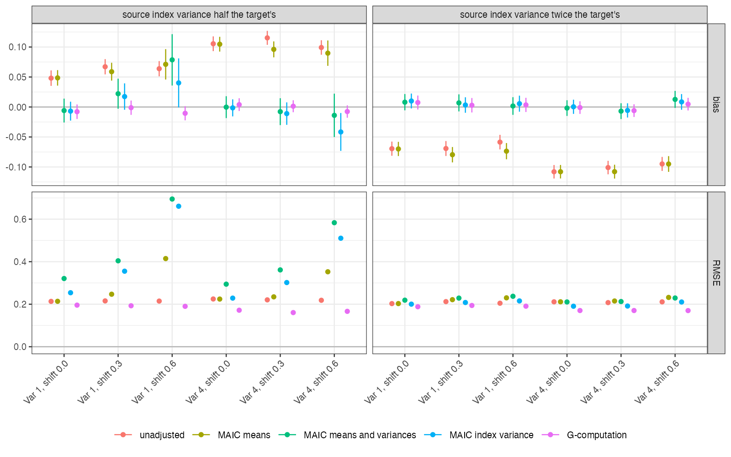
Figure 1: Bias with 95% Monte Carlo intervals and RMSE in the 12 primary anchored scenarios.
MAIC on means removed none of the bias that the unadjusted Bucher comparison carried when prognostic spread differed (Figure 1): both were biased in the direction the exact calculation predicted, negative when the source was more dispersed. Balancing variances or the index variance removed it in all 12 scenarios.
Effective sample size decided whether that removal paid. With the source less dispersed than the target, variance balancing had to up-weight the few extreme source patients, and its RMSE exceeded that of MAIC on means in NA of 6 scenarios. With the source more dispersed, it cost little: balancing the index variance lowered RMSE in NA of 6 scenarios and balancing every variance in NA, the rest within 0.01. Balancing only the estimated index variance kept more effective sample size than balancing every variance (522 against 361 on average) with similar bias.
With effect modification present the same pattern held (largest MAIC-on-means bias 0.118). Unanchored, every adjustment beat the unadjusted comparison, whose bias reached 1.533, and G-computation was again unbiased. Controls held: with identical populations every method was unbiased, and the positive control was biased as predicted.

4. What this does not answer
Independent normal covariates and a correctly specified logistic model, which favor G-computation; with a misspecified outcome model its advantage can reverse. Hazard ratios, skewed covariates and augmented estimators were not run. MAIC intervals treat the weights as fixed. Peer review has not been done.

References
1. James E. Signorovitch, Eric Q. Wu, Andrew P. Yu, Charles M. Gerrits, Evan Kantor, Yanjun Bao, Shiraz R. Gupta, Parvez M. Mulani. Comparative effectiveness without head-to-head trials: A method for matching-adjusted indirect comparisons applied to psoriasis treatment with adalimumab or etanercept. PharmacoEconomics. 2010;28(10):935–45. doi:10.2165/11538370-000000000-00000
2. Tim P. Morris, Ian R. White, Michael J. Crowther. Using simulation studies to evaluate statistical methods. Statistics in Medicine. 2019;38(11):2074–102. doi:10.1002/sim.8086

