Missing covariates in the individual-data trial of a MAIC: the mechanism decides, and the repairs can make it worse
A simulation study answering catalog problem MIS-01
Ahmad Sofi-Mahmudi
2026-09-23

Abstract
Background. When a matched covariate is missing for some patients in the individual-data trial, complete-case MAIC matches the target on the records it keeps, so the balance table looks perfect whatever deletion did. Catalog problem MIS-01 asks when this is biased and whether weighting or imputation repairs it.
Methods. Continuous-outcome anchored MAIC with a partly missing matched covariate , an observed matched covariate and an unmatched covariate correlated with . Missingness of 15%, 30% or 50% driven by nothing, , , the outcome, in one arm only, or itself; prognostic only or also modifying: 36 scenarios, 1000 replicates each. Complete case, observation weighting (1) and multiple imputation with and without arm interactions.
Results. Complete-case bias followed the mechanism, not the rate: unbiased in all 24 scenarios predicted unbiased, including missingness driven by itself, and biased already at 15% where predicted (for example -0.338 with arm-specific missingness). When missingness depended on itself, weighting and imputation, which assume the data missing at random, were biased by up to 0.221 while complete case stayed within 0.035. When 95% of one arm was missing, weighting and arm-interacted imputation failed (bias -0.978 and -0.193). Otherwise imputation with arm interactions was the most reliable repair under missing at random.
Conclusion. Report the missingness mechanism, not the rate. Complete case is the right analysis when missingness depends only on the matched covariates, including the missing one; imputation with arm interactions when it depends on unmatched variables or the outcome.

1. The problem
MAIC (2) gives both arms of the individual-data trial the same weights, so a shift in an unmatched covariate that deletion causes in both arms cancels in the contrast unless modifies the effect. A shift confined to one arm does not cancel, even for a purely prognostic . Deletion driven by the matched covariates themselves, including the missing one, leaves the conditional law of everything else given the matched covariates unchanged, so MAIC on the complete cases still targets the right population. Weighting and imputation assume the data missing at random given observed variables, which fails exactly when missingness depends on itself.

2. Design
Registered protocol: protocol.md; ADEMP structure (3). 250 per arm; ; , ; target means of 0.5. Missingness logistic in the driver with an intercept set to the rate; for the arm-specific mechanism all missingness falls in arm A at twice the rate (95% at most). Observation weighting models the probability of a complete record on , and interacted with arm; imputation uses five draws, normal regression, and Rubin’s rules (4).

3. Results
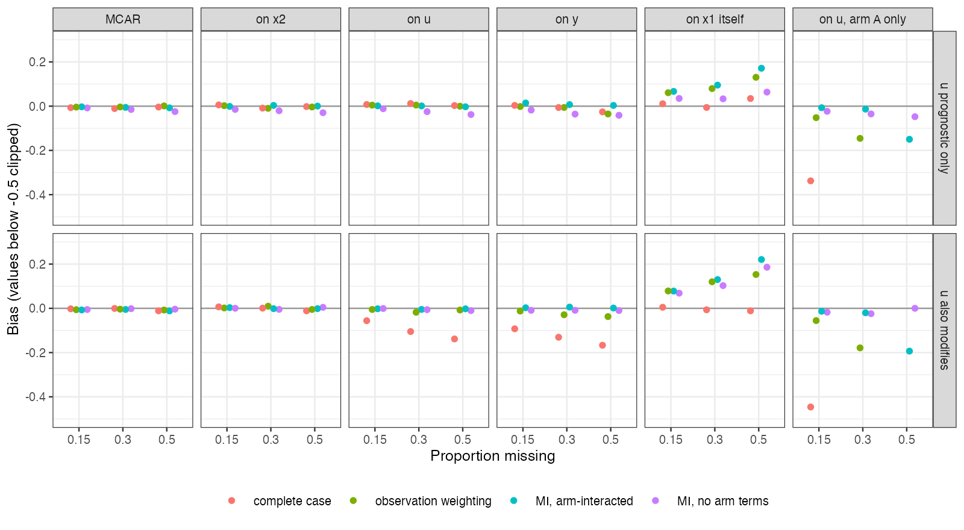
Figure 1: Bias by missingness mechanism, method and rate. Arm-specific missingness produced complete-case bias below the plotted range.
Figure 1 shows the pattern. Missingness driven by or biased complete case only when modified the effect (-0.105 and -0.131 at 30%). Missingness in one arm driven by biased it whether or not modified (-0.652 at 30% with prognostic only).
Under missing at random, imputation with arm interactions was within 3 MCSE of zero in 24 of 24 scenarios; imputation without arm terms had small systematic bias (up to 0.041), since it ignores the modification of ’s relation to by arm. Observation weighting was unbiased except under arm-specific missingness, where 60% to 95% of arm A was missing and weights became extreme (bias -0.146 at 30% and -0.780 at 50%).
When missingness depended on itself, the repairs were biased by 0.079 (weighting) and 0.095 (imputation) at 30%, against -0.006 for complete case.

4. What this does not answer
Missing outcomes, binary outcomes, STC, overlap levels and a pattern-mixture sensitivity analysis for missingness not at random were not run. The mechanisms are single-driver; mixtures make the choice between complete case and imputation depend on their relative weight, which the data cannot reveal. Peer review has not been done.

References
1. Fang, Li, Lai, He. Missing data handling in the application of matching-adjusted indirect comparison. Therapeutic Innovation & Regulatory Science. 2026;60(4):1103–11. doi:10.1007/s43441-026-00914-2
2. James E. Signorovitch, Eric Q. Wu, Andrew P. Yu, Charles M. Gerrits, Evan Kantor, Yanjun Bao, Shiraz R. Gupta, Parvez M. Mulani. Comparative effectiveness without head-to-head trials: A method for matching-adjusted indirect comparisons applied to psoriasis treatment with adalimumab or etanercept. PharmacoEconomics. 2010;28(10):935–45. doi:10.2165/11538370-000000000-00000
3. Tim P. Morris, Ian R. White, Michael J. Crowther. Using simulation studies to evaluate statistical methods. Statistics in Medicine. 2019;38(11):2074–102. doi:10.1002/sim.8086
4. Donald B. Rubin. Multiple imputation for nonresponse in surveys. New York: Wiley; 1987.

