Transporting count outcomes: overdispersion breaks the interval, a differing zero fraction breaks the absolute rate
A simulation study answering catalog problem OUT-08
Ahmad Sofi-Mahmudi
2026-09-23

Abstract
Background. Count outcomes such as exacerbations are transported from an individual-data trial to a target population with Poisson or negative binomial G-computation. Catalog problem OUT-08 asks what overdispersion and structural zeros do to the transported estimate.
Methods. A versus C trial of 300 per arm, one covariate, target shifted by 0.5 SD. Part A: negative binomial counts with size , 2 or 0.7 and no structural zeros. Part B: Poisson counts with a structural-zero fraction of 0.2 in the source and 0, 0.2 or 0.4 in the target, or 0 and 0.2. Each with or without effect modification: 14 scenarios, 500 replicates each. Poisson, Poisson with a sandwich variance, negative binomial, zero-inflated Poisson, and zero-inflated Poisson with its zero part recalibrated to the target’s reported proportion of control patients without events.
Results. Overdispersion left the Poisson rate ratio unbiased and cut its coverage to 0.610; a sandwich variance restored 0.926 to 0.948 and the negative binomial 0.936 to 0.962. The registered rule required the sandwich to reach 0.93 in every cell and missed by 0.004 in one (MCSE 0.012). A structural-zero fraction that differed between populations biased the transported absolute log rate by up to 0.564 in every count model, with coverage near zero. The rate ratio was protected without effect modification (bias at most 0.007) and biased by up to 0.115 with it. Recalibrating the zero part to the target’s reported zero proportion removed the absolute-rate bias when the source had structural zeros (at most 0.041), but not when it had none (0.254).
Conclusion. Overdispersion is a variance problem that a sandwich or negative binomial fixes. A differing zero fraction is a transport problem that no dispersion parameter fixes; it needs target information on zeros and a source in which the zero process is identifiable.

1. The problem
Under a negative binomial with the correct mean, the Poisson score equations are unbiased, so the estimate is consistent and only the model-based variance is wrong (1). Structural zeros are different. If a fraction of patients cannot have events, the target rate is , and a model fitted to the source learns . The rate ratio cancels when the effect is constant; with effect modification the at-risk composition enters the ratio too. A zero-inflated model (2) separates the two parts, but its zero part still describes the source.

2. Design
Registered protocol: protocol.md; ADEMP structure (3). Counts: structural zero with probability , otherwise NB with mean , . The two parts are not crossed, so the zero-inflated fit is not misspecified by dispersion in part B. G-computation over the target law; delta-method SEs. The recalibrated model shifts the zero-part intercept until its predicted zero proportion in the target control arm matches the reported one; its SE ignores the sampling error of that proportion.

3. Results
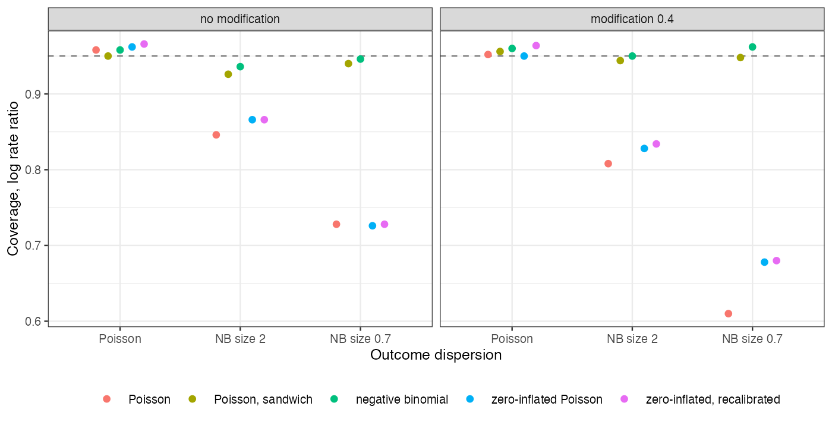
Figure 1: Coverage of the transported log rate ratio by outcome dispersion (part A).
Part A (Figure 1): every mean model was unbiased for the rate ratio (Poisson at most 0.010); only the intervals differed. The zero-inflated Poisson, misspecified by the dispersion, lost coverage like the Poisson (0.678).
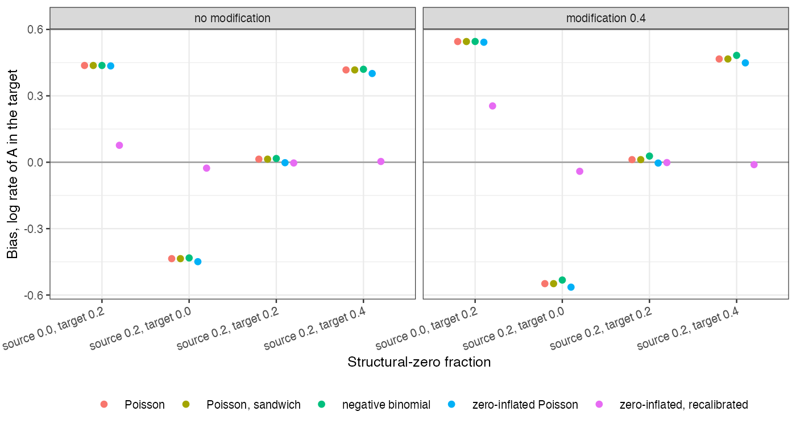
Figure 2: Bias of A’s transported log rate by structural-zero fractions (part B).
Part B (Figure 2): with equal zero fractions every model transported correctly. With the target’s fraction higher or lower than the source’s, the absolute rate was off by the log of the ratio of at-risk fractions, and the zero-inflated model was no better than the Poisson. Recalibration needs the zero part’s slope from the source, which is not identified when the source has no structural zeros; there it overcorrected. Its coverage (0.872 to 0.950 where it was unbiased) reflects the ignored uncertainty in the reported zero proportion.

4. What this does not answer
One covariate; frailty models, exposure-time weighting (CMP-20), recurrent-event models and zero-inflated negative binomial fits were not run. The target’s zero proportion was assumed reported for its control arm. Peer review has not been done.

References
1. Achim Zeileis. Object-oriented computation of sandwich estimators. Journal of Statistical Software. 2006;16(9):1–16. doi:10.18637/jss.v016.i09
2. Diane Lambert. Zero-inflated poisson regression, with an application to defects in manufacturing. Technometrics. 1992;34(1):1–14. doi:10.2307/1269547
3. Tim P. Morris, Ian R. White, Michael J. Crowther. Using simulation studies to evaluate statistical methods. Statistics in Medicine. 2019;38(11):2074–102. doi:10.1002/sim.8086

