A shared interaction matrix in component multilevel network meta-regression forces a causal coefficient to equal a confounded one
A simulation study answering catalog problems CMP-13 and IDN-06
Ahmad Sofi-Mahmudi
2026-07-28

Abstract
Component multilevel network meta-regression estimates treatment-by-covariate interactions from individual and aggregate data together, fitting one shared interaction matrix on a globally centered covariate. For a binary modifier with study-specific prevalence that parameterization is algebraically identical to imposing that the within-trial interaction, which randomization makes causal, equals the across-trial association between a study’s case mix and its treatment effect, which nothing randomizes.
In 320 scenarios and 640,000 simulated component networks, coverage of a nominal 95% interval for the causal within-trial interaction falls from 93.8% when the restriction happens to be true to 17.2% when the two coefficients are equal and opposite. Separating them restores it: the joint split and the IPD-anchored estimator stay within 92.6% to 96.3% across every discordance examined.
The catalog’s stated cause is incomplete rather than wrong. CMP-13 says aggregate studies pull the shared estimate. With all twelve trials supplying individual patient data the shared model still has median absolute standardized bias 0.15 and coverage as low as 44.6%, so aggregate data are not necessary for the conflation. But removing individual data makes it worse, from median 0.15 at full availability to 0.29 at the sparsest, so aggregate data amplify it. The restriction is the cause; aggregate data are an aggravating factor.
A component with no within-trial information behaves differently again. There the IPD-anchored estimator declines to report, as it should; the shared model returns an estimate of -0.34 against a truth of zero, of the wrong sign and sourced entirely from the ecological gradient; and the joint split returns intervals so wide that coverage approaches one, when it returns one at all. The failure in both cases is that a number is produced at all, not that the interval is narrow.
A cluster-robust variance made things worse. With twelve studies the study-clustered sandwich covered 75.4% to 92.4% in scenarios where the shared model is correctly specified, so it is reported as a finding rather than used as a comparator.

1. The problem
Component network meta-analysis decomposes multicomponent interventions into the parts they share, so that a network which is disconnected at the level of whole treatments can be reconnected through common components (1). Multilevel network meta-regression (ML-NMR) synthesizes individual and aggregate data by specifying a model at the individual level and integrating it over each study’s covariate distribution (2,3). Component ML-NMR combines the two, and estimates a single interaction matrix describing how covariates modify component effects.
That single matrix is the problem. For a binary modifier with prevalence in study , a shared interaction fitted on the globally centered covariate satisfies the identity

The two pieces are not the same kind of quantity. The within-trial coefficient is identified by randomized comparisons between covariate strata inside a trial; it is a causal interaction. The across-trial coefficient is the association between a study’s case mix and its treatment effect across trial populations that nobody randomized, and is confounded by everything else that differs between them: era, setting, adherence, concomitant care.
Equation 1 shows that fitting one shared does not pool two sources of information. It imposes .
Separating them by centering covariates at the trial mean is long-standing advice in individual-participant meta-analysis (4–6). It has not been carried into component ML-NMR. multinma’s center argument does not do it: that centers regression terms about the overall mean, which is numerical conditioning, and only per-study centering separates the two sources. This was checked against the package documentation for version 0.9.1.9002.
Two catalog entries state the gap. CMP-13 says a shared lets aggregate studies pull the estimate toward a non-randomized across-trial association. IDN-06 says interaction directions without adequate within-study individual data are weakly identified and are then sensitive to aggregate variation, so one coefficient carrying both sources conflates individual-level effect modification with an ecological gradient.
Equation 1 already settles that the shared model is misspecified when . Three things it does not settle, and which this study measures: how much the restriction costs and at what discordance; whether the cause is really the aggregate data, as CMP-13 states; and what happens to a component that has no within-trial information at all.

2. Design
The protocol was registered before the run and is reproduced at studies/CMP-13-within-between-interaction/protocol.md. Reporting follows ADEMP (7).

2.1 Data-generating mechanism
Twelve two-arm randomized trials over four regimens built from two components: control , A , B , AB . One binary modifier with study prevalence ; write . The individual log rate is

with , , , and , . The within-trial interactions are and , that is, rate-ratio interaction multipliers of 1.50 and 0.70 for against ; they are zero under null and between-only. Reviewers asked for these because alone does not fix the absolute discrepancy: at the gap is for component A on the log-rate scale, and at it is . The nonlinear pattern uses and with the mean of over the twelve prevalences, so its linear projection is near zero by symmetry. The twelve prevalences are 0.35 to 0.65 in the narrow setting and 0.15 to 0.85 in the wide one, allocated so that each of the four trial designs receives one value from each tertile. Outcomes are Poisson with unit exposure. The across-trial term is with , so is the discordance: at a single shared is exactly correct.
Aggregate arms are generated by exact integration: the arm total is Poisson with mean . This is exactly the distribution of the sum of the individual outcomes because the covariate counts are fixed: allocation is stratified with and , so is a realized finite-sample stratum proportion and not a Bernoulli sampling probability. Had covariates been drawn independently as Bernoulli, the arm total would be a Poisson mixture with extra variation and the stated equality would be false. Peer review asked which construction was used; it is the fixed-count one, and the distinction matters for the standard errors. Generating aggregate arms by a regression on would test a method nobody uses, since ML-NMR integrates precisely to avoid that.

2.2 Factors
Factor | Levels
Network structure | isolating, bundled
Discordance | , plus null, between-only, nonlinear
Individual data | all 12 trials, six, four, four lowest-prevalence, none containing component B
Participants per arm | 100, 400
Prevalence spread | narrow (0.35 to 0.65), wide (0.15 to 0.85)
Fully factorial: 320 scenarios, 2000 replicates each, 640,000 networks.
Two of these exist because an adversarial review of the design found the study would otherwise have answered a different question.
Network structure. In the design as first proposed, every contrast added exactly one component, so each interaction was recoverable from a directly component-isolating comparison: the study would have tested ordinary network meta-regression while claiming to test component models. The bundled network contains control:AB, which moves both components at once, and A:B, which removes one while adding the other, so contrasts are aliased across components and the component decomposition has to do real work. Both structures still identify both component main effects.
A component with no within-trial information. No proposed pattern produced IDN-06’s actual case. The no-B-ipd scheme gives individual data only to trials in which component B never appears in any arm. Constructing it required a correction: the within-trial estimator identifies from the covariate slope inside an arm, which is , not from the treatment contrast, so a single arm containing component B identifies once is known even where no contrast in that trial changes B.
That construction also bounds what “within-trial” buys here, and peer review was right to press on it. Randomization identifies a treatment-by-covariate interaction through differences in treatment contrasts across baseline covariate strata. The stage-one estimator instead reads off arm-level covariate slopes, which additionally assumes a prognostic slope common across arms and studies. Under this data-generating mechanism that assumption holds by construction. It is a modeling assumption, not a consequence of randomization, and calling the resulting coefficient causal is therefore conditional on it. In bundled networks a component interpretation further requires component additivity and consistency, which also hold here by construction.

2.3 Estimand and methods
The estimand is the within-trial component interaction : the difference in conditional log rate ratio for adding component between otherwise comparable randomized individuals with and in the same trial. The truth is the coefficient the pattern specifies, so no Monte Carlo evaluation is needed.
All methods maximize the same integrated component likelihood by maximum likelihood with analytic gradients, study intercepts profiled analytically (8), and Newton polishing until the maximum absolute score falls below .
Method | Interaction parameterization | What may inform
Shared (status quo) | one on | everything, with imposed
Shared + sandwich | identical point estimate | as above, with a 12-study cluster sandwich
Joint split | on , on | everything, including aggregate curvature
IPD anchored | from individual data only, free intercept per study-arm | within-arm covariate slopes in individual data only
The sandwich variant exists so the comparison cannot be won merely by giving the proposed method a more robust variance estimator. The IPD-anchored method declines to report a component appearing in no individual-data arm, returning it as not estimable rather than supplying a number from an ecological gradient.
Failures are not dropped silently: every measure is computed over converged replicates and again counting a failure as non-coverage, and declining to report is counted separately from failing to converge, because refusing to answer is a design feature of one method.

3. Results

3.1 The registered global result
Read across all 320 scenarios, the registered gates fail: the negative controls of the shared model lie outside 0.93 to 0.97 in 15 of 160 control scenarios and the split model’s in 27 of 160. The registered conclusion is therefore uninformative, and it is reported first for the same reason it was in the previous study of this program.
The cause is confined to one factor level, and everything below is what follows from splitting on it. That split was made after seeing the pooled result. It is on a level of a factor fixed before the run rather than on an observed outcome, which is a weaker objection than selection on results but not the same as prespecification, and the protocol amendment says so.

3.2 Two regimes
The grid splits into 256 scenarios in which every component has within-trial information, and 64 in which one component has none. In the second the shared and joint models are near-unidentified for that component, failing to return an interval on 11% of replicates against 0.02% elsewhere. Pooling the two makes the negative controls fail and describes neither, so they are reported separately. This is a different move from restricting by an observed outcome, and the protocol amendment says so.
In the primary regime every gate passes: convergence, agreement between conditional and unconditional summaries, and the negative controls of all three main methods.

3.3 What the restriction costs
Table 1: Coverage of nominal 95% intervals for the within-trial component interaction in the primary regime, as a range over network structure, individual-data availability, arm size, prevalence spread and component.
Discordance | Shared | Joint split | IPD anchored
(shared correct) | 93.850 to 95.800 | 93.844 to 96.000 | 93.750 to 95.900
 | 88.250 to 95.900 | 93.750 to 96.148 | 93.800 to 96.200
 | 65.500 to 96.250 | 93.644 to 95.950 | 93.900 to 96.050
 | 38.600 to 95.600 | 93.700 to 95.950 | 93.600 to 95.950
 | 17.200 to 95.950 | 92.635 to 96.042 | 93.100 to 96.300
no within-trial modification | 67.700 to 96.000 | 94.100 to 96.250 | 94.050 to 96.250
nonlinear across-trial | 64.950 to 95.550 | 94.400 to 96.200 | 94.300 to 96.300

Median coverage under the shared restriction falls monotonically as the two coefficients diverge: 0.950, 0.947, 0.941, 0.934, 0.918 at . It is lower in the bundled network, where contrasts move two components at once, than where every contrast isolates one, by -0.9 to -0.3 percentage points on the medians; the direction is consistent across every discordance but the size is modest and should not be overstated.
Separating the coefficients removes almost all of it. The joint split lies inside 0.93 to 0.97 in 511 of 512 scenarios; the single exception covers 0.926, about four Monte Carlo standard errors below nominal, so “nominal everywhere” would be wrong and is not claimed. The IPD-anchored estimator lies inside the band in 512 of 512. Both hold under the nonlinear across-trial pattern, where the linear split model is itself misspecified.
What separation costs. It is not free, but it is cheap. Across discordant scenarios in the primary regime, the split estimator’s empirical standard error is 1.048 times the shared model’s and its intervals are 1.058 times as wide, while its median absolute bias is 0.003 against 0.039. Roughly five per cent more width buys an order of magnitude less bias.
The prespecified conclusion is material at mild discordance: at and , 2 of 32 cells fall below 0.90 coverage with Monte Carlo intervals excluding nominal, both in the bundled network.
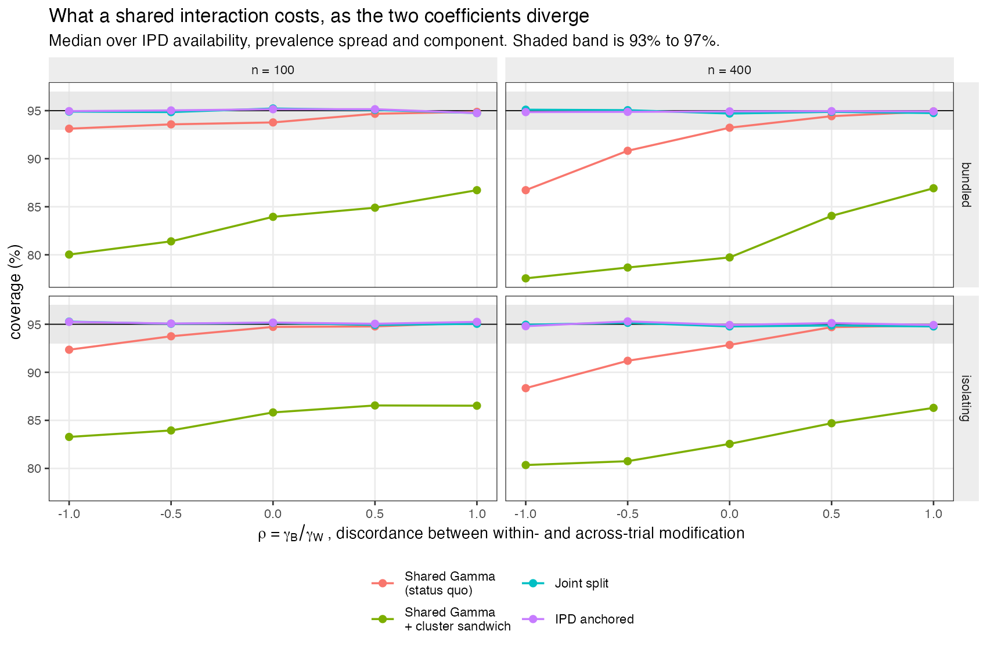
Figure 1: Coverage against the discordance between the within-trial and across-trial coefficients.
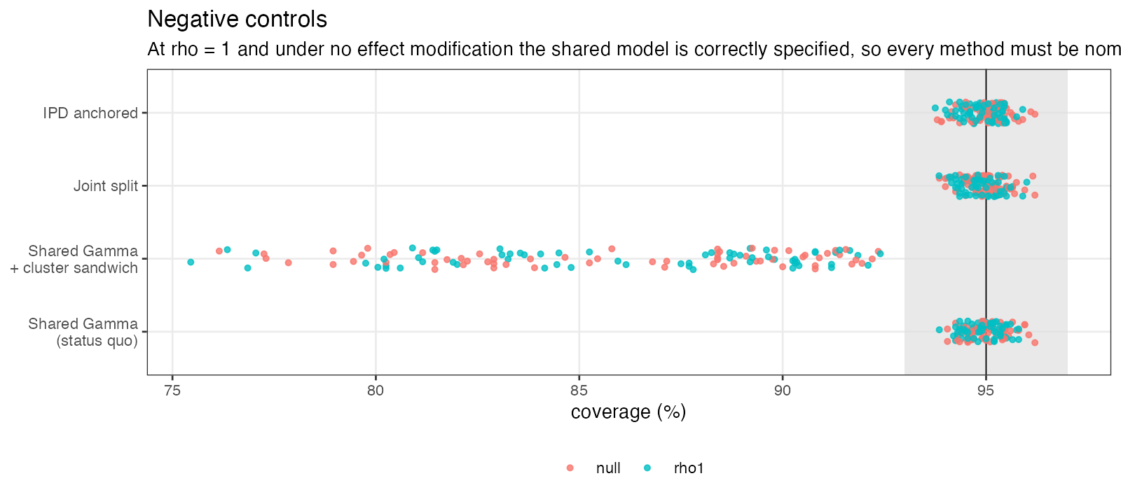
Figure 2: Negative controls: where the shared model is correctly specified, every method is nominal.

3.4 The cluster-robust comparator fails its own controls
The sandwich here is the uncorrected CR0 form, with over the study score vectors, with normal critical values and no degrees-of-freedom adjustment. No small-cluster correction of the CR2 or Bell-McCaffrey type was applied, and the established small-sample cluster-robust literature would predict exactly the anticonservatism seen; the result is reported as an observation about an uncorrected twelve-cluster estimator in this setting, not as a contribution to that literature.
shared-sandwich was included so the comparison could not be won by giving the proposed method a better variance estimator. It covered 75.4% to 92.4% in the 128 control scenarios where the shared model is correctly specified. With twelve studies the study-clustered sandwich is badly anticonservative, and it is reported as a finding rather than used as the status quo. The status quo is the model-based interval, which passes its controls.

3.5 Is the cause the aggregate data?
CMP-13 states that aggregate studies pull the shared estimate toward the across-trial association. That is a claim about cause and the protocol registered it as a separate test.
Table 2: Absolute standardized bias of the shared model across discordant scenarios, by how many trials supply individual patient data. If the catalog’s mechanism were right, the first row would be near zero.
Individual data from | Median | Maximum | Above 0.20 | Worst coverage
All 12 trials | 0.15 | 2.03 | 48% | 44.6%
Six trials | 0.22 | 2.32 | 52% | 33.7%
Four trials | 0.29 | 2.80 | 56% | 17.2%
Four lowest-prevalence trials | 0.26 | 2.82 | 56% | 18.2%

With every trial supplying individual patient data the shared model still has median absolute standardized bias 0.15, a maximum of 2.03, and coverage as low as 44.6%.
The prespecified support threshold required absolute standardized bias below 0.10 everywhere, which fails. The prespecified refutation threshold required more than half of the cells above 0.20; 48% are, which is just short of it. The claim is therefore not supported, and falls narrowly short of the registered refutation threshold. We report it that way rather than moving the threshold.
What the evidence does show is narrower than an earlier draft claimed. Bias is present at full individual-data availability, so aggregate data are not necessary for the conflation; the parameterization alone produces it. But bias also grows as individual data are removed, from median 0.153 with all twelve trials to 0.285 at the sparsest, with worst-case coverage falling from 44.6% to 17.2%. Aggregate data therefore amplify it. CMP-13’s mechanism is incomplete rather than wrong: it names an aggravating factor as the cause.
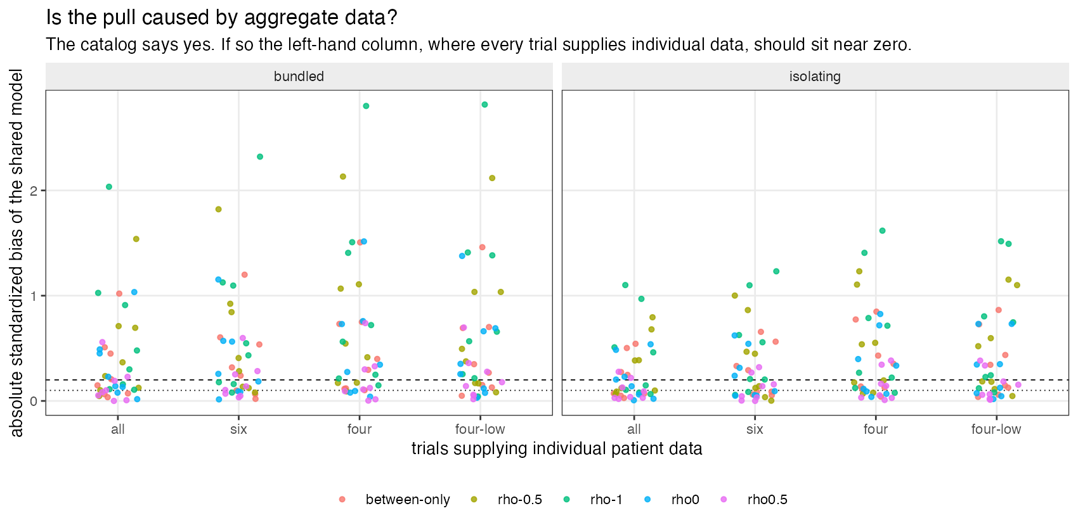
Figure 3: If the catalog’s mechanism were right, the left-hand column would sit near zero.

3.6 A component with no within-trial information
In the second regime one component appears in no individual-data arm, so its within-trial interaction has no within-trial information anywhere. Three behaviors, all different.
The IPD-anchored estimator declined to report it in 100% of replicates, which is what it is designed to do.
The shared model returned an estimate. In the pattern where the true within-trial interaction is exactly zero, its mean estimate was -0.340: the wrong sign and magnitude, sourced entirely from the across-trial gradient. Its coverage there is 90.5%, which is high only because the intervals are very wide, not because the estimate is good. The failure is that a number is produced at all.
The joint split returned intervals so wide that coverage approaches one, when it returned one at all; it failed to produce an interval on a large minority of replicates. Separating the coefficients protects the estimate from ecological information but cannot manufacture within-trial information that does not exist, and the honest output in that case is the refusal.
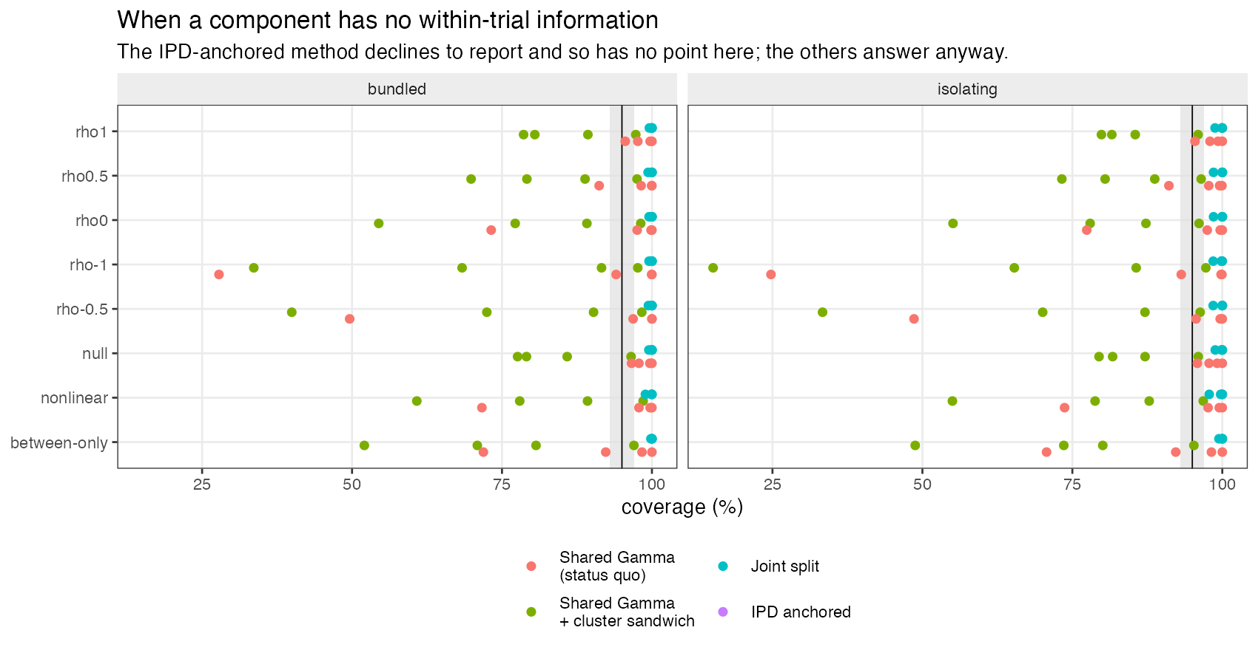
Figure 4: What each method does for a component that appears in no individual-data arm.

4. What this answers, and what it does not
What the identity does and does not constrain. Equation 1 is an algebraic decomposition of one regression term. Whether a given implementation is thereby constrained depends on its nuisance structure: free study-by-treatment or study-by-component effects can absorb the study-constant term , and random treatment effects or priors can change the pseudo-true value of a shared coefficient rather than simply forcing the equality. This study fits fixed study effects and no random treatment effects, and does not map its likelihood onto the fixed- and random-effect specifications available in component ML-NMR. The headline should be read as applying to the specification simulated here.
Relatedly, the shared and IPD-anchored estimators differ in two ways, not one: the interaction parameterization and the nuisance intercept structure, since the IPD-anchored stage has a free intercept per study-arm. Their contrast is therefore not a clean single-factor comparison, and the joint split, which shares the shared model’s intercept structure, is the cleaner one. Both are reported.
A further precision: the across-trial coefficient here is a nonrandomized contextual association, but it is not confounded by any variable modeled in this mechanism. “Confounded” describes what such a coefficient is exposed to in practice, not something this simulation instantiates.
Scope. This is a maximum-likelihood analogue of component ML-NMR. Implemented ML-NMR is Bayesian, and priors matter most exactly where interactions are weakly identified, so the coverage numbers here do not transfer directly to multinma. What does transfer is Equation 1, which is a property of the parameterization rather than of the estimation paradigm, and therefore the direction of the effect. A Bayesian evaluation is a separate study.
Also out of scope: continuous or multiple correlated modifiers, misspecified or uncertain aggregate covariate distributions, component synergy, random component-effect heterogeneity, inconsistency, time-to-event outcomes, and links other than log. Study prevalences are reported exactly, and under the patterns the split model is correctly specified, so the study quantifies the cost of an algebraically known restriction rather than establishing that real networks contain within/across disagreement or how large it typically is.
What is established, and by what. Algebraically, and independently of the simulation: a shared interaction on a globally centered covariate imposes , so it is misspecified whenever the two differ. Empirically, in the primary regime: the size of the resulting coverage loss, its monotone dependence on discordance, its worsening in bundled component networks, and the fact that both separated estimators are nominal throughout. Empirically, and answering a claim the catalog makes: the loss is present at full individual-data availability, so aggregate data are not necessary for it, though they amplify it substantially.
Accordingly this answers CMP-13 for the maximum-likelihood analogue, and refines rather than corrects its stated mechanism; and it answers a named part of IDN-06, namely what happens when an interaction has no within-trial support. It does not touch IDN-05.
One prespecified rule fell narrowly short. The mechanism claim was registered with a refutation threshold of more than half the full-individual-data cells exceeding 0.20 standardized bias. 48% do. We report the claim as not supported and short of the registered refutation threshold rather than adjusting the threshold to the result.

5. Peer review
This manuscript was reviewed in two rounds by two independent reviewers. Reports, the authors’ point-by-point responses and the editorial decision are published in full at studies/CMP-13-within-between-interaction/review/peer-review.md.

6. Reproducibility
R: R version 4.6.0 (2026-04-24) Platform: aarch64-apple-darwin23 Running under: macOS Tahoe 26.5

6.1 Packages
package | version
base | 4.6.0
stats | 4.6.0
future | 1.70.0
furrr | 0.4.0

6.2 Run
- study: CMP-13 / IDN-06 within versus across-trial component interaction
- scenarios: 320
- replicates_per_scenario: 2000
- total_datasets: 640000
- master_seed: 20260728
Replicate seeds derive from one master seed through L’Ecuyer-CMRG streams, so a run gives identical results on any number of cores and an interrupted run resumes. Code, protocol and results are at https://github.com/choxos/ITC-open-problems/tree/main/studies/CMP-13-within-between-interaction.
Rscript R/04-run.R # 320 scenarios, resumable
Rscript R/05-analyze.R
Rscript R/06-figures.R

References
1. Gerta Rücker, Maria Petropoulou, Guido Schwarzer. Network meta-analysis of multicomponent interventions. Biometrical Journal. 2020;62(3):808–21. doi:10.1002/bimj.201800167
2. David M. Phillippo, Sofia Dias, A. E. Ades, Mark Belger, Alan Brnabic, Alexander Schacht, Daniel Saure, Zbigniew Kadziola, Nicky J. Welton. Multilevel network meta-regression for population-adjusted treatment comparisons. Journal of the Royal Statistical Society Series A. 2020;183(3):1189–210. doi:10.1111/rssa.12579
3. David M. Phillippo, Sofia Dias, A. E. Ades, Nicky J. Welton. Multilevel network meta-regression for general likelihoods: Synthesis of individual and aggregate data with applications to survival analysis. Journal of the Royal Statistical Society Series A. 2025. doi:10.1093/jrsssa/qnaf169
4. Hairui Hua, Danielle L. Burke, Michael J. Crowther, Joie Ensor, Catrin Tudur Smith, Richard D. Riley. One-stage individual participant data meta-analysis models: Estimation of treatment-covariate interactions must avoid ecological bias by separating out within-trial and across-trial information. Statistics in Medicine. 2017;36(5):772–89. doi:10.1002/sim.7171
5. Suzanne C. Freeman, David Fisher, Jayne F. Tierney, James R. Carpenter. A framework for identifying treatment-covariate interactions in individual participant data network meta-analysis. Research Synthesis Methods. 2018;9(3):393–406. doi:10.1002/jrsm.1300
6. Richard D. Riley, Thomas P. A. Debray, David Fisher, Miriam Hattle, Nadine Marlin, Jeroen Hoogland, François Gueyffier, Jan A. Staessen, Jiguang Wang, Karel G. M. Moons, Johannes B. Reitsma, Joie Ensor. Individual participant data meta-analysis to examine interactions between treatment effect and participant-level covariates: Statistical recommendations for conduct and planning. Statistics in Medicine. 2020;39(15):2115–37. doi:10.1002/sim.8516
7. Tim P. Morris, Ian R. White, Michael J. Crowther. Using simulation studies to evaluate statistical methods. Statistics in Medicine. 2019;38(11):2074–102. doi:10.1002/sim.8086
8. Leonard A. Stefanski, Dennis D. Boos. The calculus of m-estimation. The American Statistician. 2002;56(1):29–38. doi:10.1198/000313002753631330

