Which analysis choice flips a population-adjusted decision
A re-scoring study answering catalog problem DEC-02
Ahmad Sofi-Mahmudi
2026-09-23

Abstract
Background. A population-adjusted analysis involves choices made at different stages, and their effects on the recommendation are rarely compared. Catalog problem DEC-02 asks which choice most often flips a decision.
Methods. Re-scoring of 32,000 stored replicates from DIA-08 (anchored binary-outcome comparisons under linear and nonlinear effect modification at three overlap levels). Decision: adopt B when its estimated log odds ratio against A is below a threshold 0.1 or 0.3 from the truth. For four choices we counted how often the two options gave different decisions within the same replicate. Changing the target population, which changes the question, was reported separately.
Results. Near the threshold, adjusting or not flipped the decision in 0.363 of analyses, weighting against an outcome model in 0.202, linear against quadratic STC in 0.132 and MAIC on means against means and SDs in 0.073. Far from the threshold the rates were 0.284, 0.143, 0.090 and 0.056. Moving the target covariate mean from 0.3 to 1.2 changed the true log odds ratio by 0.39 to 0.59 across the modification patterns.
Conclusion. The choices are ordered, not dominated by one: whether to adjust, then which estimator family, then model form and moment set. The target population moves the true answer more than any estimator choice moves the estimate, and should be declared as the question rather than varied as a sensitivity.

1. The problem
A reversal between two analyses can mean two different questions (two target populations) or two answers to one question (two estimators). Only the second is sensitivity. Within one question the estimator choices are nested: whether to adjust at all, whether to weight or model the outcome, and then the specification within a family.

2. Design
Registered protocol: protocol.md, committed before any scoring; DIA-08’s estimation results were already known. Replicates carried the five methods’ estimates for the same data, so a flip is a within-replicate disagreement. ADEMP structure of the source study (1).

3. Results
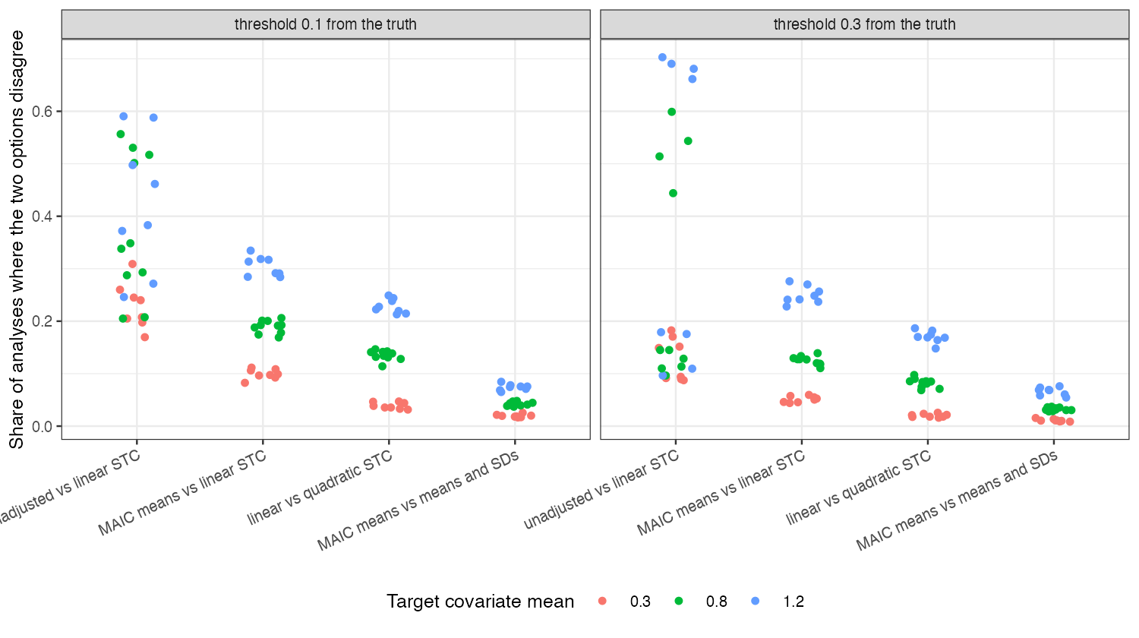
Figure 1: Share of analyses in which the two options of each choice give different decisions, by threshold distance and target covariate mean (normal covariates).
The ordering held at every overlap level (Figure 1). Flip rates rose with the target’s distance from the source, where the options’ estimates diverge and their variances grow, and fell by more than half when the threshold was 0.3 rather than 0.1 from the truth. The unadjusted analysis flipped most because it is biased, not because it is noisy; the within-family choices flipped through sampling disagreement between correlated estimates.

4. What this does not answer
No prior or bridge factor, since the source replicates contain no Bayesian or disconnected analysis; the decision is on the relative effect alone, not a net-benefit model; one outcome type. Peer review has not been done.

References
1. Tim P. Morris, Ian R. White, Michael J. Crowther. Using simulation studies to evaluate statistical methods. Statistics in Medicine. 2019;38(11):2074–102. doi:10.1002/sim.8086

