A simulated-covariate bias analysis works by MAIC as well as by STC
A simulation study answering catalog problem QBA-13
Ahmad Sofi-Mahmudi
2026-09-23

Abstract
Background. A simulated-covariate bias analysis for unanchored comparisons imputes an unmeasured covariate from assumed relations and adjusts for it. Its authors restricted it to STC, arguing that a MAIC version would lose too much effective sample size or fail to find weights. Catalog problem QBA-13 tests that reason.
Methods. Unanchored transport with an unmeasured binary covariate (prevalence 0.3 in the source), independent of or dependent on a measured covariate, and an outcome association known to the analyst. The analysis swept the assumed target prevalence from 0.1 to 0.9, imputing the covariate ten times from its posterior given the measured covariate and outcome, and adjusted by STC or by MAIC balancing its mean (2 scenarios, 500 replicates each).
Results. MAIC weights were feasible in 0.998 to 1.000 of replicates at every sweep point. Effective sample size fell from about 231 to 85 of 300 at the extreme, and MAIC’s reported SE was 1.03 to 1.14 times STC’s. Both routes were unbiased (at most 0.009). Their reported SEs widened toward the extremes (to 0.282) while the estimates’ spread stayed near 0.134, so coverage rose to 1.000.
Conclusion. The restriction to STC was a conservative choice, not a necessity: the MAIC extension is feasible and nearly as precise. Both routes, combined over imputations, report intervals that widen along the sweep faster than the estimate’s real uncertainty, so a curve should show its effective sample size and not be read as more robust where it is merely wider.

1. The problem
Adding a simulated covariate adds a balancing constraint to MAIC (1): feasibility can only shrink and effective sample size only fall as its assumed target mean moves from the source’s. Both are computable. For a binary covariate the constraint is feasible whenever both categories occur in the source, and the loss depends on how far the assumed prevalence is from the source’s, which is the sensitivity parameter itself.

2. Design
Registered protocol: protocol.md; ADEMP structure (2). 300 patients of A; target mean of the measured covariate 0.5; outcome log odds ratio of the unmeasured covariate 0.8; dependence on the measured covariate 0 or 0.8 on the log odds scale. Estimand at each sweep point: A’s marginal log odds in a target with that prevalence. Imputations combined by Rubin’s rules (3).

3. Results
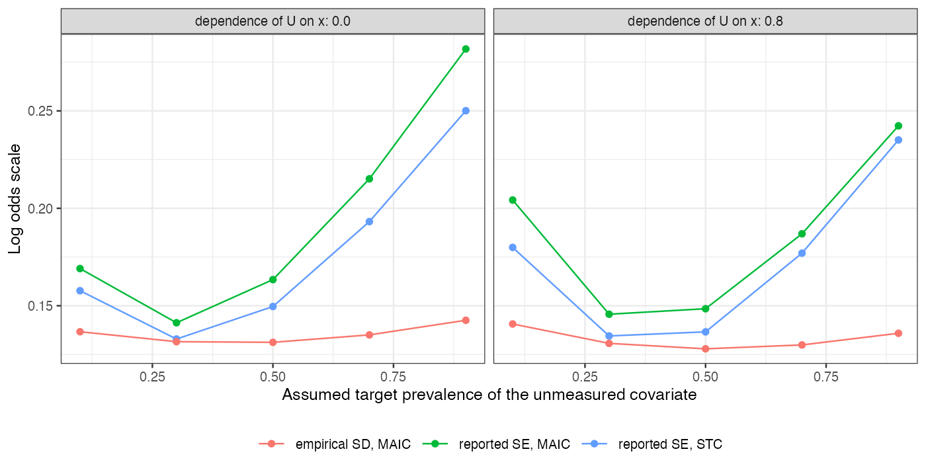
Figure 1: Reported SE of the STC and MAIC routes and the MAIC estimate’s empirical SD along the sweep.
Figure 1 shows the two routes’ reported SEs tracking each other and both departing from the empirical spread toward the extremes. The between-imputation variance grows as the assumed prevalence moves away from the source’s, but the imputations are drawn from a model the analyst holds fixed, so that variance is not uncertainty about the target estimate under the stated assumption.

4. What this does not answer
One binary unmeasured covariate with a logistic dependence (no copula factor); the analyst’s assumed relations are correct; unanchored A side only; no decision-threshold reading of the curve. Peer review has not been done.

References
1. James E. Signorovitch, Eric Q. Wu, Andrew P. Yu, Charles M. Gerrits, Evan Kantor, Yanjun Bao, Shiraz R. Gupta, Parvez M. Mulani. Comparative effectiveness without head-to-head trials: A method for matching-adjusted indirect comparisons applied to psoriasis treatment with adalimumab or etanercept. PharmacoEconomics. 2010;28(10):935–45. doi:10.2165/11538370-000000000-00000
2. Tim P. Morris, Ian R. White, Michael J. Crowther. Using simulation studies to evaluate statistical methods. Statistics in Medicine. 2019;38(11):2074–102. doi:10.1002/sim.8086
3. Donald B. Rubin. Multiple imputation for nonresponse in surveys. New York: Wiley; 1987.

