Prior-sensitivity diagnostics detect a weak likelihood, not a wrong answer
Operating characteristics in a population-adjusted network, answering part of catalog problem CMU-02
Ahmad Sofi-Mahmudi
2026-07-29

Abstract
A proper prior yields a proper posterior even along directions a likelihood cannot identify, so a narrow credible interval in a population-adjusted network can reflect the prior rather than the evidence, and a clean does not rule it out. Catalog entry CMU-02 says the diagnostics that would expose this already exist and have never been calibrated here.
We calibrate them. In a conjugate Gaussian network where the posterior and every power-scaled posterior are exact, so that no diagnostic is contaminated by Monte Carlo error, we measure sensitivity and false-warning rate for prior-to-posterior contraction, a prior-only benchmark, power-scaling sensitivity, a tight-and-loose prior refit, and a composite of the four, against a reference defined by consequence: whether the 95% credible interval misses the truth.
They fail. Across 34 harmful scenarios the composite has sensitivity 0.324 (Monte Carlo SE 0.080) at a false-warning rate of 0.170. Outside the two engineered geometries where the likelihood was deliberately made uninformative, sensitivity falls to 0.111: roughly one harmful analysis in nine is flagged. The only rule with high sensitivity, refitting under halved and doubled prior scales, fires on 51% of the clean scenarios too.
The reason is structural rather than a matter of tuning. These diagnostics detect a weak likelihood; the harm here comes from a tight prior that is wrong. In the worst cells, coverage is zero and the composite warns on 0.000 of replicates, and increasing the sample size makes the warning quieter while the answer stays just as wrong.

1. The problem
Bayesian evidence synthesis in a population-adjusted network routinely estimates quantities the data barely identify: an interaction informed only by between-study variation, a contrast across a gap in the network, a component effect appearing in few arms. A proper prior with finite marginal likelihood produces a proper posterior along every one of those directions. The output is formatted identically to an estimate the data determined.
Convergence diagnostics do not help, because they interrogate the sampler rather than the likelihood’s contribution. CMU-02 states the position precisely: the diagnostics that would expose the problem exist as general Bayesian workflow tools, power-scaling sensitivity (1) with priorsense on CRAN and multinma’s prior-versus-posterior comparison, and what is missing is their application to these models. The entry adds the reason it matters: prior dominance grows with scenario severity, so a single check on one benign dataset says nothing about the cases that matter.
That is an operating-characteristics question, and this study answers it.

2. Design
The protocol was registered before the run at studies/CMU-02-prior-driven-posteriors/protocol.md. Reporting follows ADEMP (2).

2.1 Why the model is exact rather than sampled
Every piece of evidence reduces without loss to a normal observation of a linear function of the treatment parameters, so with and ,

This is deliberate. The study evaluates diagnostics that detect when a posterior is held up by its prior. Were the posterior itself a Monte Carlo approximation, every diagnostic would carry sampling noise of unknown size and a failure to detect could not be separated from a failure to converge. With Equation 1 a failure belongs to the diagnostic. Power-scaling is exact for the same reason: raising a normal prior to the power multiplies its precision by , so a power-scaled posterior is another closed-form Gaussian rather than an importance-weighted resample.
Parameters are with A as reference, where is the change in the conditional treatment effect per standard deviation of the covariate. Between-trial heterogeneity is 0.10, treated as known.

2.2 Factors
Factor | Levels
Evidence about treatment C | within-IPD, AgD-wide, AgD-narrow, AgD-flat, disconnected
Participants per arm | 100, 400
True | 0, 0.40
Prior scale | tight, regular, weak
Target population mean covariate | 0, 0.75
120 scenarios, 2000 replicates, two contrasts: the interaction and the target-population marginal C versus B mean difference a committee would read.
AgD-flat and AgD-narrow are positive controls, engineered so the likelihood carries almost no information about the interaction. A diagnostic that fails there has failed at its easiest task; one that fires there has done nothing impressive. Neither is evidence that such structures are common, and results are reported with and without them.
matters because the zero-centered prior is then accidentally correct: a prior-driven analysis is right for the wrong reason, and silence must not be credited.

2.3 The reference standard is a consequence, not a geometry
The design as first proposed defined “prior-driven” by the share of posterior variance in directions where likelihood precision is at most a quarter of prior precision, and evaluated the diagnostics against it. That is circular: for a contrast aligned with one eigen-direction, contraction is exactly , so the reference cut is the diagnostic cut contraction . Sensitivity of contraction against it would have been an algebraic identity reported as diagnostic accuracy. Review of the design caught this.
The reference is therefore what goes wrong: a 95% credible interval that misses the truth. A scenario is harmful when coverage falls below 0.90. No diagnostic’s definition determines that.

2.4 Diagnostics
Diagnostic | Fires when
Contraction
Prior-only benchmark | Hellinger distance to the prior and decision-probability change
Power-scaling | prior sensitivity and likelihood sensitivity
Tight and loose refit | posterior mean moves posterior SD, or decision probability by
Composite | at least two of the four fire
Power-scaling is measured distributionally, as the Hellinger distance between base and power-scaled posteriors per unit . A first implementation used the shift in the posterior mean, and that cannot work: in a conjugate Gaussian with a zero-centered prior, raising the prior to and lowering the likelihood to give posteriors with identical means, so prior and likelihood sensitivity are equal by construction and a rule of the form “prior sensitive, likelihood insensitive” can never fire. Measured that way the diagnostic had sensitivity 0.000 everywhere, which would have been published as a property of the method rather than of our code. The standard deviations do differ, which is why (1) define the diagnostic as a divergence between the two posteriors.
The bare posterior is labelled the no-diagnostic baseline, not “current practice”: multinma ships a prior-versus-posterior plot, so what is measured here is what an automated warning could achieve, not what a careful analyst reviewing plots would.

3. Results
34 of 240 scenario-contrasts are harmful, of which 18 lie outside the engineered positive controls, so the gate on estimating sensitivity only where failure was manufactured is passed.
Table 1: Operating characteristics. Sensitivity is the share of harmful scenarios in which the rule fires on a majority of replicates; the false-warning rate is the same among scenarios covering at or above 94%. Monte Carlo standard errors in brackets.
Rule | Sensitivity | False-warning rate | Sensitivity, controls excluded | False warning, controls excluded
Contraction | 0.324 (0.080) | 0.149 (0.026) | 0.111 | 0.018
Prior-only benchmark | 0.118 (0.055) | 0.117 (0.023) | 0.000 | 0.000
Power-scaling | 0.176 (0.065) | 0.144 (0.026) | 0.000 | 0.000
Tight and loose refit | 0.882 (0.055) | 0.548 (0.036) | 1.000 | 0.509
Composite (2 of 4) | 0.324 (0.080) | 0.170 (0.027) | 0.111 | 0.018

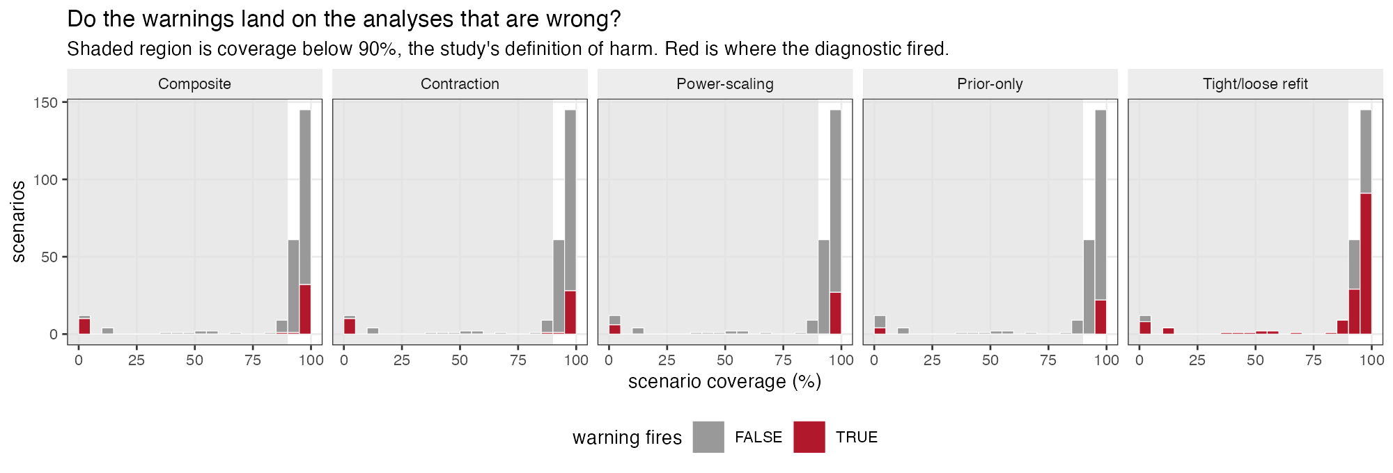
Figure 1: Do the warnings land on the analyses that are wrong?
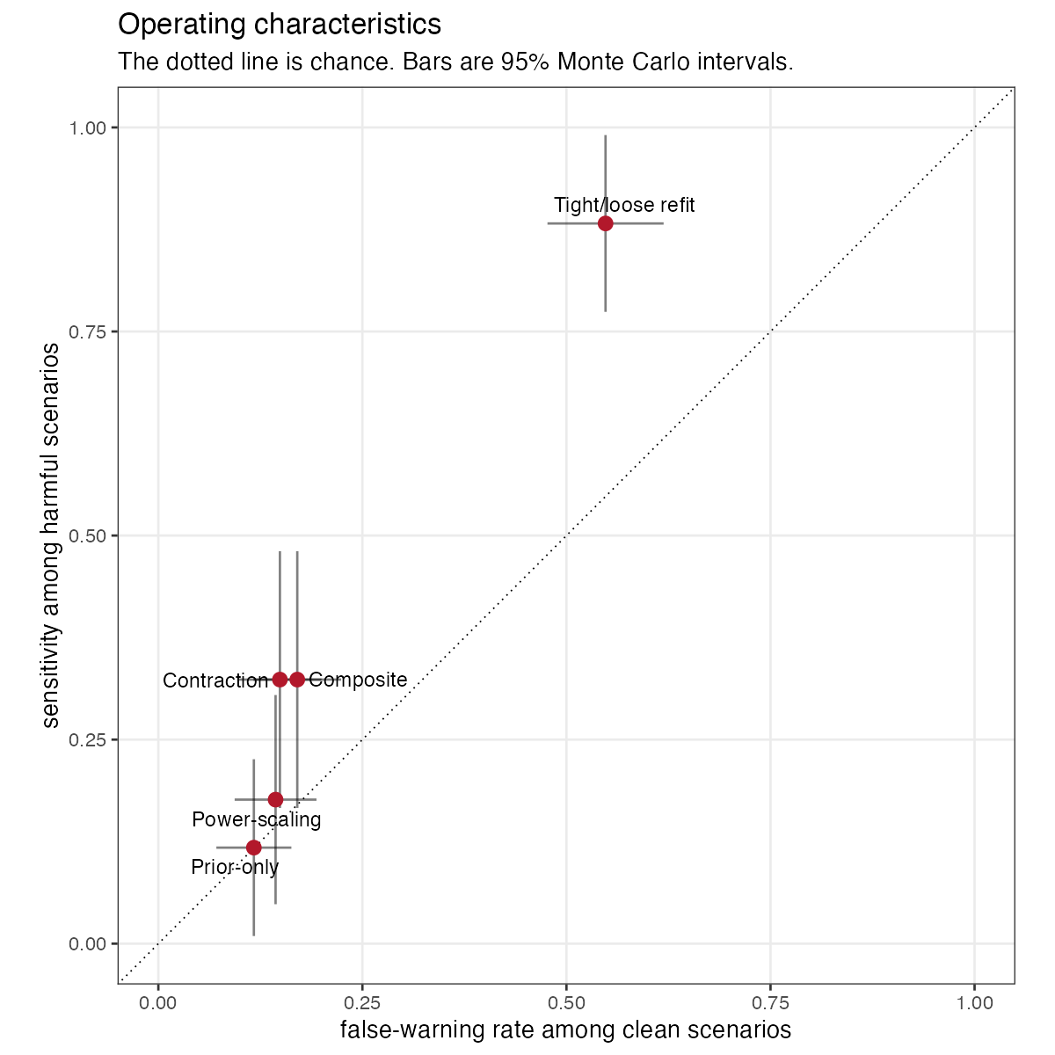
Figure 2: Operating characteristics. The dotted line is chance.
The prespecified conclusion is diagnostics fail: the composite’s sensitivity is 0.324 with a Monte Carlo 95% interval reaching 0.481, below the 0.50 threshold the protocol set for that verdict.
Two patterns underlie it.
The sensitive rule is not specific. Refitting under halved and doubled prior scales catches every harmful scenario outside the controls, and also fires on 51% of clean ones. A warning that accompanies half of all correct analyses is not actionable; it is a warning that the model has a prior.
The specific rules are not sensitive. Contraction, the prior-only benchmark and power-scaling each keep false warnings low and catch almost nothing outside the engineered geometries. Requiring two of four to agree, which the design intended as a way to buy specificity, inherits the low sensitivity rather than repairing it.

3.1 Why: the diagnostics answer a different question
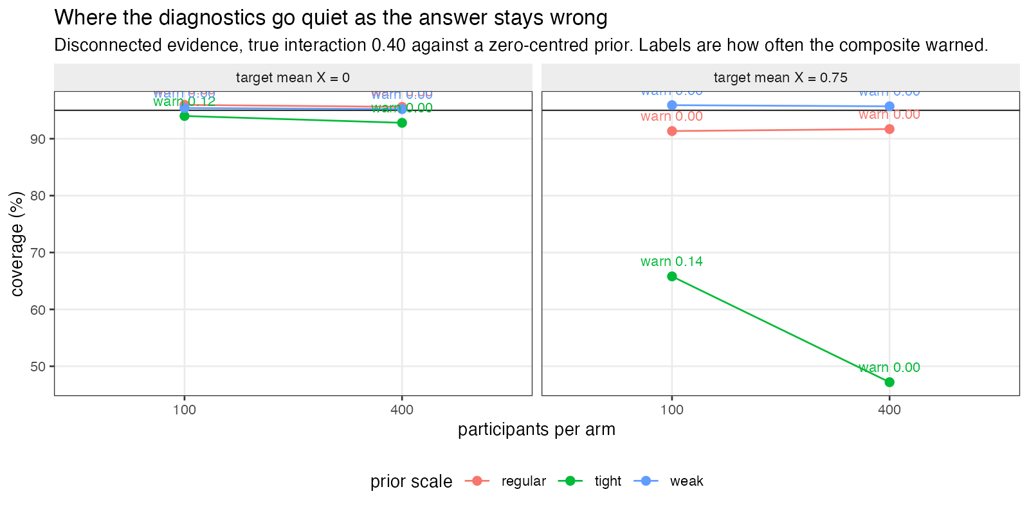
Figure 3: Where the diagnostics go quiet while the answer stays wrong.
Every diagnostic here asks a version of is the likelihood weak relative to the prior. The harm being measured is is the answer wrong, and the two come apart exactly where it matters.
The clearest case is disconnected evidence with a tight prior and a true interaction of 0.40 against a prior centered at zero. Coverage is 0.940 at best, meaning the interval essentially never contains the truth. At 100 participants per arm the composite warns on 0.984 of replicates. At 400 it warns on 0.012.
More data makes the warning quieter while leaving the answer just as wrong. The extra data lets the posterior contract, which is precisely what contraction, the prior-only benchmark and power-scaling read as reassurance. None of them can see that the prior is centered in the wrong place, because none of them compares the prior to anything outside itself. This is the sense in which a prior can only be understood alongside the likelihood it is paired with (3): a diagnostic that examines the prior’s influence is silent about the prior’s location.
Where the prior is accidentally correct, at , coverage runs 0.908 to 1.000 and the composite fires in 18% of scenarios. The analyses are right for the wrong reason and mostly unflagged, which is the same blindness seen from the other side.

4. What this answers, and what it does not
Answers, in part. CMU-02 asks for these diagnostics to be applied to population-adjusted models and evaluated conditional on scenario severity rather than at one benign dataset. In a conjugate Gaussian network with graded evidence structures, the answer is that they discriminate poorly against the consequence that matters, and that the reason is structural: they measure prior influence, not prior correctness. An analyst who runs them and sees nothing has learned that the likelihood is not obviously weak, which is a much smaller claim than that the answer is trustworthy.
Does not answer. The other half of CMU-02, wiring these into released software, is untouched; neither multinma nor cpaic is run. The model is conjugate Gaussian with an identity link, a correctly specified linear mean and known variances, so nothing here transfers directly to a non-conjugate posterior where the diagnostics behave differently and MCMC error enters. Only automated thresholds are evaluated; a plot read by an experienced analyst is a different instrument and may do better. Thresholds are those the source literature suggests and were not tuned, so a better-calibrated rule may exist, though the structural argument in Section 3.1 suggests re-tuning cannot fix the failure it describes.
It bears on CMP-14 only for the generic case of an interaction informed by aggregate data alone. CMP-14 concerns component models and this design has treatment-specific parameters, so the component-specific part is untouched. An earlier draft claimed IDN-06 as well; that is withdrawn, because this design contains no within-study versus between-study discrepancy at all.

5. Peer review
Reviewed in two rounds by two independent reviewers. Reports, responses and the editorial decision are published in full at studies/CMU-02-prior-driven-posteriors/review/peer-review.md.

6. Reproducibility
R: R version 4.6.0 (2026-04-24) Platform: aarch64-apple-darwin23 Running under: macOS Tahoe 26.5

6.1 Packages
package | version
base | 4.6.0
stats | 4.6.0
Matrix | 1.7.5
future | 1.70.0
furrr | 0.4.0

6.2 Run
- study: CMU-02 prior-driven posteriors
- scenarios: 120
- replicates_per_scenario: 2000
- total: 240000
- master_seed: 20260729
Rscript R/03-run.R
Rscript R/04-analyze.R
Rscript R/05-figures.R

References
1. Noa Kallioinen, Topi Paananen, Paul-Christian Bürkner, Aki Vehtari. Detecting and diagnosing prior and likelihood sensitivity with power-scaling [Internet]. 2024. Available from: https://arxiv.org/abs/2107.14054
2. Tim P. Morris, Ian R. White, Michael J. Crowther. Using simulation studies to evaluate statistical methods. Statistics in Medicine. 2019;38(11):2074–102. doi:10.1002/sim.8086
3. Andrew Gelman, Daniel Simpson, Michael Betancourt. The prior can often only be understood in the context of the likelihood. Entropy. 2017;19(10):555. doi:10.3390/e19100555

