Interval censoring fixes the visit grid of an external comparator but not the events it misses
A simulation study answering catalog problem QBA-07
Ahmad Sofi-Mahmudi
2026-09-23

Abstract
Background. A trial assesses progression at scheduled visits with adjudication; a routine-care comparator sees patients irregularly and can miss progression. Catalog problem QBA-07 asks which of these ascertainment differences an interval-censored analysis covers.
Methods. Unanchored RMST(24) comparison of a trial arm (visits every 2 months, every event detected) with an external arm (visits about every 3 months, regular or more frequent for higher-risk patients, per-visit detection probability 1, 0.85 or 0.7), with a true difference of 0 or 1.59 months: 12 scenarios, 1000 replicates each. Kaplan-Meier on recorded times, interval midpoints, and an interval-censored Weibull model.
Results. With every event detected, the interval-censored model was within 0.05 months of the truth under both visiting patterns, where recorded times were biased by up to 0.42. When the external arm missed events, every method was biased: 0.25 to 0.38 months at a per-visit sensitivity of 0.85 and 0.67 to 0.94 at 0.7, up to more than half the true difference.
Conclusion. Interval censoring handles grid differences, and here risk-dependent visiting too; missed detections need their own bias parameter, the per-visit sensitivity, in a sensitivity analysis.

1. The problem
With every event detected at the next visit and visits unrelated to risk, the event is known to lie between the last negative and the detecting visit, and an interval-censored likelihood is correct (OUT-14). A missed detection moves the recorded event one or more visits later while the last negative visit, as recorded, is already after the event, so the bracket itself is wrong. RMST (1) accumulates the delay.

2. Design
Registered protocol: protocol.md; ADEMP structure (2). Weibull event times (shape 1.2, median 12 months in A) with a normal frailty on the log hazard (SD 0.6). Risk-dependent visiting: each external patient’s spacing proportional to with the same average. Administrative end at 36 months and uniform dropout from 12 to 60 months.

3. Results
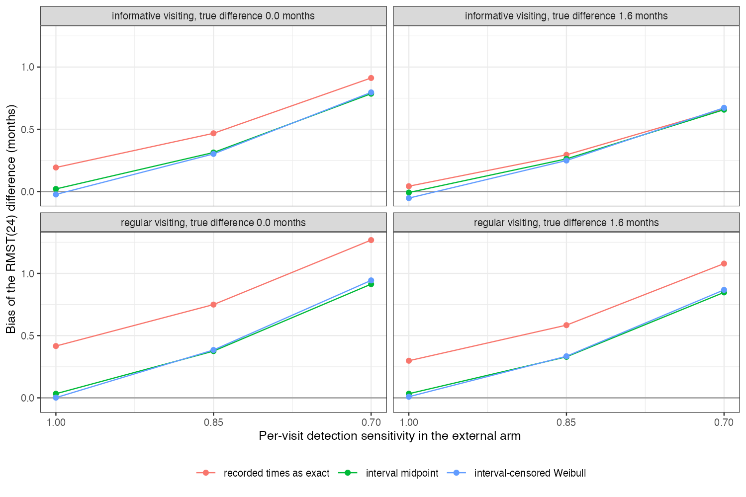
Figure 1: Bias of the RMST(24) difference by per-visit detection sensitivity, for each visiting pattern and true difference.
The midpoint and interval-censored methods tracked each other (Figure 1) and removed the grid bias. Visiting that depended on risk reduced the recorded-time bias rather than creating one, because the patients most likely to progress were seen most often; the interval-censored model was unaffected at this strength, against DESIGN.md’s prediction. Missed detections added bias roughly in proportion to the miss probability, and no method in the grid addressed it.

4. What this does not answer
No recording lag, linkage loss or false-positive events; one frailty strength and visiting dependence; no sensitivity analysis implemented over the detection parameter; no covariates or population adjustment. Peer review has not been done.

References
1. Patrick Royston, Mahesh K. B. Parmar. Restricted mean survival time: An alternative to the hazard ratio for the design and analysis of randomized trials with a time-to-event outcome. BMC Medical Research Methodology. 2013;13:152. doi:10.1186/1471-2288-13-152
2. Tim P. Morris, Ian R. White, Michael J. Crowther. Using simulation studies to evaluate statistical methods. Statistics in Medicine. 2019;38(11):2074–102. doi:10.1002/sim.8086

