The half-standard-error pooling rule for interactions is stated in the wrong standard error
An exact computation answering catalog problem MOD-15
Ahmad Sofi-Mahmudi
2026-09-23

Abstract
Background. An individual-data network meta-analysis has within-trial and across-trial information about a treatment-covariate interaction. The only published criterion for pooling them is that the within-trial estimate lie within half a standard error of the across-trial estimate (1), described as relatively strict and never calibrated.
Methods. Under equality the difference of the two estimates has standard error , not , so the rule’s operating characteristics are bivariate-normal integrals. We computed them exactly for 24 network configurations (5, 10 or 20 trials of 200; trial covariate means spread with SD 0.25 or 0.75; ecological bias 0 to 0.4), and checked the standard errors and two exact quantities against 2000 individual-level networks.
Results. The rule pools with probability at most under equality; in the configurations studied 0.314 to 0.374. When it does pool under ecological bias, the pooled interval’s coverage falls to 0.221. Its RMSE is within 0.3% of never pooling in every configuration, so it forgoes the 2% to 19% RMSE reduction pooling offers when the two estimates agree.
Conclusion. The rule is strict in every regime, not only some, and it is strict in the wrong way: it refuses pooling most of the time when pooling is valid, and when it admits pooling under bias the interval is not trustworthy. A test on the difference in its own standard error is the minimal repair; no rule of this kind can detect bias small relative to the across-trial standard error.

1. The problem
Across-trial interaction information is identified only if there is no trial-level confounding of the association between trial covariate means and trial effects (2,3). Pooling it with the within-trial estimate gains precision at the risk of ecological bias . Write and , independent. The rule pools when with . Under ,

approached when . The catalog’s design argued the rule is “not necessarily strict” and loosest with few trials. It is strict everywhere; the ratio only decides how strict.

2. Methods
Registered protocol: protocol.md. Standard errors came from a network of trials of 200 (1:1), within-trial covariate SD 1, residual SD 1: and . Conditional on , the within-trial error is normal with mean , so the error of whatever a policy reports, and its interval’s coverage, integrate exactly over . Policies: never pool; always pool; the half- rule; tests on at size 5% and 20%. The individual-level check (R/01-check.R, 2000 networks per row) reproduced the standard errors and the exact pass probability and conditional coverage, for example a pass rate of 0.366 against 0.374 exact.

3. Results
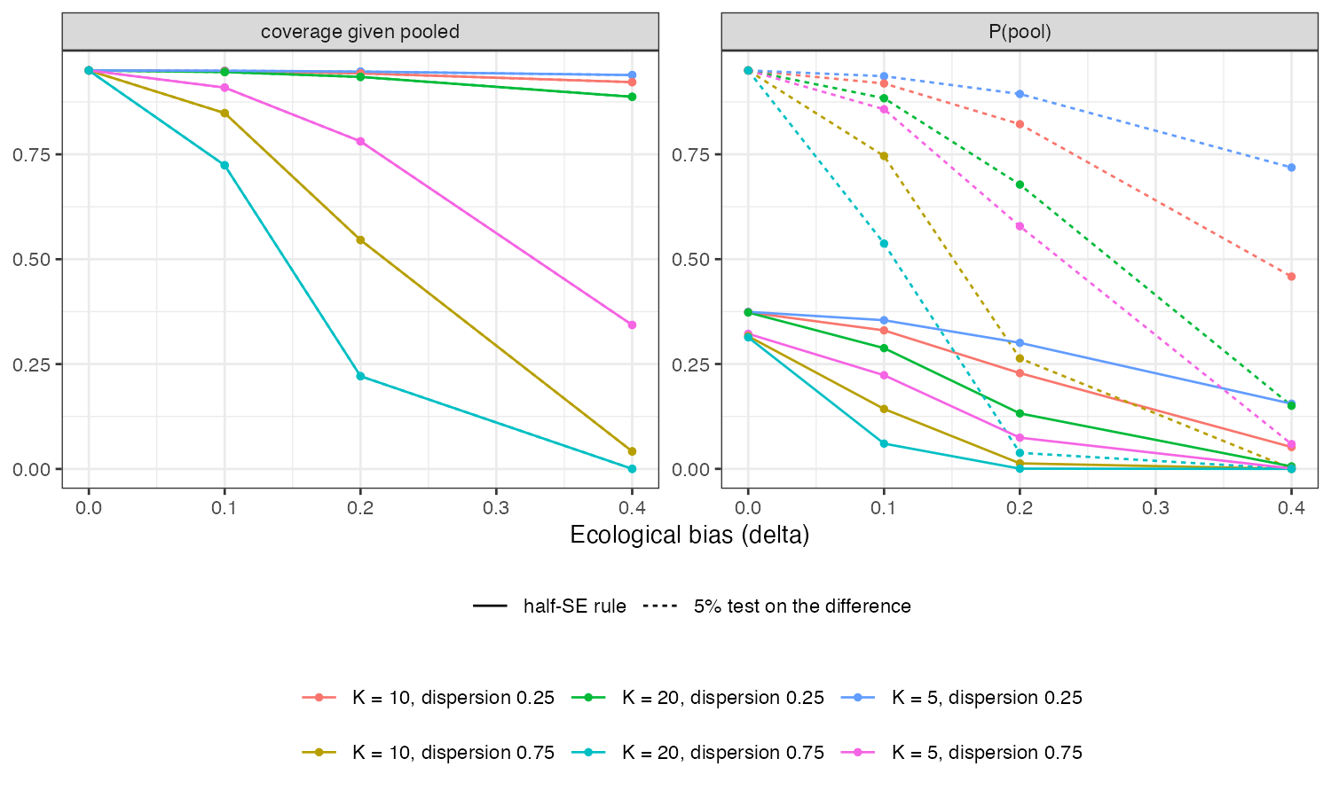
Figure 1: Probability of pooling and coverage of the pooled interval given pooling, by ecological bias.
Table 1: The half-SE rule by configuration and ecological bias.
K | dispersion | delta | sW/sA | P(pool) | coverage given pooled | RMSE
5 | 0.25 | 0.0 | 0.224 | 0.374 | 0.950 | 0.063
10 | 0.25 | 0.0 | 0.237 | 0.373 | 0.950 | 0.045
20 | 0.25 | 0.0 | 0.244 | 0.373 | 0.950 | 0.032
5 | 0.75 | 0.0 | 0.671 | 0.322 | 0.950 | 0.063
10 | 0.75 | 0.0 | 0.712 | 0.316 | 0.950 | 0.045
20 | 0.75 | 0.0 | 0.731 | 0.314 | 0.950 | 0.032
5 | 0.25 | 0.1 | 0.224 | 0.354 | 0.949 | 0.063
10 | 0.25 | 0.1 | 0.237 | 0.330 | 0.948 | 0.045
20 | 0.25 | 0.1 | 0.244 | 0.288 | 0.946 | 0.032
5 | 0.75 | 0.1 | 0.671 | 0.223 | 0.909 | 0.063
10 | 0.75 | 0.1 | 0.712 | 0.143 | 0.848 | 0.045
20 | 0.75 | 0.1 | 0.731 | 0.060 | 0.724 | 0.032
5 | 0.25 | 0.2 | 0.224 | 0.301 | 0.947 | 0.063
10 | 0.25 | 0.2 | 0.237 | 0.228 | 0.943 | 0.045
20 | 0.25 | 0.2 | 0.244 | 0.132 | 0.935 | 0.032
5 | 0.75 | 0.2 | 0.671 | 0.074 | 0.781 | 0.063
10 | 0.75 | 0.2 | 0.712 | 0.013 | 0.546 | 0.045
20 | 0.75 | 0.2 | 0.731 | 0.000 | 0.221 | 0.032
5 | 0.25 | 0.4 | 0.224 | 0.155 | 0.939 | 0.063
10 | 0.25 | 0.4 | 0.237 | 0.052 | 0.922 | 0.045
20 | 0.25 | 0.4 | 0.244 | 0.006 | 0.887 | 0.032
5 | 0.75 | 0.4 | 0.671 | 0.001 | 0.343 | 0.063
10 | 0.75 | 0.4 | 0.712 | 0.000 | 0.042 | 0.045
20 | 0.75 | 0.4 | 0.731 | 0.000 | 0.000 | 0.032

The rule pools in about a third of analyses where pooling is valid (Table 1). As ecological bias grows, pooling becomes rarer but not rare enough: at 20 trials with dispersed trial means and it pools in 0.000 of analyses, and the pooled interval then covers in 0.221 (Figure 1). Averaged over pooling and not pooling, the rule behaves like never pooling: its RMSE matches never pooling to within 0.3%. The size-5% test pools more often under equality and fails similarly under bias; always pooling has the lowest RMSE without bias and the worst with it. Never pooling had the lowest worst-case RMSE over in five of six network configurations.

4. What this does not answer
The two estimates are treated as independent and normal with known standard errors; between-trial heterogeneity in the treatment effect, which widens , is not modeled, and the network is IPD in every trial. The ML-NMR case, where aggregate trials inform only the across-trial component, is not computed. Nothing here tests whether trial-level confounding is present; no agreement rule can. Peer review has not been done.

References
1. Suzanne C. Freeman, David Fisher, Jayne F. Tierney, James R. Carpenter. A framework for identifying treatment-covariate interactions in individual participant data network meta-analysis. Research Synthesis Methods. 2018;9(3):393–406. doi:10.1002/jrsm.1300
2. Jesse A. Berlin, Jill Santanna, Christopher H. Schmid, Lynda A. Szczech, Harold I. Feldman. Individual patient- versus group-level data meta-regressions for the investigation of treatment effect modifiers: Ecological bias rears its ugly head. Statistics in Medicine. 2002;21(3):371–87. doi:10.1002/sim.1023
3. Hairui Hua, Danielle L. Burke, Michael J. Crowther, Joie Ensor, Catrin Tudur Smith, Richard D. Riley. One-stage individual participant data meta-analysis models: Estimation of treatment-covariate interactions must avoid ecological bias by separating out within-trial and across-trial information. Statistics in Medicine. 2017;36(5):772–89. doi:10.1002/sim.7171

