Reconstruction ensembles were not imputations: their spread overstated the error in restricted mean survival and understated it in the extrapolated tail
A simulation study answering catalog problem OUT-13
Ahmad Sofi-Mahmudi
2026-09-23

Abstract
Background. Individual data reconstructed from a published Kaplan-Meier curve by Guyot’s algorithm (1) are often reconstructed several times and pooled as if the repetitions were multiple imputations (2). That is valid only if their spread matches the error of the reconstruction. Catalog problem OUT-13’s refuting sentence: the ensembles analysts already build are calibrated.
Methods. One arm of 250 patients, Weibull event times, rendered as a pixel-rounded curve (fine or coarse) with a 3-monthly, 6-monthly or no risk table and spread or clustered censoring; 300 replicates per cell. Two ensembles: six analyst variants (30, 60 or 120 digitized points, event total given or not) and 20 observation-model draws (pixel positions and censoring times redrawn). Calibration ratio: the ensemble’s between-reconstruction variance times over the variance of its mean’s error against the true data; one for an imputation.
Results. For RMST to 24 months at a 6-month risk table the ratio was 31.79 to 44.30 for the variants and 2.30 to 11.24 for the draws: both far from one, the registered outcome. Across all cells the draws overstated the error of RMST (2.05 to 13.08) and of 12-month survival (1.11 to 3.48) and understated it for Weibull survival at 48 months (0.15 to 0.77). The variants’ mean was biased by 0.17 to 0.19 months of RMST in every cell. Reconstruction error itself was small against sampling error: a single reconstruction’s RMSE was 0.02 to 0.08 of the sampling SD for RMST and 0.11 to 0.26 for 48-month survival, and population coverage stayed at 0.91 to 0.98.
Conclusion. Neither ensemble is an imputation. The miscalibration has a direction that depends on the functional: conservative for RMST, anticonservative in the extrapolated tail, which is where the reconstruction error is concentrated.

1. The problem
Write for a functional of the true data and for the publication. An ensemble computed from reconstructions pools as an imputation when the are draws from . Then the ensemble mean’s error has variance , with the between-reconstruction variance, and the calibration ratio equals one. Analyst variants are not draws from anything: they differ by choices whose effects are deterministic. Observation-model draws redraw what the publication does not fix (the position of each step within its pixel and each censoring within its risk-table interval) but hold Guyot’s event-count rounding fixed and use no likelihood for the published ordinates, so they approximate the posterior at best.

2. Design
Registered protocol: protocol.md. One arm, , Weibull event times (shape 1.2, median 18 months), uniform accrual over 24 months and follow-up to 36; in the clustered pattern 30% also drop out just before a 6-monthly visit. The publication is the curve read at pixel-column centers of a (fine) or (coarse) plot with ordinates rounded to the pixel grid, the risk table and the event total. Reconstruction by IPDfromKM 0.1.10. Functionals: RMST to 24 months and survival at 12 months from the Kaplan-Meier curve, survival at 48 months from a Weibull fit. The error is each reconstruction’s value minus the value on the true data of the same replicate, so the ratio estimates the expected conditional variance. Near one: 0.67 to 1.5; far: below 0.5 or above 2. MCSEs by bootstrap over replicates. 12 cells plus a null control (fine, monthly table, spread censoring).

3. Results
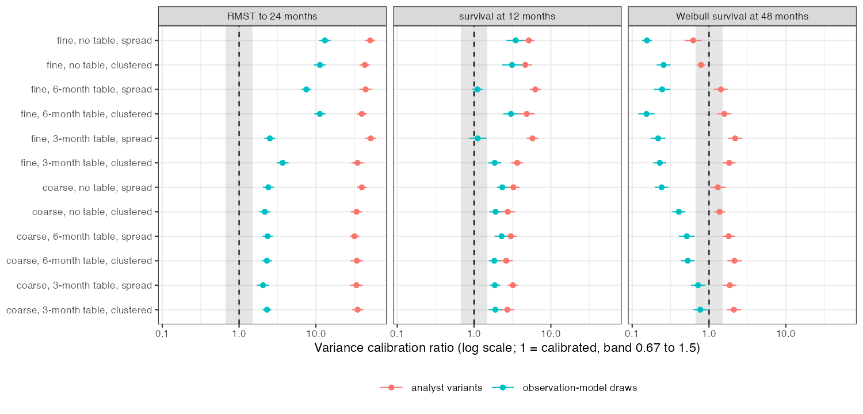
Figure 1: Variance calibration ratio by design cell and functional, with 95% Monte Carlo intervals; shaded, the registered band of calibration.
Table 1: Ranges over the 12 main cells, 298 to 300 replicates each. RMST in months.
functional | ensemble | variance ratio | MSE ratio | mean error | coverage of the true-data value (nominal 0.90)
rmst24 | variants | 31.79 to 51.80 | 0.42 to 0.53 | 0.168 to 0.191 | 0.59 to 0.91
rmst24 | draws | 2.05 to 13.08 | 1.72 to 9.50 | -0.006 to 0.001 | 0.95 to 1.00
s12 | variants | 2.62 to 6.26 | 0.78 to 1.04 | 0.006 to 0.008 | 0.73 to 0.85
s12 | draws | 1.11 to 3.48 | 1.06 to 3.49 | 0.000 | 0.46 to 1.00
s48 | variants | 0.62 to 2.19 | 0.47 to 2.11 | -0.002 to 0.013 | 0.49 to 0.90
s48 | draws | 0.15 to 0.77 | 0.15 to 0.63 | 0.000 to 0.002 | 0.42 to 0.77

Primary. In the four 6-month-table cells the variants’ ratio was 31.79 to 44.30 and the draws’ 2.30 to 11.24, all far from one: the registered “both far” outcome (Figure 1).
Analyst variants. The variants’ mean missed the true-data RMST by 0.17 to 0.19 months in every cell, with a variance ratio of 31.79 to 51.80 but an MSE ratio of 0.42 to 0.53. A large variance ratio with an MSE ratio below one is the signature of a deterministic disagreement between variants repeated in every replicate: their spread is analyst choice, not uncertainty about the data. A post hoc rerun of the first 10 replicates of two 6-month-table cells (R/05-mechanism.R) located it: the RMST error was 0.29 to 0.34 months with 30 digitized points, 0.15 to 0.16 with 60 and 0.06 with 120, identical with and without the event total. Sparse digitization misses drops and keeps the curve high; the ensemble’s spread is that ordering.
Observation-model draws. For RMST the draws overstated the error, by a factor of 2.52 to 13.08 at fine resolution and 2.05 to 2.40 at coarse resolution; for survival at 48 months they understated it (0.15 to 0.77), and their 90% intervals covered the true-data value in only 0.42 to 0.77 of replicates. In the same post hoc rerun, the between-reconstruction variance of RMST came mainly from random censoring placement at fine resolution (median ratio to the combined variance: censoring only 1.02, pixel jitter only 0.25) and from pixel jitter at coarse resolution (1.03 against 0.52); for 12-month survival it was pixel jitter alone (0.93 and 1.00 against at most 0.04). What the draws miss in the tail was not located; Guyot’s event-count rounding, which they hold fixed, is an untested candidate.
Non-uniformity. Width inflation from Rubin pooling differed across the three functionals by a factor of at least 2 in 12 of 12 cells, meeting the registered criterion; but the draws’ inflation was at most 0.010 in every cell, and the variants’ reached 0.23 only for 48-month survival without a risk table.
Materiality. A single reconstruction’s RMSE was 0.02 to 0.08 of the sampling SD for RMST, 0.03 to 0.13 for 12-month survival and 0.11 to 0.26 for 48-month survival. Coverage of the population value was 0.91 to 0.98 for every method, and interval widths were 0.95 to 1.11 times the true-data analysis’s.
Controls. Null control (fine, monthly table): single-reconstruction RMSE 0.020 and 0.050 of the sampling SD for RMST and 12-month survival, below the registered 0.10, on 161 of 300 replicates (below). Positive control: in the coarse, no-table, clustered cell the single reconstruction’s RMSE for 12-month survival was 0.131 of the sampling SD, short of the registered 0.25, so the entry’s concern about milestone survival is not reachable in this design.
Failed replicates. The reconstruction carried a 20-second wall-clock guard against hangs. The null control ran while the shared machine’s load average was 500 to 900, and the guard fired on reconstructions that would have finished: 139 of its 300 replicates were lost when the single reconstruction timed out, and ensembles shrank in others (to one member in three), so its ensemble ratios are not reported. In the main cells 2 replicates were dropped (cell 9) and four ensembles ran one or two members short. Two of the lost replicates, rerun from their seeds, completed without error, so the losses are plausibly independent of the data; a full rerun with a CPU-time guard was not done.

4. What this does not answer
Observation-model draws hold Guyot’s event-count rounding fixed and use no likelihood for the published ordinates, so they are not the posterior; a principled imputation was not built. One arm, no downstream comparison: how the tail miscalibration propagates into a population-adjusted or component comparison is CMP-17’s question. No human digitization error, line width or censoring marks; one sample size. The positive control failed, so milestone survival was never materially affected here. The mechanism analyses are post hoc. Peer review has not been done.

References
1. Patricia Guyot, A. E. Ades, Mario J. N. M. Ouwens, Nicky J. Welton. Enhanced secondary analysis of survival data: Reconstructing the data from published Kaplan-Meier survival curves. BMC Medical Research Methodology. 2012;12:9. doi:10.1186/1471-2288-12-9
2. Donald B. Rubin. Multiple imputation for nonresponse in surveys. New York: Wiley; 1987. doi:10.1002/9780470316696

