Calibrating the correlation does not fix the copula: the family moves a standardized contrast by up to 0.03 on the log odds and log hazard scales
A numerical study answering catalog problem CMP-15
Ahmad Sofi-Mahmudi
2026-09-23

Abstract
Background. Multilevel network meta-regression integrates over a target covariate distribution reconstructed from reported margins and correlations with a Gaussian copula (1). Calibrating the copula’s latent correlation so that the output correlations match the reported ones fixes the variance of any linear predictor. Catalog problem CMP-15 asks whether the remaining error, which lives in asymmetry and tail dependence, can move a standardized contrast.
Methods. A population-level calculation: three covariates with normal or skewed margins and a true Clayton, Gumbel or copula at Pearson correlation 0.3 or 0.6, against Gaussian copulas calibrated to the same margins and correlation; logit, complementary log-log and log links; draws per law with a control variate.
Results. The calibrated Gaussian’s error in the standardized contrast reached 0.034 on the log odds ratio scale and 0.032 on the log cumulative hazard ratio scale, above the registered threshold of 0.02 in 5 of 16 primary cells, with Monte Carlo error below 0.001. Lower- and upper-tail dependence pushed the error in opposite directions. On the log link the error reached 0.629. More integration points did not help: the error plateaued by 256 points. A wrong flexible family was further from the truth than the Gaussian in 61% of comparisons.
Conclusion. The copula family matters above the second moment, modestly on the log odds and log hazard scales and strongly on the log rate scale. Since the family is not identified from published data, the defensible report is an envelope over families, not a switch to a different single copula.

1. The problem
For a curved inverse link the target-standardized contrast depends on the covariate law through all moments of the linear predictor. Its variance depends only on margins and pairwise correlations, so calibrating the correlation fixes the second-order term. The third- and higher-order terms depend on the copula’s asymmetry and tail dependence, which the Gaussian copula sets to zero. Whether that residual is large enough to matter is an empirical question, and it can only be answered in a setting where the true joint law is known.

2. Design
Registered protocol: protocol.md. Covariates with common standard normal or standardized Beta(2, 6) margins; exchangeable dependence from a Gaussian, Clayton, Gumbel or copula whose parameter was calibrated so the mean pairwise Pearson correlation equals (realized within 0.0057 on independent draws). Outcome model , . The contrast for identity, logit, log and complementary log-log links (the last is survival at under an exponential model). Each law was evaluated with draws in four batches, using , whose mean is exactly zero, as a control variate. Reconstructions: the Gaussian copula calibrated to , the Gaussian with latent correlation (uncalibrated), and each other family calibrated to ; the envelope is the range over the Gaussian, Clayton, Gumbel and their survival versions.

3. Results
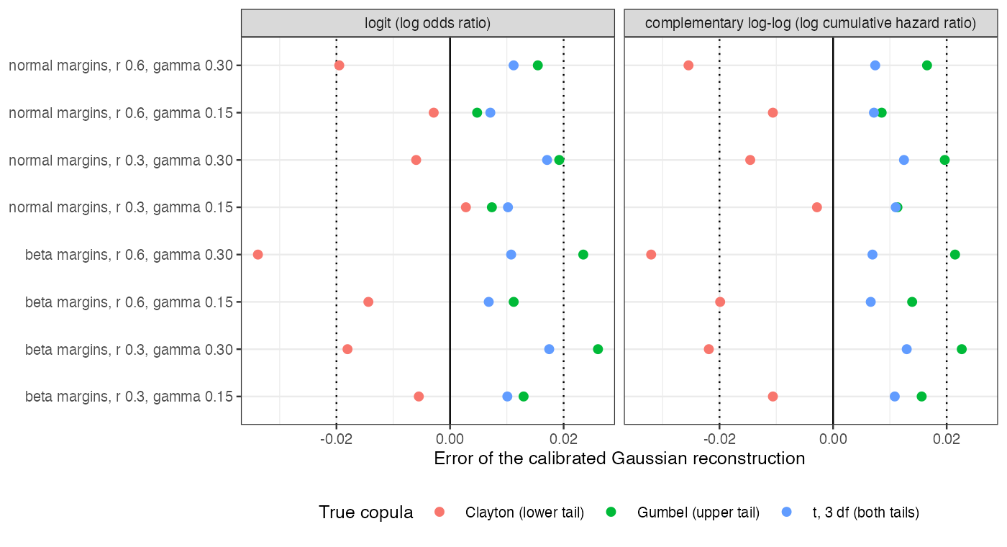
Figure 1: Error of the calibrated Gaussian reconstruction. Dotted: the registered threshold 0.02.
Table 1: Largest absolute error of the calibrated Gaussian over margins, correlations and \gamma. MCSE at most 0.0006 on the logit and complementary log-log scales and 0.027 on the log scale.
link | largest error, Clayton | Gumbel
identity | 0.000 | 0.000 | 0.000
logit | 0.034 | 0.026 | 0.017
complementary log-log | 0.032 | 0.023 | 0.013
log | 0.510 | 0.629 | 0.473

The registered primary fired: on the complementary log-log scale with a tail-dependent truth the calibrated Gaussian erred by up to 0.032, beyond 0.02 in 5 of 16 cells, largest with skewed margins, the higher correlation and the stronger modification (Figure 1, Table 1). The sign followed the tail: against a Clayton truth (lower-tail dependence) the Gaussian’s contrast was too negative, and against a Gumbel truth (upper-tail dependence) too positive, so the Gaussian sits inside the range the families span. A symmetric tail-dependent copula () gave smaller errors. At the identity link every error was exactly zero, as the second-order argument requires. On the log link, where the marginal rate is an exponential moment of the linear predictor and is dominated by the joint upper tail, errors reached 0.629.
Calibration itself was a small correction here: the uncalibrated Gaussian differed from the calibrated one by at most 0.001 on the logit and complementary log-log scales. With randomized quasi-Monte Carlo the calibrated Gaussian’s RMSE against a Gumbel truth fell from 0.026 at 64 points to 0.022 at 256 and stayed at 0.021 at 4096: integration error vanishes quickly and the copula error remains. DESIGN.md’s prediction that the error grows with integration order did not hold; it plateaus.
A misspecified flexible family was worse than the calibrated Gaussian in 61% of comparisons, the design’s falsifier for recommending a flexible copula. The envelope over five families contained the truth, which lies outside them, in 14 of 16 logit and complementary log-log cells, with median width 0.031.
The matched-correlation control narrowly failed: the copula at with skewed margins realized a correlation 0.0057 from its target on independent draws, against a tolerance of 0.005, within the Monte Carlo error of the check.

4. What this does not answer
Population-level: no trials, fitting or reconstruction uncertainty. Three exchangeable covariates with common margins, one parameter per copula; no mixed or discrete margins, so the numerical inversion of latent correlations for binary covariates is not measured; no vines. Peer review has not been done.

References
1. David M. Phillippo, Sofia Dias, A. E. Ades, Mark Belger, Alan Brnabic, Alexander Schacht, Daniel Saure, Zbigniew Kadziola, Nicky J. Welton. Multilevel network meta-regression for population-adjusted treatment comparisons. Journal of the Royal Statistical Society Series A. 2020;183(3):1189–210. doi:10.1111/rssa.12579

