The aggregate Poisson likelihood is biased by the exposure-rate covariance, and exposure-weighted covariate moments remove the bias
A simulation study answering catalog problem CMP-20
Ahmad Sofi-Mahmudi
2026-09-23

Abstract
Background. Aggregate count data enter a multilevel network meta-regression as an arm’s total events and total exposure, with the expected count computed as total exposure times the mean modeled rate over the arm’s covariate law (1). That is exact only if exposure and rate are uncorrelated within the arm; otherwise the expected count is off by the factor . Catalog problem CMP-20 asks whether the factor cancels in the reported contrast.
Methods. An anchored network, individual data on A versus C and arm totals on B versus C, with lognormal exposure solved so that each arm’s exposure-rate correlation and dispersions take registered values; 208 main cells, 1000 replicates each. Integration over the unweighted, exposure-weighted or slope-tilted covariate moments.
Results. The observed bias followed the identity (slope 0.994, SE 0.002). At plausible dispersions with a differential correlation of at least 0.2, 27 of 64 cells showed material bias or undercoverage; bias reached 0.140 and coverage fell to 0.169. Integrating over exposure-weighted moments kept bias within 0.008 and coverage 0.908 to 0.965 in every cell. With no population correlation at all, the unweighted likelihood still undercovered at large dispersions (0.838), because the sample covariance is not zero.
Conclusion. The covariance cancels in the contrast only when it is common to both arms. Aggregate count data should be integrated over exposure-weighted covariate moments, which a publication can report at no cost.

1. The problem
For an aggregate Poisson arm the model’s expected count is , while the truth is . Their ratio is . In a two-arm aggregate study the study intercept absorbs the control arm’s factor and the treatment effect absorbs the log ratio of the two arms’ factors, so the contrast is biased by . Differential follow-up, where treatment changes who stays long enough to accumulate exposure, makes the two factors differ. Integrating over the exposure-weighted covariate law makes the product exact, because with weights proportional to .

2. Design
Registered protocol: protocol.md; ADEMP (2). Study 1: individual data on A versus C, ; study 2: arm totals on B versus C, . Rate model with , , and set by the control rate’s CV. Exposure lognormal given with mean 1, its slope on and residual variance solved so that each arm’s correlation and are exact. Factors: control-arm correlation 0 to , treated-arm difference 0, 0.2, 0.4, 0.3, 0.6, 1.0, control 0.2, 0.4, 0.8, 250 or 1000 per arm; 208 attainable main cells and 26 control cells. Estimand: the log marginal rate ratio B versus C in study 1’s population, in closed form. All methods fit the same joint likelihood by maximum likelihood and differ only in the aggregate arms’ integration law: the arm’s reported sample moments (unweighted), its exposure-weighted moments (weighted), or the unweighted moments tilted by the exposure slope estimated in study 1 (borrowed). A sensitivity interval shifted the unweighted interval by the identity over per arm.

3. Results
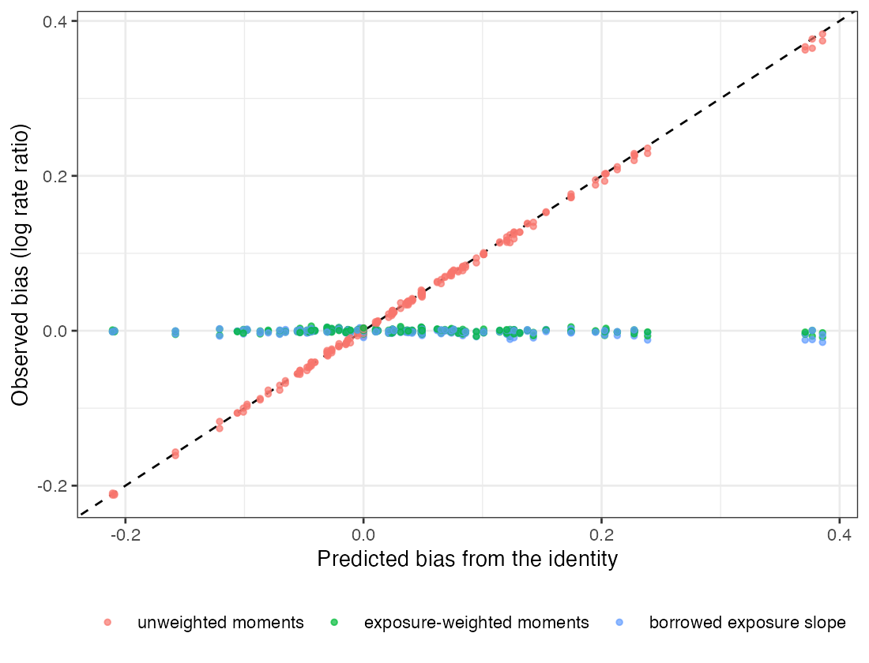
Figure 1: Observed bias of each method against the identity’s prediction, 208 main cells. Dashed: equality.
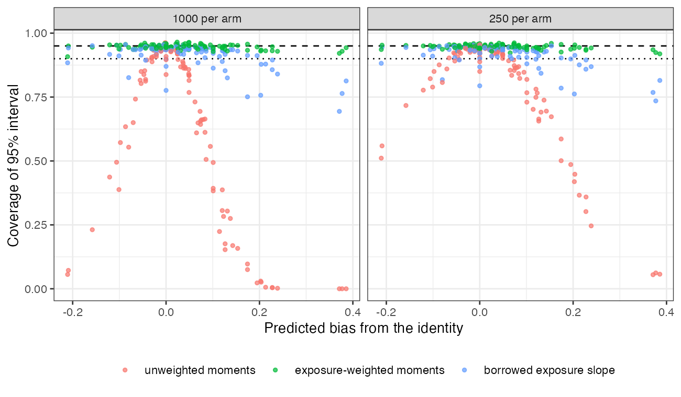
Figure 2: Coverage against the predicted bias. Dashed 0.95; dotted 0.90.
Table 1: 1000 replicates per cell; bias MCSE at most 0.004. Plausible: CV(T) at most 0.6 and control CV(\lambda) at most 0.4.
method | largest absolute bias | coverage, all cells | coverage, plausible cells with differential correlation | mean width
unweighted | 0.383 | 0.000 to 0.963 | 0.169 to 0.963 | 0.291
exposure-weighted | 0.008 | 0.908 to 0.965 | 0.935 to 0.965 | 0.278
borrowed slope | 0.015 | 0.694 to 0.957 | 0.926 to 0.957 | 0.278
sensitivity | 0.383 | 0.706 to 1.000 | 0.861 to 1.000 | 0.704

The registered rule returned confirmed material (Figure 2, Table 1). The bias tracked the identity closely (Figure 1): slope 0.994 and no cell more than 2.91 MCSE from its prediction. With a common correlation in both arms the contrast was unbiased while each arm’s absolute rate was biased, as the second null control required. The exposure-weighted likelihood removed the bias in every cell, with coverage 0.908 to 0.965 (0.935 to 0.965 at plausible dispersions). The borrowed slope removed the bias but undercovered at large rate dispersion (down to 0.694), because its interval ignores the uncertainty in the slope it borrows.
Three registered statements did not hold as written. The null control failed on coverage, not bias: at zero correlation in both arms the unweighted likelihood was unbiased but covered 0.838 to 0.957, falling as grew, because a finite arm’s sample exposure-rate covariance is not zero and its variance is missing from the Poisson arm likelihood; the exposure-weighted likelihood covered 0.936 to 0.959 in the same cells. The positive control’s cell selection was corrected after the run: the analysis script required the largest CV(T) and the largest CV() together, a combination not attainable at , so it selected no cell; selecting the attainable cells with the largest product, as the protocol’s text says, the control passed. And the protocol stated that the sensitivity range contained every grid value; it did not contain cells whose treated-arm correlation was positive ( with a difference of 0.2 or 0.4, or with 0.4), where the sensitivity interval covered as little as 0.706. Its mean width was 2.42 times the unweighted width.

4. What this does not answer
One covariate and one lognormal exposure law; no overdispersion; the exposure mechanism is the same in both studies, which is what makes the borrowed slope unbiased; the likelihood is the study’s own code, not multinma. Peer review has not been done.

References
1. David M. Phillippo, Sofia Dias, A. E. Ades, Mark Belger, Alan Brnabic, Alexander Schacht, Daniel Saure, Zbigniew Kadziola, Nicky J. Welton. Multilevel network meta-regression for population-adjusted treatment comparisons. Journal of the Royal Statistical Society Series A. 2020;183(3):1189–210. doi:10.1111/rssa.12579
2. Tim P. Morris, Ian R. White, Michael J. Crowther. Using simulation studies to evaluate statistical methods. Statistics in Medicine. 2019;38(11):2074–102. doi:10.1002/sim.8086

