Where the individual data sit decides the error of a population-adjusted network contrast at the same total sample size
A numerical study answering catalog problem DIA-07
Ahmad Sofi-Mahmudi
2026-09-23

Abstract
Background. Simulation studies of population adjustment use two-trial templates and index information by sample size. Catalog problem DIA-07 asks whether, at the same total size, the network’s topology and the position of the individual-data trial change the error of the decision contrast.
Methods. An exact calculation for four-treatment networks (line, star, loop-with-tail, two paths) of 1200 patients, with effect modification on every treatment, one individual-data trial standardized to the target and placed on each edge in turn, and a fixed-effect network meta-analysis of the rest.
Results. With moderate modification and a target shifted by one covariate SD, the probability of getting the sign of D versus A wrong ranged from 0.362 to 0.933 across topologies and placements. An individual-data trial off every path to the contrast carried zero weight and changed nothing. Standardizing one edge could increase the bias, from 0.20 to 0.30 in the line network, by removing an error that had offset the others.
Conclusion. Results from a two-trial template do not transfer to a network by matching total size. Reports should state the topology, where the individual data sit, and the share of the decision contrast those data carry.

1. The problem
A network estimate of a contrast is a weighted sum of the trial estimates, the target row of the hat matrix. In a population-adjusted network only some trials are standardized to the target; the rest estimate their own population’s effect. The error of the contrast is the weighted sum of the unadjusted trials’ population biases, so it depends on which trials lie on the paths to the contrast, with what weights, and on whether their biases add or cancel. None of that is a function of total sample size. Multilevel network meta-regression addresses this by modeling the modification throughout the network (1); a trial-by-trial adjustment does not.

2. Design
Registered protocol: protocol.md. Effect of treatment against A at covariate : with and , . The decision contrast D versus A in a target with covariate mean ; all trial populations have mean 0. 1200 patients split equally over the trials; the individual-data trial is standardized by regression (unbiased, variance inflated by ); the others report their own population’s effect. Bias, SD, coverage and decision error are exact.

3. Results
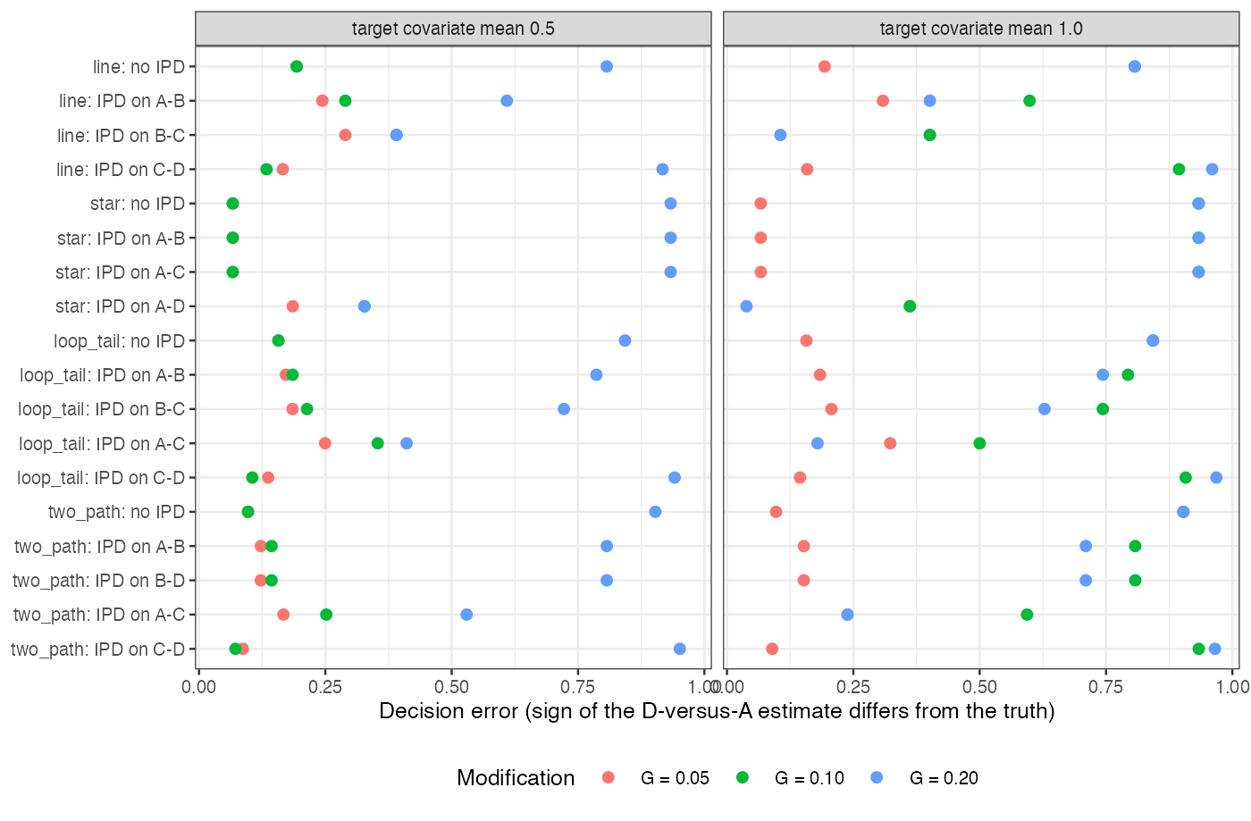
Figure 1: Decision error by topology and position of the individual-data trial.
Table 1: G = 0.1, M_T = 1: D is slightly worse than A in the target (truth 0.05) but better in the trials’ populations. IPD share: the individual-data trial’s share of the absolute hat-matrix row.
configuration | truth | bias | SD | coverage | decision error | IPD share
line, no IPD | 0.05 | -0.200 | 0.173 | 0.789 | 0.807 | 0.00
line, IPD on A-B | 0.05 | -0.100 | 0.200 | 0.921 | 0.599 | 0.33
line, IPD on B-C | 0.05 | 0.000 | 0.200 | 0.950 | 0.401 | 0.33
line, IPD on C-D | 0.05 | -0.300 | 0.200 | 0.677 | 0.894 | 0.33
star, no IPD | 0.05 | -0.200 | 0.100 | 0.484 | 0.933 | 0.00
star, IPD on A-B | 0.05 | -0.200 | 0.100 | 0.484 | 0.933 | 0.00
star, IPD on A-C | 0.05 | -0.200 | 0.100 | 0.484 | 0.933 | 0.00
star, IPD on A-D | 0.05 | 0.000 | 0.141 | 0.950 | 0.362 | 1.00
loop_tail, no IPD | 0.05 | -0.200 | 0.149 | 0.731 | 0.843 | 0.00
loop_tail, IPD on A-B | 0.05 | -0.175 | 0.153 | 0.791 | 0.793 | 0.11
loop_tail, IPD on B-C | 0.05 | -0.150 | 0.153 | 0.834 | 0.744 | 0.11
loop_tail, IPD on A-C | 0.05 | -0.050 | 0.163 | 0.939 | 0.500 | 0.20
loop_tail, IPD on C-D | 0.05 | -0.300 | 0.189 | 0.644 | 0.908 | 0.43
two_path, no IPD | 0.05 | -0.200 | 0.115 | 0.590 | 0.903 | 0.00
two_path, IPD on A-B | 0.05 | -0.160 | 0.126 | 0.756 | 0.808 | 0.20
two_path, IPD on B-D | 0.05 | -0.160 | 0.126 | 0.756 | 0.808 | 0.20
two_path, IPD on A-C | 0.05 | -0.080 | 0.126 | 0.903 | 0.594 | 0.20
two_path, IPD on C-D | 0.05 | -0.240 | 0.126 | 0.525 | 0.933 | 0.20

The registered condition failed in all six scenarios: decision error spread by 0.223 to 0.930 across configurations at the same total size (Figure 1). Three mechanisms produced the spread (Table 1). Zero weight: in the star, an individual-data trial of A versus B or A versus C has no weight on D versus A, so standardizing it changed nothing; only the direct A-D trial removed the bias. Cancellation: in the line, the modification differences along A-B-C-D are , and ; standardizing B-C left and an unbiased estimate by coincidence. Partial adjustment making things worse: standardizing C-D removed the one bias that offset the others, raising the bias from 0.20 to 0.30 and dropping coverage to 0.677.

4. What this does not answer
A deterministic calculation for a continuous outcome with linear modification, four hand-built topologies, one individual-data trial and a fixed-effect model; no generated topology families, component networks, ML-NMR or articulation-edge enumeration. Peer review has not been done.

References
1. David M. Phillippo, Sofia Dias, A. E. Ades, Mark Belger, Alan Brnabic, Alexander Schacht, Daniel Saure, Zbigniew Kadziola, Nicky J. Welton. Multilevel network meta-regression for population-adjusted treatment comparisons. Journal of the Royal Statistical Society Series A. 2020;183(3):1189–210. doi:10.1111/rssa.12579

