Carrying a hazard-ratio bias into net benefit: the extrapolation family moved the decision more than the bias did
A numerical study answering catalog problem QBA-25
Ahmad Sofi-Mahmudi
2026-09-23

Abstract
Background. A bias analysis of an indirect comparison is specified on the observed hazard ratio, but a reimbursement decision depends mostly on extrapolated survival. Catalog problem QBA-25 asks whether propagating a corrected estimate and its interval into the economic model reproduces the decision uncertainty, or whether the bias must share a parameter space with the extrapolation.
Methods. A decision model with a three-year trial, a reported hazard ratio of 0.75 (SE of the log 0.10), a bias of up to ±0.15 on the log hazard ratio, three treatment-effect extrapolations (persisting, waning by year 8, cure), and a price at which the base case is just favorable. Point propagation, scenario analysis and a joint probabilistic reference; 4000 draws.
Results. The probability that net benefit was negative was 0.384 under point propagation and 0.668 under the joint reference. Almost all of the difference came from the extrapolation family: adding the bias alone, with the persisting effect, moved it to 0.416, while waning or cure alone reversed the decision at the reported estimate. The worst joint combination (net benefit -9,618) was worse than any one-at-a-time scenario (-6,657).
Conclusion. Point propagation understated decision uncertainty, but here because it fixed the extrapolation, not because it omitted the bias. The bias region and the extrapolation choice should be varied jointly, and the extrapolation is the larger of the two.

1. The problem
Net benefit integrates the survival difference over a lifetime, and most of that horizon lies beyond the trial. A bias parameter specified on the observed hazard ratio reaches the decision only through the model that extrapolates the treatment effect, and that model is itself a choice. Current guidance recommends feeding sensitivity results into scenario analyses; a scenario analysis varies one input at a time, which is the cross-versus-region problem of multiple bias analysis (1) in the decision layer.

2. Design
Registered protocol: protocol.md. Control survival Weibull (shape 1.3, median 4 years), or 30% cured plus the same Weibull. Reported log hazard ratio , SE 0.10, over 3 years of follow-up; bias with reported = true + , elicited uniform on . After year 3 the effect persists, wanes linearly to none by year 8, or acts only on the uncured. Horizon 25 years, discounting 3.5%, utility 0.75, background cost 5000 per year alive, threshold 30000 per QALY; the treatment cost for the first three years was set to 90% of the break-even price under a persisting effect.

3. Results
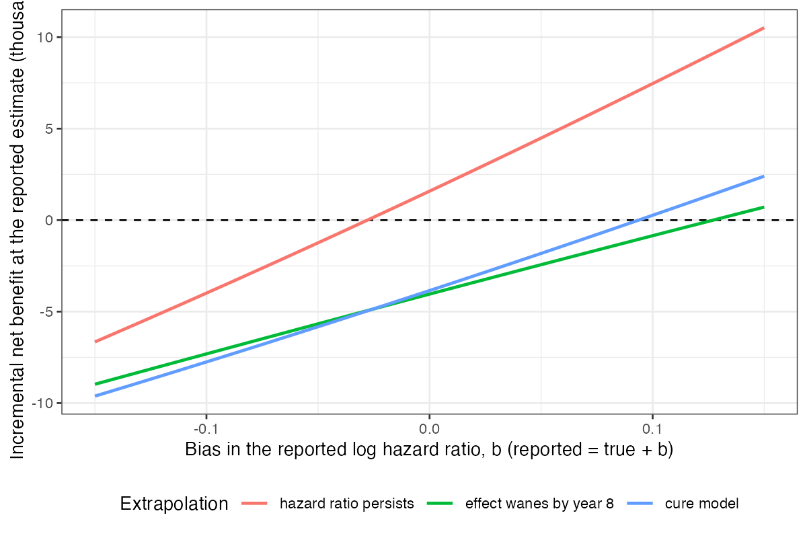
Figure 1: Net benefit at the reported estimate across the bias region, by extrapolation family.
Table 1: 4000 probabilistic draws.
propagation | probability of negative net benefit | mean net benefit
point propagation (PH, b = 0) | 0.384 | 1,895
family ph (b = 0) | 0.384 | 1,895
family waning (b = 0) | 0.895 | -3,990
family cure (b = 0) | 0.821 | -3,632
joint over b and family | 0.668 | -1,898
joint over b, ph | 0.416 | 1,988
joint over b, waning | 0.818 | -4,034
joint over b, cure | 0.745 | -3,567

The registered primary was confirmed: the joint reference gave a reversal probability 1.74 times that of point propagation (Table 1). The attribution matters for what to do about it. Net benefit moved roughly linearly and symmetrically with the bias under each family (Figure 1), so averaging over a symmetric bias region barely changed the reversal probability. The extrapolation family shifted the whole curve: with the effect waning or confined to the uncured, the decision reversed at the reported estimate. In scenario analysis, varying the bias under a persisting effect and varying the family at no bias gave a lowest net benefit of -6,657; the joint region reached -9,618, a combination no single scenario showed.

4. What this does not answer
A deterministic survival model rather than fitted extrapolations; three families, not splines; one symmetric bias parameter; no uncertainty in costs or utilities; one price. With an asymmetric elicited bias the bias layer would shift the reversal probability directly. Peer review has not been done.

References
1. Sander Greenland. Multiple-bias modelling for analysis of observational data. Journal of the Royal Statistical Society Series A. 2005;168(2):267–306. doi:10.1111/j.1467-985X.2004.00349.x

