The reported weight panel cannot see where support is missing
A simulation study answering catalog problem DIA-02
Ahmad Sofi-Mahmudi
2026-09-22

Abstract
Background. Matching-adjusted indirect comparison reports its overlap diagnostics as a panel of weight summaries: Kish effective sample size, its percentage of the source sample, entropy efficiency, the largest weight and the share of weight held by the top units. Every member of that panel is a symmetric function of the weights, so none can depend on which units carry which weight. Catalog problem DIA-02 states the consequence: the panel cannot encode where in covariate space support is missing, or whether the missing region matters for the contrast being estimated.
Methods. We built two source populations that remove the same mass at the same threshold on exchangeable standard normal coordinates and differ only in which coordinate carries the hole: the one that modifies the treatment effect, or a purely prognostic one. A binary outcome on the logit scale makes the target marginal risk difference non-collapsible. Across 48 cells and 96,000 replicates we scored the five panel members and four diagnostics that read covariate position as well as weight, both within the high-modification arm (the registered primary outcome) and across the two hole placements (the design’s second null control, read as a number).
Results. The manipulation works. With strong effect modification a hole in the modifying coordinate biases the marginal risk difference by 0.0164, and a hole of identical size in a prognostic coordinate by -0.0001, while every panel member agrees between the two arms to within 1.62%. Across placements, no panel member separates the two arms: the best reaches 0.505 against 0.5 for chance, with a standard error of 0.005. Region-specific ESS separates them at 1.000 and sliced optimal transport cost at 0.726. The registered within-arm primary reads the other way: the best panel member reaches 0.574 and the best geometric diagnostic 0.592, a gap far below the registered materiality of 0.10, so the registered rule returns “refuted”. We report both readings and explain why they disagree: within one arm every replicate shares a hole placement, so the registered outcome asks which replicate drew a bad sample, a variance question a concentration measure answers as well as anything. Two of three controls failed on parts of the grid and the analysis runs on the 12 of 48 cells they leave standing.
Conclusion. The blindness of the reported panel to support geometry is algebraic, and it bites in an ordinary covariate law: two analyses whose panels agree to 2% differ in bias by 0.0165, about half the material threshold, and in their rate of material error by a factor of 24. A diagnostic that reads position is necessary but not sufficient; convex hull distance taken as a maximum over coordinates is as blind as the panel here. No diagnostic studied is calibrated, and the one that separated the arms perfectly was given the easiest possible instance.

1. The problem
Matching-adjusted indirect comparison (MAIC) reweights individual participant data from a source trial so its weighted covariate moments equal those published for a target trial (1,2). The adequacy of the reweighting is reported through summaries of the weights. The effective sample size (3),

is universal; its percentage of , the entropy efficiency with , the largest normalized weight, and the share of total weight held by the top 5% of units are common companions. Reporting of even these is incomplete: of 117 oncology MAICs reviewed by Farinasso and colleagues, three met all NICE reporting recommendations and the weight distribution was among the least reported items (4).
Each of these statistics is a symmetric function of . For any permutation ,

so depends on the weights only through their multiset. Covariate positions never enter. Two analyses whose weight multisets coincide therefore report identical panels, whatever the geometry of the region their source fails to cover. This is not a property of ESS alone: it holds for every member of the panel at once, and the equivalence of ESS, ESS as a percentage and the coefficient of variation of the weights that our DIA-03 study established is a special case of it.
What the invariance does not settle is whether it matters. The refuting sentence registered in the design was that in realistic covariate laws weight concentration and support geometry move together tightly enough that the global summary is an adequate proxy, so that a counterexample requires configurations that do not occur. That is an empirical claim, and it is what this study tests.
A second defect sits in the same entry: at least three ESS calculations have been proposed for population adjustment (5), so two analyses of the same evidence can report different numbers. That is a comparability problem rather than a discrimination problem and is reported separately in Section 3.4.

2. Design
The design of record is DESIGN.md in the study directory, written against the program’s design standard. The study was not registered as a separate protocol; protocol.md records which choices were fixed before the first replicate and which were made after, and the restriction the analysis applies was written after the run was complete and read. The reporting follows ADEMP (6).

2.1 Data-generating mechanism
Target covariates are independent standard normal in dimensions. The source is the same law shifted by (good overlap) or (moderate overlap) in every coordinate, with a wedge removed by rejection sampling: source records with are discarded in coordinate (the high-modification hole), in coordinate (the low-modification hole), or not at all. Coordinate 1 modifies the treatment effect and every coordinate is prognostic:

with (moderate) or (strong) and treatment randomized 1:1 in the source. Because the two holes are the same size on exchangeable coordinates, the amount of extrapolation the weights must perform is nearly the same in both arms, and so is the weight multiset. Their relevance to the contrast is not.
The source has 16,000 records. That size was set before the run from a noise floor measured at the middle of the grid, so that the estimator’s own sampling error would rarely exceed the material threshold with no hole present. The target sample has 4,000 records, used only to supply the published moments.

2.2 Factors
Six factors fully crossed give 48 cells: covariate dimension (3, 8), hole placement (none, low modification, high modification), overlap (good, moderate), balancing set (all first and second moments matched, or the modifier’s second moment left unmatched), and effect modification (moderate, strong). Each cell has 2,000 replicates.

2.3 Estimand and estimator
The estimand is the target-population marginal risk difference, computed as a Monte Carlo mean over 400,000 target draws per dimension and modification level. MAIC weights solve the standard dual problem on first and second moments, and the estimate is the weighted difference in outcome proportions between arms. An error is material when it exceeds 0.03 in absolute value, a threshold set from the decision context rather than from the spread of the estimates.

2.4 Diagnostics
Five panel members, all symmetric in the weights: Kish ESS, ESS as a percentage, entropy efficiency, maximum weight, and top 5% share. Four candidates that read position as well as weight:
- balance on an omitted moment, the standardized difference in the second moment of between weighted source and target. It is identically near zero when that moment is matched and was registered as the comparator most likely to overturn the expected headline;
- region-specific ESS, Kish ESS computed on source records in the target’s upper decile of the effect modifier;
- convex hull distance, approximated coordinatewise as the largest amount by which the target’s 1st or 99th percentile lies outside the range of effectively weighted source records, maximized over coordinates;
- sliced optimal transport cost, the mean absolute difference between weighted source and target quantiles along 20 fixed random directions.
The last two are approximations and are named as such.

2.5 Outcomes
Each diagnostic is scored by its area under the ROC curve (AUROC) in the direction a practitioner reads it, so an AUROC below 0.5 means it misleads. Two readings are computed.
- Registered primary. Within the high-modification arm, AUROC against material error.
- Cross-arm separation. Across the two hole placements, at matched panels, for distinguishing the arms. This is the design’s second null control, which required every panel member to agree between the arms, turned into a number.
Standard errors are nonparametric bootstrap standard errors over replicates.

2.6 Controls
- Null. With no hole, material error must occur in at most 2% of replicates in a stratum; otherwise the label measures the estimator’s own noise.
- Matched multiset. Every panel member must agree between the two hole arms to within 2% relative difference; otherwise the manipulation did not happen.
- Positive. With a hole in the modifying coordinate and strong modification, MAIC must incur material error at a substantial rate.

3. Results

3.1 What the controls left standing
Two of three controls failed on parts of the grid, and the analysis runs on what they leave (Table 1).
Table 1: Null control by stratum: probability of material error with no support hole. The registered limit is 0.02.
 | stratum | P(material error) | passes
dim3/good | dim3/good | 0.0005 | yes
dim3/moderate | dim3/moderate | 0.0213 | no
dim8/good | dim8/good | 0.0026 | yes
dim8/moderate | dim8/moderate | 0.2885 | no

At eight covariates and a moderate shift, MAIC’s own sampling error exceeds the material threshold in 0.288 of replicates with no hole at all. The source size had been set from a noise floor measured at the middle of the grid, and the middle is not the worst corner. The same defect, a threshold below the estimator’s own noise, is what our IDN-05 study documented. The dim3/moderate stratum fails narrowly at 0.0213; adding it back changes no separation by more than 0.034, so the cut is not doing the work.
The matched-multiset control passes when every moment is matched (largest panel residual 1.62%) and fails when the modifier’s second moment is left unmatched (largest residual 90.80%). Dropping that moment breaks the coordinate symmetry the manipulation rests on: the high-modification hole now truncates a coordinate whose spread the weights no longer control, and the multisets diverge. This eliminates every cell in which balance on the omitted moment has anything to see. The comparator registered as most likely to overturn the headline was therefore never given a fair test, and that is recorded as a live threat in Section 4.
The positive control passes: with strong modification and a hole in the modifying coordinate, material error occurs in 0.106 of replicates on the surviving subgrid.
The analysis runs on 12 of 48 cells, 24,000 replicates: dimensions 3 and 8 at good overlap, all moments matched, all three hole placements and both modification strengths.

3.2 The manipulation
Table 2: Bias, mean absolute error and probability of material error by hole placement, on the surviving subgrid. mod share is the share of the target’s effect-modification mass lying in the unsupported region.
modification | hole | bias | mean abs error | P(material) | mod share
moderate | none | 0.0001 | 0.0073 | 0.0018 | 0.00
moderate | low_modification | -0.0001 | 0.0081 | 0.0037 | 0.10
moderate | high_modification | 0.0055 | 0.0093 | 0.0090 | 0.22
strong | none | 0.0003 | 0.0076 | 0.0025 | 0.00
strong | low_modification | -0.0001 | 0.0084 | 0.0045 | 0.10
strong | high_modification | 0.0164 | 0.0170 | 0.1062 | 0.22

A hole in the modifying coordinate biases the estimate; a hole of the same size in a prognostic coordinate does not, to the fourth decimal place (Table 2, Figure 1). The panel agrees between the two arms to within 1.62%. That is the counterexample the refuting sentence said would require configurations that do not occur, built from a symmetry in an ordinary multivariate normal law.
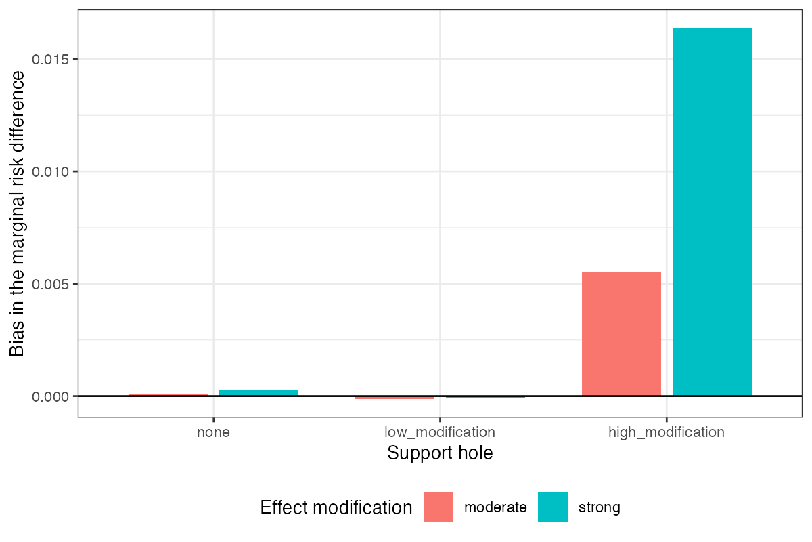
Figure 1: Bias of the MAIC estimate of the marginal risk difference by hole placement, on the surviving subgrid.

3.3 Two readings
Table 3: Within-arm AUROC against material error (registered primary) and cross-arm separation of the two hole placements (second null control), with bootstrap standard errors.
statistic | family | within AUROC | SE | cross separation | SE
ess_region | geometric | 0.592 | 0.011 | 1.000 | 0.0000
ot_cost | geometric | 0.577 | 0.013 | 0.726 | 0.0042
balance_omitted | geometric | 0.465 | 0.014 | 0.535 | 0.0048
max_weight | panel | 0.574 | 0.013 | 0.505 | 0.0044
hull_gap | geometric | 0.560 | 0.013 | 0.503 | 0.0044
ess_kish | panel | 0.510 | 0.014 | 0.502 | 0.0045
ess_pct | panel | 0.510 | 0.014 | 0.502 | 0.0043
entropy_eff | panel | 0.491 | 0.014 | 0.501 | 0.0044
top_share | panel | 0.481 | 0.014 | 0.500 | 0.0046

The two readings disagree (Table 3, Figure 2).
Across placements, which is the question the proposition asks, every panel member sits within 0.005 of chance. With 16,000 replicates and a standard error near 0.005, that is a measured blindness rather than an unrejected null. Region-specific ESS separates the arms at 1.000 and sliced transport cost at 0.726. Convex hull distance, though it reads position, separates at 0.503: it takes a maximum over coordinates, both arms remove an identical wedge, and the maximum is therefore identical. Reading position is not enough if the reading is then symmetrized.
Within the high-modification arm, which is the registered primary, the best geometric diagnostic reaches 0.592 and the best panel member 0.574. The gap of 0.018 is far below the registered materiality of 0.10, and the registered rule reads refuted: the panel discriminates as well as the geometric diagnostics.
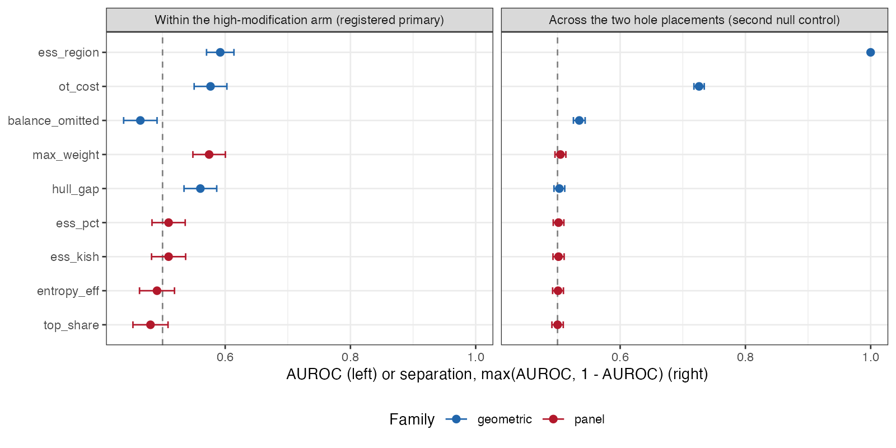
Figure 2: Within-arm AUROC (left, registered primary) and cross-arm separation (right). Bars are 95% intervals from bootstrap standard errors. The dashed line is chance.
The reason is that the registered outcome measured the wrong thing. Within one arm every replicate shares a hole placement, so the only thing varying across replicates is sampling noise, and AUROC against material error asks which replicate drew a bad sample. A concentration measure answers that about as well as anything, which is why the panel is competitive there. The proposition is about where the support sits, and answering it requires comparing analyses at different placements. The registered primary outcome was the wrong measurement for the proposition, and the design’s own control was the right one. We report the registered verdict as it stands and do not relabel the cross-arm reading as primary after the fact.

3.4 The comparability defect
On identical data, the largest of the three ESS definitions divided by the smallest has median 1.55, 90th percentile 3.50 and maximum 15.48. One qualification changes what that number means. As implemented, the Kish form and the coefficient-of-variation form are the same statistic up to the divisor, because the weights are normalized to a fixed mean; their ratio is one on every replicate. The measured spread is therefore between Kish ESS and the entropy form alone. Two analyses reporting “the ESS” of the same weights can still differ by a factor of 1.5 at the median and 3.5 at the 90th percentile, which is the comparability complaint quantified, but the three published definitions (5) were not all implemented and the figure should not be read as their spread.

3.5 What rescuing the failed strata would cost
A post hoc probe measured the source size at which the two failed strata would pass the null control, using the upper Clopper-Pearson bound on 300 replicates rather than the point estimate (Figure 3). dim3/moderate needs 48,000 source records and dim8/moderate needs 192,000. At those sizes the per-replicate cost is dominated by the sliced transport cost and was not measured, so the rescue run was not done.
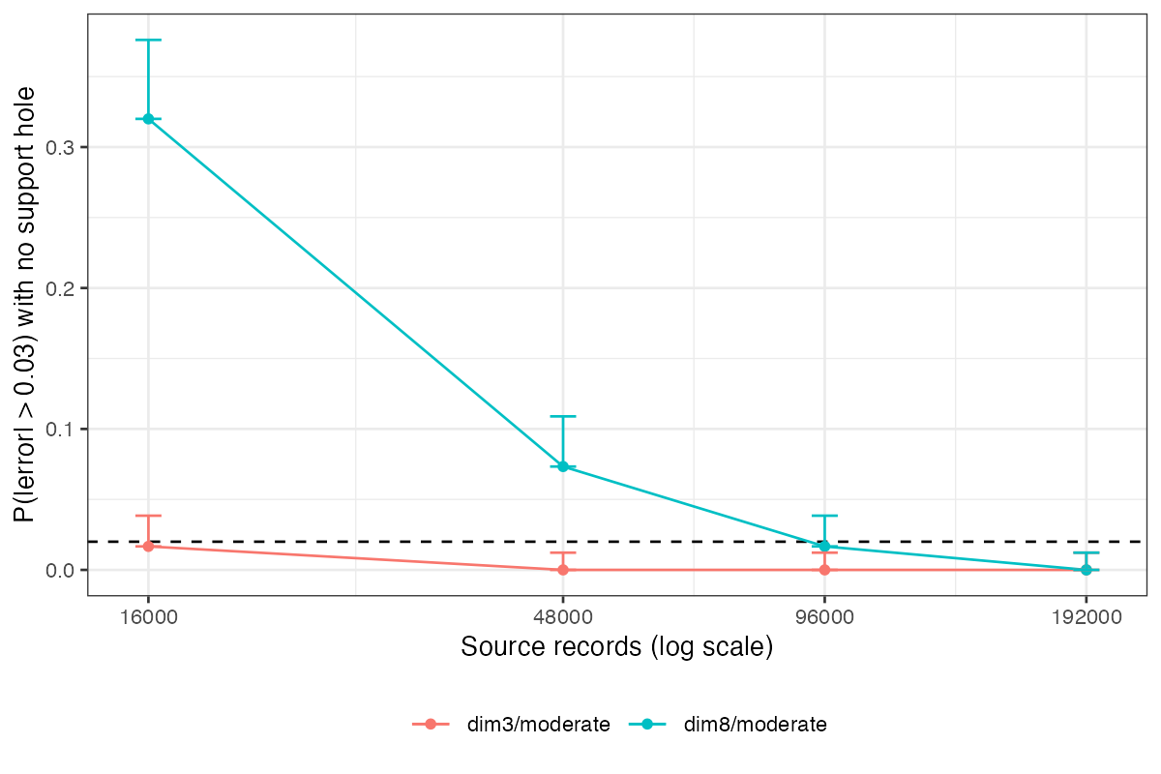
Figure 3: Probability of material error with no support hole, by source size, in the two strata that failed the null control. Bars run to the upper Clopper-Pearson bound; the dashed line is the 0.02 limit.

4. What this does not answer
- Balance on the omitted moment was not tested. It was the registered comparator most likely to overturn the headline, and every cell where it had something to see was removed by the matched-multiset control. Its separation of 0.535 on the surviving cells is the tautological near-zero its definition predicts. Whether a free check that every implementation can compute would do as well as a geometric diagnostic remains open.
- Region-specific ESS was handed the easiest possible instance. The region it examines and the region the hole empties are the same construction, the modifier’s upper decile, so its separation of 1.000 is an upper bound on field performance rather than an estimate of it. Two things keep it from being circular: the region is chosen from the effect-modifier structure MAIC already requires naming, not from knowledge of the hole, and in the prognostic-hole arm the statistic reads near normal rather than firing on any hole at all. A hole in a high-modification region the analyst did not think to examine is untested, and there it would fail as the panel does.
- No diagnostic is calibrated. Separating two placements is not a threshold, and this study supplies none.
- The analysis subgrid was chosen after the results were read. The rule that chose it is mechanical and derived from the controls, and adding back the borderline stratum changes nothing, but it was written after the run.
- Scope. MAIC weights only, a binary outcome, multivariate normal covariates, a single rectangular hole, moderate or strong linear effect modification in one coordinate, and two of the three published ESS definitions. STC and ML-NMR produce no weight vector and are outside the complaint. Moderate overlap was removed by the null control, so every positive result here is at good overlap.
- The high-modification hole is weaker than its registered definition. The configuration registered that a hole counts as high-modification when it holds at least 25% of the target’s effect-modification mass. The realized share is 0.22, so by its own definition the hole falls short, and the positive control passed at that weaker strength. A stronger hole would make the manipulation larger, not the panel less blind.
- Peer review has not been done.

Reproducing this study
Rscript R/03-run.R # 48 cells, resumable, one file per cell
Rscript R/04-analyze.R # controls, restriction, both readings
Rscript R/05-decision.R # results/decision.md
Rscript R/06-floor-probe.R
Rscript R/07-figures.R
Seeds are a deterministic function of the cell and replicate. Per-replicate output is regenerable and not tracked; results/analysis.rds and results/decision.md are.

References
1. James E. Signorovitch, Eric Q. Wu, Andrew P. Yu, Charles M. Gerrits, Evan Kantor, Yanjun Bao, Shiraz R. Gupta, Parvez M. Mulani. Comparative effectiveness without head-to-head trials: A method for matching-adjusted indirect comparisons applied to psoriasis treatment with adalimumab or etanercept. PharmacoEconomics. 2010;28(10):935–45. doi:10.2165/11538370-000000000-00000
2. David M. Phillippo, A. E. Ades, Sofia Dias, Stephen Palmer, Keith R. Abrams, Nicky J. Welton. Methods for population-adjusted indirect comparisons in health technology appraisal. Medical Decision Making. 2018;38(2):200–11. doi:10.1177/0272989X17725740
3. Leslie Kish. Survey sampling. New York: Wiley; 1965.
4. Farinasso, others. Matching-adjusted indirect comparison studies in oncology: A scoping review focused on reporting quality. Value in Health Regional Issues. 2025. doi:10.1016/j.vhri.2025.101088
5. Three new methodologies for calculating the effective sample size when performing population adjustment. BMC Medical Research Methodology. 2024. doi:10.1186/s12874-024-02412-1
6. Tim P. Morris, Ian R. White, Michael J. Crowther. Using simulation studies to evaluate statistical methods. Statistics in Medicine. 2019;38(11):2074–102. doi:10.1002/sim.8086

