A binary replication label changes with precision alone, and interval overlap carries most of the change
A simulation study answering the pair-level component of catalog problem BEN-02
Ahmad Sofi-Mahmudi
2026-08-01

Abstract
Background. Agreement between an emulated and a randomized trial is often reported as a binary label, such as whether the confidence intervals overlap or whether the estimates share a sign. Catalog entry BEN-02 states that such a label mixes estimand mismatch with random error. We tested the pair-level part of that claim: whether the label changes when the estimands are held fixed and only precision changes.
Methods. Sixteen structural scenarios crossed outcome family (logit, probit), baseline risk (two levels) and four mismatch mechanisms (aligned, observable effect-modifier shift, unavailable effect-modifier shift, outcome misclassification). Each was run at three nested precision levels (trial n of 500, 2,500 and 25,000; emulation n ten times larger) with 10,000 replicates, 480,000 benchmark pairs in all. True trial and emulation risk differences were computed by exact finite-cell summation. The primary statistic S was the larger of two operator-specific sensitivities, each the average over scenarios of the range in agreement probability across precision levels. The registered rule called the problem real if the lower 95% Monte Carlo limit of S exceeded 0.10.
Results. S was 0.4915 (95% Monte Carlo interval 0.4903 to 0.4931), supplied by the interval-overlap operator; direction agreement varied by 0.1244. Under an observable effect-modifier shift, overlap agreement fell from 0.937 at the smallest samples to 0.018 at the largest, with the true discrepancy unchanged. The underlying estimators had coverage 0.944 to 0.956 and no failures.
Conclusions. A binary agreement label, and the interval-overlap label in particular, is largely determined by precision when the estimands are fixed.

1. Introduction
Benchmarking programs compare target trial emulations with the randomized trials they emulate and summarize each pair by whether the two “agree” (1). A systematic review and meta-analysis related concordance to design features using effect correlation and standardized differences rather than a pass or fail label (2). BEN-02 argues that a binary label conflates two things: whether the trial and emulation target the same estimand, and how precisely each was estimated. Two pairs that estimate the same pair of quantities can be labeled differently because one was estimated more precisely.
That claim has a testable core. If estimands are held fixed and only sample size changes, a label that measured estimand agreement would not move. This study measures how far it moves. It addresses only this pair-level component; heterogeneity across a benchmarking portfolio, the choice of tolerance, and the calibration of graded metrics are outside its scope.

2. Methods
The study follows the ADEMP structure (3); the design was reviewed and revised before any code was written.

2.1 Data-generating mechanism
Each replicate contains an independent trial cohort and emulation cohort with a binary outcome at one year. Covariates L1 ~ Bernoulli(0.5) and L2 ~ Bernoulli(0.4) are shared; Z is an observed and U an unavailable effect modifier. Trial treatment is randomized; emulation treatment follows logit P(A = 1) = −0.40 + 0.80L1 − 0.60L2 + 0.70Z. The outcome index is , with a logit or probit link and two intercepts per link. The four mismatch mechanisms are: aligned populations and measurement; an observable shift in the prevalence of Z (0.35 in the trial, 0.65 in the emulation); the same shift in the unavailable U; and emulation outcome misclassification with sensitivity 0.85 and specificity 0.98. No parameter was solved to produce a chosen discrepancy. Counts at the three precision levels are nested multinomial increments, so the mechanism and estimands are identical across levels and only sampling error changes.

2.2 Estimands and truth
The trial and emulation marginal risk differences, their raw discrepancy, and the discrepancy after standardizing the emulation to the trial distribution of observed covariates. Truth was computed by exact summation over the 16 covariate cells; the largest summation error was 2.2e-16. True raw discrepancies ranged from 0 in the aligned scenarios to 0.060 (Table 1).

2.3 Methods evaluated
Trial effects were estimated by the difference in arm risks and emulation effects by augmented inverse probability weighting. Two illustrative binary operators were applied to each pair: direction agreement (same sign) and interval overlap (the two 95% Wald intervals intersect). As secondary methods that answer a stated tolerance question, |discrepancy| below 0.02, a forced plug-in classifier and a three-way procedure (aligned, mismatched or indeterminate from the 90% interval of the discrepancy) were also evaluated.

2.4 Primary statistic and decision rule
For each operator, V is the average over the 16 scenarios of the range of its agreement probability across the three precision levels; S = max(V_direction, V_overlap). Its 95% Monte Carlo interval came from 20,000 stratified paired bootstrap resamples. The problem is real for this component if the lower limit exceeds 0.10, not real if the upper limit is below 0.10, and inconclusive otherwise. The result is uninformative if truth checks fail or estimator nonconvergence exceeds 1% in any scenario.

3. Results

3.1 The estimators are sound
Across all scenarios, precision levels and estimands, coverage ran from 0.9442 to 0.9557 and absolute bias was at most 0.00086. The nonconvergence rate was 0 in every scenario. Label changes below are therefore not an estimation artifact.

3.2 The primary statistic
S = 0.4915, 95% Monte Carlo interval 0.4903 to 0.4931. The lower limit exceeds 0.10 by about 538 Monte Carlo standard errors. The registered branch is that the problem is real for the pair-level component. Interval overlap supplies S; direction agreement varies by 0.1244, a quarter as much.

3.3 Where the change occurs
Table 2 gives agreement probabilities averaged within mismatch mechanism. When the true discrepancy is zero (aligned), overlap agreement is near 0.99 at every precision and direction agreement rises from 0.860 to 1 as the effects become distinguishable from zero. When the estimands differ, overlap agreement collapses as precision grows: under the observable Z shift from 0.937 to 0.018, under the unavailable U shift from 0.964 to 0.108. Pairwise, the overlap label of the same replicate changed between the smallest and largest samples in 0.920 of pairs under the Z shift and 0.861 under the U shift (Figure 1).
Table 1: True trial risk difference and raw discrepancy (emulation minus trial) by scenario.
family | baseline | mismatch | trial RD | raw discrepancy | after Z standardization
logit | lower | aligned | -0.0217 | 0.0000 | 0.0000
probit | lower | aligned | -0.0341 | 0.0000 | 0.0000
logit | common | aligned | -0.0535 | 0.0000 | 0.0000
probit | common | aligned | -0.0986 | 0.0000 | 0.0000
logit | lower | observed_z_shift | -0.0310 | 0.0187 | 0.0000
probit | lower | observed_z_shift | -0.0496 | 0.0311 | 0.0000
logit | common | observed_z_shift | -0.0717 | 0.0363 | 0.0000
probit | common | observed_z_shift | -0.1286 | 0.0600 | 0.0000
logit | lower | hidden_u_shift | -0.0286 | 0.0139 | 0.0139
probit | lower | hidden_u_shift | -0.0458 | 0.0234 | 0.0234
logit | common | hidden_u_shift | -0.0659 | 0.0248 | 0.0248
probit | common | hidden_u_shift | -0.1176 | 0.0381 | 0.0381
logit | lower | measurement_mismatch | -0.0217 | 0.0037 | 0.0037
probit | lower | measurement_mismatch | -0.0341 | 0.0058 | 0.0058
logit | common | measurement_mismatch | -0.0535 | 0.0091 | 0.0091
probit | common | measurement_mismatch | -0.0986 | 0.0168 | 0.0168

Table 2: Agreement probability averaged over the four scenarios in each mismatch mechanism, by precision (trial n 500, 2500, 25000).
operator | mismatch | small | medium | large
direction | aligned | 0.860 | 0.979 | 1.000
direction | hidden_u_shift | 0.894 | 0.994 | 1.000
direction | measurement_mismatch | 0.858 | 0.978 | 1.000
direction | observed_z_shift | 0.890 | 0.994 | 1.000
overlap | aligned | 0.985 | 0.986 | 0.987
overlap | hidden_u_shift | 0.964 | 0.855 | 0.108
overlap | measurement_mismatch | 0.984 | 0.972 | 0.796
overlap | observed_z_shift | 0.937 | 0.664 | 0.018

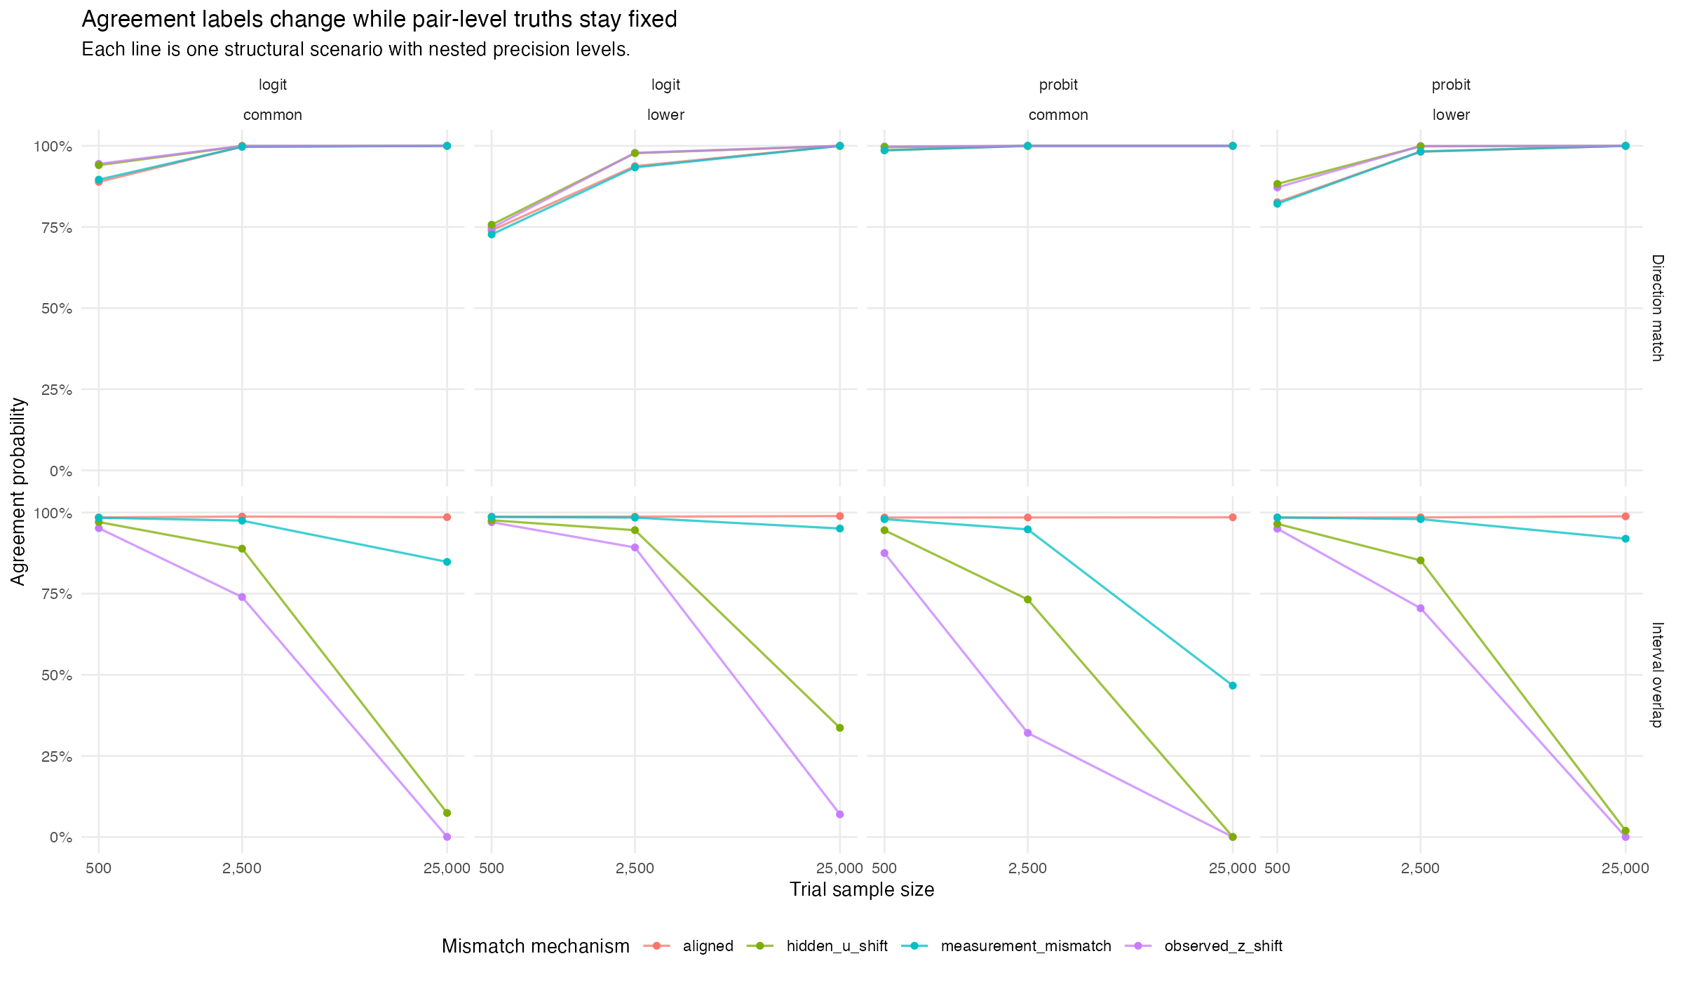
Figure 1: Agreement probability by trial sample size. Each line is one structural scenario; the truth is fixed along each line.

3.4 Procedures that answer a tolerance question
Treating |discrepancy| < 0.02 as the question, the forced plug-in classifier made a wrong definitive call in 0.407 of pairs at the smallest samples and 0.062 at the largest. The three-way procedure kept wrong calls at 0.019 and 0.003 by declining to decide in 0.945 and 0.309 of pairs. A procedure that reports indeterminacy separates precision from discrepancy; a binary label cannot.

4. Discussion
Holding the estimands fixed and changing only precision moved the probability of an interval-overlap “agreement” by about half on average. The direction of the movement depends on the truth: with no discrepancy, overlap is stable; with any discrepancy, more precision produces “disagreement”. A binary overlap label therefore reports, in large part, how large the two studies were. Direction agreement is less exposed but moves the other way, towards agreement, as precision grows, including when the estimands differ.
For benchmarking, this supports reporting the discrepancy on the effect scale with its uncertainty, and, where a decision is needed, a tolerance procedure that can return “indeterminate”, as the catalog entry proposes.

4.1 What this study does not establish
S is a maximum over two illustrative operators, so the result is an at-least-one-operator claim: it shows that interval overlap is materially precision-sensitive, not that every binary label is. It holds for these 16 scenarios and three nested precision levels, on the risk-difference scale at a single horizon. It says nothing about heterogeneity across a benchmarking portfolio, about how a tolerance should be chosen, or about graded measures already in use.

4.2 Review
The design review returned unsound with three fatal findings, all resolved before any code was written: it answered a neighboring question, its mechanism solved a parameter to produce the discrepancies it then measured, and its decision rule had an unreachable negative branch. The results were reviewed in a fresh context that did not see this summary and returned supported, with one minor finding on scope.

Data and code availability
Code, protocol and result files: https://github.com/choxos/TTE-open-problems/tree/main/studies/BEN-02-pair-level-precision-sensitivity. The registered design is documentation/studies/designs/BEN-02-*-revised.json.

References
1. Shirley V. Wang, Sebastian Schneeweiss, RCT-DUPLICATE Initiative. Emulation of randomized clinical trials with nonrandomized database analyses: Results of 32 clinical trials. JAMA. 2023;329(16):1376–85. doi:10.1001/jama.2023.4221
2. Canlong Wang, Dongfeng Tang, Peter von Dadelszen, Chengsheng Ju, Lu Liu, Yanzhong Wang, Laura A. Magee. Concordance between target trial emulation and randomised controlled trials: Systematic review and meta-analysis. BMJ. 2026;393:e086810. doi:10.1136/bmj-2025-086810
3. Tim P. Morris, Ian R. White, Michael J. Crowther. Using simulation studies to evaluate statistical methods. Statistics in Medicine. 2019;38(11):2074–102. doi:10.1002/sim.8086

